Қазақстан Республикасы білім және ғылым министрлігі
Е.А. Бөкетов атындағы Қарағанды мемлекеттік университеті

Физика-техникалық факультеті

Радиофизика және электроника кафедрасы

Тусупбекова Айнура Каиржановна
Рожкова Ксения Сергеевна

«Digital electronics» пәні бойынша
Дәрістер курсы

мамандығы: «5B060400-Физика»

(10 тақырып)

Караганда 2019
Theme № 1. Lection № 1
Binary Logic and Logic Gates.

Plan of lecture

- Binary Arithmetic.
- Logic Gates

1 Binary Arithmetic

The idea behind binary logic is to represent information using only two states. You can call these states TRUE and FALSE, or you can use the corresponding numerical values 1 and 0. We will explore in much more detail how to represent and use information in this form, but for now, note that we call the fundamental (abstract) element that carries these states a bit. That is, a single bit can have either the values 0 or the value 1.
In binary number system there are only 2 digits 0 and 1, and any number can be represented by these two digits. The arithmetic of binary numbers means the operation of addition, subtraction, multiplication and division. Binary arithmetic operation starts from the least significant bit i.e. from the right most side. We will discuss the different operations one by one in the following article.
Binary multiplication may sound like it would be more difficult than binary addition or subtraction – but is actually a simple process. Here are the four steps to be followed, using the same binary numbers 10001001 and 10010101:
The idea behind digital logic and digital electronics is to represent the binary states by two different electronic states, usually different voltages or voltage ranges, but sometimes different currents. For example, the standard for transistor-transistor logic (TTL) is to use nominal voltages of 0 V for FALSE, and +5 V for TRUE.
Consider the basic logical operations and their truth tables.
1) Logical multiplication or conjunction:
A conjunction is a complex logical expression that is considered true if and only if both simple expressions are true, in all other cases this complex expression is false. Designation: F = A & B.
The truth table for conjunction is shown in Figure 1.1.

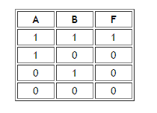

Fig.1.1. Truth Table for conjunction
2) Logical addition or disjunction:
Disjunction is a complex logical expression that is true if at least one of the simple logical expressions is true and false if and only if both simple logical expressions are false. Designation: F = A + B.
The truth table for the disjunction is presented in Figure 1.2.

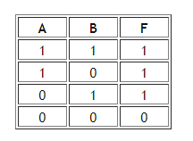

Fig.1.2. Truth Table for disjunction

3) Logical negation or inversion:
Inversion is a complex logical expression, if the initial logical expression is true, then the result of the negation will be false, and vice versa, if the initial logical expression is false, then the result of the negation will be true. In other simple words, this operation means that the particle is NOT or the words WRONG THAT are added to the initial logical expression.
The truth table for inversion is shown in Figure 1.3.

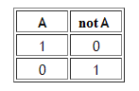

Fig.1.3. Truth Table for inversion

4) Logical following, implication or ambiguity:
Implication is a complex logical expression that is true in all cases, except falsehood follows from truth. That is, this logical operation connects two simple logical expressions, of which the first is condition (A) and the second (B) is a consequence.
The truth table for implication is shown in Figure 1.4.

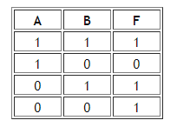

Fig.1.4. Truth Table for implication

5) Logical equivalence:
Equivalence is a complex logical expression that is true if and only if both simple logical expressions have the same truth.
The truth table for equivalence is presented in Figure 1.5.

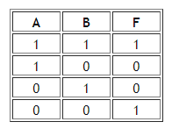

Fig.1.5. Truth Table for equivalence

The order of performing logical operations in a complex logical expression:
1. Inversion;
2. Conjunction;
3. Disjunction;
4. Implication;
5. Equivalence.
To change the specified order of logic operations, brackets are used.

2 Logic Gates

Electrical circuit designed to perform any logical operation with input data is called a logical gate or logical element. The input data are presented here as voltages of various levels, and the result of a logical operation at the output is also obtained as a voltage of a certain level.
Operands in this case are fed in binary number system - signals to the input of a logic element are in the form of high or low voltage, which are essentially input data. Thus, the high-level voltage is a logical unit of 1, which indicates the true value of the operand, and the low-level voltage of 0 is a false value. 1 - TRUE, 0 - FALSE.

A logical element is an element that implements certain logical dependencies between input and output signals. Logic elements are usually used to build logic circuits of computers, discrete circuits of automatic control and management. For all types of logic elements, regardless of their physical nature, discrete values of input and output signals are characteristic.
Logic elements have one or more inputs and one or two (usually inverse to each other) output. The values of “zeros” and “units” of the output signals of logical elements are determined by the logic function that the element performs, and the values of “zeros” and “units” of input signals playing the role of independent variables. There are elementary logical functions from which one can compose any complex logical function.
Depending on the device’s device circuitry, on its electrical parameters, the logic levels (high and low voltage levels) of the input and output have the same values for high and low (true and false) states.
Traditionally, logic elements are produced in the form of special radio components - integrated circuits. Logical operations, such as conjunction, disjunction, negation and addition modulo (AND, OR, NOT, exclusive OR) - are the basic operations performed on the logical elements of the main types. Next, we consider each of these types of logical elements more closely.
The logical element "AND" - conjunction, logical multiplication.
"AND" is a logical element that performs a conjunction or a logical multiplication operation on the input data. This element can have from 2 to 8 (the most common in the production of the elements "AND" with 2, 3, 4 and 8 inputs) inputs and one output.
Symbols of logical elements "AND" (Fig.1.6) with a different number of inputs are shown in the figure. In the text, the logical element "And" with one or another number of inputs is designated as "2AND", "4AND", etc. - the element "AND" with two inputs, with four inputs, etc.

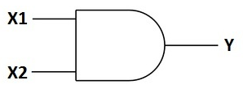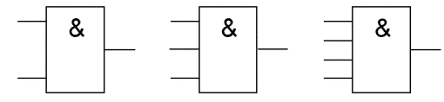

Fig.1.6. Logical element "AND"

The truth table for the element 2AND shows that the output of the element will be a logical unit only if the logical units will be simultaneously at the first input And at the second input. In the remaining three possible cases, the output will be zero.
In Western schemes, the icon of the element "AND" has a straight line at the entrance and a rounding at the exit. On domestic schemes - a rectangle with the symbol "&".
The logical element "OR" - disjunction, logical addition.
“OR” is a logical element that performs a disjunction or logical addition operation on the input data. As well as the element "And" it is produced with two, three, four, etc. inputs and with one output. Symbols of logical elements "OR" (Fig.1.7) with a different number of inputs are shown in the figure. These elements are denoted as follows: 2OR, 3OR, 4OR, and so on.

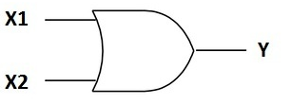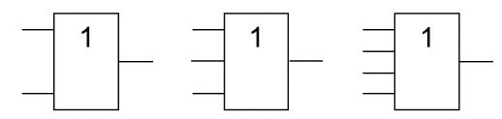

Fig.1.7. Logical element "OR"

The truth table for the element "2OR" shows that in order for a logical unit to appear at the output, it is enough that the logical unit is at the first input OR at the second input. If logical units will be immediately on two inputs, the output will also be one.
In Western schemes, the OR element icon has a rounding at the entrance and a rounding with a point at the exit. On domestic schemes - a rectangle with the symbol "1".
Logic element "NOT" - negation, inverter.
"NOT" is a logical element that performs a logical negation operation on the input data. This element, having one output and only one input, is also called an inverter, since it actually inverts (inverts) the input signal. The Figure 1.8 shows the symbol of the logical element "NOT".

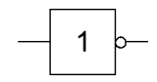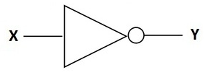

Fig.1.8. Logical element "NOT"
The truth table for the inverter shows that a high potential at the input gives a low potential at the output and vice versa.
In Western schemes, the icon of the element "NOT" has the shape of a triangle with a circle on the output. On domestic schemes - a rectangle with the symbol "1", with a circle at the exit.
Logical element "AND-NOT" - conjunction (logical multiplication) with negation, NAND
"AND-NOT" is a logical element that performs a logical addition operation on the input data, and then a logical negation operation, the result is output. In other words, it is in principle the element "AND", supplemented by the element "NOT". The Figure 1.9 shows the symbol of the logical element "2AND-NOT."

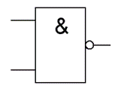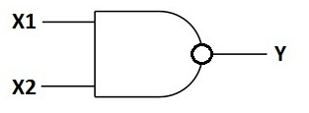

Fig.1.8. Logical element "AND-NOT"

The truth table for the element "AND-NOT" is opposite to the table for the element "AND". Instead of three zeros and ones, three ones and zero. The element "AND-NOT" is also called the "element Scheffer" in honor of the mathematician Henry Maurice Scheffer, who first noted the significance of this logical operation in 1913. It is denoted as "AND", only with a circle at the exit.
The logical element "OR-NOT" is a disjunction (logical addition) with negation, NOR.
"OR-NOT" is a logical element that performs a logical addition operation on the input data, and then a logical negation operation, the result is output. In other words, this is the element "OR", supplemented by the element "NOT" - an inverter. The Figure 1.9 shows the symbol of the logical element "2OR-NOT."

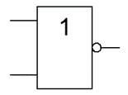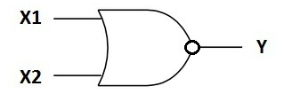

Fig.1.9. Logical element "OR-NOT"

The truth table for the element "OR-NOT" is opposite to the table for the element "OR". A high output potential is obtained only in one case - both potentials are simultaneously supplied to both inputs. It is denoted as “OR”, only with a circle at the exit, denoting inversion.
The logical element "exclusive OR" - addition module 2, XOR
"Exclusive OR" is a logical element that performs a logical modulo-2 operation on the input data and has two inputs and one output. Often, these elements are used in control circuits. The Figure 1.10 shows the symbol of this element.
The image in the western schemes is like an "OR" with an additional curved strip on the entrance side, in the domestic one - like "OR", only instead of "1" it will be written "= 1".

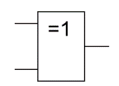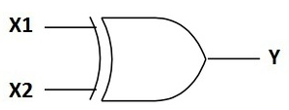

Fig.1.10. Logical element "Exclusive OR"

This logical element is also called "disparity". A high voltage level will be at the output only when the signals at the input are not equal (at one unit, at the other zero or at one zero, and at the other one) if even at the input there are two units at the same time, the output will be zero - this is the difference from "OR". These elements of logic are widely used in adders.

LITERATURE
Main:

- 8 Class Physics Zambak, 2008
- Курашвили Е.И. Английский язык для студентов –физиков. Часть 1. –М.: ООО «Изд-во АСТ», 2010. – 317с.
- Жетписбаева Б.А., Шайхызада Ж.Г., Сугралина Л.М. Английский язык для естественно-научных специальностей. –Караганда.: Изд-во КарГУ, 2012
- David Sang. Physics. Course Book: Cambrige, 2012.
- Class Physics Zambak, 2009
- www.steck.us/teaching - D.A. Steck. Analog and Digital electronics. – Oregon, USA. - 2015.
- Anil K. Maini. Digital Electronics. – Wiley, 2007. – 741 p.
- https://72arkarcy.files.wordpress.com/2016/09/foundation-of-digital-electronics-and-logic-design-2014.pdf - Subir K.S., etc. Foundation of Digital Electronics and Logic Design. – Pan Stanford Publ., Boca Raton, 2014. – 372 Р. - 7.01 MB
- https://www.pdfdrive.com/the-art-of-electronics-d33411099.html - Horowitz & Hill. The Art of Electronics. – Cambridge Univ. Press, 2016. – 1225 P. – 29 MB.
- elibrary.ru
Additional:

- Val Lambert & Elaine Murray. Everyday Technical English: Longman, 2010
- Ашихмин А.С. Цифровая схемотехника: шаг за шагом/ А.С. Ашихмин. - М.: Диалог-МИФИ, 2008. - 304 с.
- Eurasian Physical Technical Journal: Karaganda State University. №1,2. 2013
- CD-ROM. Keith Kelly. Science: Macmillan Vocabulary Practice Series, 2008
Theme № 2
Lection № 2
Boolean Algebra.

Plan of lecture

- Algebras and Boolean Algebra.
- Boolean-Algebraic Theorems and Manipulations.
- Karnaugh Maps.

1 Algebras and Boolean Algebra.

The algebra of logic (Boolean algebra) is a branch of mathematics that studies statements considered from the side of their logical values ​​(truth or falsehood) and logical operations on them. The logic algebra allows you to encode any statements, the truth or falsity of which you need to prove, and then manipulate them like ordinary numbers in mathematics.
Boolean algebra as a subject area is defined by the following criteria:
1. A non-empty set A.
2. Binary Operations Conjunction (ʌ) and Disjunction (v)
3. Unary negation operation (¬ or not)
4. Logical constants True (1) and False (0)
Boolean algebra is named after the great English mathematician George Boole (1815–1864), who in 1854 published the book “The Laws of Thinking” which later became famous. At the beginning of ch. 1 he wrote: “The purpose of this treatise is to investigate the basic laws of those mind operations through which reasoning is effected; express them in the symbolic language of some calculus and, on this basis, establish the science of logic and construct its method; make this method the basis of the general application of the mathematical doctrine of probabilities; and, finally, to gather from the various elements of truth revealed in the course of these investigations some plausible indications as to the nature and structure of the human mind. ”
In this book, Boule outlined most of the new algebra, especially suitable for the analysis of classes and sentences (statements).
Other mathematics and logic, including John Venn and Ernst Schroeder, subsequently significantly improved and expanded the Boolean algebra.
In 1938, Claude E. Shannon, then a student at the Massachusetts Institute of Technology, later a well-known mathematician and engineer at the Bell telephone laboratories, and now a professor at the Massachusetts Institute of Technology, showed that Boolean algebra can be perfectly used in the synthesis of switching electrical circuits. His article "The Symbolic Analysis of Relay-Switching Circuits" represents a milestone in the development of applications of Boolean algebra.

2 Boolean-Algebraic Theorems and Manipulations.

Axioms
1) A boolean variable is always equal to either zero or one
x = 0 if x ≠ 1
x = 1 if x ≠ 0
2) The inverse value of the variable x is opposite to its direct value
x = 0 if ¬х = 1
x = 1 if ¬х = 0
3) Rules for performing logical multiplication (conjunction)
0 ʌ 0 = 0
1 ʌ 1 = 1
0 ʌ 1 = 1 ʌ 0 = 0
4) Rules for performing logical addition (disjunction)
0 v 0 = 0
1 v 1 = 1
0 v 1 = 1 v 0 = 1
Laws
1) Associative (combining) law
The associativity of conjunction and disjunction is expressed by the following formulas:

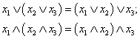

In practice, this means that you can omit those brackets that determine in which order the conjunction and disjunction should be performed.
2) Commutative (commutative) law.
If the operation is commutative, the result of its application does not depend on which of the operands was the first and which of the operands was the second. Operands of commutative operations can be swapped with each other, getting the same result.

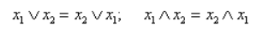

3) Distributive (distribution) law
The property of distributivity of one operation relative to another allows one to “open” the parentheses by analogy with the procedure from elementary algebra. Conjunction and disjunction are distributive relative to each other, which is expressed in the following formulas:

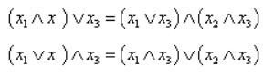

4) The laws of de Morgan (laws of general inversion or duality)
De Morgan's laws allow negations to be applied to the whole bracket, allowing one to go over to so-called close negations, when no single negation is in front of the bracket.

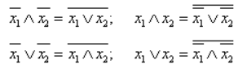

5) The law of absorption (elimination)
If an expression is applied with the same operand, first one operation, and then, with the same operand, absorbing it, then the value of the expression is absorbed, becoming equal to the operand. Thus, pairs of operations absorbing each other can be “thrown out” during the simplification.

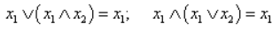

6) Gluing Law (Exceptions)

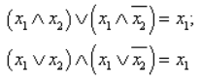

7) Unit and zero properties
A conjunction and a disjunction "in a special way" react to a unit or zero as one of the operands, regardless of the value of the second. These properties are similar to multiplication by one, familiar from elementary algebra, multiplication by zero, addition with zero:

A ʌ 0 = 0
A ʌ 1 = A
A v 0 = A
A v 1 = 1

8) Idempotency
An operation is said to be idemotent if, applying it to two equal operands, the same operand is obtained. Idempotency allows you to "throw out" unnecessary repeated use of the operation from the formula. Conjunction and disjunction idempotent:

A ʌ A = A
A v A = A

9) Addition
The negation of an operand is called its complement. The conjunction or disjunction of the operand with its addition gives an unambiguous result regardless of the value of the operand:

A ʌ ¬А = 0
And v ¬A = 1

10) Double denial
Double negation compensates for itself. Thus, in the form with close negations, each variable in the expression either does not have a single negation, or only one.

¬¬A = A

3 Karnaugh Maps.

The Karnaugh map (minimization map) is a scan of a certain volumetric figure on a plane. A Karnaugh map is made up of cells whose number is equal to the number of sets of function variables. Each cell corresponds to a strictly defined set.
For example, the Karnaugh map of one variable (Fig. 2.1): n = 1, the number of sets N = 2¹= 2.

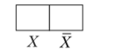

Fig.2.1. Karnaugh map one variable

The Karnaugh map of two variables (Fig. 2.2): n = 2, the number of sets N = 2² - 4.

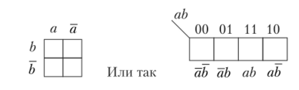

Fig.2.2. Karnaugh map of two variables

The outermost cells corresponding to combinations 00 and 10 are adjacent and differ in one variable a.
Variables in a map can be arbitrarily located, but any cells adjacent vertically or horizontally can differ by no more than one variable.
The Karnaugh map of three variables (Fig. 2.3): n = 3, the number of sets N = 2³ = 8.

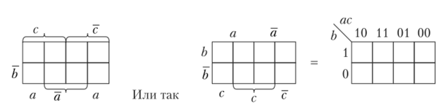

Fig.2.3. Karnaugh map of three variables

If there is a function of three variables, given by the truth table presented below, the corresponding Karnaugh map looks like the one shown in Fig.2.4.

№ | X
№ | а | b | с | d
0 | 0 | 0 | 0 | 1
1 | 0 | 0 | 1 | 0
2 | 0 | 1 | 0 | 1
3 | 0 | 1 | 1 | 1
4 | 1 | 0 | 0 | 1
5 | 1 | 0 | 1 | 0
6 | 1 | 1 | 0 | 0
7 | 1 | 1 | 1 | 1
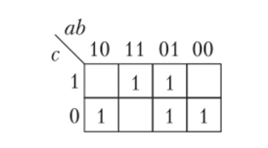

Fig. 2.4. Karnaugh map features

Usually zeros do not write to the card, but only ones are entered. The Karnaugh map of four variables (Fig. 2.5): n = 4, N = 16.

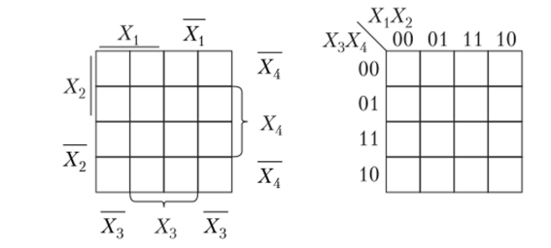

Fig. 2.5. The Karnaugh map of four variables

In these maps, the variables are arranged in different ways, but both of them are correct, since any neighboring cells horizontally or vertically differ only in one of the variables. The cells of the upper row are adjacent to the cells of the lower row, and the cells of the rightmost column are adjacent to the cells of the leftmost column.
The Karnaugh map of five variables (Fig. 2.6) n = 5, N = 32. These are two 16-cell maps that differ only in one (fifth) variable.

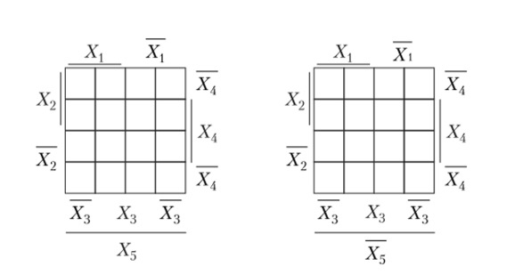

Fig. 2.6. Karnaugh map function of five variables

The Karnaugh map of six variables (Fig. 2.7): n = 6, N = 64. These are four 16-cell maps.

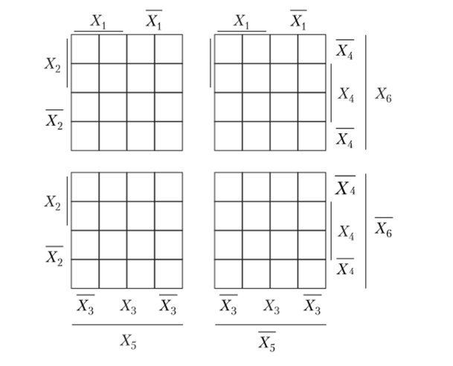

Fig. 2.7. Karnaugh map function of six variables

Here, any cells are adjacent if they differ only in one variable.
After filling the card with units from the truth table, proceed to minimization. The essence of minimization: to cover all units of the Karnaugh map with the smallest number of cubes of the highest rank. Minterms of common variables are written out from each cube. Minterma unite disjunctively.
A cube is a rectangular or square contour containing cells with units only:
• one unit is a cube of “0” rank, since 2⁰ = 1;
• two units - cube of “1” rank, since 2¹ = 2;
• four units - cube of “2” rank, since 2² = 4;
• eight units - cube of “3” rank, since 2³ = 8;
• 16 units - cube of “4” rank, since 2⁴ = 16, etc.
A cube cannot contain a different number of ones and cells with zeros. The same unit can simultaneously belong to several cubes so that the rank of the cube is greatest. Then the form will be minimal.

LITERATURE
Main:

- 8 Class Physics Zambak, 2008
- Курашвили Е.И. Английский язык для студентов –физиков. Часть 1. –М.: ООО «Изд-во АСТ», 2010. – 317с.
- Жетписбаева Б.А., Шайхызада Ж.Г., Сугралина Л.М. Английский язык для естественно-научных специальностей. –Караганда.: Изд-во КарГУ, 2012
- David Sang. Physics. Course Book: Cambrige, 2012.
- Class Physics Zambak, 2009
- www.steck.us/teaching - D.A. Steck. Analog and Digital electronics. – Oregon, USA. - 2015.
- Anil K. Maini. Digital Electronics. – Wiley, 2007. – 741 p.
- https://72arkarcy.files.wordpress.com/2016/09/foundation-of-digital-electronics-and-logic-design-2014.pdf - Subir K.S., etc. Foundation of Digital Electronics and Logic Design. – Pan Stanford Publ., Boca Raton, 2014. – 372 Р. - 7.01 MB
- https://www.pdfdrive.com/the-art-of-electronics-d33411099.html - Horowitz & Hill. The Art of Electronics. – Cambridge Univ. Press, 2016. – 1225 P. – 29 MB.
- elibrary.ru

Additional:

- Val Lambert & Elaine Murray. Everyday Technical English: Longman, 2010
- Ашихмин А.С. Цифровая схемотехника: шаг за шагом/ А.С. Ашихмин. - М.: Диалог-МИФИ, 2008. - 304 с.
- Eurasian Physical Technical Journal: Karaganda State University. №1,2. 2013
- CD-ROM. Keith Kelly. Science: Macmillan Vocabulary Practice Series, 2008

Theme № 3
Lection № 3-4
Physical Implementation of Logic Gates

Plan of lecture

- Simple Mechanical Switches.
- Diode Logic (DL).
- Resistor-Transistor Logic (RTL).
- The Real Thing: Transistor-Transistor Logic (TTL).

1 Simple Mechanical Switches.

Switching (contact) implementation of logic elements are used in automatic devices. One of the first applications for such devices was switchboard telephone exchanges, where they were used to connect various subscribers of the telephone network to each other. It is clear that the speed of such a system depends significantly on the response time of the switch.
The first switching circuits were created on the basis of an electromagnetic (electromechanical) relay (Fig. 3.1). When an electric current flows through its winding, a contact lever is attracted to the electromagnet, which closes the electrical circuit and goes into the "on" state. When the current does not pass through the electromagnet, the switch opens the circuit.

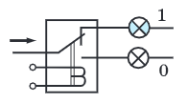

Fig. 3.1. Switch based on electromechanical relay

The operation of the electromagnetic relay takes about 0.1 seconds. An electronic relay based on an electronic device - a triode - is much faster. The first triodes were tube (Fig. 3.2). If a negative potential is applied to the grid of the triode, then the current does not pass through the triode. If the potential is positive, then the triode passes an electric current. Electronic switching systems are thousands of times faster than electro-mechanical ones.
With the invention of semiconductor devices, electronic tubes have been replaced by transistors. Transistor circuits are smaller and more reliable in operation than tube ones. In the 1970s, chip production began. Modern technology allows you to create chips that hold millions of transistors.

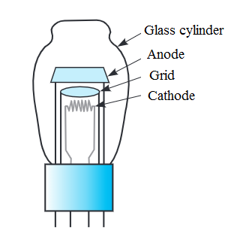

Fig. 3.2. Lamp triode circuit

With the invention of semiconductor devices, electronic tubes have been replaced by transistors. Transistor circuits are smaller and more reliable in operation than tube ones. In the 1970s, chip production began. Modern technology allows you to create chips that contain millions of transistors

2 Diode Logic (DL).

Diode logic (DL) or diode resistor logic (DRL), is the construction of the gate Boolean logic from the diodes. Diode logic was used extensively in the construction of early computers, where semiconductor diodes could replace the large and expensive active elements of a vacuum tube. The most popular way to use diode logic is in DTL (Transistor Diode Logic) integrated circuits, which include an inverter for power and signal recovery.
While diode logic has the advantage of simplicity, the lack of a gain stage in each gate limits its use. Not all logical functions can be implemented in diode logic alone; only logical non-inverting AND and logical OR functions can be understood by a diode gate. If several diode gate logic cascade, the voltage levels at each stage are significantly changed, thus one-step is usually used. In special projects, two-stage statements are sometimes achieved.
Diode Gate Version Logic. In logic gates, logic functions are executed by parallel, or a series of connected switches (such as relay contacts, or isolated gate FETs like CMOS), controlled by logic inputs or parallel resistors or diodes, which are passive components. The diode logic is implemented by diodes that show low impedance, when the forward-shifted and very high impedance, when the change has had an effect. There are two kinds of diode gate logic - OR and I. It is not possible to build a NOT (Invert) diode gate, because NOT or the Invert function requires an active component, such as a transistor.
Simplify Assumptions. For illustration, this discussion takes idealized diodes, which lead in the forward direction without a voltage drop and do not lead in the opposite direction. The logical design accepts two distinct signal levels that are labeled "1" or "0". For positive logic, this 1 represents the most positive level and 0 for the most negative level. For illustration in this discussion, positive logic 1 is represented by +6 V, and 0 V represents logic 0. In binary logic, the exact magnitude of the signal voltage is not important, and it is only necessary that 1 and 0 states are detectably represented by different voltage levels.
In these examples, at least one input for each gate must be connected to a voltage level providing a certain logic 1 or logic 0 levels. If all inputs are disconnected from any master source, the output signal is not limited to the correct voltage range.
The schematic diagram of the simplest logical element "And" is presented in Fig. 3.3. If at least one input of the circuit has a low level of positive voltage, taken as a conditional zero, then the diode connected through the cathode with this input is open and the voltage at its anode, and, consequently, at the device output is zero. If on all inputs of the circuit there is a high (single) voltage level, then the output signal is equal to one.

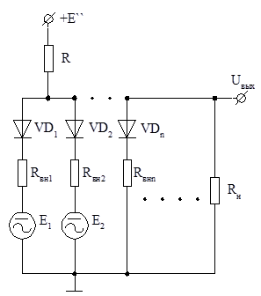

Fig. 3.3. The schematic diagram of the simplest logical element "AND" based on diode logic

3 Resistor-Transistor Logic (RTL).

Resistor-transistor circuits can be of two types - with direct connections to the inputs and resistor. In the first case, the wire connection is considered an elementary resistor with a minimum active resistance. Each of the circuits is an inverter that performs the Boolean function NOT y = x. The functions of the inverter are performed by a transistor switch with a transistor connected according to the scheme with OE (Fig. 3.4).
In the circuit, the bias in the transistor VT is created by a fixed voltage divider consisting of resistors R1 and R3 and elements of the control circuit (the resistance of the previous stage or the source of the signal — the input resistance Rin is shown by a dashed line).

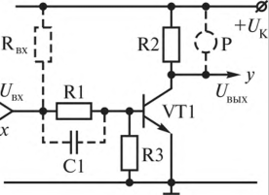

Fig. 3.4. The circuit of the logical element is NOT in the resistor-logic logic (RTL)

When a low level signal is applied to the input of the circuit (for positive logic, this is a negative potential - log.O) the transistor switch is closed, since the necessary forward bias voltage of the emitter junction is not equal to (UE <0.6 V. At the same time, a positive potential (log.1). When a log.1 signal is applied to the input (a high level signal (positive potential)), a voltage drop occurs on the divider resistors, which acts on the emitter junction as a forward bias (f / R3) and as a reverse bias on the collector j transition (f / r3 Rbx). The transistor opens and a negative potential (log.O) appears at the output of the transistor switch, ie, the logical NOT operation is performed. This happens when the input voltage x (UBX) reaches the threshold voltage (t / ^ op). The transistor opens at UEZ> 0.6 V. Therefore, to create this condition, it is necessary to choose the resistors of the divider R1 and R3 so that the equality

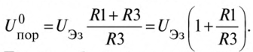

Thus, the transistor switch is a circuit solution of the logical element NOT. The disadvantage of the circuit is the reduction of the input signal (U / I) due to the voltage drop across the resistor R1, which will require an increase in the amplitude of the input signal. If you do not increase the amplitude of the input signal, i.e. do not compensate for losses on R1, then the performance of the circuit will decrease due to a decrease in the amplitude of the signal acting on the transistor. To increase the amplitude of this signal, the coupling resistor R1 is shunted by an accelerating (boosting) capacitor C1.
Inverters in the RTL circuit solution can be performed with an open collector, i.e. without a constructive load resistor in the collector circuit (R2), when the collector is not connected in the circuit and is a free output (for example, do not include R2 in the circuit in Fig. 3.4). An open collector allows you to include as a constructive load between the collector and the power source. To the incandescent bulb, relay and other loads (for example, in the diagram in Fig. 3.4, relay P is shown by dashes). In such a circuit solution, a higher-voltage UK source can be used for a collector circuit (at a high-voltage transistor), obtaining circuits with a higher output current (U/ B1X) and combining the outputs of individual circuits operating on a common load.
For the implementation of circuit solutions of the basic functions of AND-NOT and IL-AND-NOT, respectively, apply a series and parallel connection of transistor switches (inverters) between themselves, working on a common load (Fig. 3.5).
In fig. 3.5, a, shows a circuit of parallel-connected inverters. In this circuit, a high level (log. 1) is generated at the output, if a low level signal (log.O) is sent to all inputs simultaneously, closing the transistors. As a result, the output is formed by the function y = x] lx2 - AND-NOT on the low level signals. Logic function y = Xj vx2 - OR-NOT is performed on the high level signals. Indeed, if one of the inputs (for example, x,) gives a high level signal, then the transistor VT1 will open and due to the flowing output current through R5 at the output we will get a low signal level (log.O). This circuit solution in DRL is used in the logical element IL AND-NOT.

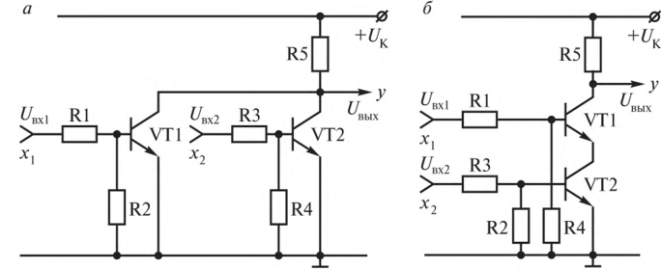

Fig. 3.5. Schemes of the logical element OR-NOT (a) and the logical element NAND in the resistor-transistor logic (b) circuit solutions

4 The Real Thing: Transistor-Transistor Logic (TTL).

Transistor-transistor logic (TTL; Transistor-Transistor Logic, TTL) is a method of converting discrete information using electronic devices based on bipolar transistors and resistors. Transistors are used both to perform logic functions (for example, AND, OR), and to amplify the output signal (as opposed to resistor-transistor and diode-transistor logic). TTL-principle of microelectronic circuits means that the transistors are interconnected directly. TTL circuits have higher performance than similar microcircuits built using CMOS technology, but they consume more electricity and require stable operation of power supplies.
TTL is used in personal and industrial computers, in instrumentation and other equipment. The input and output circuits of electronic equipment are compatible with electrical characteristics with TTL. TTL technology became well-known among electronic system developers in 1962, when Texas Instruments introduced the 7400 series integrated circuits. This series of chips became an industry standard. TTL chips were the first devices, the use of which made it possible to introduce digital methods of information processing for problems previously solved solely by analog methods.
The power of the TTL-circuits is carried out from a single source with a voltage of +5 V. The circuit of the TTL-element, which performs the function of NAND, is shown in fig. 3.6, a.
A multi-emitter transistor VT1 is turned on at the input of the element. (when considering the principle of operation of the circuit, for greater clarity, the two-emitter transistor can be replaced by two parallel-connected transistors, as shown in Fig. 3.4, b). If a high level voltage is applied to both emitters of VT1, then the emitter junction of the transistor will be closed. In this case, the current flowing through the resistor R1 and the collector junction of the transistor VT1, will open the transistor VT2. The voltage drop across the resistor RЗ will be sufficient to open the VT5 transistor. The voltage on the collector of the transistor VT2 is such that the transistor VТЗ is closed, respectively, the transistor VТ4 is also closed. As a result, a low level voltage corresponding to logical 0 will appear at the output of the element. If, however, a low level voltage is applied to at least one of the element inputs, the emitter junction of the VT1 transistor will open and the VT2 and VT5 transistors will be closed. The VTZ transistor will open due to the current flowing through the resistor R2, will enter the saturation mode. Accordingly, the VT4 transistor will open, and a high-level voltage corresponding to logical 1 will appear at the output of the element. Consequently, the considered element performs the function AND-NOT.
The composition of microcircuits of the TTL series also includes a logical element AND-NOT without a collector load in the output stage. This is the so-called open collector NAND element. It is designed to work on an external load, in which electromagnetic relays, indicator devices, etc. can be used. In addition, open-collector circuits are used in data transmission buses in the case where two or more outputs are connected to the same physical line .

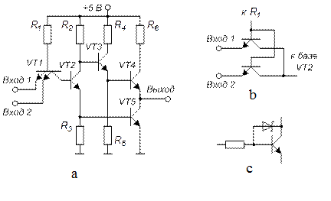

Fig. 3.6. Transistor Transistor Logic: a - diagram of the TTL element; b - transistor circuit similar to a two emitter transistor; c - adding a Schottky diode to prevent saturation

The output two-transistor cascade creates a number of problems. When the output changes for a short period of time, both transistors open. This causes a short, strong current pulse from the power supply. The magnitude of the pulse can reach up to 100 mA, which in practice serves as a source of interference. Therefore, in such circuits it is often resorted to decoupling the circuit from the power bus using a capacitor with a capacity of 0.01 μF.
In addition, in TTL circuits, transistors operate in a saturation mode, which causes a problem associated with the so-called charge accumulation phenomenon. In this case, the switching of the transistor, which is in saturation mode, occurs with a delay of several nanoseconds. The effect of charge accumulation is eliminated by introducing a Schottky diode into the circuit, as shown in fig. 3.4 c.

LITERATURE
Main:

- 8 Class Physics Zambak, 2008
- Курашвили Е.И. Английский язык для студентов –физиков. Часть 1. –М.: ООО «Изд-во АСТ», 2010. – 317с.
- Жетписбаева Б.А., Шайхызада Ж.Г., Сугралина Л.М. Английский язык для естественно-научных специальностей. –Караганда.: Изд-во КарГУ, 2012
- David Sang. Physics. Course Book: Cambrige, 2012.
- Class Physics Zambak, 2009
- www.steck.us/teaching - D.A. Steck. Analog and Digital electronics. – Oregon, USA. - 2015.
- Anil K. Maini. Digital Electronics. – Wiley, 2007. – 741 p.
- https://72arkarcy.files.wordpress.com/2016/09/foundation-of-digital-electronics-and-logic-design-2014.pdf - Subir K.S., etc. Foundation of Digital Electronics and Logic Design. – Pan Stanford Publ., Boca Raton, 2014. – 372 Р. - 7.01 MB
- https://www.pdfdrive.com/the-art-of-electronics-d33411099.html - Horowitz & Hill. The Art of Electronics. – Cambridge Univ. Press, 2016. – 1225 P. – 29 MB.
- elibrary.ru

Additional:

- Val Lambert & Elaine Murray. Everyday Technical English: Longman, 2010
- Ашихмин А.С. Цифровая схемотехника: шаг за шагом/ А.С. Ашихмин. - М.: Диалог-МИФИ, 2008. - 304 с.
- Eurasian Physical Technical Journal: Karaganda State University. №1,2. 2013
- CD-ROM. Keith Kelly. Science: Macmillan Vocabulary Practice Series, 2008

Theme № 4
Lection № 5-6

Multiplexers and Demultiplexers.

Plan of lecture

- Multiplexers
- Demultiplexers.

1 Multiplexers.

A multiplexer is a device that samples one of several inputs and connects it to its output. The multiplexer has several information inputs (D0, D1, ...), address inputs (A0 A1, ...), an input for supplying a strobe signal C and one output Q. In Fig. 4.1, a symbolic image of a multiplexer with four information inputs is shown.
Each information input of the multiplexer is assigned a number, called an address. When a strobe signal is applied to input C, the multiplexer selects one of the inputs, whose address is specified by a binary code on the address inputs, and connects it to the output.

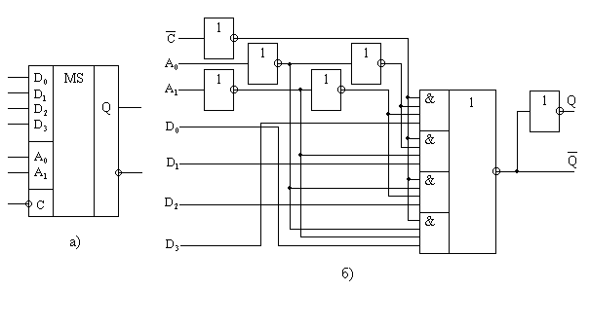

Fig. 4.1. Symbolic image of a multiplexer with four information inputs

Multiplexer (MUX) is a signal switch with several inputs to one output. For a switch with four inputs Xi to one output Y (Fig. 4.2, a) the output signal is related to the input ratio:

Y = E (X0AB + X1AB + X2AB + X3AB)
This expression shows the way to implement the multiplexer on the logical elements (Fig. 4.2, b).
In the presence of permission at the input E (E = 1), the output repeats the information of the input, the code of which is given to address inputs A and B. When E = 0 the switch is closed (Y = 0 regardless of the signals at the inputs X).
If the digital code on the address inputs of the multiplexer alternately enumerates all combinations of binary variables at address inputs, the state at the output successively repeats the state of all its information inputs (data multiplexing mode). In this mode multiplexer converts parallel binary code to informational inputs to the serial code at its output.

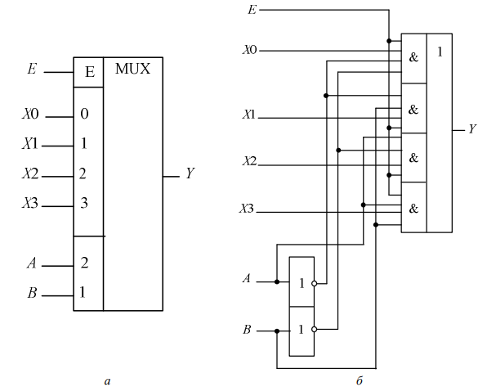

Fig. 4.2. Multiplexer

Schematically, the multiplexer can be represented as a switch that provides connection of one of several inputs (they are called informational) to one output of the device. In addition to the information inputs in the multiplexer there are address inputs and, as a rule, enable (gating). The signals at the address inputs determine which specific information channel is connected to the output. If the relation n = 2m is valid between the number of information inputs n and the number of address inputs m, then this multiplexer is called complete. If n <2m, then the multiplexer is called incomplete.
Permissive inputs are used to extend the functionality of the multiplexer. They are used to increase the capacity of the multiplexer, synchronize its work with the work of other nodes. The signals on the enabling inputs can allow, and can prohibit the connection of a specific input to the output, that is, they can block the operation of the entire device.
Multiplexers are universal logic devices, on the basis of which they create various combinational and sequential circuits. Multiplexers can be used in frequency dividers, trigger devices, shifters, etc. Multiplexers are often used to convert parallel binary code to serial. For such a conversion, it is enough to submit a parallel binary code to the information inputs of the multiplexer, and to send signals to the address inputs in such a sequence that the inputs are connected in turn from the first to the last.
Consider an example of the use of multiplexers for the implementation of the so-called combinational device shift, providing a binary shift, the number of digits. The principle of operation of this device is clear from the device diagram and the state table of its inputs and outputs (Fig. 4.3).
In the designation of multiplexers use two Russian letters KP, for example, the industry produces such multiplexers as K155KP1, K531KSH8, K561KPZ, K555KP17, etc.
A demultiplexer is a device in which signals from a single information input are received in the desired sequence along several outputs, depending on the code on the address buses. Thus, the demultiplexer is functionally opposed to the multiplexer. Demultiplexers are denoted by DMX or DMS.
If the ratio between the number of outputs n and the number of address inputs is determined by the equality n = 2m, then such a demultiplexer is called complete, when n <2m the demultiplexer is incomplete.
If there are zeros on the address buses A0 and A1, information input X is connected to the upper output DMX0 and, depending on the status of address buses A2 and A3, it can be connected to one of the DMX1 outputs. So, when A2 = A3 = 0, input X is connected to Y0. When A0 = 1 and A1 = 0, input X is connected to DMX2, depending on the state of A2 and A3, the input is connected to one of the outputs Y4 - Y7, etc.
The functions of demultiplexers are similar to the functions of the decoders. The decoder can be considered as a demultiplexer, in which the information input maintains the voltage of the outputs in the active state, and the address inputs act as the inputs of the decoder. Therefore, in the designation of both decoders and demultiplexers are used the same letters - ID. Produce decoders (demultiplexers) K155IDZ, K531ID7, etc.
When using CMOS technology, it is possible to build bidirectional keys that have the ability to pass current in both directions and transmit not only digital, but also analog signals. Due to this, it is possible to build multiplexers-demultiplexes, which can be used either as multiplexers or as demultiplexers. Multiplexer-demultiplexers are denoted by MX.

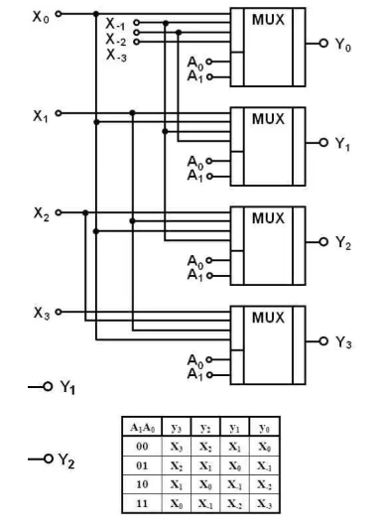

Fig. 4.3. The principle of operation of multiplexer

2 Demultiplexers

Demultiplexer (DMX) - signal switch from one input to several outputs. If there is an enable input E (Fig.4.4, a), the decoder can be used as a demultiplexer. Signal applied to input E, repeated at the output Yi whose address is fed to the inputs A and B.
When E = 0, the operation of the decoder is prohibited (logical 0 on all outputs of the device). The implementation of the demultiplexer on the PE is shown in Fig. 4.4, b.

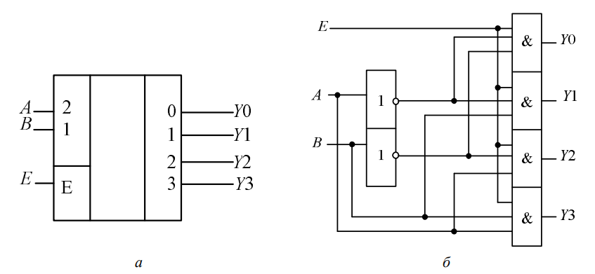

Fig. 4.4. Demultiplexer

Integrated circuits of decoders and multiplexers often have inverse outputs, as well as a group of enabling inputs (direct and inverse), combined by AND logic (Fig. 4.5).

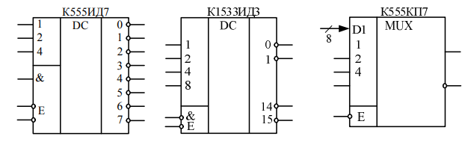

Fig. 4.5 Multiplexers and demultiplexers

When E = E1 E2EZ = 1 at the control inputs of the K555ID7 chip, a logical 0 (active level - low) is formed at the output, the code of which is fed to the information inputs of the decoder.
The signal supplied to one of the E inputs of the K1533IDZ demultiplexer when the second input is grounded, it will be repeated on the output of the chip, the code of which is fed to the address inputs. When feeding a logical 0 input permission E of the K555KP7 chip switches the signal from that information input of the multiplexer DIi, whose code is fed to its address inputs, to the output.
Among the switching circuits, it is necessary to highlight the devices that are able to pass signals in both directions. To such elements includes switching circuits made by CMOS technology using bidirectional keys. CMOS switches are capable pass both analog and digital signals, they can be changed places of entry and exit. Such microcircuits perform the functions of a multiplexer-de-multiplexor (DMX).
Multiplexers are convenient to use to implement logical functions written directly to the PDNF. Any Boolean function of four variables can be implemented using an eight-channel multiplexer. So, to implement, for example, a logic function where D is a high-order variable, the input inputs of the K555KP7 multiplexer are input signals A, B, C, and inputs X0 - X7 are used as tuning (Fig. 30.10, a). Comparing the expression for the function F with the logical multiplexer equation, we obtain the equivalence conditions:

X0 = X3 = D, X7 = D, X5 = D + D = 1, XI = X2 = X4 = X6 = 0.

These relationships allow you to encrypt the multiplexer inputs to execution of a given logical equation.

LITERATURE
Main:

- 8 Class Physics Zambak, 2008
- Курашвили Е.И. Английский язык для студентов –физиков. Часть 1. –М.: ООО «Изд-во АСТ», 2010. – 317с.
- Жетписбаева Б.А., Шайхызада Ж.Г., Сугралина Л.М. Английский язык для естественно-научных специальностей. –Караганда.: Изд-во КарГУ, 2012
- David Sang. Physics. Course Book: Cambrige, 2012.
- Class Physics Zambak, 2009
- www.steck.us/teaching - D.A. Steck. Analog and Digital electronics. – Oregon, USA. - 2015.
- Anil K. Maini. Digital Electronics. – Wiley, 2007. – 741 p.
- https://72arkarcy.files.wordpress.com/2016/09/foundation-of-digital-electronics-and-logic-design-2014.pdf - Subir K.S., etc. Foundation of Digital Electronics and Logic Design. – Pan Stanford Publ., Boca Raton, 2014. – 372 Р. - 7.01 MB
- https://www.pdfdrive.com/the-art-of-electronics-d33411099.html - Horowitz & Hill. The Art of Electronics. – Cambridge Univ. Press, 2016. – 1225 P. – 29 MB.
- elibrary.ru

Additional:

- Val Lambert & Elaine Murray. Everyday Technical English: Longman, 2010
- Ашихмин А.С. Цифровая схемотехника: шаг за шагом/ А.С. Ашихмин. - М.: Диалог-МИФИ, 2008. - 304 с.
- Eurasian Physical Technical Journal: Karaganda State University. №1,2. 2013
- CD-ROM. Keith Kelly. Science: Macmillan Vocabulary Practice Series, 2008

Theme № 5. Lection № 7-8

Comparators

Plan of lecture

- Open-Collector Output.
- Schmitt Trigger.

1 Open-Collector Output.

In electronics, a comparator is a device that compares two electrical signals with each other and outputs a digital signal indicating an increase in one input signal over another. The comparator has two analog inputs and one digital output.
A comparator is typically built on a high gain differential amplifier. Comparators are widely used in devices that measure and digitize analog signals, for example, in analog-to-digital converters (ADC)
Examples of the comparator operation are given on the basis of the LM339 chip (quad voltage comparator) and LM393 (dual voltage comparator). These two chips are identical in their functionality. The voltage comparator LM311 can also be used in these examples, but it has a number of functional features.
Typically, the voltage comparator output is an open collector output. Output open collector has a negative polarity. This means that at this output there is no positive signal and the load must be connected between this output and the power supply.
In some circuits, a load (pull-up) resistor is connected to the output of the comparator in order to provide a high level signal to the input of the next circuit element.
The figure 5.1 shows the logic of the comparator operation with an open collector output.
The current will flow through the open collector when the input voltage (+) is lower than the input voltage (-). And accordingly, the current will not flow through the open collector when the voltage at the input (+) is higher than the voltage at the input (-).
Equivalent voltage comparator circuit with unipolar power supply. The “voltage comparator” schematic diagram is equivalent to the operation of an operational amplifier, for example, LM358 or LM324, having two NPN transistors at the output (see Fig.5.2). Thus, it is possible to make all 4 outputs of an op-amp (LM339) with an open collector. Each such output can withstand a load current of 15 mA and voltage up to 50 volts.
The output is turned on or off depending on the relative voltages at the positive (+) and minus (-) inputs of the comparator. The inputs of the comparator are extremely sensitive and the voltage difference between them of just a few millivolts leads to the switching of its output.
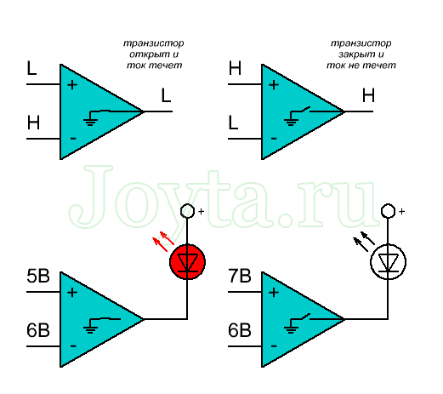

Fig. 5.1. The logic of the comparator operation with an open collector output

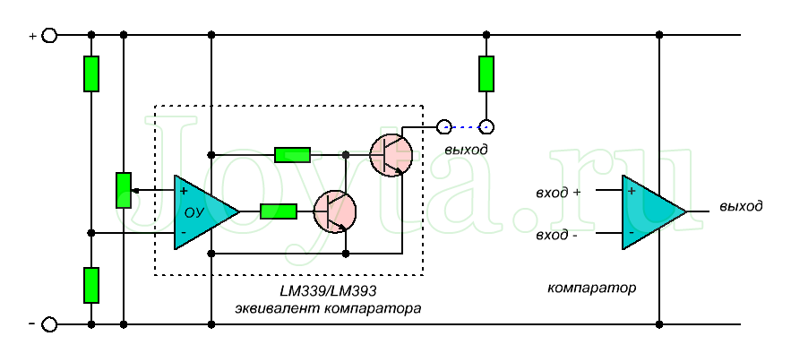

Fig. 5.2. Equivalent voltage comparator circuit with unipolar power supply

Equivalent Voltage Comparator with Bipolar Power Supply. The voltage comparators LM339, LM393 and LM311 can work with a single or bipolar power supply up to 32 volts maximum.
When working with bipolar power, the voltage comparison mode remains the same, except that for most circuits the emitter of the output transistor is connected to the negative power bus, and not to the common circuit. An exception to this rule is the LM311 operational amplifier, which has an isolated emitter, which can be connected either to the negative of a unipolar power source or to a common bipolar wire.
When working with a bipolar power supply, the input voltage may be higher or lower relative to the common wire of the power supply. In addition, one of the inputs of the comparator can be connected to a common wire, thus creating a “zero crossing” detector (Fig.5.3).

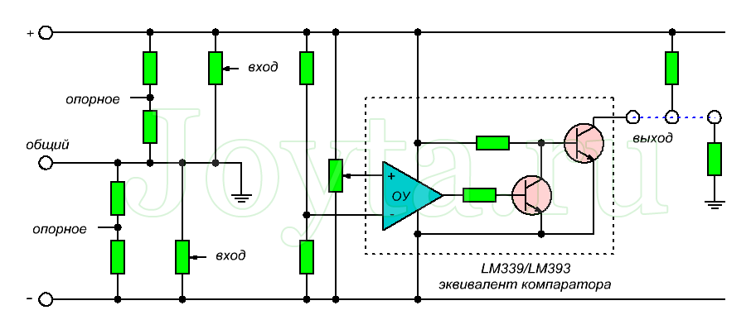

Fig.5.3. Equivalent Voltage Comparator with Bipolar Power Supply

Job description of the comparator. The figure 5.4 shows the simplest configuration for a voltage comparator, as well as a graphic representation of its mode of operation. In this circuit, the reference voltage is half the supply voltage, and the input voltage can vary from zero to the supply voltage. In theory, the reference and input voltage can have a value from zero to the voltage of the power supply, but there are real limitations depending on the particular comparator used.
Output signal:
- The current will flow through the open collector when the input voltage plus (+) is lower than the input voltage minus (-).
- The current will not flow through the open collector when the input voltage plus is higher than the input voltage minus.

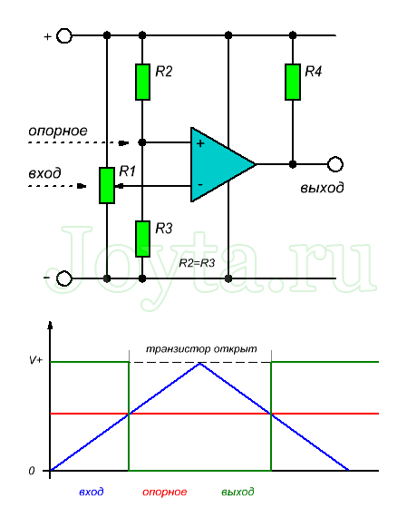

Fig. 5.4. The simplest configuration for a voltage comparator

2 Schmitt Trigger.

The functionality of the device is the rapid transition from one steady state to another under external influence.
Most of these devices have the same set value for the rising signal. For fast-growing signals, this is not a problem. But for signals that have a very slow rise (noise, for example), oscillations back and forth from the off to on position and back can damage the device. Schmitt triggers are applicable for slowly varying signals or noise (fig.5.5).
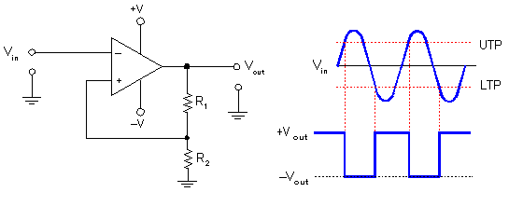

Fig.5.5. Schmitt Trigger

This solution is for cases when the input signal oscillates around a given point. The scheme for obtaining a hysteresis loop - this means that there are two sets of points, one on the low side and the other on the high one. Suppose that on the low side the specified value is 2.0 V, and on the high side it is 1.5 V. As soon as the rising input signal (noise) hits the 2.0 V point, the trigger will switch the output to 1. And the output signal will remain on 1 until the input signal drops back to 1.5 V. In the zone between 1.5 and 2.0 V, the signal does not switch.
The simplest example of use is a single-pole two-way toggle switch. Moving the lever to the right connect the protrusions in the center. Digital circuits operate on 1 and 0 (on and off) There are no midpoints.
Schmitt Trigger Schemes. There are many schemes in which it is necessary to include elements that have fixed thresholds at the input. Discrete transistors can be used, as well as an operational amplifier (op-amp) with additional components to create a hysteresis loop.
The fig.5.6 shows how the device generates a pulse of the correct configuration, with an arbitrary input signal. A similar scheme is used to convert slowly varying signals into pulses with clearly defined edges. This is done on multiple devices and on a single op-amp.

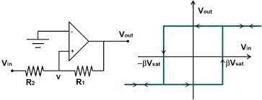

Fig.5.6. Schmitt Trigger Schemes
Schmitt trigger circuit on transistors. For asymmetric trigger is characterized by several stable states, when the transition from one to another occurs only at threshold levels. Therefore, such a trigger is characterized by a hysteresis transfer characteristic. In the diagram below, bipolar transistors are used (fig.5.7).

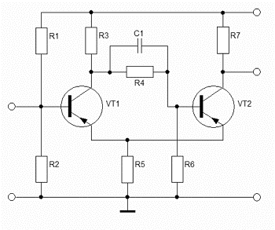

Fig.5.7. Schmitt trigger circuit on transistors

This drawing shows that the Schmitt trigger includes transistors VT1 and VT2, galvanically interconnected by means of a resistor R5. All elements have a common busbar. R1 and R2 provide the operating mode of the transistor VT1. Organized voltage divider (two resistors). Capacitor C1 serves for accelerated switching. Timing diagrams of input and output voltages of the device are shown in the figure 5.8.
When power is applied to the device, it switches to the initial state when the transistor VT1 is closed and VT2 is open. In this state, the output of the device receives some voltage Ue, depending on the elements of the strapping VT2. There are two thresholds in the Schmitt trigger (this difference between voltages is called the width of the hysteresis loop).
Schmidt Trigger on Logic. This device is special because it has one analog input and one digital output. The simplest Schmitt trigger circuit is based on digital logic elements, i.e., two inverters connected in series. Through resistive feedback, a digital output signal changes the switching input voltage. The rate of increase of the signal at the output and input are independent of each other, being a constant value for this circuit (depending on the speed of the logic gates). A Schmitt trigger circuit, built on two inverters, is shown below (fig.5.9).
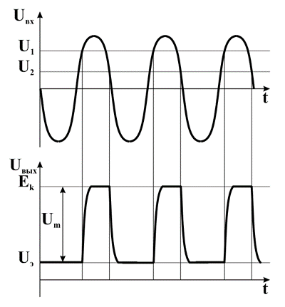

Fig.5.8. Timing diagrams of input and output voltages of the device

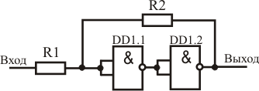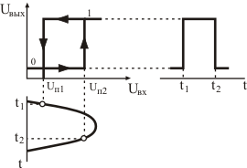

Fig.5.9. Schmidt Trigger on Logic

Added feedback, provided by two resistors, contributes to the rapid change in the voltage at the output of the circuit when the signal crosses the threshold voltage. The ratio between the resistors affects the depth of this connection. The fact that part of the signal from the output of the circuit arrives at the input leads to the fact that instead of one threshold, the circuit produces two. One of them is called the trigger threshold of the circuit (when the level “1” is formed at the output of the device). The second threshold is called the release threshold (when the level “0” is formed at the output of the circuit). The presence of two thresholds gave the Schmitt trigger a second name - a scheme with hysteresis. Positive feedback is used to set a limit to reach the saturation point at the output and, thus, you can change the sinusoidal voltage to digital.
How to identify low and high threshold levels at the input of the circuit? The logic for determining these threshold levels is as follows. You must select a high threshold that is below the minimum high level. In other words, this is the level where the input signal will exceed each output pulse. Similarly, the lower threshold is selected, which is correspondingly higher than the low level of the signal. The difference between the upper and lower level is the hysteresis. The greater the hysteresis, the greater will be the susceptibility of the circuit to noise. It is also necessary to take into account the influence of time.
The image clearly shows two thresholds where a sinusoidal voltage is applied to the input of the device.

LITERATURE
Main:

- 8 Class Physics Zambak, 2008
- Курашвили Е.И. Английский язык для студентов –физиков. Часть 1. –М.: ООО «Изд-во АСТ», 2010. – 317с.
- Жетписбаева Б.А., Шайхызада Ж.Г., Сугралина Л.М. Английский язык для естественно-научных специальностей. –Караганда.: Изд-во КарГУ, 2012
- David Sang. Physics. Course Book: Cambrige, 2012.
- Class Physics Zambak, 2009
- www.steck.us/teaching - D.A. Steck. Analog and Digital electronics. – Oregon, USA. - 2015.
- Anil K. Maini. Digital Electronics. – Wiley, 2007. – 741 p.
- https://72arkarcy.files.wordpress.com/2016/09/foundation-of-digital-electronics-and-logic-design-2014.pdf - Subir K.S., etc. Foundation of Digital Electronics and Logic Design. – Pan Stanford Publ., Boca Raton, 2014. – 372 Р. - 7.01 MB
- https://www.pdfdrive.com/the-art-of-electronics-d33411099.html - Horowitz & Hill. The Art of Electronics. – Cambridge Univ. Press, 2016. – 1225 P. – 29 MB.
- elibrary.ru

Additional:

- Val Lambert & Elaine Murray. Everyday Technical English: Longman, 2010
- Ашихмин А.С. Цифровая схемотехника: шаг за шагом/ А.С. Ашихмин. - М.: Диалог-МИФИ, 2008. - 304 с.
- Eurasian Physical Technical Journal: Karaganda State University. №1,2. 2013
- CD-ROM. Keith Kelly. Science: Macmillan Vocabulary Practice Series, 2008
Theme № 6. Lection № 9-10

Pulse and Waveform Generation.

Plan of lecture

- The Classic 555 Timer.
- Monostable Multivibrators.

1 The Classic 555 Timer.

Consider a device on a microcircuit 555. Its history began as far back as 1971, when Signetics Corporation launched the SE555 / NE555 microcircuit called The IC Time Machine. In those days, it was the only "timer" chip that was available to the mass consumer. Immediately after the release of 555, it gained widespread popularity and almost all semiconductor manufacturers began to produce it. Domestic manufacturers also released this chip called KR1006VI1.
The microcircuit is produced in two versions of the case - a plastic DIP and a round metal one. True to meet the 555 in a round metal case in our times is very difficult, can not be said about the version in a plastic DIP package. Inside the case with eight pins, transistors, diodes and resistors are hidden. We will not go into a thorough study of 555, but I will tell you more about the legs of this microcircuit. Total legs 8 (fig.6.1).

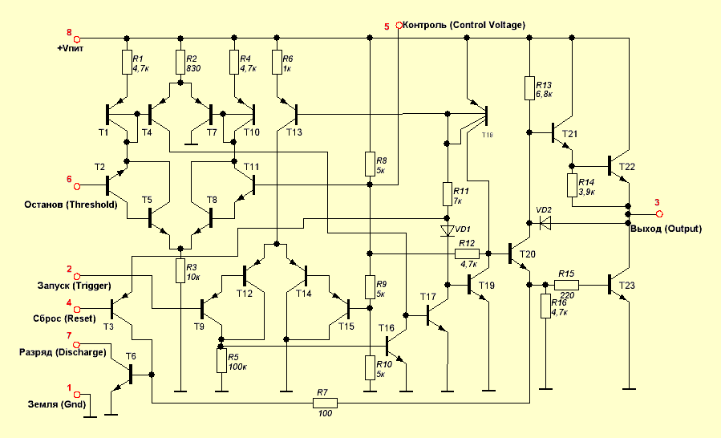

Fig.6.1. The Classic 555 Timer

1. Earth. Conclusion, which in all schemes must be connected to the power supply minus.
2. Trigger, it is a launch. If the voltage at the start falls below 1/3 V, then the timer starts. The current consumed by the input does not exceed 500 nA.
3. Exit. The output voltage is approximately 1.7 V below the supply voltage when it is turned on. The maximum load that the output can withstand is 200 mA.
4. Reset. If you apply a low voltage level (less than 0.7 V) to it, then the circuit returns to its original state, regardless of what mode the timer is in at the moment. If the circuit does not need a reset, it is recommended to connect this pin to the power supply.
5. Control. This pin will allow us to access the reference voltage of comparator # 1. This conclusion is used very rarely, and hanging in the air can knock down the work, so in the scheme it is best to attach it to the ground.
6. Threshold, he's stop. If the voltage at this output is higher than 2/3 Vcc, then the timer stops and the output goes to rest. It is worth noting that the output only works when the input is turned off.
7. Discharge. This output connects to the ground inside the microcircuit when the output of the microcircuit is low and closed when the output is high. It can pass up to 200 mA and is sometimes used as an additional output.
8. Power. This output must be connected to the power plus. The microcircuit maintains voltage in the range of 4.5-16 V. It can work from a conventional 9V-battery or from USB wiring.
Modes. Consider the modes of the chip 555, there are only 3.
Monostable. When a signal is applied to the input of our microcircuit, it turns on, generates an output pulse of a given length and turns off, waiting for an input pulse. It is important that after turning on the chip will not respond to new signals. The pulse length can be calculated by the formula t = 1.1 * R * C. There are no limits on the duration of the pulses, both in the minimum and in the maximum duration. There are some practical limitations that can be circumvented, but it is worth considering whether this is necessary and whether it is not easier to choose another solution. So, the minimum values established in a practical way for R is 10 kOhm, and for C - 95pF. It is possible and less, but at the same time the scheme will begin to absorb a lot of electricity (fig.6.2).
Unstable Multivibrator. In this mode, everything is pretty simple. You do not need to control the timer. He will do everything himself - he will turn on first, wait for t1, then turn off, wait for t2 and start all over again. At the exit we get a fence of high and low states. The frequency with which will fluctuate depends on the parameters of the values of R1, R2 and C and is determined by the formula F = 1.44 / ((R1 + R2) C). During the time t1 = 0.693 (R1 + R2) C the output will be high, and during the time 2 = 0.693R2C it will be low (fig.6.3).
Bistable. In this mode, our chip 555 is used as a switch. I pressed one button - the output turned on, pressed another - turned off.
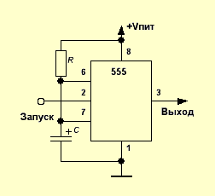

Fig.6.2. Monostable mode

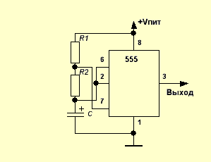

Fig.6.3. Unstable Multivibrator

2 Monostable Multivibrators.

The feedback circuit of a monostable multivibrator (Fig. 6.4) contains one C-R chain, namely C2-R2. When the circuit is initially turned on, the transistor T2 opens, since a positive voltage + VCC is supplied to its base through the resistor R2, and the transistor T1 closes. The negative voltage source –VBB ensures that T1 will remain locked. In this state, the scheme can be indefinitely long in the absence of external influence.
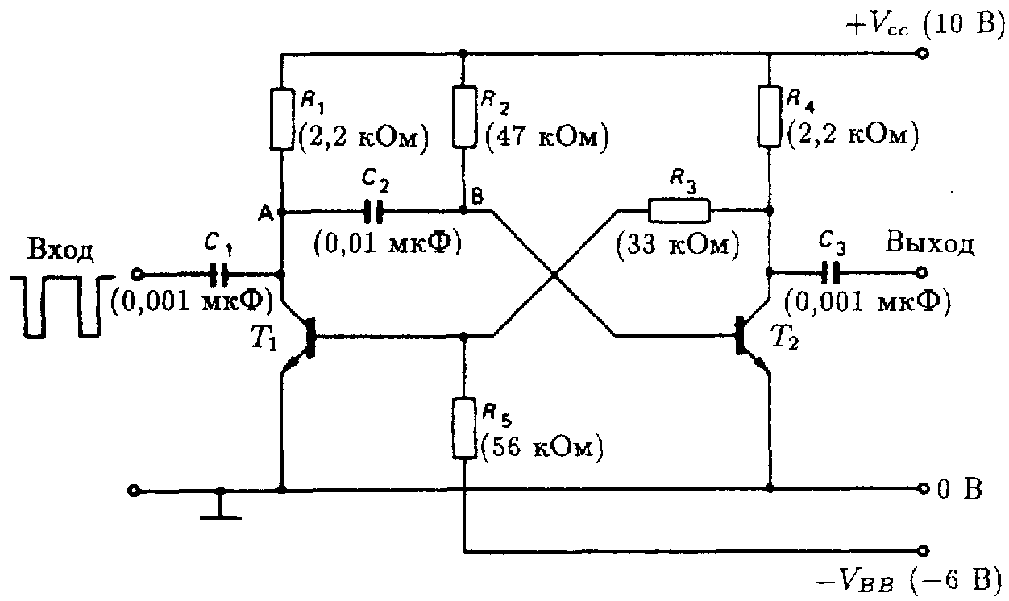

Fig.6.4. Monostable Multivibrators

If we now apply a negative pulse to the input of the circuit, its high-frequency front will pass through the capacitor C2 to the base of the transistor T2 and ban it. Just as it happens in a bistable multivibrator, the transistor T1 goes into a saturation state, and the transistor T2 goes into a cutoff state. The voltage at the collector of the transistor T1 (point A in Fig. 6.4) decreases sharply from +10 V (VCC) to zero. This voltage drop of 10 V charges the capacitor C2 to -10 V. In other words, the base of the transistor T2 (point B in the diagram in Figure 6.5) is now under -10 V, keeping the transistor in the locked state. Capacitor C2 begins to discharge through resistor R2 from -10 V, trying to reach a voltage of +10 V. The negative potential at point B begins to gradually decrease with a speed determined by the time constant C2R2. As soon as the voltage at point B changes its sign from negative to positive (Fig. 6.5 (b)), transistor T2 will start to conduct, and transistor T1 will go to cut-off state. The monostable multivibrator returns to the initial state, waiting for the next switching pulse to arrive.
The pulse shape at the output of the circuit is shown in Fig. 6.5 (c). The pulse duration is determined by the period during which the transistor T2 remains in the locked state, which in turn depends on the time constant C2R2. For example, the scheme given on fig. 6.5, produces a pulse with a duration of approximately 350 µs.
It can be changed by varying the capacitance values of the capacitor C2 or resistor R2 or both. It should be noted that the frequency of the output signal is equal to the frequency of the input signal, but their durations are different. A single vibrator is used to increase the pulse width and obtain a time delay.
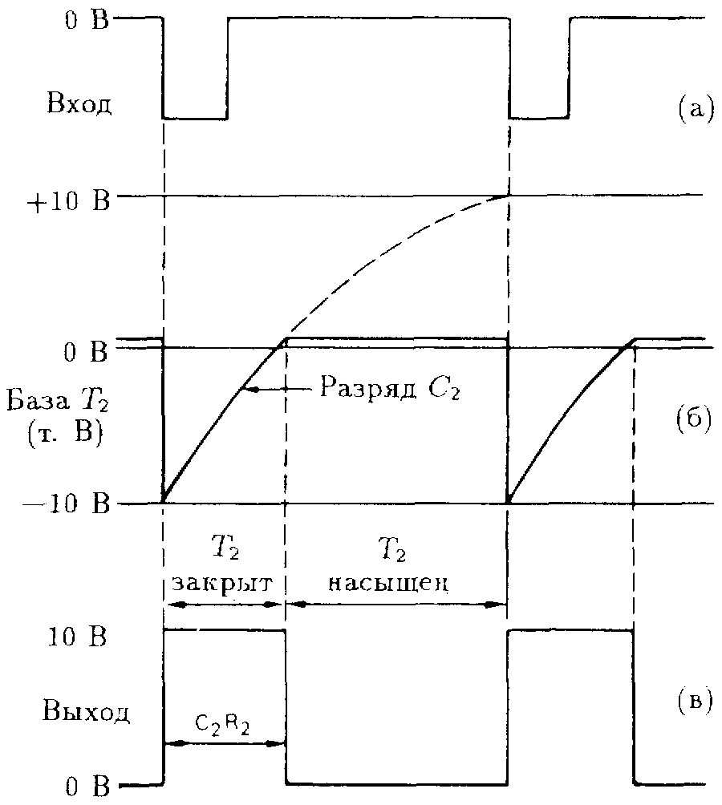

Fig.6.5. The shape of the pulses acting at different points in the one-shot circuit.

Self-oscillating multivibrator

In fig. 6.6 shows the scheme of self-oscillating (or unsynchronized) multivibrator. The feedback loop is characterized by two time constants C1R1 and C2R2. When the power supply is turned on, more current flows through one of the transistors than the other. Due to the presence of a feedback circuit, this leads to the fact that one of the transistors comes to saturation, and the other to a cutoff state. Suppose that the transistor T1 is open and saturated, and T2 is closed. Then the capacitor C1 is charged to –VCC and keeps T2 in the locked state. Capacitor C1 begins to discharge through resistor R1, trying to recharge to + VCC, as in the case of a single vibrator. At the moment when the potential of the chain R1 - C1 (the base of the transistor T2) passes through zero, the transistor T2 opens, closing the transistor T1. Capacitor C1 now reboots in a negative direction, keeping transistor T1 closed. As soon as capacitor C2 is discharged through R2, the transistor T1 opens, and so on. The output signal as a series of rectangular pulses is removed from the collector of any of the transistors. The label / pause (fill factor) ratio is determined by the time constant of the circuit. The output signal as a series of rectangular pulses is removed from the collector of any of the transistors.

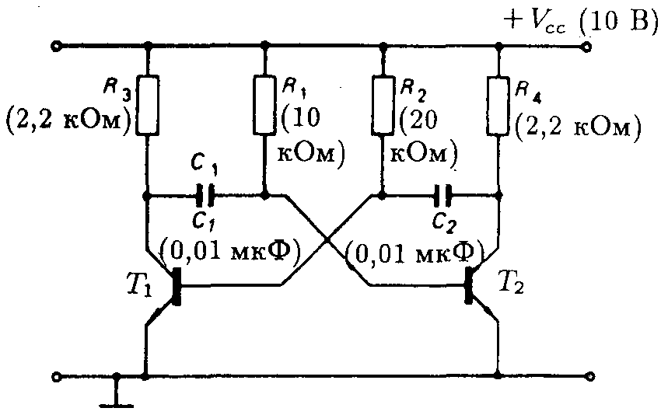

Fig.6.6. Schematic diagram of the self-oscillating multivibrator.

In fig. 6.7 shows the output pulses at the collector of each of the transistors. To obtain pulses of equal duration, the time constants C1R1 and C2R2 are made equal.

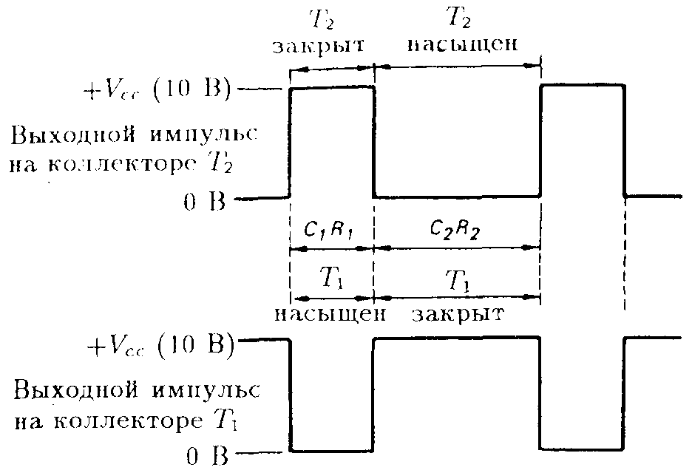

Fig.6.7. The output pulses on the collector of each of the transistors of a self-oscillating multivibrator

LITERATURE

Main:

- 8 Class Physics Zambak, 2008
- Курашвили Е.И. Английский язык для студентов –физиков. Часть 1. –М.: ООО «Изд-во АСТ», 2010. – 317с.
- Жетписбаева Б.А., Шайхызада Ж.Г., Сугралина Л.М. Английский язык для естественно-научных специальностей. –Караганда.: Изд-во КарГУ, 2012
- David Sang. Physics. Course Book: Cambrige, 2012.
- Class Physics Zambak, 2009
- www.steck.us/teaching - D.A. Steck. Analog and Digital electronics. – Oregon, USA. - 2015.
- Anil K. Maini. Digital Electronics. – Wiley, 2007. – 741 p.
- https://72arkarcy.files.wordpress.com/2016/09/foundation-of-digital-electronics-and-logic-design-2014.pdf - Subir K.S., etc. Foundation of Digital Electronics and Logic Design. – Pan Stanford Publ., Boca Raton, 2014. – 372 Р. - 7.01 MB
- https://www.pdfdrive.com/the-art-of-electronics-d33411099.html - Horowitz & Hill. The Art of Electronics. – Cambridge Univ. Press, 2016. – 1225 P. – 29 MB.
- elibrary.ru

Additional:

- Val Lambert & Elaine Murray. Everyday Technical English: Longman, 2010
- Ашихмин А.С. Цифровая схемотехника: шаг за шагом/ А.С. Ашихмин. - М.: Диалог-МИФИ, 2008. - 304 с.
- Eurasian Physical Technical Journal: Karaganda State University. №1,2. 2013
- CD-ROM. Keith Kelly. Science: Macmillan Vocabulary Practice Series, 2008
Theme № 7
Lection № 11

Digital–Analog Interfaces.

Plan of lecture

- Digital-to-Analog Conversion
- Analog-to-Digital Conversion.

1 Digital-to-Analog Conversion

To be able to listen to the sound after digitizing, you need to convert it back to analog.
An analog signal can be processed by amplifiers and other analog devices and played by speakers.
Converts a digital signal to analog - digital-analog converter (DAC). The conversion process is an inverse ADC procedure.
Modern systems reproduce and record sound through an audio interface, the task of which is the input and output of audio information, i.e. This is the device to convert the analog signal to digital and back.
The operation of the audio interface can be explained in simpler words.
Initially, the input analog sound enters the analog input (or mixer), then it is sent to the ADC, which quantizes it and samples it. The result is a digital audio signal that goes to the computer and produces digital audio.
When outputting audio information, a similar process occurs, only in the opposite direction. The data flow passes through the DAC, which converts the numbers that determine the amplitude of the signal into an electrical - analog signal.
Schematically, it all looks as shown in Figure 7.1.
Most sensors and actuators of automatic systems work with analog signals. To input such signals into a computer, they need to be converted into digital form, i.e. discretized by level and time. This task is solved by the ADC. The inverse problem, i.e. the transformation of a quantized (digital) signal into a continuous one, decides the DAC.
ADCs and DACs are the main input-output devices of information in digital systems designed to process analog information or control any process.
The most important characteristics of the ADC and DAC:
1) Type of analog value, which is the input for the ADC and the output for the DAC (voltage, current, time interval, phase, frequency, angular and linear displacement, illumination, pressure, temperature, etc.). The most widely used converters, in which the input (output) analog value is the voltage, because Most analog values are relatively easily converted to voltage.
2) Resolution and conversion accuracy (resolution is determined by the number of binary digits of the code or the possible number of levels of an analog signal, accuracy is determined by the largest deviation of the analog signal from the digital and vice versa).
3) The speed determined by the time interval from the moment the polling (start) signal was given until the output signal reached the steady-state value (units of microseconds, tens of nanoseconds)
In any converter allocate digital and analog parts. Digital coding and decoding of digital signals, their memorization, counting, digital comparing (comparison), generation of logical control signals are performed. To do this, use: decoders, multiplexers, registers, counters, digital comparators, logic elements.
In the analog part of the converter, operations are performed: amplification, comparison, switching, addition, and subtraction of analog signals. For this purpose, analog elements are used: op-amps, analog comparators, keys and switches, resistive matrices, etc.
Converters are made in the form of digital and analog IC or LSI.

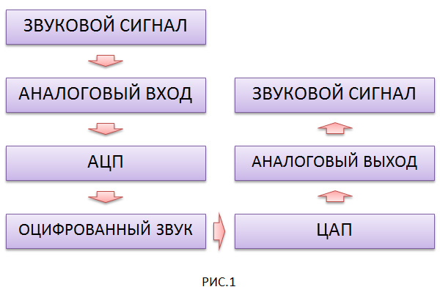

Fig. 7.1.Digital-to-Analog Conversion

DACs are based on the representation of any binary number X as a sum of powers of two (fig.7.2).
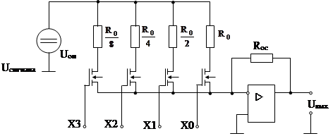

Fig. 7.2.Digital-to-Analog Conversion. Scheme.

2 Analog-to-Digital Conversion.

In analog equipment, analog sound has the form of a continuous electrical signal, computer equipment, in turn, works only with digital data - hence the sound in the computer has a digital form.
I think you already have some confusion between the "sounds". Whatever the misunderstandings, let's consider what digital sound is and how analog is converted “into digital”.
Digital sound is a method of representing a sound signal by means of discrete numerical values of its amplitude.
As usual - I will try to explain everything easier. I repeat a little.
A sound wave is a complex function depicting the dependence of its amplitude on time.
To digitize this wave, you should describe it, saving the discrete value to specific points.
The amplitude value of the sound wave should be measured at each time point, and the resulting value recorded in the form of numbers. But, because of the impossibility of fixing the amplitude values with an accuracy of 100%, they have to be written in a rounded form. As a result, there is a slight distortion of the original signal. In other words, an approximation of this function along the amplitude and time coordinate axes will occur.
As you can see, the process of digitizing the signal consists of two stages.
1. First - sampling (sampling)
2. The second - quantization.
Discretization is the process of obtaining the values of the values of the signal being converted at specific time intervals. In other words, it is like a “sampling” of a signal by given values.
Quantization - is the process of replacing the obtained values of the amplitude of the signal with the most approximate accuracy.
As mentioned above, when converting a signal, it is necessary to round the values due to the impossibility of fixing the “real” amplitude value with perfect (essentially infinite) accuracy. To do this, computers would need a huge amount of RAM (more than 1TB), and you can refine to infinity, which as a result leads to the creation of RAM with an infinite amount of memory.
The accuracy of rounding is influenced by the level of quantization (or the quantization width). The greater the number of levels, the smaller the magnitude of the amplitude is rounded, which as a result we obtain a smaller amount of error.
Based on the above, we can already conclude that the digitization of the signal is a recording of the amplitude of the sound wave at certain intervals of time, and recording the resulting error with the minimum value.
Another conclusion suggests itself. The higher the sampling rate and quantization width, the more accurate the description of the received signal is.
The quality depends on the parameters chosen for digitization. This is the sampling rate (expressed in kHz) and bit depth (expressed in bits).
In other words - the higher the bit depth and sampling rate, the higher quality the signal is received, and the larger the volume of digitized data is obtained. Therefore, one should look for a “middle ground” between weight and quality.
Kotolnikov's theorem (in the English-language literature — the Nyquist – Shannon theorem or the reading theorem) states that if an analog signal has a finite (limited in width) spectrum, then it can be restored uniquely and without loss in its discrete readings taken at a frequency strictly more than double the upper frequency.
In the “translation into normal human language”, in order to get the most complete information about the sound, say, in the frequency range up to 22 000 Hz, sampling with a frequency of at least 44.1Kg is necessary.
This suggests that there is no point in strongly pursuing high sampling rates, since the frequency of 44.1 KHz covers the entire range of frequencies that a person is able to hear, and even a little higher.
By the method of conversion are divided into serial, parallel and serial-parallel (fig.7.3).
In consecutive ADCs, the conversion of an analog value to a digital code proceeds in steps (steps), successively approaching the measured voltage.
Dignity: simplicity; disadvantage: low speed.
In parallel ADCs, the input voltage is simultaneously compared with the X– reference voltages. The result is obtained in one step, but large hardware costs are required.
Dignity: speed; disadvantage: how many reference voltages, so many comparators.

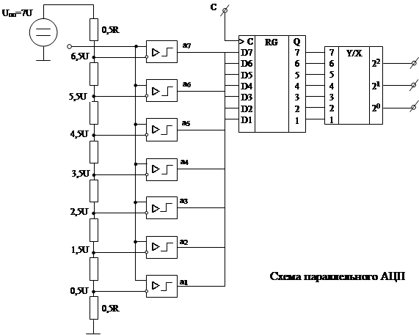

Fig. 7.3. Analog-to-Digital Conversion. Scheme.

The process of converting a continuous signal into a code consists of quantization and coding.
Quantization is the representation of a continuous quantity in the form of a finite number of discrete values (for example, potential levels), and coding is the translation of combinations of discrete values into binary numbers for information processing in a computer.
From input devices that convert analog values to the corresponding codes of binary numbers of combinations, devices of the voltage-to-number type are of interest.
Consider (fig.7.4):

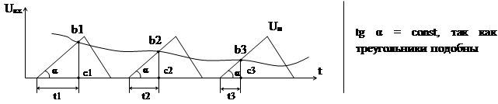

Fig. 7.4. Simple of Analog-to-Digital Conversion
bc = t∙tg α => 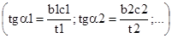

The input voltage is converted to an intermediate value "time interval", which in turn is converted to a digital code (temporary coding system).
The input voltage Uin is compared with a sawtooth voltage Un varying according to a linear law.
The b1c1, b2c2, b3c3 segments represent the discrete value of the input voltage. The interval from the beginning of the comparison to the moment of equality of the voltages Uin = Up is the leg of the triangle with the angle of inclination α. All three triangles are similar, therefore, tg α = const. Therefore, it can be said that the bc segments on a scale are proportional to the corresponding time interval t. Therefore, the measurement of discrete values of voltages can be replaced by measuring proportional time intervals, replaced by a binary number (fig.7.5).

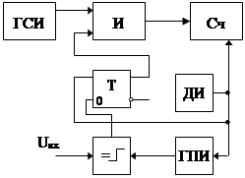

Fig.7.5. Signal conversion circuit

LITERATURE

Main:

- 8 Class Physics Zambak, 2008
- Курашвили Е.И. Английский язык для студентов –физиков. Часть 1. –М.: ООО «Изд-во АСТ», 2010. – 317с.
- Жетписбаева Б.А., Шайхызада Ж.Г., Сугралина Л.М. Английский язык для естественно-научных специальностей. –Караганда.: Изд-во КарГУ, 2012
- David Sang. Physics. Course Book: Cambrige, 2012.
- Class Physics Zambak, 2009
- www.steck.us/teaching - D.A. Steck. Analog and Digital electronics. – Oregon, USA. - 2015.
- Anil K. Maini. Digital Electronics. – Wiley, 2007. – 741 p.
- https://72arkarcy.files.wordpress.com/2016/09/foundation-of-digital-electronics-and-logic-design-2014.pdf - Subir K.S., etc. Foundation of Digital Electronics and Logic Design. – Pan Stanford Publ., Boca Raton, 2014. – 372 Р. - 7.01 MB
- https://www.pdfdrive.com/the-art-of-electronics-d33411099.html - Horowitz & Hill. The Art of Electronics. – Cambridge Univ. Press, 2016. – 1225 P. – 29 MB.
- elibrary.ru

Additional:

- Val Lambert & Elaine Murray. Everyday Technical English: Longman, 2010
- Ашихмин А.С. Цифровая схемотехника: шаг за шагом/ А.С. Ашихмин. - М.: Диалог-МИФИ, 2008. - 304 с.
- Eurasian Physical Technical Journal: Karaganda State University. №1,2. 2013
- CD-ROM. Keith Kelly. Science: Macmillan Vocabulary Practice Series, 2008
Theme № 8. Lection № 12-13

Phase-Locked Loops

Plan of lecture

- Frequency Multiplier
- FM Demodulation

1 Frequency Multiplier

A frequency multiplier, an electronic (less commonly electromagnetic) device designed to increase by an integer number of times the frequency of periodic electrical oscillations applied to it. The ratio fo / fi (fi and fo - the oscillation frequencies, respectively, at the input and output of the multimeter) is called the multiplication factor of frequency m (m ³ 2; it can reach several tens). A characteristic feature of a dielectric h. Is the constancy of m when changing (in a certain finite region) fin, as well as the parameters of a charr. H. (For example, the resonant frequencies of oscillatory circuits or resonators included in the waveform). It follows that if fi for any reason received an increment of Dfi (quite small), then the increment of Dfo frequency fo is such that Dfi / fi = Dfi / fi, i.e., the relative instability of the frequency of oscillations during multiplication remains unchanged. This important feature of the D / c. Allows their use to increase the frequency of stable oscillations (usually obtained from a quartz master oscillator) in various radio transmitters, radar, measuring and other installations.
The most common types of oscillations are those consisting of a nonlinear device (for example, a transistor, a varactor, or a varicap, a coil with a ferrite core; an electron tube), and an electric filter (one or more). A nonlinear device changes the shape of the input oscillations, as a result of which components with frequencies that are multiples of fc in the oscillation spectrum at its output appear. These complex oscillations come to the input of the filter, which allocates a component with a given frequency mfin, suppressing (not missing) the rest. Since such suppression in real filters is not complete, unwanted (so-called side) components remain at the output of the D-unit, ie, harmonics with numbers different from m. The task is facilitated if the nonlinear device generates practically only the m-th harmonic fin, - in this case, sometimes they do without a filter (similar W.-h are known on tunnel diodes and special electron-beam devices). When m> 5, it is energetically more advantageous to use multi-stage D. h (in which the output oscillations of one cascade serve as input for another).
Are also used, the action of which is based on the synchronization of the autogenerator (see Generation of electrical oscillations). In the latter, oscillations with a frequency f0 = mfin are excited, which becomes exactly equal to mfin due to the oscillations arriving at its input with a frequency fin. The disadvantage of such Dv h. Is a relatively narrow band of ffc values at which synchronization is possible. In addition to these, some radio-frequency impulse oscillations have become widespread, in which radio pulses of a certain form, generated under the action of input oscillations with frequency fin, are supplied to the input of an electric filter.
The main problem in creating the D / c. Is a decrease in the phase instability of the output oscillations (due to the random nature of the change in their phase), which leads to an increase in the relative frequency instability at the output compared to the corresponding value at the input. The rigorous calculation of the differential equation is associated with the integration of nonlinear differential equations.
Quite often, when constructing circuits of various oscillators and frequency synthesizers, it becomes necessary to convert signals of one frequency into signals of higher frequency. This can be done using the mixer schemes described in the Mixers section (ensuring conversion up). However, when multiple conversions are required (two, three or more times), it is more convenient and efficient to use the so-called frequency multiplier circuits. As the name implies, such schemes provide a multiple conversion (multiplication) of the frequency of the input signal.
Diode frequency multipliers are characterized by a number of positive features that determine the rather wide use of such devices (especially at high and ultrahigh frequencies). The most important are: low level of thermal and phase noise, the ability to operate at very high frequencies (up to frequencies of the submillimeter range), as well as relative simplicity of design.
Currently, in practice, three fundamentally different methods of frequency multiplication in diode multipliers are used:
- varactor multiplication (multiplication by nonlinear capacity);
- doubling on the scheme of full-wave straightening;
- diode conversion of the pulse shape with the subsequent selection of the desired harmonic.
The operation of frequency multipliers is characterized by a number of parameters: multiplication factor, input (Pin) and output (PinuN) power, efficiency (η = PinnN / Pin, sometimes called multiplier efficiency or power transfer coefficient), operating frequency band, etc.
Varactor frequency multipliers are devices whose main working element is a multiplying varicap (varactor) - a semiconductor diode, which is used as a non-linear capacitance with low losses. Frequency conversion occurs due to the distortion of the waveform on the non-linearly voltage-dependent capacitance of the varactor and the subsequent selection of the desired harmonic component. The structural diagrams of the two main types of varactor multipliers are shown in Fig. 8.1.

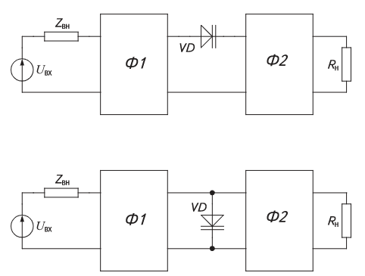

Fig. 8.1. The structural diagrams of the two main types of varactor multipliers

2 FM Demodulation

FM demodulation or detection implies a change in the frequency variation in the signal in the amplitude variation in the main frequency band, for example, audio. There are several methods and schemes that can be used each with its own advantages and disadvantages.
The modulation frequency is widely used for radio transmission for a wide range of applications from broadcasting to a common point to a communication point.
Frequency modulation, FM offers many advantages, especially in mobile radio, where its resistance to fading and interference is a big advantage. It is also widely used for broadcasting on VHF frequencies, where it is able to provide an environment for transmitting high quality audio.
Given its widespread use of receivers, it is necessary to be able to demodulate the transmitted information. There are a wide variety of different methods and circuits that can be used, including receiver-Seals, as well as coefficient detectors, using discrete components, and where integrated phase-locked loop and quadrature detectors are used more widely.
What is frequency modulation, FM?
As the name of frequency modulation suggests, FM uses frequency changes to transfer sound or other information necessary for placement on the carrier. As shown below, it can be seen that how the modulating or base voltage of the band signal changes, so that the frequency of the signal changes according to it. This type of modulation offers several advantages with this:
• Reduced interference: Compared to AM, FM offers a noticeable improvement in interference. Given that the majority of the received noise is the amplitude of the noise, the FM receiver can remove any amplitude sensitivity while the IF is moving in limiting.
• Remove many of the effects of signal intensity variations: FM is widely used for mobile applications, since amplitude changes do not lead to a change in sound signal level. As audio is carried out by changing the frequency, not the amplitude of them, under good signal strength conditions, this does not manifest itself as a change in sound level.
• Transmitter amplifier performance: As the modulation is performed by changing the frequency, this means that transmitter power amplifiers may be non-linear. These amplifiers can be made to be much more efficient than linear ones, thereby saving battery power — a valuable item for mobile or portable equipment.
These advantages mean that FM is widely used for many broadcast and mobile applications (fig.8.2).

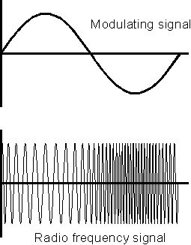

Fig.8.2. Signal modulation frequency

When the signal is frequency modulated, the carrier frequency shifts according to the modulation. This is called deviation. In the same way that the modulation level can vary for an amplitude-modulated signal, the same is true for a frequency-modulated one, although there is no maximum or 100% modulation level, as in the case of AM.
The modulation level is determined by a number of factors. The bandwidth that is available alone. It was also found that signals with large deviations are capable of supporting higher quality transmissions, although they naturally occupy a large bandwidth. As a result of these conflicting requirements, different levels of variance are used in accordance with the application that is used.
Those with a low deviation level are called narrow band modulation (NBFM) and usually levels of +/- 3 kHz or more are used depending on the available bandwidth. Typically, NBFM is used for point to point communication. Significantly higher deviation levels are used for broadcasting. This is called FM wideband (WBFM) and is used for broadcast rejection +/- 75 kHz.

LITERATURE

Main:

- 8 Class Physics Zambak, 2008
- Курашвили Е.И. Английский язык для студентов –физиков. Часть 1. –М.: ООО «Изд-во АСТ», 2010. – 317с.
- Жетписбаева Б.А., Шайхызада Ж.Г., Сугралина Л.М. Английский язык для естественно-научных специальностей. –Караганда.: Изд-во КарГУ, 2012
- David Sang. Physics. Course Book: Cambrige, 2012.
- Class Physics Zambak, 2009
- www.steck.us/teaching - D.A. Steck. Analog and Digital electronics. – Oregon, USA. - 2015.
- Anil K. Maini. Digital Electronics. – Wiley, 2007. – 741 p.
- https://72arkarcy.files.wordpress.com/2016/09/foundation-of-digital-electronics-and-logic-design-2014.pdf - Subir K.S., etc. Foundation of Digital Electronics and Logic Design. – Pan Stanford Publ., Boca Raton, 2014. – 372 Р. - 7.01 MB
- https://www.pdfdrive.com/the-art-of-electronics-d33411099.html - Horowitz & Hill. The Art of Electronics. – Cambridge Univ. Press, 2016. – 1225 P. – 29 MB.
- elibrary.ru

Additional:

- Val Lambert & Elaine Murray. Everyday Technical English: Longman, 2010
- Ашихмин А.С. Цифровая схемотехника: шаг за шагом/ А.С. Ашихмин. - М.: Диалог-МИФИ, 2008. - 304 с.
- Eurasian Physical Technical Journal: Karaganda State University. №1,2. 2013
- CD-ROM. Keith Kelly. Science: Macmillan Vocabulary Practice Series, 2008

Theme № 9. Lection № 14. Methods of frequency synthesis

Plan of lecture

- Direct Digital Synthesis
- Direct Analog Synthesis (DAS)
- Phase-Locked Loop (PLL)
- Harmonic Synthesis
- Mixer-based Synthesis

Frequency synthesis is the process of generating a specific frequency by combining or manipulating other frequencies. It is widely used in communications, signal processing, instrumentation, and radio-frequency (RF) applications. There are several methods of frequency synthesis, each with its own advantages, disadvantages, and areas of application. Below are the main methods of frequency synthesis:
1 Direct Digital Synthesis.

A few years ago, direct digital frequency synthesizers (Direct Digital Synthesizers, DDS) were a wonder and had limited scope. Their widespread use was constrained by the complexity of implementation, as well as by the insufficiently wide range of operating frequencies. Although synthesizers based on phase-locked loop (PLL) are currently the most popular, direct digital synthesizers with a number of unique capabilities are increasingly used. DDS is no longer perceived by developers as complex, incomprehensible and expensive devices.
The term "frequency synthesizer" is understood as an electronic device capable of forming a desired frequency or set of frequencies from a reference frequency at the output, according to control signals. The most common are the following methods of frequency synthesis:
Direct Analog Synthesis (Direct Analog Synthesis, DAS) based on the mixer / filter / divider structure, in which the output frequency is obtained directly from the reference frequency through the operations of mixing, filtering, multiplying and dividing; indirect (indirect) synthesis based on phase automatic frequency control (Phase Locked Loop, PLL), in which the output frequency is generated using an additional oscillator (most often a voltage controlled oscillator - Voltage Controlled Oscillator, VCO) covered by a PLL loop;
Direct digital synthesis (Direct Digital Synthesis, DDS), in which the output signal is synthesized by digital methods; hybrid synthesis, which is a combination of several methods described above.
Each of these methods of frequency synthesis has advantages and disadvantages, therefore, for each specific application, you need to make a choice based on the most acceptable combination of trade-offs.
The main parameters characterizing the quality of the frequency synthesizer include:
- the purity of the output spectrum (the level of side components and the noise level);
- tuning range (frequency band of the output signal);
- adjustment rate;
- frequency resolution;
- the number of generated frequencies;
- flexibility (the ability to implement various types of modulation);
- continuity of the phase of the output signal during the adjustment.

2. Direct Analog Synthesis (DAS).

Direct Analog Synthesis (DAS). The block diagram of the direct analog synthesizer is shown in Fig. 8.3. This synthesis method is called direct, because it lacks an error correction process. Therefore, the quality of the output signal is directly related to the quality of the reference signal. The phase noise of such a synthesizer is quite low due to direct synthesis. Frequency tuning can be very fast.

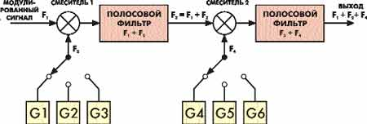

Fig.8.3. Direct Analog Synthesis (DAS).

One of the important features of the mixer / filter based DAS synthesizer is the ability to return to any frequency and continue working in the same phase as if there was no transition at all. This effect is called “phase memory.” For frequency tuning, a switch bank of reference oscillators is used. This is convenient, for example, for radio stations with a small number of channels. But to cover a wide range of frequencies a large number of reference oscillators will be required, which is a very expensive solution. Using frequency dividers, which have a mixer / filter / divider structure, it is possible to reduce the number of reference oscillators required, although in this case the adjustment possibilities will remain more than modest.

3. Phase-Locked Loop (PLL)

A PLL is a feedback control system that locks the phase of a variable oscillator (VCO) to that of a reference signal. By using a PLL, you can multiply or divide a reference frequency to generate the desired output frequency. A reference frequency is fed into a phase detector, which compares the phase of the reference with the phase of the output from a VCO. A low-pass filter smooths the error signal, which adjusts the VCO to lock it to the reference signal. The PLL can be used with frequency dividers or multipliers to generate a frequency different from the reference. Advantages:
- Stable and accurate frequency generation.
- Wide output frequency range and good spectral purity.
- Can generate very high frequencies using low-frequency reference signals.
Disadvantages:
- Complex design (requires careful selection of components for stability).
- Noise and jitter can affect performance.
Applications: RF oscillators, communication systems, clock generation for digital circuits, frequency synthesis in radio and satellite systems.

4. Harmonic Synthesis.

This method uses the harmonic content of a basic signal to generate multiple frequencies, typically by applying a non-linear element (like a diode or transistor) to a pure sine wave or square wave. The basic signal is passed through a non-linear circuit, which generates harmonics (integer multiples of the base frequency). A filter is often used to isolate the desired harmonic (for example, the second harmonic, third harmonic, etc.). Advantages:
- Simple implementation.
- Can generate high-frequency signals from a low-frequency source.
Disadvantages:
- Harmonics can lead to signal distortion or unwanted spectral components.
- Limited frequency control.
Applications: Generating specific high-frequency signals, signal generators, and harmonic mixers.

5. Mixer-based Synthesis

This method uses a mixer (usually a diode or transistor) to combine two signals, generating sum and difference frequencies. These frequencies can be used as intermediate frequencies or as the desired output. Two signals with known frequencies are fed into the mixer. The output of the mixer contains the sum and difference of the input frequencies. Additional filtering is used to select the desired frequency. Advantages:
- Can generate very high-frequency signals by mixing lower-frequency signals.
- Simple to implement.
Disadvantages:
- Requires good filtering to isolate the desired frequency.
- The system may introduce spurious frequencies or unwanted noise.
Applications: Used in heterodyne receivers, RF signal generation, and superheterodyne receivers.
Summary of Frequency Synthesis Methods:

Method | Advantages | Disadvantages | Applications
DDS (Direct Digital Synthesis) | High precision, flexible, low jitter | Limited output power, quantized output | Signal generators, SDR, test equipment
PLL (Phase-Locked Loop) | Stable, accurate, wide frequency range | Complex, potential for noise and jitter | RF oscillators, communication systems
Harmonic Synthesis | Simple, generates high frequencies from low base | Harmonics lead to distortion, limited control | Frequency multiplication, signal generation
Mixer-based Synthesis | Can generate high frequencies with low inputs | Requires filtering, spurious signals may appear | Heterodyne receivers, RF generation
Frequency Multiplication | Simple, efficient at low multiplication factors | Harmonics and inefficiency at higher factors | RF signal generation
VCO (Voltage-Controlled Oscillator) | Fast tuning, flexible frequency range | Limited by VCO characteristics, drift over time | PLLs, frequency synthesizers
Digital Frequency Synthesis | Precise, simple digital implementation | Limited by clock resolution, high power for high frequencies | Clock generation, signal processing
Superheterodyne Synthesis | Well-established for RF applications | Complex, requires careful filtering | Radio receivers, radar systems

Each frequency synthesis method has its own best-use scenario depending on the frequency range, precision, complexity, and application requirements.

LITERATURE

Main:

- 8 Class Physics Zambak, 2008
- Курашвили Е.И. Английский язык для студентов –физиков. Часть 1. –М.: ООО «Изд-во АСТ», 2010. – 317с.
- Жетписбаева Б.А., Шайхызада Ж.Г., Сугралина Л.М. Английский язык для естественно-научных специальностей. –Караганда.: Изд-во КарГУ, 2012
- David Sang. Physics. Course Book: Cambrige, 2012.
- Class Physics Zambak, 2009
- www.steck.us/teaching - D.A. Steck. Analog and Digital electronics. – Oregon, USA. - 2015.
- Anil K. Maini. Digital Electronics. – Wiley, 2007. – 741 p.
- https://72arkarcy.files.wordpress.com/2016/09/foundation-of-digital-electronics-and-logic-design-2014.pdf - Subir K.S., etc. Foundation of Digital Electronics and Logic Design. – Pan Stanford Publ., Boca Raton, 2014. – 372 Р. - 7.01 MB
- https://www.pdfdrive.com/the-art-of-electronics-d33411099.html - Horowitz & Hill. The Art of Electronics. – Cambridge Univ. Press, 2016. – 1225 P. – 29 MB.
- elibrary.ru

Additional:

- Val Lambert & Elaine Murray. Everyday Technical English: Longman, 2010
- Ашихмин А.С. Цифровая схемотехника: шаг за шагом/ А.С. Ашихмин. - М.: Диалог-МИФИ, 2008. - 304 с.
- Eurasian Physical Technical Journal: Karaganda State University. №1,2. 2013
- CD-ROM. Keith Kelly. Science: Macmillan Vocabulary Practice Series, 2008

Theme № 10. Lection № 15. Prospects for the development of digital electronics

Plan of lecture:
- Miniaturization and Integration
- Artificial Intelligence and Machine Learning (AI/ML) Integration
- Energy Efficiency and Sustainability
- Advanced Semiconductor Materials and Architectures
- 5G and Beyond (6G) Communication
- Quantum Computing and Digital Electronics
- Embedded Systems and the Internet of Things (IoT) and Blockchain and Secure Digital Electronics

The development of digital electronics is advancing rapidly, with significant innovations that are reshaping many industries, from consumer electronics to healthcare, communications, and artificial intelligence (AI). Here are some key prospects and trends for the future of digital electronics: Miniaturization and Integration, Artificial Intelligence and Machine Learning (AI/ML) Integration, Energy Efficiency and Sustainability, Advanced Semiconductor Materials and Architectures, 5G and Beyond (6G) Communication, Quantum Computing and Digital Electronics, Embedded Systems and the Internet of Things (IoT) and Blockchain and Secure Digital Electronics etc.

1. Miniaturization and Integration

The continued push for smaller, more integrated components is a hallmark of digital electronics. This trend is driven by advances in semiconductor manufacturing processes (e.g., 5 nm, 3 nm, and even smaller process nodes), which allow more transistors to fit into a smaller chip area.
Miniaturization is enabling more powerful devices with lower power consumption. Innovations like system-on-chip (SoC) and 3D chip stacking are improving performance while reducing the size and cost of electronic devices.
Further shrinkage of transistors (e.g., moving toward 2 nm or sub-1 nm process technologies). Quantum computing might introduce new methods of integration beyond traditional CMOS technologies.
Widespread adoption of flexible electronics, where circuits are embedded into substrates like plastic, could revolutionize wearables, health monitoring, and even smart textiles.

2. Artificial Intelligence and Machine Learning (AI/ML) Integration

Digital electronics are increasingly being designed to optimize AI/ML workloads. Neuromorphic computing and AI accelerators (e.g., Google's, TPUs, NVIDIA's, GPUs) are examples of specialized hardware that speed up processing for AI tasks.
Digital electronics will become even more powerful by integrating AI capabilities, allowing for smarter devices, improved autonomous systems, and real-time data analysis. The rise of edge AI will lead to devices capable of processing AI algorithms locally, reducing latency and dependency on cloud infrastructure. Enhanced chip designs that combine AI processing with traditional tasks, creating more versatile and energy-efficient devices (e.g., smartphones, self-driving cars, robotics). Quantum computing may unlock new paradigms for AI by solving problems that are intractable for classical computers.

3. Energy Efficiency and Sustainability

Energy efficiency is becoming a critical consideration for digital electronics due to growing concerns about energy consumption, especially in data centers and mobile devices.
Low-power computing and green electronics are essential for reducing the carbon footprint of technology. Technologies like low-power semiconductors, energy harvesting (e.g., solar-powered devices), and power-efficient circuit design are gaining traction. Development of energy-efficient hardware based on new materials (such as graphene, 2D materials, or spintronics) to reduce power consumption further.
The proliferation of 5G and future 6G networks, which will demand energy-efficient devices for communication.
Sustainable electronics will drive innovation in recyclable, biodegradable, and eco-friendly materials for semiconductors and consumer electronics.

4. Advanced Semiconductor Materials and Architectures

Beyond traditional silicon, other materials are being explored to improve performance, speed, and energy efficiency. Gallium nitride (GaN) and silicon carbide (SiC) are gaining attention in power electronics due to their high efficiency in high-voltage and high-temperature environments.
The evolution of semiconductor materials will enable next-generation electronics, from power systems to faster, more efficient digital circuits.
The potential of 2D materials (such as graphene and transition metal dichalcogenides) to offer superior electron mobility and new electronic properties.
Quantum dots and other novel materials could lead to revolutionary developments in optoelectronics (optical and electronic components combined).
Photonic circuits using light instead of electricity to transfer data could drastically improve speed and reduce heat generation in digital systems.

5. 5G and Beyond (6G) Communication

The rollout of 5G technology is enabling higher data rates, ultra-low latency, and massive connectivity. Digital electronics are playing a central role in supporting these advancements, particularly with devices like 5G-enabled smartphones, IoT sensors and autonomous vehicles.
The Internet of Things (IoT), smart cities and autonomous systems will see a dramatic expansion, requiring the continuous evolution of digital electronics to handle new communication standards. The shift toward 6G will introduce even faster data speeds (up to 100 times faster than 5G) and ultra-low-latency communication, opening the door for technologies like holographic communication, AI-driven networks, and advanced augmented reality (AR) and virtual reality (VR) experiences.
More IoT devices will be integrated into daily life, requiring smaller, energy-efficient, and robust digital electronics.

6. Quantum Computing and Digital Electronics

Quantum computing promises to revolutionize digital electronics by performing certain types of calculations exponentially faster than classical computers. Although still in its early stages, it has the potential to address complex problems in fields like cryptography, materials science, and machine learning.
Digital electronics will likely shift from traditional computing paradigms (based on bits) to quantum mechanics-based systems (qubits), enabling breakthroughs in processing power.
Hybrid computing systems that combine quantum and classical digital electronics for specific tasks, such as using quantum computing for optimization while relying on classical computing for other parts of the task.
Quantum algorithms will be developed, leveraging quantum processors to achieve new breakthroughs in digital electronics and computational efficiency.
Quantum computing and digital electronics are two areas of computing and technology that are rapidly evolving, and their convergence is poised to drive significant advancements in computational power, problem-solving capabilities, and the very way we approach information processing. While digital electronics, based on classical principles of computation, have enabled the world to develop powerful computers, quantum computing represents an entirely new paradigm that could address problems beyond the reach of even the most advanced classical systems.
Let’s explore how quantum computing is related to and could shape the future of digital electronics:
1. Quantum Computing: A New Paradigm
- Quantum Bits (Qubits): Unlike classical bits, which can represent a 0 or 1, quantum bits (qubits) can exist in a superposition of states, meaning they can represent both 0 and 1 simultaneously. This property allows quantum computers to process a massive number of possible solutions at once.
- Entanglement: Qubits can be entangled, meaning that the state of one qubit can depend on the state of another, even across large distances. This phenomenon enables quantum computers to perform certain types of calculations exponentially faster than classical computers.
- Quantum Gates: Quantum computers manipulate qubits using quantum gates, which are analogous to classical logic gates but with quantum mechanical properties. This allows quantum computers to perform complex operations on large data sets in parallel.
2. The Role of Digital Electronics in Quantum Computing
While quantum computers operate based on quantum mechanics, digital electronics continue to play a critical role in their operation and interface with the classical world. Quantum computers require classical systems for several purposes, including:
- Control Systems: Classical electronics are used to control quantum operations, prepare qubits in initial states, apply quantum gates, and read out the results of quantum calculations. Digital circuits such as microcontrollers, Field Programmable Gate Arrays (FPGAs), and Application-Specific Integrated Circuits (ASICs) are often used to coordinate and manage quantum operations.
- Measurement and Feedback: Quantum computers require precise measurement of qubit states (usually involving some form of quantum collapse, where the superposition state is reduced to a definite 0 or 1). Classical digital electronics process these measurements, interpret the data, and manage feedback loops, which help optimize the quantum computing process.
- Error Correction: Quantum error correction is a major challenge due to qubits being highly sensitive to external noise. Digital electronics will be essential in developing and implementing error-correction protocols, where classical systems help monitor and mitigate errors that occur in quantum bits.
3. Quantum Computing and Classical Digital Electronics Synergy
- Hybrid Computing Models: One of the key trends in the evolution of quantum computing is the development of hybrid computing systems that combine classical and quantum processing. These systems leverage the strengths of both approaches:
- Classical systems handle the majority of the computation (e.g., data storage, classical logic, user interface) and run tasks that do not require quantum processing.
- Quantum systems tackle specific tasks like complex simulations, cryptographic problems, or optimization challenges, where quantum algorithms can outperform classical counterparts.
4. Quantum Hardware Technologies and Digital Electronics
Quantum computers rely on very specific types of hardware that are fundamentally different from classical systems. However, digital electronics will be crucial in the development, management, and control of these hardware components:
- Superconducting Qubits: Many quantum computers today use superconducting qubits, which are created and manipulated in ultra-low-temperature environments (close to absolute zero). Digital electronics are used for the control of microwave pulses that manipulate these qubits, as well as for maintaining stable cryogenic environments.
- Trapped Ion Qubits: In trapped ion quantum computing, qubits are represented by ions trapped in electromagnetic fields. Digital electronics control the laser beams used to manipulate these ions and read their states, with high precision.
- Topological Qubits: Emerging technologies, such as topological quantum computing, which aims to use qubits based on the topological properties of quantum states, will also rely on digital electronics to manage their operations and error correction.
Quantum computing and digital electronics will continue to evolve together in a symbiotic relationship. While digital electronics will remain the backbone of most computing systems in the near future, quantum computing will offer unprecedented computational power for specific applications. The two will likely coexist in hybrid computing environments, with quantum systems accelerating tasks that are otherwise impractical for classical systems to handle.
The next decade will likely see more sophisticated quantum-classical interfaces, the rise of quantum-safe cryptography, and further development of quantum cloud computing - all underpinned by the advances in digital electronics that continue to evolve in parallel with quantum technologies. The convergence of these two fields will ultimately unlock new potentials in computational power, problem-solving capabilities, and technological innovation.

7. Embedded Systems and the Internet of Things (IoT) and Blockchain and Secure Digital Electronics

The expansion of IoT devices, from smart home products to industrial IoT sensors, is creating a growing market for embedded systems that combine digital electronics with sensors, actuators, and software.
Embedded systems are becoming more capable, energy-efficient, and integrated into everyday objects. Edge computing, where processing is done locally rather than in the cloud, is improving real-time decision-making.
AI and ML will be embedded in IoT devices, enabling them to make decisions autonomously without relying on cloud-based services.
The rise of wearables, smart health devices, and augmented reality (AR) will drive demand for more powerful yet energy-efficient embedded systems.
Advances in low-power Bluetooth and 5G technologies will enable even more advanced IoT applications in healthcare, agriculture, logistics, and home automation.
Blockchain and Secure Digital Electronics. The rise of cryptocurrency and blockchain technologies has spurred a demand for secure digital electronics, particularly for encryption and secure transactions. As blockchain and other decentralized technologies gain traction, digital electronics will play a key role in ensuring the security, integrity, and speed of data processing.
Hardware-based security (e.g., secure processors and hardware security modules) will be more widely integrated into consumer devices and industrial systems to enhance privacy and security.
Quantum-resistant cryptography will emerge as a critical requirement, given the future potential of quantum computers to break traditional cryptographic systems.
Autonomous Systems and Robotics. Robotics and autonomous systems are increasingly relying on digital electronics for sensors, decision-making algorithms, and real-time processing.
The combination of AI, sensors, and advanced digital circuits is enabling the development of autonomous vehicles, drones, industrial robots, and more.
AI-driven robotics will allow robots to work more autonomously in unstructured environments.
Enhanced sensor fusion techniques will improve the perception capabilities of autonomous systems, enabling them to operate safely and effectively.
Flexible and Wearable Electronics. Flexible and wearable digital electronics are revolutionizing fields such as healthcare, sports, and personal technology. These devices are lightweight, conformable, and can be integrated into clothing or worn on the body. Wearable electronics are creating new opportunities for health monitoring, fitness tracking, and human-computer interaction. The development of flexible displays, wearable sensors, and energy harvesting technologies will expand the scope of wearable electronics for health, fitness, and even fashion. Smart textiles and bioelectronics may allow for real-time health data monitoring, disease prediction, and personalized treatment.
The future of digital electronics is vibrant, with profound implications across all sectors of society. As technologies evolve, digital electronics will become even more integrated, efficient, intelligent, and capable, enabling new applications that were once the realm of science fiction. The convergence of AI, quantum computing, sustainable energy solutions, and miniaturization will continue to redefine the possibilities of what digital electronics can achieve in the coming decades.

LITERATURE

Main:

- 8 Class Physics Zambak, 2008
- Курашвили Е.И. Английский язык для студентов –физиков. Часть 1. –М.: ООО «Изд-во АСТ», 2010. – 317с.
- Жетписбаева Б.А., Шайхызада Ж.Г., Сугралина Л.М. Английский язык для естественно-научных специальностей. –Караганда.: Изд-во КарГУ, 2012
- David Sang. Physics. Course Book: Cambrige, 2012.
- Class Physics Zambak, 2009
- www.steck.us/teaching - D.A. Steck. Analog and Digital electronics. – Oregon, USA. - 2015.
- Anil K. Maini. Digital Electronics. – Wiley, 2007. – 741 p.
- https://72arkarcy.files.wordpress.com/2016/09/foundation-of-digital-electronics-and-logic-design-2014.pdf - Subir K.S., etc. Foundation of Digital Electronics and Logic Design. – Pan Stanford Publ., Boca Raton, 2014. – 372 Р. - 7.01 MB
- https://www.pdfdrive.com/the-art-of-electronics-d33411099.html - Horowitz & Hill. The Art of Electronics. – Cambridge Univ. Press, 2016. – 1225 P. – 29 MB.
- elibrary.ru

Additional:

- Val Lambert & Elaine Murray. Everyday Technical English: Longman, 2010
- Ашихмин А.С. Цифровая схемотехника: шаг за шагом/ А.С. Ашихмин. - М.: Диалог-МИФИ, 2008. - 304 с.
- Eurasian Physical Technical Journal: Karaganda State University. №1,2. 2013
- CD-ROM. Keith Kelly. Science: Macmillan Vocabulary Practice Series, 2008

