Қазақстан Республикасы білім және ғылым министрлігі
Е.А. Бөкетов атындағы Қарағанды мемлекеттік университеті

Физика-техникалық факультеті

Радиофизика және электроника кафедрасы

Рожкова Ксения Сергеевна
Тусупбекова Айнура Каиржановна

«Nuclear physics» пәні бойынша
Дәрістер курсы

мамандығы: «5B011000-Физика, 5B012800-Физика-Информатика»

Қарағанды 2019

Theme 1. Properties and Structure of Atomic Nuclei
Review:
- The charge and mass of atomic nuclei.
- Composition of the core.
- The binding energy of the nucleus. Mass defect.
- The Four Fundamental Forces of Nature.
- Nuclear forces. Characteristics of nuclear forces.

Nuclear physics is the field of physics that studies the constituents (protons and neutrons) and interactions of atomic nuclei.
The physical world is composed of combinations of various subatomic or fundamental particles. These are the smallest building blocks of matter. The electrons are spinning around the atomic nucleus (Fig. 1).

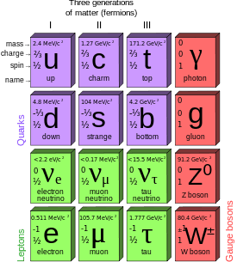

Fig. 1

The properties of the atomic nucleus are summarized and shown to be consistent with a description in which the nucleus is regarded as an assembly of elementary particles (neutrons and protons) bound together by means of nuclear forces.
The binding energy is a measure of the stability of the nucleus. Nuclear binding energy equal to the work you want to do for splitting the nucleus into its constituent nucleons without informing them of the kinetic energy.
The most important features are nuclei is its core charge Z and mass M. Z-charge of the nucleus is determined by the number of positive elementary charges concentrated in the nucleus. Of the positive elementary charge p = 1.6021·10⁻¹⁹ Сl is the proton in the nucleus. Atom as a whole is neutral and the charge of the nucleus determines both the number of electrons in the atom. The distribution of electrons in the atom for energy shells and subshells essentially depends on the total number of the atom. Therefore, the nuclear charge to a large extent determines the distribution of the electrons in an atom of their states and the position of the element in the periodic system. Charge of the nucleus is q_{n} = z·e, where z - charge number of the nucleus equal to the ordinal number of the element in the periodic system.
Mass of the atomic nucleus is almost equal to the mass of the atom, because the mass of the electrons of all atoms except hydrogen, is about 2.5·10⁻⁴ atomic mass. Atomic mass expressed in atomic mass units (amu). For amu adopted 1/12 the mass of a carbon atom ¹²₆C.

1 amu. =1,6605655(86)·10⁻²⁷ kg.

m_{N} = m_{a} - Z m_{e}.

Isotopes are called varieties of atoms of the chemical element, having the same charge, but different mass.
Nearest whole number to the atomic mass expressed in amu called the mass number and is denoted by the letter A. Identification of the chemical elements: A - mass number, X - symbol of a chemical element, Z-atomic number - number in the periodic table (^{A}_{Z}X): (Fig. 2)
Beryllium ⁹₄Be; Isotopes: ⁷₄Be; ⁹₄Be; ¹⁰₄Be (Fig. 1);
The radius of the nucleus:

r_{N}=1.3·10⁻¹³(A)^{-1/2} sm,

where A - the mass number.

Fig. 2

The nucleus of the hydrogen atom ¹₁H is called a proton: m_{proton} = 1,00783 amu, m(H)=1.67·10⁻²⁷ kg.
In 1932, opened a particle called a neutron, which has a mass close to the mass of a proton (m_{neutron} = 1.00867 amu) and has no electrical charge. Then D.D. Ivanenko conjectured proton-neutron structure of the nucleus: the nucleus consists of protons and neutrons, and their sum is equal to the mass number A. The charge number Z determines the number of protons in the nucleus, the neutron number N = A - Z.
Elementary particles - protons and neutrons in nuclei, have the common name of the nucleons. Nucleons in nuclei are conditions that are significantly different from their free states. Between nucleons are special nuclear force. They say that the nucleon can be in two "charged states" - proton with charge + e, and the neutron with a charge of 0.
Nuclear particles - protons and neutrons - are firmly held within the nucleus, so between them are very large forces of attraction that can withstand the huge forces of repulsion between like-charged protons. These special forces due to the short distances between nucleons, called nuclear forces. Nuclear forces are electrostatic (Coulomb).
The study of nuclei showed that the existing nuclear force between nucleons have the following features: a) The short-range forces - is shown at distances of 10⁻¹⁵ m and decreases sharply with only a small increase in the distance;
b) nuclear forces do not depend on whether a particle (nucleon) charge - charge independence of nuclear forces. Nuclear forces between neutrons and protons, between two neutrons, the two protons are equal. Protons and neutrons to the nuclear forces are the same.

(p↔n+π⁺; p↔p+π⁰).
The binding energy is a measure of the stability of the nucleus. Nuclear binding energy equal to the work you want to do for splitting the nucleus into its constituent nucleons without informing them of the kinetic energy (Fig. 3): M_{N}<Σ(m_{p}+m_{n}), M_{N} - the core mass.

Fig. 3

Measurement of the core shows that the mass of the nucleus rest less than the sum of the rest masses of its constituent nucleons.
Value Δm₀=Z·m_{p}+(A-Z)·m_{n}-M_{N} a measure of the binding energy is called the mass defect.
Einstein's equation in the special theory of relativity relates the energy and the rest mass of the particle: E₀=mc².
In general, the binding energy of a nucleus can be calculated by the formula

E=[Z·m_{p}+(A-Z)·m_{n}-M_{N}]·c²,

where Z - atomic number (number of protons in the nucleus);
A - mass number (the total number of nucleons in the nucleus);
m_{p}, m_{n} and M_{N} - mass of the proton, neutron and the nucleus
Mass defect (Δm) equal to 1 a.m.u. (a.m.u. - atomic mass unit) corresponds to the binding energy (E_{b}) of 1 a.u.e. (a.u.e. - atomic unit of energy) and equal 1a.m.u. · c² = 931 MeV.
According to the Bohr-Rutherford model of the atom, also called the “solar system model” the atom consist of a small but massive nucleus surrounded by a cloud of rapidly moving electrons (Fig. 4).

Fig. 4

The chemists tell us that the chemical properties of an atom depend on the electrons in the outermost shell.
The electrons are negatively charged, almost massless particles that nevertheless account for most of the size of the atom. Electrons were discovered by Sir J. J. Thomson (1897). Electrons are located in an electron cloud, which is the area surrounding the nucleus of the atom. The electron is only one member of a class of elementary particles, which forms an atom. The nucleus is composed of protons and neutrons. Total number of protons in the nucleus is called the atomic number of the atom and is given the symbol Z. The total electrical charge of the nucleus is therefore +Ze, where e (elementary charge) equals to 1,602 x 10⁻¹⁹ coulombs. In a neutral atom there are as many electrons as protons moving about nucleus. It is the electrons that are responsible for the chemical behavior of atoms, and which identify the various chemical elements (Fig. 5).

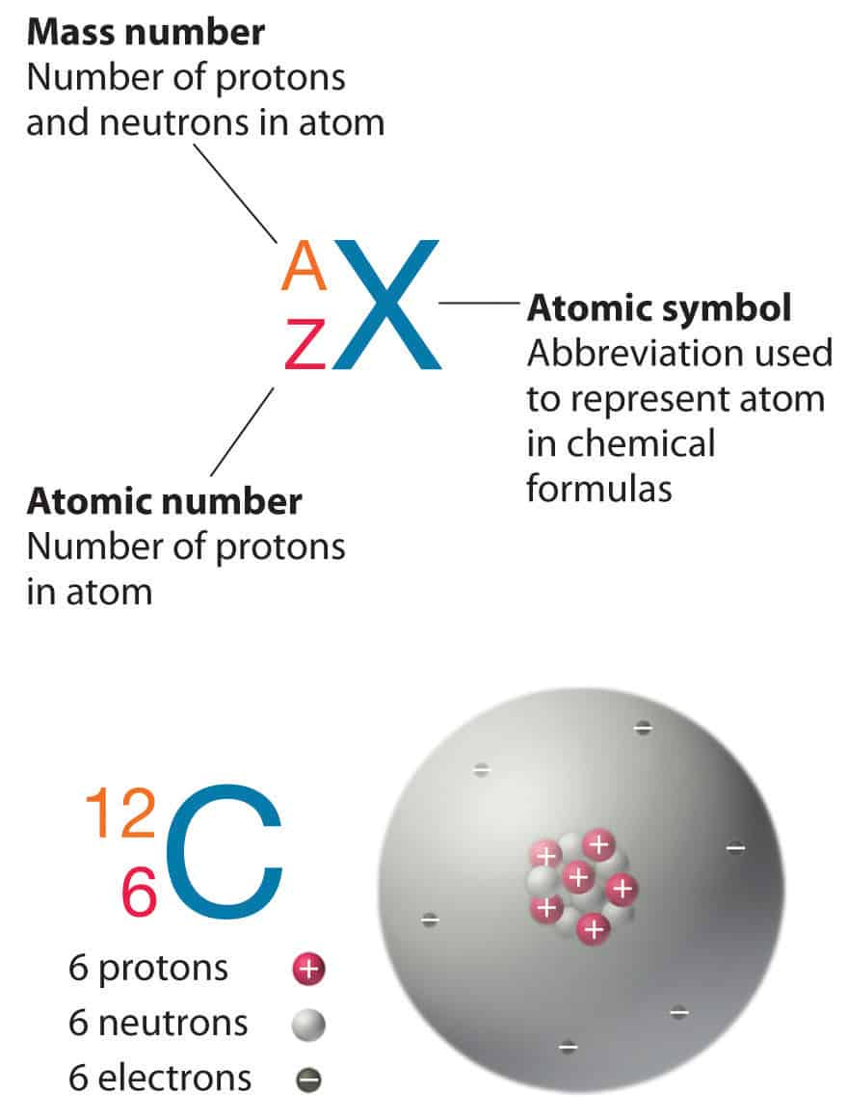

Fig. 5

Isotopes are nuclides that have the same atomic number (Z) and are therefore the same element, but differ in the number of neutrons (N). Uranium, for instance, has three isotopes occurring in nature –²³⁸U, ²³⁵U and²³⁴U. All have 92 protons in their nuclei.
Isotones are nuclides that have the same neutron number and are therefore different elements, since they must differ in the number of protons.
Isobars are nuclides of different elements that have the same mass number (same number of nucleons).
Isomers are nuclides with equal proton number and equal mass number (thus making them by definition the same isotope), but different energy states.
Atomic mass expressed in atomic mass units (a.m.u.): 1 a.m.u. =1,6605655(86)·10⁻²⁷ kg, m_{N} = m_{a} - Z m_{e}, 1 eV =1,602176487(40)·10⁻¹⁹ J.
For a.m.u. adopted 1/12 the mass of a carbon atom ¹²₆C.
The Four Fundamental Forces of Nature are:
- Gravitational force;
- weak Nuclear force;
- electromagnetic force;
- strong Nuclear force.
There are basic characteristics of the nuclear forces which are as follows:
- The nuclear forces are by far the strongest class of forces known.
- The nuclear forces are the unique short range forces 10^{–15}m.
- In regard to their net effect on the average, the nuclear forces must be attractive forces, other wise nuclei would not exist.
- Nuclear forces between two neutrons in particular quantum states must be nearly the repulsion of the proton is not of course accounted.
- Nuclear forces can’t be such that there is nearly the same purely attractive interaction potential between all pairs of nucleons in all quantum states. This is direct approximately proportional to A for all nuclei with A≥ 4.

Summary:
- Nuclear physics is the field of physics that studies the constituents (protons and neutrons) and interactions of atomic nuclei.
- The atoms consist of two parts. An atomic nucleus and an electron cloud.
- The nucleus is composed of protons and neutrons.
- Isotopes are nuclides that have the same atomic number.
- Isotones are nuclides that have the same neutron number.
- Isobars are nuclides of different elements that have the same mass number.
- Binding energy of the nucleus – the energy required to separate the nucleus into protons and neutrons;
- The Einstein mass-energy equivalence relationship;
- The Four Fundamental Forces of Nature are gravitational force, weak Nuclear force, electromagnetic force and strong Nuclear force;
- The nuclear forces are attractive forces that bind protons and neutrons in the nucleus;
- The nuclear forces are the unique short range forces (10^{–15} m);

Literature:

Basic:
- https://www.nuclear-power.net/
- https://physics.tutorvista.com/modern-physics/nuclear-physics.html
- Широков Ю.М., Юдин Н.П. Ядерная физика. М: Наука. 1980. - 729 с.
- Roy R.R., Nigam B.P. Nuclear Physics: Theory And Experiment. – 617 p.

Additional:
1. Савельев И.В., Курс общей физики: в 3т. Квантовая оптика. Атомная физика. Физика твердого тела. Физика атомного ядра и элементарных частиц (Т. 3). -М.: Астрель, 2007.
2. Трофимова Т.И Курс физики, - М.: Академия, 2014
3. Детлаф А.А.. Яворский Б.М. Курс физики -М.: Академия, 2014.
4. Лауринас В.Ч. Мультимедийная презентация курса лекций «Физика атома и атомного ядра». 2012
5. Матвеев А.Н. Атомная физика. -М.: Высшая школа, 1989.
6. Иродов И.Е. Задачи по общей физике. - СПб.: Лань, 2003.

Theme 2. Nuclear reactions.
Review:
- Nuclear reaction scheme.
- Nuclear reactions classification.
- Some Commonly Used Constants and Conversion Factors.
- Fission reactors.
- Fusion.
- Fusion reactors.

Changes in the nuclei during their interaction with the individual particles and with each other are called nuclear reactions. Nuclear reactions are transformations of atomic nuclei in the interaction with elementary particles or with each other:

a+X→b+Y,

where:
X, Y – original and final (new) nuclei;
a, b – bombared (projectile) and emitted particles in nuclear reactions (Fig. 1).

Fig. 1
Nuclear reaction scheme is shown in Fig. 2. Where and its short nuclear reaction is ¹⁴N(αp)¹⁷O. It is nuclear reaction is called Rutherford reaction (1919).

Fig. 2

There are the following, the most common nuclear reaction.
1. Reaction conversion. In this case, the flown particle remains in the nucleus, but the intermediate nucleus emits some other particle, so the kernel - the product is different from the target nucleus.
2. Radiative capture reaction. Gust particle stuck in the nucleus, but the excited nucleus emits excess energy by emitting a γ-photon (used in nuclear reactors).
3. Scattering. Intermediate nucleus emits a particle identical a gust, and can be: elastic scattering, inelastic scattering.
4. Fission reaction. It is a response that comes always with energy release. It is the basis for the technical production and use of nuclear energy. When fission excitation intermediate compound nucleus is so large that it is divided into two approximately equal fragments, with the release of several neutrons.
Ernest Rutherford (1871–1937), was a British physicist who came to be known as the father of nuclear physics. He is known as the father of nuclear physics. The element rutherfordium, Rf, Z=104. (1997). The rutherford (R_{d}), an obsolete unit of radioactivity equivalent to one megabecquerel.
Some Commonly Used Constants and Conversion Factors are shown in the Table 1.
Table 1

Speed of light | c=2.998·10⁸ m/s
Electronic charge | e=1.602·10⁻¹⁹ C
Boltzmann constant | k=1.381·10⁻²³ J/K=8.617·10⁻¹⁵ eV/K
Planck’s constant | h=6.626·10⁻³⁴ J·s=4.136·10⁻¹⁵ eV·s
Avogadro’s constant | N_{A}=6.022·10²³ mole⁻¹
Electron mass | m_{e}=5.49·10-⁴ u=0.511 MeV/c²
Proton mass | m_{p}=1.007276 u=938.3 MeV/c²
Neutron mass | m_{n}=1.008665 u=939.6 MeV/c²
Bohr radius | a₀=0.0529 nm
Hydrogen ionization energy | 13.6 eV
Thermal energy | kT=0.02525 eV≈(1/40) eV (T=293 K)
hc=1240 eV·nm (MeV·fm) | ћc=197 eV·nm (MeV·fm)
e²/4πε₀=1.440 eV· nm (MeV·fm) | 1 u=931.5 MeV/c²  1 eV=1.602·10⁻¹⁹ J

In any nuclear reaction:
- the laws of conservation of charge and mass numbers;
- the laws of conservation of energy;
the laws of conservation of momentum and angular momentum.
Nuclear reaction are classified:
- by the nature of the particles participating in them;
- by energy of the particles causing them;
- by the nature of the nuclei participating in them;
- by the nature of occurring nuclear reactions.
The term fission is used to describe the rare cases where the two daughters have similar masses. If the decay occurs without external action, it is called spontaneous fission to distinguish it from induced fission, where some external stimulus is required to initiate the decay. Spontaneous fission only occurs with a probability greater than that for a-emission for nuclei with Z>110. Finally, nuclei may decay by the emission of photons, with energies in the γ–ray part of the electromagnetic spectrum (gamma emission). This occurs when an excited nuclear state decays to a lower state and is a common way whereby excited states lose energy. The lower energy state is often the ground state. A competing process is internal conversion, where the nucleus de-excites by ejecting an electron from a low-lying atomic orbit. Both are electromagnetic processes.
The massive nucleus ²⁵⁴Cf (Z=98) can be produced in accelerators by collisions between suitably chosen projectiles and targets. This nucleus is of special interest because it is also produced in supernova explosions, and knowledge of its properties provides a key to understanding the formation of the elements in stars. ²⁵⁴Cf is radioactive, decaying with a half-life of 60.5 d. The Q values for positive and negative beta decay of ²⁵⁴Cf are both negative, so that mode of decay is not available. Alpha decay is energetically possible but the Coulumb barrier is very high, making that decay mode improbable. Instead, ²⁵⁴Cf decays by splitting into 2 pieces of much smaller masses – for example:

²⁵⁴₉₈Cf₁₅₆ → ²⁵⁴₅₄Xe₈₆ + ¹¹⁰₄₄Ru₆₆ + 4n.

This mode of decay is known as nuclear fission. Fission can occur as a spontaneous radioactive decay process for a relatively small number of massive nuclei and it can also be induced in other nuclei by adding energy to make the nucleus less stable. In addition to the two fission fragments, some neutrons are usually emitted in the fission process.
We can consider the nucleus to be a mixture of protons and neutrons moving about under the mutual attraction of their nuclear forces and the repulsion of their Columbs forces. For many nuclei, the result of these interactions is a spherical shape that has often been compared to a drop of liquid floating freely in a region where no external forces act. The equilibrium shape will be close to spherical and if the nucleus is distorted it can vibrate about its equilibrium shape and eventually return to its spherical shape somewhat like a stretched spring or other elastic system returns to its original configuration. Fig. 3 shows a schematic representation of the energy of the drop as a function of the distortion.
A typical sequence of processes in fission is shown on Fig. 3. A nucleus of ²³⁵U absorbs a neutron and fissions, two prompt neutrons and one delayed neutron are emitted.

Fig. 3

Following moderation, two neutrons cause new fissions and the third is captured by ²³⁸U, resulting finally in ²³⁹Pu.
Fission reactors. The components of a pressurized-water reactor (Fig. 4).

Fig. 4

In a fission reactor, the heat produced in the fuel must be extracted to generate electrical power. It must also be extracted for reasons of safety, because enough heat is produced to melt the core and cause a serious accident. For this reason, reactors contain an emergency core cooling system that is designed to prevent the core from overheating if the heat extraction system should fail.
Schematic diagram of processes in the fusion of protons to form helium is shown on Fig. 5.

Fig. 5

One of the largest tokamaks in existence is the Joint European Torus (JET), which is a European collaboration and sited at the Culham Laboratory in Berkshire, UK. A schematic view of the arrangement of the fields in JET is shown in Fig. 6. This shows the external coils that generate the main toroidal field. The poloidal field is generated by transformer action on the plasma. The primary windings of the transformer are shown with the plasma itself forming the single-turn secondary. The current induced in the plasma not only generates the poloidal field, but also supplies several megawatts of resistive heating to the plasma. However, even this is insufficient to ensure a sufficient temperature for fusion and additional energy is input via other means, including r_{f} sources.

Fig. 6

Energy may also released in nuclear reactions in the process of fusion, in which two light nuclei combine to form a heavier nucleus.
Spontaneous fission has been defined as the process whereby a parent nucleus breaks into two daughter nuclei of approximately equal masses without external action. Precisely equal masses are very unlikely and in the most probable cases the daughter nuclei have mass numbers that differ by about 45, with peaks around mass numbers 95 and 140. The reason for this is unknown.

Literature:

Basic:
- https://www.nuclear-power.net/
- https://physics.tutorvista.com/modern-physics/nuclear-physics.html
- Широков Ю.М., Юдин Н.П. Ядерная физика. М: Наука. 1980. - 729 с.
- Roy R.R., Nigam B.P. Nuclear Physics: Theory And Experiment. – 617 p.

Additional:
1. Савельев И.В., Курс общей физики: в 3т. Квантовая оптика. Атомная физика. Физика твердого тела. Физика атомного ядра и элементарных частиц (Т. 3). -М.: Астрель, 2007.
2. Трофимова Т.И Курс физики, - М.: Академия, 2014
3. Детлаф А.А.. Яворский Б.М. Курс физики -М.: Академия, 2014.
4. Лауринас В.Ч. Мультимедийная презентация курса лекций «Физика атома и атомного ядра». 2012
5. Матвеев А.Н. Атомная физика. -М.: Высшая школа, 1989.
6. Иродов И.Е. Задачи по общей физике. - СПб.: Лань, 2003.

Theme 3: Radioactivity
Review:
- Radioactivity.
- Types of radioactivity.
- Natural radioactivity.
- Artificial radioactive.
- The Basic Law of radioactive decay.
- Units of Activity.
- Radiation in Daily Life.

Radioactivity is the spontaneous conversion of an unstable nucleus of one element into the other core element. Natural radioactivity is called radioactivity observed in the naturally occurring unstable isotopes. Artificial radioactive isotopes called radioactivity produced by nuclear reactions.
Radioactivity is a phenomenon which is discover by a French scientist Henri Becquerel in 1896. He verified that uranium is a powerful radiations that is capable of blackening a photographic plate. Here uranium was discovered about hundred years as these radiations are not observed.
This process which is considered as the disintegration are not stopped or slowed down by the use of and instrument are not observed by Henri Becquerel in discover of radioactivity
Types of radioactivity:
1. α-decay. The emission of the nuclei of some chemical elements α-system of two protons and two neutrons are connected together. α-decay inherent in heavy nuclei with A > 200 and Z > 82.
2. β-decay.
a) Electronic (β⁻): the nucleus emits an electron and an electron antineutrino;
b) positron (β⁺): the nucleus emits a positron and a neutrino;
c) K - capture (electron capture) - nucleus absorbs one of the electrons at the K shell (or more rarely L or M) of its atom, resulting in one of the protons becomes a neutron, thereby emitting neutrinos.
3. γ -rays. Generally, all types of radioactivity are accompanied by the emission of γ-rays. γ-rays - is electromagnetic radiation having wavelengths ranging from one to a few hundredths of angstroms λ’=~ 1- 0.01 Å=10⁻¹⁰-10⁻¹²m energy γ-rays reaches millions of eV.
Natural radioactivity was discovered in 1896 by A. Becquerel, M. Curie and P. Curie. Artificial radioactivity - in 1933-1934 gg. Irene and Frederic Joliot-Curie. The process of radioactive decay does not depend on external conditions (temperature, pressure, electric and magnetic fields, the chemical composition of the substance into which the radioactive isotope enters, the aggregate state of matter, etc.) (Fig .1).

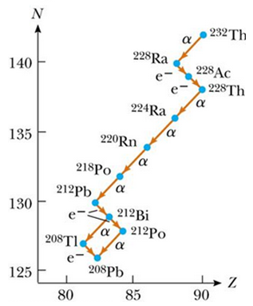

Fig. 1

This fact clearly indicates that the cause of radioactivity are the deep properties of matter, namely the properties of the nucleus.
When the process of radioactivity takes place, the nuclei undergoes the disintegration as per the Laws of radioactive disintegration which states that If N = Number of active nuclei at time t: N – dN= Number of active nuclei after time interval of dt. The Rate of radioactive decay is given by:

Rate of decay = - dN/dt

The decay rate (R) or the activity of a sample of radioactive material is defined as the number of decays per second, given by R = − λ N
According to the Rutherford and Soddy law of radioactive decay At any instant the rate of decay of a radioactive material is directly proportional to the number of atoms present at that instant. Hence rate of decay is directly proportional to N. If N = No of active nuclei left at time t.
The atoms which possess radioactivity or whose disintegration releases radioactive rays are called Radioactive Atoms. Some examples of radioactive substances are:
- Uranium,
- Radium,
- Thorium,
- Polonium, Neptunium etc.
The process of radioactive decay does not depend on external conditions (temperature, pressure, electric and magnetic fields, the chemical composition of the substance into which the radioactive isotope enters, the aggregate state of matter, etc.). This fact clearly indicates that the cause of radioactivity are the deep properties of matter, namely the properties of the nucleus.
Since nuclei with a large number of nucleons are less stable than nuclei with an average value of A, most natural radioactive nuclei in the periodic system of elements are behind lead. By artificial means, radioactive isotopes can be obtained with both large and small A.
From the modern point of view, radioactivity in most cases is explained by the overload of nuclei by neutrons. In the general case, the cause of radioactivity is associated with the excited state of the nucleus, due to some nuclear reaction.
The main sign of radioactivity is the change in the decay of both Z and A. Using these two numbers, we can indicate the main stages of radioactive decay.
The nuclear radioactivity condition is Z> 82, A> 206.
Basic information on the properties of the structure of the nucleus can be obtained by studying the radioactive decay of matter. There are three types of radioactive decay: α-, β- and γ- decays.
The emission of the nuclei of some chemical elements α-system of two protons and two neutrons are connected together.
α-decay inherent in heavy nuclei with A > 200 and Z > 82.
β- decay are:
- Electronic (β⁻): the nucleus emits an electron and an electron antineutrino;
b) Positron (β⁺): the nucleus emits a positron and a neutrino;
c) K - capture (electron capture) - nucleus absorbs one of the electrons at the K shell (or more rarely L or M) of its atom, resulting in one of the protons becomes a neutron, there by emitting neutrinos.
Generally, all types of radioactivity are accompanied by the emission of γ-rays.
γ-rays - is electromagnetic radiation having wavelengths ranging from one to a few hundredths of angstroms λ’=~ 1- 0.01 Å=10⁻¹⁰-10⁻¹²m energy γ-rays reaches millions of eV.
The term "activity", known from the Latin word «radio» - «radiate» and «activus» - «effective" means the spontaneous conversion of atomic nuclei, accompanied by the emission of gamma radiation, elementary particles or lighter nuclei. At the heart of all types of radioactive transformations known to science are the fundamental (strong and weak) interactions of particles that make up the atom. Unknown to this kind of penetrating radiation emitted by uranium, discovered in 1896 by French scientist Henri Becquerel, and in wide use the term "radioactivity" launched at the beginning of the 20th century, Marie Curie, which is investigating the invisible rays emitted by certain minerals, able to distinguish pure radioactive element - radium.
Characteristics of radioactive decay are shown on Fig. 2.

Fig. 2

The Basic Law of radioactive decay:

N=N₀e^{-λt}.

The main feature of radioactive transformations is that they occur spontaneously, while for chemical reactions, in any case, some external influences are required. In addition, radioactive transformations proceed continuously and are always accompanied by the release of a certain amount of energy, which depends on the strength of the interaction of atomic particles with each other. The speed of the reactions within the atoms is not affected by the temperature, the presence of electric and magnetic fields, nor the use of the most effective chemical catalyst, nor the pressure, nor the aggregate state of the substance. Radioactive transformations do not depend on any external factor and can’t be accelerated or slowed down.
The intensity of radioactive decay, as well as its dependence on the number of atoms, and the time is expressed in the law of radioactive decay, open Ernest Rutherford and Frederick Soddy in 1903. In order to arrive at certain conclusions, who found later reflected in the new law, the researchers conducted the following experiment: they are separated one from radioactive products, and studied its independent activity separate from the radioactive substance from which it was isolated. As a result, it was found that the activity of any radioactive products, regardless of the chemical element, decreases with time in a geometric progression. Proceeding from this, the scientists concluded that the rate of radioactive transformation is always proportional to the number of systems that have not yet undergone transformation.
Irradiation from radioactive decay can damage living cells. This can be put to good use as well as being a hazard (Fig. 3).

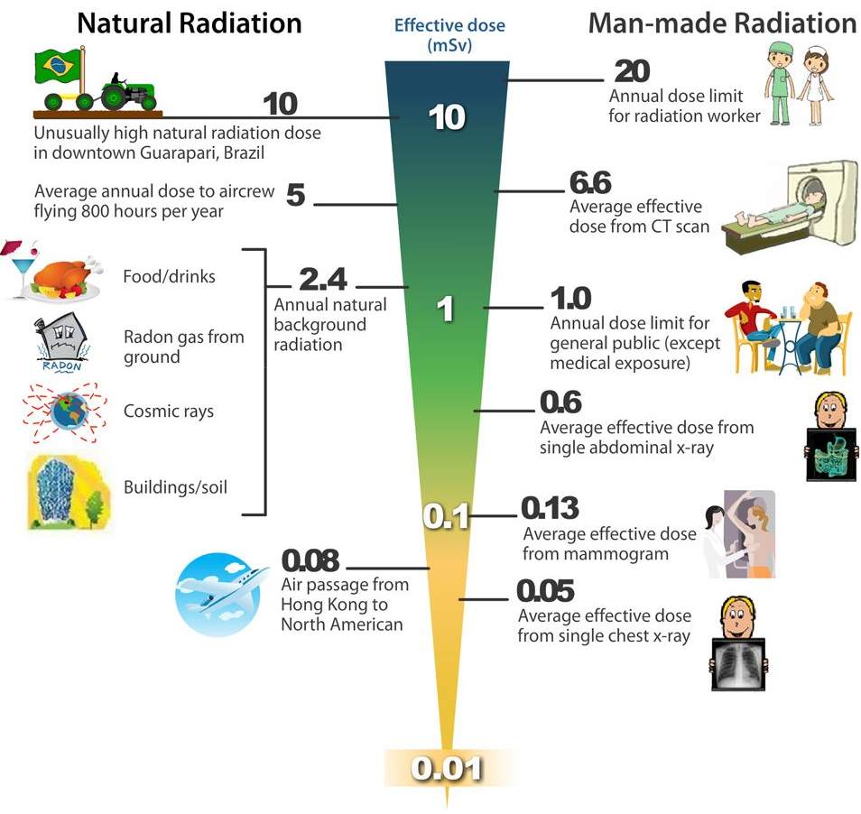

Fig. 3

1) Irradiation for sterilization.
Irradiation can be used to preserve fruit sold in supermarkets by exposing the fruit to a radioactive source - typically cobalt-60. The gamma rays emitted by the cobalt will destroy any bacteria on the fruit but will not change the fruit in any significant way. The process of irradiation does not cause the irradiated object to become radioactive.
2) Medical irradiation
Doctors also use radioactive sources for a number of reasons, eg:
- Sterilisation of surgical instruments.
b) Beams of gamma rays, called a gamma knife, can be used to kill cancerous tumours deep inside the body.
In medical applications that involve using radioactive sources, efforts are made to ensure that irradiation does not cause any long-term effects. This is done by considering:
- the nature of decay (alpha, beta or gamma);
- the half-life;
- toxicity.
Becquerel. The becquerel is SI unit of radioactivity defined in 1974. It is named in honour of Henri Becquerel, a French physicist who discovered radioactivity in 1896. One becquerel (1Bq) is equal to 1 disintegration per second.
Curie. The curie is a non-SI unit of radioactivity defined in 1910. It was originally defined as equivalent to the number of disintegrations that one gram of radium-226 will undergo in one second. Currently, a curie is defined as

1Ci = 3.7 x 10¹⁰ disintegrations per second.

Rutherford. Rutherford (symbol Rd) is also a non-SI unit defined as the activity of a quantity of radioactive material in which one million nuclei decay per second.
Summary:
Activity - the number of decays of a radioactive element per second. Measured in Becquerels (Bq).
Half-life - the time it takes for the number of nuclei of a radioactive isotope in a sample to halve. Also defined as the time it takes for the count rate from a sample containing a radioactive isotope to fall to half its starting level.
Radioactive decay - the process in which unstable atomic nuclei break apart or change, releasing radiation as they do so.

Literature:

Basic:
- https://www.nuclear-power.net/
- https://physics.tutorvista.com/modern-physics/nuclear-physics.html
- Широков Ю.М., Юдин Н.П. Ядерная физика. М: Наука. 1980. - 729 с.
- Roy R.R., Nigam B.P. Nuclear Physics: Theory And Experiment. – 617 p.

Additional:
1. Савельев И.В., Курс общей физики: в 3т. Квантовая оптика. Атомная физика. Физика твердого тела. Физика атомного ядра и элементарных частиц (Т. 3). -М.: Астрель, 2007.
2. Трофимова Т.И Курс физики, - М.: Академия, 2014
3. Детлаф А.А. Яворский Б.М. Курс физики - М.: Академия, 2014.
4. Лауринас В.Ч. Мультимедийная презентация курса лекций «Физика атома и атомного ядра». 2012
5. Матвеев А.Н. Атомная физика. -М.: Высшая школа, 1989.
6. Иродов И.Е. Задачи по общей физике. - СПб.: Лань, 2003.

Theme 4: Basics of dosimetry
Review:
- Introduction.
- Quantities and units used for describing the interaction of ionizing radiation with matter.
- Charged particle equilibrium in dosimetry.
- Cavity theory.
- Practical dosimetry with ion chambers.

Radiation dosimetry in the fields of health physics and radiation protection is the measurement, calculation and assessment of the ionizing radiation dose absorbed by the human body. This applies both internally, due to ingested or inhaled radioactive substances, or externally due to irradiation by sources of radiation.
Internal dosimetry assessment relies on a variety of monitoring, bio-assay or radiation imaging techniques, whilst external dosimetry is based on measurements with a dosimeter, or inferred from measurements made by other radiological protection instruments.
Dosimetry is used extensively for radiation protection and is routinely applied to monitor occupational radiation workers, where irradiation is expected, or where radiation is unexpected, such as in the aftermath of the Three Mile Island, Chernobyl or Fukushima radiological release incidents. The public dose take-up is measured and calculated from a variety of indicators such as ambient measurements of gamma radiation, radioactive particulate monitoring, and the measurement of levels of radioactive contamination.
Other significant areas are medical dosimetry, where the required treatment absorbed dose and any collateral absorbed dose is monitored, and in environmental dosimetry, such as radon monitoring in buildings.
The application of nuclear physics to biomedicine is a very large subject and for reasons of space we will therefore concentrate on just two topics: the therapeutic uses of radiation and medical imaging. Radiation therapy is a long-standing treatment for cancer, often combined with chemotherapy and/or surgery. By damaging DNA, the ability of the cell to reproduce is inhibited and so tumour tissue can, in principle, be destroyed. However, the same of course applies to healthy tissue so, when using radiation in a medical environment, a balance has to be struck between the potential diagnostic and/or therapeutic benefits and the potential deleterious effects of damage done by the radiation. This is a particularly delicate balance for cancer treatment because, as we shall see below, highly oxygenated tissue has a greater sensitivity to radiation and unfortunately many tumours are less oxygenated than healthy tissue and therefore more resistant to radiation. We start by reviewing the biological effects of radiation and then describe the use of various types of radiation for cancer treatment.
Exposure of living tissue to radiation is a complex process. Immediate physical damage may be caused by the initial deposition of energy, but in addition there can also be secondary damage due to the production of highly active chemicals. The latter may not be evident in full for several hours after exposure. For low levels of radiation this effect is the only one. High levels of damage may lead to the rapid death of living cells, but cells that survive in a damaged form may still have serious consequences. However caused, damage to the DNA of the nucleus of cells can result in long-term biological effects, such as cancer or genetic abnormalities, which may not reveal themselves for years, even decades, after the original exposure.
Radiation measurements and investigations of radiation effects require various specifications of the radiation field at the point of interest. Radiation dosimetry deals with methods for a quantitative determination of energy deposited in a given medium by directly or indirectly ionizing radiations. A number of quantities and units have been defined for describing the radiation beam, and the most commonly used dosimetric quantities and their units are defined below. A simplified discussion of cavity theory, the theory that deals with calculating the response of a dosimeter in a medium, is also given. The following quantities are used to describe a monoenergetic ionizing radiation beam: particle fluence, energy fluence, particle fluence rate and energy fluence rate. These quantities are usually used to describe photon beams and may also be used in describing charged particle beams.
Kerma is an acronym for kinetic energy released per unit mass. It is a non-stochastic quantity applicable to indirectly ionizing radiations such as photons and neutrons. It quantifies the average amount of energy transferred from indirectly ionizing radiation to directly ionizing radiation without concern as to what happens after this transfer. In the discussion that follows we will limit ourselves to photons.
The energy of photons is imparted to matter in a two stage process. In the first stage, the photon radiation transfers energy to the secondary charged particles (electrons) through various photon interactions (the photoelectric effect, the Compton effect, pair production, etc.). In the second stage, the charged particle transfers energy to the medium through atomic excitations and ionizations. In this context, the kerma is defined as the mean energy transferred from the indirectly ionizing radiation to charged particles (electrons) in the medium dE_{tr} per unit mass dm:

K=dE_{tr}/dm (1)

The unit of kerma is joule per kilogram (J/kg). The name for the unit of kerma is the gray (Gy), where 1 Gy = 1 J/kg.
Cema is the acronym for converted energy per unit mass. It is a non-stochastic quantity applicable to directly ionizing radiations such as electrons and protons. The cema C is the quotient of dEcby dm, where dEcis the energy lost by charged particles, except secondary electrons, in collisions in a mass dm of a material:

C=dE_{c}/dm (2)

The unit of cema is joule per kilogram (J/kg). The name for the unit of cema is the gray (Gy).
Absorbed dose is a non-stochastic quantity applicable to both indirectly and directly ionizing radiations. For indirectly ionizing radiations, energy is imparted to matter in a two step process. In the first step (resulting in kerma), the indirectly ionizing radiation transfers energy as kinetic energy to secondary charged particles. In the second step, these charged particles transfer some of their kinetic energy to the medium (resulting in absorbed dose) and lose some of their energy in the form of radiative losses (bremsstrahlung, annihilation in flight).
The absorbed dose is related to the stochastic quantity energy imparted. The absorbed dose is defined as the mean energy e imparted by ionizing radiation to matter of mass min a finite volume V by:

d=dε/dm (3)

The energy imparted e is the sum of all the energy entering the volume of interest minus all the energy leaving the volume, taking into account any mass–energy conversion within the volume. Pair production, for example, decreases the energy by 1.022 MeV, while electron-positron annihilation increases the energy by the same amount.
Note that because electrons travel in the medium and deposit energy along their tracks, this absorption of energy does not take place at the same location as the transfer of energy described by kerma. The unit of absorbed dose is joule per kilogram (J/kg). The name for the unit of absorbed dose is the gray (Gy).
Stopping powers are widely used in radiation dosimetry, but they are rarely measured and must be calculated from theory. For electrons and positrons the Bethe theory is used to calculate stopping powers. The linear stopping power is defined as the expectation value of the rate of energy loss per unit path length (dE/dx) of the charged particle. The mass stopping power is defined as the linear stopping power divided by the density of the absorbing medium. Division by the density of the absorbing medium almost eliminates the dependence of the mass stopping power on mass density, except for the density effect discussed further below. Typical units for the linear and mass stopping powers are MeV/cm and MeV·cm²/g, respectively.
Two types of stopping power are known: collision (ionization), resulting from interactions of charged particles with atomic orbital electrons; and radiative, resulting from interactions of charged particles with atomic nuclei. The unrestricted mass collision stopping power expresses the average rate of energy loss by a charged particle in all hard and soft collisions.
● A soft collision occurs when a charged particle passes an atom at a considerable distance (i.e. b>> a, where b is the impact parameter and a the atomic radius). The net effect of the collision is that a very small amount of energy is transferred to an atom of the absorbing medium in a single collision.
● In a hard collision where b ≈a, a secondary electron (often referred to as a delta electron or historically as a delta ray) with considerable energy is ejected and forms a separate track.
● In the unrestricted mass collision stopping power the maximum energy transfer to an orbital electron allowed due to a hard collision is half of the kinetic energy of the electron (collision of indistinguishable particles) or the full kinetic energy of a positron (collision of distinguishable particles).
Cavity theory. In order to measure the absorbed dose in a medium, it is necessary to introduce a radiation sensitive device (dosimeter) into the medium. Generally, the sensitive medium of the dosimeter will not be of the same material as the medium in which it is embedded. Cavity theory relates the absorbed dose in the dosimeter’s sensitive medium (cavity) to the absorbed dose in the surrounding medium containing the cavity. Cavity sizes are referred to as small, intermediate or large in comparison with the ranges of secondary charged particles produced by photons in the cavity medium. If, for example, the range of charged particles (electrons) is much larger than the cavity dimensions, the cavity is regarded as small. Various cavity theories for photon beams have been developed, which depend on the size of the cavity; for example, the Bragg-Gray and Spencer-Attix theories for small cavities and the Burlin theory for cavities of intermediate sizes.
Bragg–Gray cavity theory. The Bragg–Gray cavity theory was the first cavity theory developed to provide a relation between the absorbed dose in a dosimeter and the absorbed dose in the medium containing the dosimeter. The conditions for application of the Bragg–Gray cavity theory are:
a) The cavity must be small when compared with the range of charged particles incident on it, so that its presence does not perturb the fluence of charged particles in the medium;
b) The absorbed dose in the cavity is deposited solely by charged particles crossing it (i.e. photon interactions in the cavity are assumed negligible and thus ignored).
The Bragg-Gray cavity theory does not take into account the creation of secondary (delta) electrons generated as a result of hard collisions in the slowing down of the primary electrons in the sensitive volume of the dosimeter. The Spencer-Attix cavity theory is a more general formulation that accounts for the creation of these electrons that have sufficient energy to produce further ionization on their own account. Some of these electrons released in the gas cavity would have sufficient energy to escape from the cavity, carrying some of their energy with them. This reduces the energy absorbed in the cavity and requires modification of the stopping power of the gas. The Spencer-Attix theory operates under the two Bragg-Gray conditions; however, these conditions now even apply to the secondary particle fluence in addition to the primary particle fluence.
A dosimeter can be defined generally as any device that is capable of providing a reading that is a measure of the average absorbed dose deposited in its (the dosimeter’s) sensitive volume by ionizing radiation. A dosimeter can generally be considered as consisting of a sensitive volume filled with a given medium, surrounded by a wall of another medium.
In the context of cavity theories, the sensitive volume of the dosimeter can be identified as the ‘cavity’, which may contain a gaseous, liquid or solid medium. Gas is often used as the sensitive medium, since it allows a relatively simple electrical means for collection of charges released in the sensitive medium by radiation.
The medium surrounding the cavity of an ionization chamber depends on the situation in which the device is used. In an older approach, the wall (often supplemented with a buildup cap) serves as the buildup medium and the Bragg-Gray theory provides a relation between the dose in the gas and the dose in the wall. This is referred to as a thick walled ionization chamber and forms the basis of cavity chamber based air kerma in-air standards and of the C_{λ} based dosimetry protocols of the 1970s. If, however, the chamber is used in a phantom without a buildup material, since typical wall thicknesses are much thinner than the range of the secondary electrons, the proportion of the cavity dose due to electrons generated in the phantom greatly exceeds the dose contribution from the wall, and hence the phantom medium serves as the medium and the wall is treated as a perturbation to this concept.
In the case of a thick walled ionization chamber in a high energy photon beam, the wall thickness must be greater than the range of secondary electrons in the wall material to ensure that the electrons that cross the cavity arise in the wall and not in the medium. The Bragg–Gray cavity equation then relates the dose in the cavity to the dose in the wall of the chamber. The dose in the medium is related to the dose in the wall by means of a ratio of the mass–energy absorption coefficients of the medium and the wall (m–en/r)med, wall by assuming that:
a) The absorbed dose is the same as the collision kerma;
b) The photon fluence is not perturbed by the presence of the chamber.
Although cavity theory was designed to calculate ratios of absorbed doses, the practical application of the Spencer–Attix cavity theory has always required additional correction factors. Since the central component of the Spencer–Attix cavity theory results in averaging stopping powers, Spencer–Attix dose ratios are often referred to as ‘stopping power ratios’. In photon beams, except at or near the surface, average restricted stopping power ratios of water to air do not vary significantly as a function of depth. Stopping power ratios (with D= 10 keV) under full buildup conditions are shown in Table 1.
Table 1
Photon spectrum | S_{water, air}
⁶⁰Co | 1.134
4 MV | 1.131
6 MV | 1.127
8 MV | 1.121
10 MV | 1.117
15 MV | 1.106
20 MV | 1.096
25 MV | 1.093
35 | 1.084

Stopping power ratios not only play a role in the absolute measurement of absorbed dose, they are also relevant in performing accurate relative measurements of absorbed dose in regimes in which the energy of the secondary electrons changes significantly from one point in a phantom to another. An important example of this is apparent from Fig. 1, which shows restricted stopping power ratios (D= 10 keV) of water to air for electron beams as a function of depth in water.

Fig. 1

Note that these curves are for monoenergetic electrons; protocols or codes of practice for electron dosimetry provide fits of stopping power ratios for realistic accelerator beams. However, Fig. 1 shows clearly that the accurate measurement of electron beam depth dose curves requires depth dependent correction factors.

Literature:

Basic:
- https://www.nuclear-power.net/
- https://physics.tutorvista.com/modern-physics/nuclear-physics.html
- Широков Ю.М., Юдин Н.П. Ядерная физика. М: Наука. 1980. - 729 с.
- Roy R.R., Nigam B.P. Nuclear Physics: Theory And Experiment. – 617 p.
- Martin B. R. Nuclear and Particle Physics. John Wiley & Sons Ltd, The Atrium, Southern Gate, Chichester, West Sussex PO19 8SQ, England, 2006. – p. 415.

Additional:
1. Савельев И.В., Курс общей физики: в 3т. Квантовая оптика. Атомная физика. Физика твердого тела. Физика атомного ядра и элементарных частиц (Т. 3). -М.: Астрель, 2007.
2. Трофимова Т.И Курс физики, - М.: Академия, 2014.
3. Детлаф А.А. Яворский Б.М. Курс физики - М.: Академия, 2014.
4. Лауринас В.Ч. Мультимедийная презентация курса лекций «Физика атома и атомного ядра». 2012.
5. Матвеев А.Н. Атомная физика. - М.: Высшая школа, 1989.
6. Иродов И.Е. Задачи по общей физике. - СПб.: Лань, 2003.
7. Fundamental Quantities and Units for Ionizing Radiation, Rep. 60, ICRU, Bethesda, MD (1998).

Theme 5: Elementary particles
Review:
- Introduction.
- Standard Model of Elementary Particles.
- The fundamental fermions.
- The fundamental bosons.

Unlike nuclear physics, particle physics does have a comprehensive theory, but although the standard model is very successful at explaining a wide range of phenomena, there are still questions that remain to be answered and some hints from experiments of phenomena that lie outside the model, for example neutrino oscillations and the possibility of lepton number violation. In addition, the success of the standard model has spurred physicists to construct theories that incorporate the strong interaction, and even in some cases gravity, in wider unification schemes. A full discussion of these topics is beyond the scope of this book, but in this chapter we will briefly review some of these questions and also look at the rapidly growing field of particle astrophysics.
An elementary particle or fundamental particle is a subatomic particle with no substructure, thus not composed of other particles. Particles currently thought to be elementary include the fundamental fermions (quarks, leptons, antiquarks, and antileptons), which generally are "matter particles" and "antimatter particles", as well as the fundamental bosons (gauge bosons and the Higgs boson), which generally are "force particles" that mediate interactions among fermions. A particle containing two or more elementary particles is a composite particle (Fig. 1).

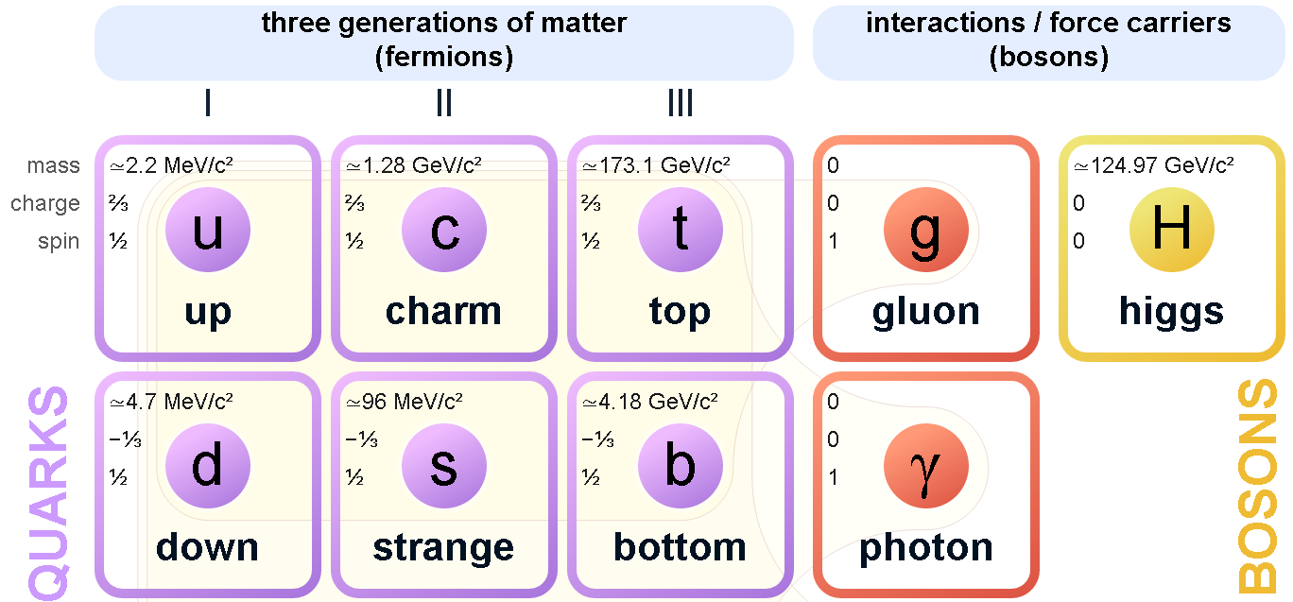
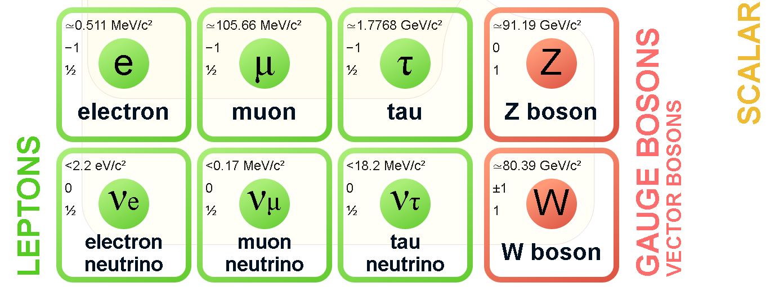

Fig. 1

Everyday matter is composed of atoms, once presumed to be matter's elementary particles-atom meaning "unable to cut" in Greek -although the atom's existence remained controversial until about 1910, as some leading physicists regarded molecules as mathematical illusions, and matter as ultimately composed of energy. Soon, subatomic constituents of the atom were identified. As the 1930s opened, the electron and the proton had been observed, along with the photon, the particle of electromagnetic radiation. At that time, the recent advent of quantum mechanics was radically altering the conception of particles, as a single particle could seemingly span a field as would a wave, a paradox still eluding satisfactory explanation.
The fundamental fermions are Quarks, Leptons, Antiquarks and Antileptons. Quark is a type of elementary particle and a fundamental constituent of matter. Quarks have various intrinsic properties, including electric charge, mass, color charge, and spin.
They are the only elementary particles in the Standard Model of particle physics to experience all four fundamental interactions, also known as fundamental forces (electromagnetism, gravitation, strong interaction, and weak interaction), as well as the only known particles whose electric charges are not integer multiples of the elementary charge.
Lepton is an elementary particle of half-integer spin that does not undergo strong interactions.
Two main classes of leptons exist:
- charged leptons (also known as the electron-like leptons);
- neutral leptons (better known as neutrinos).
Charged leptons can combine with other particles to form various composite particles such as atoms and positronium, while neutrinos rarely interact with anything, and are consequently rarely observed (Table 1). The best known of all leptons is the electron.
Table 1

For every quark flavor there is a corresponding type of antiparticle, known as an antiquark, that differs from the quark only in that some of its properties (such as the electric charge) have equal magnitude but opposite sign (Fig. 2).

Fig. 2

The fundamental bosons are Gauge boson and the Higgs boson. Gauge boson is a force carrier, a bosonic particle that carries any of the fundamental interactions of nature, commonly called forces. The Higgs boson is an elementary particle, produced by the quantum excitation of the Higgs field, one of the fields in particle physics theory.
The failure to observe Higgs bosons in present experiments leads to limits on their mass. The best results come from the Large Electron-Positron (LEP) accelerator at CERN. This machine (which is no longer operational) had a maximum energy of 208 GeV, which is enough to produce Higgs bosons with masses up to almost 120 GeV/c² in the reaction:

e⁺+e⁻ →H⁰ + Z⁰,

which is expected to occur by the dominant mechanism of Figure 1. Fig. 1 shows dominant mechanism for Higgs boson production in e⁺e⁻ annihilation.

Fig. 1

Attempts were made to detect Higgs bosons by their decays to bb pairs, where the quarks would be observed as jets containing short-lived hadrons with non-zero beauty. The results were tantalizing. By the time LEP closed down in November 2000 to make way for another project, it had shown that no Higgs bosons existed with a mass less than 113.5 GeV/c²; and some evidence had been obtained for the existence of a Higgs boson with a mass of 115 GeV/c². This is very close to the upper limit of masses that were accessible by LEP, but because the Higgs boson would have a width, its mass distribution would extend down to lower energies and would give a signal. Unfortunately, while this signal was statistically likely to be a genuine result rather than a statistical fluctuation, the latter cannot be completely ruled out.
Future investigations will involve the use of new accelerators currently under construction. This will enable searches to be made for Higgs bosons with masses up to 1 TeV/c 2 via reactions of the type

p+p→H⁰+X.

Where X is any state allowed by the conservation laws. The mechanism for this reaction is the weak interaction between the constituent quarks of the protons, an example of which is shown in Figure 2, where the other quarks in the protons are spectators, as usual.

Fig. 2

Gauge bosons are elementary particles, whose interactions are described by a gauge theory, interact with each other by the exchange of gauge bosons - usually as virtual particles.
All known gauge bosons have a spin of 1. Therefore, all known gauge bosons are vector bosons.
Gauge bosons are different from the other kinds of bosons: first, fundamental scalar bosons (the Higgs boson); second, mesons, which are composite bosons, made of quarks; third, larger composite, non-force-carrying bosons, such as certain atoms.
The Higgs boson - it is named after physicist P. Higgs, who in 1964, along with five other scientists, proposed the mechanism which suggested the existence of such a particle. Its existence was confirmed in 2012 by the ATLAS and CMS collaborations based on collisions in the LHC at CERN. In mainstream media the Higgs boson has often been called the ‘God particle’ (1993), although the nickname is strongly disliked by many physicists, including Higgs himself, who regard it as sensationalism.
Particle physics and astrophysics interact in an increasing number of areas and the resulting field of particle astrophysics is a rapidly expanding one. The interactions are particularly important in the field of cosmology where, for example, the detection of neutrinos can provide unique cosmological information. Another reason is because the conditions in the early Universe implied by standard cosmological theories (the big bang model) can only be approached, however remotely, in high-energy particle collisions. At the same time, these conditions occurred at energies that are relevant to the grand unified and SUSY theories of particle physics and so offer a possibility of testing the predictions of such theories. This is important because, as mentioned above, it is difficult to see other ways of testing such predictions. For reasons of space, we will discuss just three examples of particle astrophysics.
One of the first neutrino astrophysics experiments was the observation of neutrinos from a supernova. Supernovas are very rare events where a star literally explodes with a massive output of energy over a very short timescale measured in seconds. The mechanism for this (briefly) is as follows. If a star has a mass greater than about 11 solar masses, it can evolve through all stages of fusion, ending in a core of iron surrounded by shells of lighter elements. Because energy cannot be released by the thermonuclear fusion of iron, the core will start to contract under gravity. Initially this is resisted by the pressure of the dense gas of degenerate electrons in the core (electron degeneracy pressure), but as more of the outer core is burned and more iron deposited in the core, the resulting rise in temperature makes the electrons become increasingly relativistic. When the core mass reaches about 1.4 solar masses (the so-called Chandrasekhar limit), the electrons become ultra relativistic and they can no longer support the core. At this point the star is on the brink of a catastrophic collapse.
Summary:
- Subatomic constituents of the atom were identified.
- At that time, the recent advent of quantum mechanics was radically altering the conception of particles, as a single particle could seemingly span a field as would a wave, a paradox still eluding satisfactory explanation.
- A gauge boson is a force carrier, a bosonic particle that carries any of the fundamental interactions of nature, commonly called forces.
- The Higgs boson is an elementary particle, produced by the quantum excitation of the Higgs field, one of the fields in particle physics theory.

Literature:

Basic:
- https://www.nuclear-power.net/
- https://physics.tutorvista.com/modern-physics/nuclear-physics.html
- Широков Ю.М., Юдин Н.П. Ядерная физика. М: Наука. 1980. - 729 с.
- Roy R.R., Nigam B.P. Nuclear Physics: Theory And Experiment. – 617 p.
- Martin B. R. Nuclear and Particle Physics. John Wiley & Sons Ltd, The Atrium, Southern Gate, Chichester, West Sussex PO19 8SQ, England, 2006. – p. 415.

Additional:
1. Савельев И.В., Курс общей физики: в 3т. Квантовая оптика. Атомная физика. Физика твердого тела. Физика атомного ядра и элементарных частиц (Т. 3). -М.: Астрель, 2007.
2. Трофимова Т.И Курс физики, - М.: Академия, 2014.
3. Детлаф А.А. Яворский Б.М. Курс физики - М.: Академия, 2014.
4. Лауринас В.Ч. Мультимедийная презентация курса лекций «Физика атома и атомного ядра». 2012.
5. Матвеев А.Н. Атомная физика. - М.: Высшая школа, 1989.
6. Иродов И.Е. Задачи по общей физике. - СПб.: Лань, 2003.
7. Fundamental Quantities and Units for Ionizing Radiation, Rep. 60, ICRU, Bethesda, MD (1998).

