Министерство образования и науки Республики Казахстан

Карагандинский университет им. Е.А. Букетова

Факультет математики и информационных технологий

Кафедра прикладной математики и информатики

**Спирина Е.А.,**

к.п.н., доцент

**КУРС ЛЕКЦИЙ**

**по дисциплине «Разработка Web-приложений (на английском)»**

(9 лекций)

образовательные программы:

«7М06101 Информационные системы и технологии»,

«7М01503 Информатика»

Караганда 2022

**Theme 1. Internet technologies**

*Plan*

1 Basic concepts Internet.

2 Evolution

3 Internet Structure

4 Providers

5 Internet Addressing

6 Internet Domain Name System (DNS)

7 Protocol TCP /IP

8 Uniform Resource Locator (URL)

9 Ways to connect to the Internet

10 Internet Services

**1.1 Basic concepts network Internet**

# The Internet

The Internet is a worldwide collection of interconnected networks. *The Internet is a worldwide system of integrated computer networks for storing and transmitting information.*

The Internet can be viewed as a "network of networks", each of which is managed by an independent operator - the **ISP** (Internet Service Provider).

Internet servers support the operation of the Internet and users. Local and corporate networks, mobile devices and computers can be connected to the Internet.

*The Internet isn’t owned by any individual or group.*

There are organizations that have been developed for the purpose of helping to maintain structure and standardization of Internet protocols and processes. These organizations include the Internet Engineering Task Force (IETF), Internet Corporation for Assigned Names and Numbers (ICANN), and the Internet Architecture Board (IAB), and many others.

Internet it is a single network capable of transmitting information from anywhere in the world to any other point. Internet is defined as an Information super Highway, to access information.

From the point of view of users, the Internet is a set of information resources dispersed across various networks, including ISP networks, corporate networks, networks and individual computers of home users.

Each individual computer in a given network is called a host [1].

Internet network has the following features (fig.1):

* Every computer in internet is identified by a *unique IP address;*
* The Internet uses the suit protocols - *TCP/IP;*
* A *Domain Name System (DNS)* is used for users to find certain computer;
* Internet is accessible to every user all over the world.

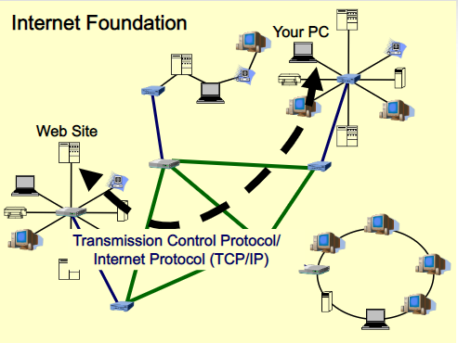

Figure 1.

**Evolution Internet**

The concept of Internet was originated in 1969 (fig. 2). The origin of Internet devised from the concept of ARPANET - Advanced Research Project Agency Network. ARPANET was developed by United States Department of Defense. Basic aim of ARPANET was to provide communication among the various bodies of government. Initially, there were only four nodes, formally called Hosts. With invention of new technologies (such as TCP/IP protocols, DNS, WWW, browsers, scripting languages etc.), Internet provided a medium to publish and access information over the Web [2].

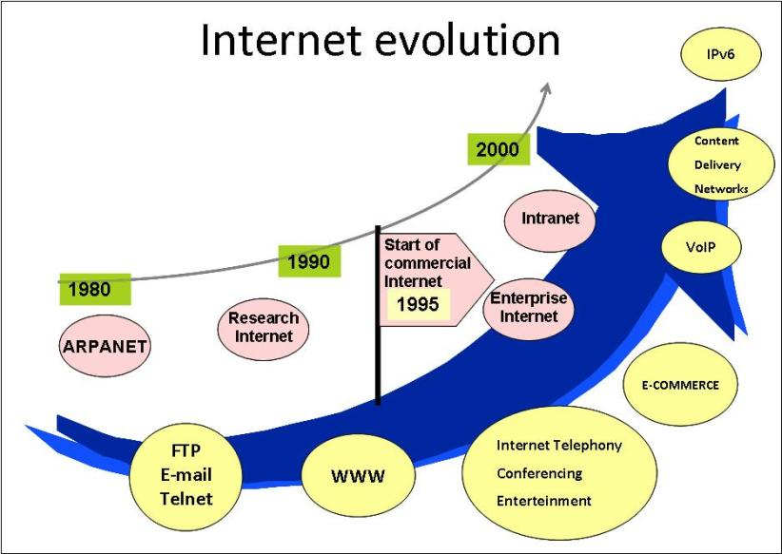

Figure 2.

Internet covers almost every aspect of life [3]. Here, we will consider the some of the advantages and disadvantages of Internet (fig. 3,4).

**Advantages**

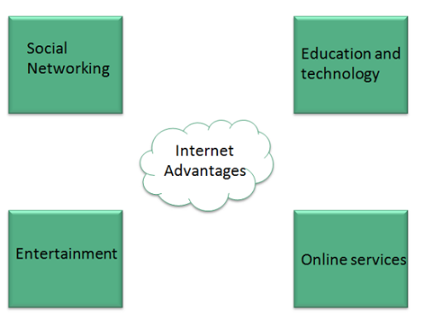

Figure 3.

*1) Social Networking*

* Internet allows us to communicate with the people sitting at remote locations.
* There are various apps available on the wed that uses Internet as a medium for communication.
  + - One can find various social networking sites such as: Facebook, Twitter, Yahoo, Google+, Flickr.

*2) Education*

One can surf for any kind of information over the internet. Information regarding various topics such as Technology, Health & Science, Social Studies, Geographical Information, Information Technology, Products etc. can be surfed with help of a search engine.

*3) Entertainment*

Apart from communication and source of information, internet also serves a medium for entertainment.

Following are the various modes for entertainment over internet:

* OnlineTelevision;
* OnlineGames;
* Songs;
* Videos;
* SocialNetworkingApps.

*4) On-line services*

Internet allows us to use many services like:

* InternetBanking;
* OnlineShopping;
* OnlineTicketBooking;
* OnlineBillPayment;
* DataSharing;
* E-mail.

**Disadvantages**

However, Internet has proved to be a powerful source of information in almost every field, yet there exist many disadvantages:

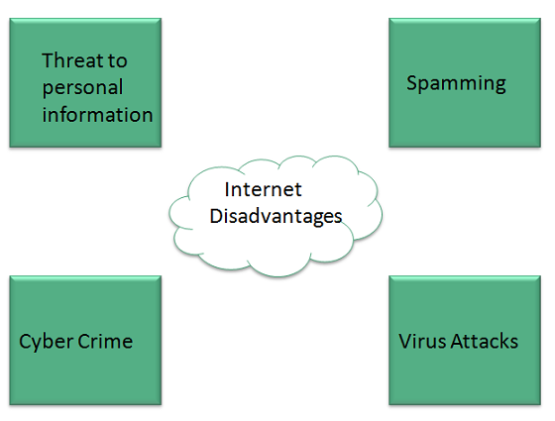

Figure 4.

* + - 1. *Threat to personal information.* There are always chances to loose personal information such as name, address, credit card number.

2) Another disadvantage is the *Spamming.* Spamming corresponds to the unwanted e-mails in bulk.

3) *Virus* can easily be spread to the computers connected to internet. Such virus attacks may cause your system to crash or your important data may get deleted.

4)*Cyber crime.* There are various websites that don’t provide the authenticated information. This leads to misunderstanding among many people. Also a biggest threat on internet is pornography.

**1.2 Internet Structure (architecture)**

The Internet is a worldwide network in which information is stored on servers (fig. 5).

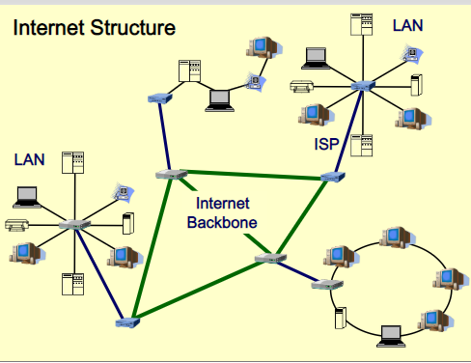

Figure 5.

**Servers** have their own addresses and are managed by specialized programs.  They allow you to send mail and files, search databases, etc. Information is exchanged between network servers via high-speed communication channels.

Access of individual users to Internet information resources is usually carried out over the telephone network through the provider or corporate network.

**ISP** **(Internet Service Provider)**. A **provider** is a certain organization that has a modem pool for connecting with customers and accessing the World Wide Web.

***Internet backbone***

The backbone network of the Internet - the main data transmission network between the huge, strategically interconnected networks and the main routers on the Internet.

*Data transmission network* is controlled by commercial, state, scientific and other high-performance centers, traffic exchange points and network access points that exchange Internet traffic between countries and continents.

Internet providers participate in the traffic exchange of the backbone Internet network through privately concluded network connection agreements, mainly on the basis of peering (agreement of Internet operators on the exchange of traffic between their networks, as well as technical interaction).

Dedicated telephone lines, fiber optic and satellite communication channels are used as a *high-speed data transmission line.*

Any organization to connect to the Internet uses a special computer called a *gateway*. It installs software that processes all messages passing through the gateway.

Each gateway has its own IP address. If a message arrives addressed to the local network to which the gateway is connected, then it is transmitted to this local network. If the message is for another network, it is forwarded to the next gateway.

Each gateway has information about all other gateways and networks. When a message is sent from a local network through a gateway to the Internet, the “fastest” way is selected. Gateways exchange routing information and network status with each other using a special *gateway protocol*.

**1.3 Internet Service Provider (ISP)**

Some companies may act as *providers*. The provider has its own gateway to the Internet and allows other companies and individual users to connect to the network through this gateway.

In addition to information about message routing, the gateway needs data on the parameters of subnets connected to a larger network in order to adjust message transmission routes in case of failures in certain parts of the network.

*Gateways are of two types: internal and external.* Gateways located in a small subnet and providing communication with a larger corporate network are called internal.

Such gateways communicate with each other using the internal gateway protocol *IGP (Internal Gateway Protocol).*

External gateways are used in large networks such as the Internet, their settings are constantly changing due to changes in small subnets.

Communication between external gateways is via the external gateway protocol *EGP (Exterior Gateway Protocol).*

There are different ***types of Internet Service Providers*** *- ISP:*

* Simply, the *Internet service provider* performs a transport function for end users - transferring their traffic to the networks of other Internet service providers;
* *Internet content provider* has its own information and reference resources, providing their content in the form of websites;
* The *hosting service provider* provides its premises, communication channels and servers for hosting external content;
* the *content delivery service provider* only delivers content to multiple access points in order to increase the speed of user access to information;
* an *application support service provider* give customers with access to large, universal software products, such as SAP R3;
* *the billing service provider* ensures the payment of bills on the Internet.

**1.4 Internet Addressing**

Three types of addresses are used to identify network interfaces:

* hardware addresses or MAC addresses or physical address;
* network addresses (IP addresses);
* symbol (domain) names.

**Hardware addresses or MAC addresses or physical** address is used to uniquely identify devices on the local network. It is recorded at the factory in the permanent (non-volatile) memory of the device, such as a network card or router

**Network addresses** **(IP addresses)**. The IP addressing system takes into account the structure of the Internet, that is, the Internet is a network of network, and not an association of individual computers.

The IP address consists of two parts, one of which is the network address, and the other is the address of the computer on the network. In the fourth version of the **Internet protocol v4**, the IP address consisted of four digits separated by periods: 123.123.34.56 (fig 6).

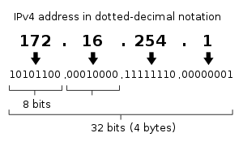

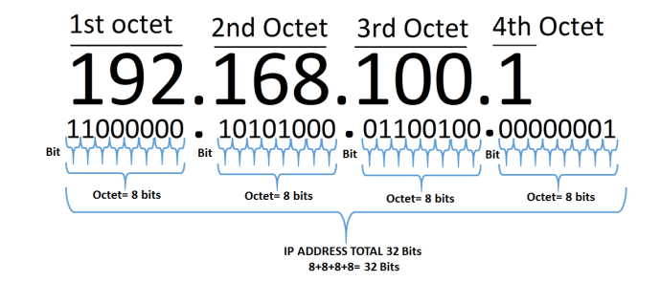

Figure 6.

Addresses are divided into three classes - A, B, C, depending on the number of networks of this class and the number of computers in the network. The first bits of the address are reserved for class identification, and the rest are divided into the network address and computer address (fig 7).

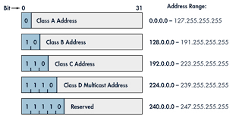

Figure 7.

In the sixth version of the **Internet protocol v6** (fig. 8), the IP address consists of 32 hexadecimal digits, separated by colons:

2091: 0db8: 0000: 0000: 0d00: ff50: 0092: 8378

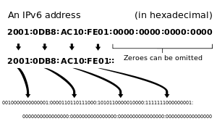

Figure 8.

That is, the end node can enter into several IP networks.

A **domain name** is a symbol registered for network addressing that uses the DNS - Domain Name System

A **domain name** is a symbolic name used to identify areas that are units of administrative autonomy on the Internet as part of a higher-level hierarchy of such an area. Each of these areas is called a ***domain*** [3, 4].

# 1.5 Internet Domain Name System (DNS)

**The Domain Name System (DNS)** is a hierarchical decentralized naming system for computers connected to the Internet [5].

Domain Name System DNS provides a match between the IP addresses of computers and the symbolic domain names (fig. 9).

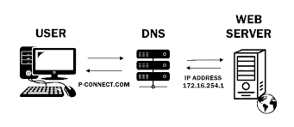

Figure 9.

The basis of DNS is the idea of a hierarchical structure of a domain name and a zone [6] (fig. 10).

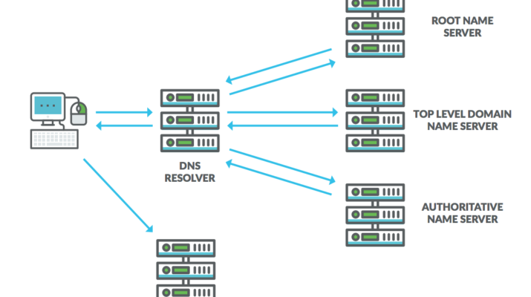

Figure 10.

**Domain Name System Architecture**

The domain name system includes domain names, domain names space, server name.

### Domain Names

Domain Name is a symbolic string associated with an IP address.

Domain names havea level structure, as you see in the figure 11.

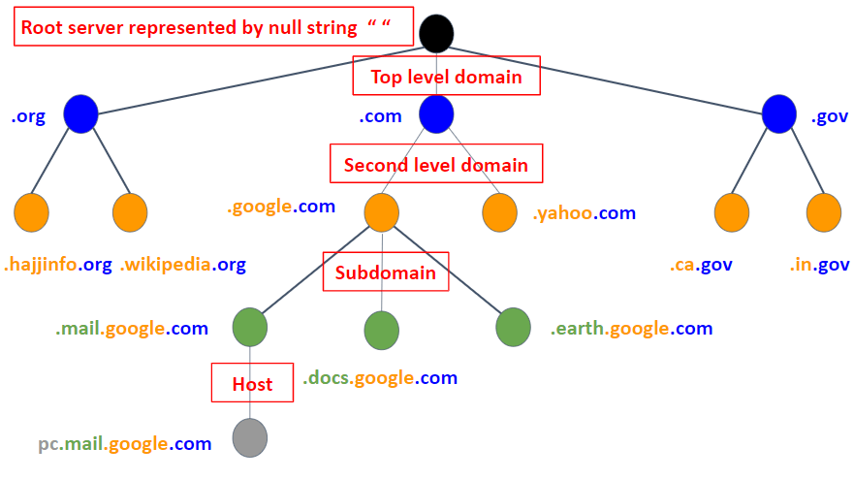

Figure 11.

Top-level domains can be of 2 types:

- generic  (administrative);

- geographical (country).

There are several domain names available; some of them are generic such as **com, edu, gov, net** etc, while some country level domain names such as **kz, ru,au, in, za, us** etc (fig. 12).

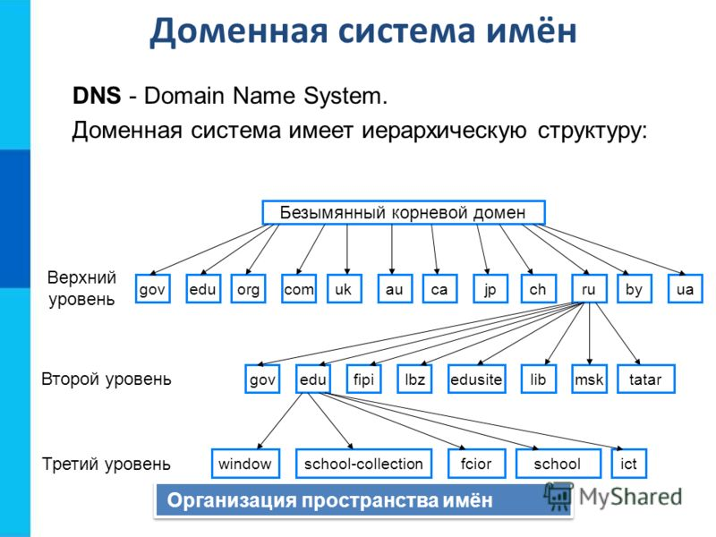

Third Level

Second Level

Top Level

ROOT

Figure 12.

The table 1 shows the *Generic Top-Level Domain names.*

Table 1.

|  |  |
| --- | --- |
| **Domain Name** | **Meaning** |
| Com | Commercial business |
| Edu | Education |
| Gov | U.S. government agency |
| Int | International entity |
| Mil | U.S. military |
| Net | Networking organization |
| Org | Non profit organization |

The table 2 shows the *Country top-level domain names.*

Table 2.

|  |  |
| --- | --- |
| **Domain Name** | **Meaning** |
| kz | Kazakhstan |
| ru | Russia |
| in | India |
| fr | France |
| us | United States |
| uk | United Kingdom |
| jp | Japan |
| es | Spain |
| de | Germany |
| ca | Canada |
| hk | Hong Kong |
| etc |  |

### Domain Name Space

The domain name space refers a hierarchy in the internet naming structure. This hierarchy has multiple levels (from 0 to 127), with a root at the top.

The figure 13 shows the domain name space hierarchy:

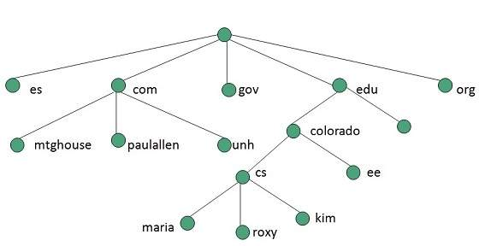

Figure 13.

In this diagram each subtree represents a domain. Each domain can be divided into sub domains and these can be further divided and so on.

### Name Server

Name Server contains the DNS database. This database comprises of various names and their corresponding IP addresses. Since it is not possible for a single server to maintain entire DNS database, therefore, the information is distributed among many DNS servers.

* Hierarchy of server is same as hierarchy of names.
* The entire name space is divided into the zones

### Zones

Zone is collection of nodes (sub domains) under the main domain. The server maintains a database called zone file for every zone (fig. 14).

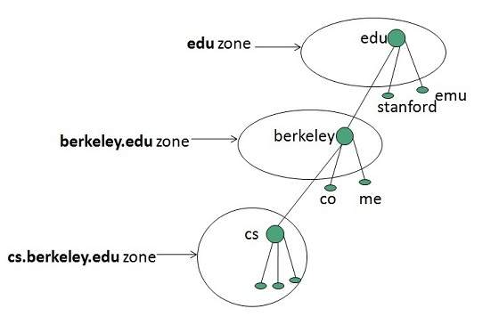

Figure 14.

If the domain is not further divided into sub domains then domain and zone refers to the same thing.

The information about the nodes in the sub domain is stored in the servers at the lower levels however; the original server keeps reference to these lower levels of servers [3, 6, 7].

**1.6 Protocol TCP /IP**

The Internet network, which is a network of networks and combining a huge number of different local, regional and corporate networks, functions and develops through the use of a single TCP/IP data transfer protocol.

TCP / IP includes two protocols:

• Transmission Control Protocol (TCP) - transport protocol;

• Internet Protocol (IP) - routing protocol.

The TCP/IP protocol ensures the transfer of information between network computers.

*Internet Protocol (IP)* - the routing protocol provides routing of IP packets, i.e. information delivery from the sending computer to the receiving computer.

*Transmission Control Protocol (TCP), i*.e. the transport protocol provides splitting files into IP packets during transmission and the assembly of files in the process of receiving [1-3].

## 1.7 Uniform Resource Locator (URL)

To indicate the addresses of Internet resources, apply **Uniform Resource Identifier** (**URI**) and **Uniform Resource Locator (URL).**

 Now the URL is positioned as part of a more general URI resource identification system. The URL standard is governed by the organization of the IETF and its departments.

*Uniform Resource Identifier (URI)* is a string of characters used to identify a resource.

A *URL* implies the means to access an indicated resource and is denoted by a protocol or an access mechanism, which is not true of every URI.

Thus *http://www.example.com* is an URL, while *www.example.com* is Uniform Resource Identifier (URI).

Most web browsers display the URL of a web page above the page in an address bar (fig. 15).

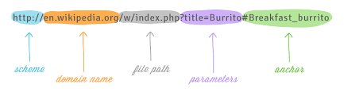

*These elements are optional*

Figure 15.

A typical URL could have the form *http://www.example.com/index.html*, which indicates a protocol (scheme) (*http*), a hostname (domain name) (*www.example.com*), and a file name (*index.html*).

For example, [*www.tutorialspoint.com/*](http://www.tutorialspoint.com/) *internet\_technology/ index.html* is an URL to the index.html which is stored on *tutorialspoint* web server under *internet\_technology* directory.

For example, *http:// www.tutorialspoint.com/ internet\_technology /index.htm,* where:

* *http* is the protocol (scheme);
* *tutorialspoint.com* is the domain name;
* *index.htm* is the file patch (resource address).

The *protocol part* tells the web browser how to handle the file. Similarly, we have some other protocols also that can be used to create URL are:

* FTP;
* https;
* Gopher;
* mailto;
* news.

Such URL locators are a combination of a URI and a DNS system.

The domain name (or IP address) is part of the URL to indicate the computer (its network interface) on which the web server program runs [2, 3, 7].

On the client computer to view information received from the web server, a special program is used a web browser. The main function of the web browser is the display of hypertext pages (web pages). To create hypertext pages on the WWW, HTML was originally used. A lot of web pages form a website.

**1.8 Ways to connect to the Internet**

**Home and Small Office Internet Connections**

The figure 16 illustrates common connection options for small office and home office users [8]:

* **Cable** - Typically offered by cable television service providers, the Internet data signal is carried on the same cable that delivers cable television. It provides a high bandwidth, always on, connection to the Internet;

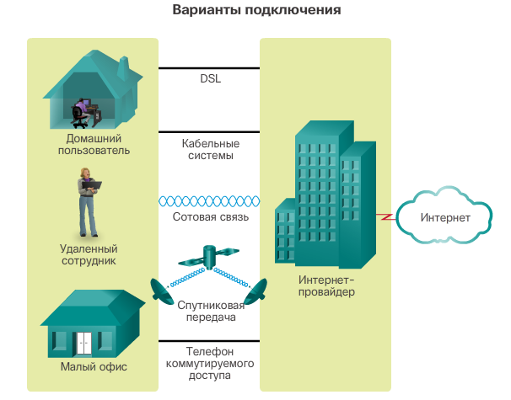

Figure 16.

* **DSL** - **Digital Subscriber Lines** provide a high bandwidth, always on, connection to the Internet. DSL runs over a telephone line. In general, small office and home office users connect using Asymmetrical DSL (ADSL), which means that the download speed is faster than the upload speed;
* **Cellular** - Cellular Internet access uses a cell phone network to connect. Wherever you can get a cellular signal, you can get cellular Internet access. Performance will be limited by the capabilities of the phone and the cell tower to which it is connected;
* **Satellite** - The availability of satellite Internet access is a real benefit in those areas that would otherwise have no Internet connectivity at all. Satellite dishes require a clear line of sight to the satellite;
* **Dial-up Telephone** - An inexpensive option that uses any phone line and a modem. The low bandwidth provided by a dial-up modem connection is usually not sufficient for large data transfer, although it is useful for mobile access while traveling.

Many homes and small offices are more commonly being connected directly with fiber optic cables. This enables an ISP to provide higher bandwidth speeds and support more services such as Internet, phone, and TV.

The choice of connection varies depending on geographical location and service provider availability.

**Businesses Internet Connections**

Corporate connection options differ from home user options. Businesses may require higher bandwidth, dedicated bandwidth, and managed services. Connection options available differ depending on the type of service providers located nearby.

The figure 17 illustrates common connection options for businesses:

* **Dedicated Leased Line** - Leased lines are actually reserved circuits within the service provider’s network that connect geographically separated offices for private voice and/or data networking. The circuits are typically rented at a monthly or yearly rate. They can be expensive.

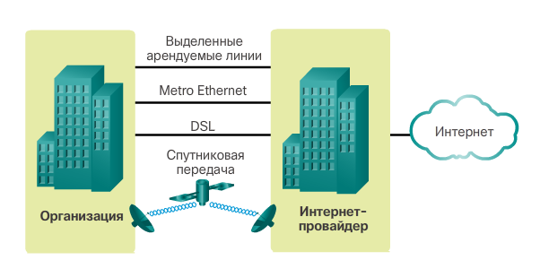

Figure 17.

* **Ethernet WAN** - Ethernet WANs extend LAN access technology into the WAN. Ethernet is a LAN technology you will learn about in a later chapter. The benefits of Ethernet are now being extended into the WAN.
* **DSL** - Business DSL is available in various formats. A popular choice is Symmetric Digital Subscriber Lines (SDSL) which is similar to the consumer version of DSL, but provides uploads and downloads at the same speeds.
* **Satellite** - Similar to small office and home office users, satellite service can provide a connection when a wired solution is not available.

The choice of connection varies depending on geographical location and service provider availability.

**1.9 Internet Services**

## Communication Services:

* *E-mail* used to send electronic message over the internet;
* *Teleconferencing* or newsgroups (Usenet), Offers a forum for people to discuss topics of common interests;
* *Telnet service*, designed to manage remote computers in terminal mode;
* *IRC service* allows the people from all over the world to communicate in real time (chat).

E-Mail works on the basis of protocols. E-mail Protocols are set of rules that help the client to properly transmit the information to or from the mail server.

SMTP stands for Simple Mail Transfer Protocol. It was first proposed in 1982. It is a standard protocol used for sending an e-mail efficiently and reliably over the internet.

IMAP stands for Internet Mail Access Protocol.

POP stands for Post Office Protocol. It is generally used to support a single client.

## Information Retrieval Services

**Service FTP** - the system of file archives, providing storage and transfer of files of various types.

**Streaming multimedia**

**World Wide Web** (WWW, W3, "World Wide Web") - hypertext (hypermedia) system, designed to integrate various network resources into a single information space;

The services listed above are standard. There are also non-standard services, which represent the original development of a particular company. As an example, we can cite various systems such as Instant Messenger (idiosyncratic Internet pagers - ICQ, AOL, etc.), Internet telephony systems, broadcasts of radio and video, etc. E-commerce, VoIP [1-3].

# Search Engines in Web

A search engines work on the basis of:

* Indexing  - Search engine indexing ( web indexing) collects, parses, and stores data to facilitate fast and accurate information retrieval for thematic;
* Web crawling - sometimes called a spider, is an Internet bot that systematically browses the World Wide Web, typically for the purpose of Web indexing (web spidering) [1].

**Reference**

1. Randy Connolly, Ricardo Hoar. Fundamentals of Web Development. – Pearson, 2015.

2. [Шевчук Е.В.](http://webirbis.ksu.kz/cgi-bin/irbis64r_12/cgiirbis_64.exe?LNG=&Z21ID=&I21DBN=IBIS&P21DBN=IBIS&S21STN=1&S21REF=1&S21FMT=full%3Cb%3E%3Cfont%20color=red%3Eweb%3C/font%3E%3C/b%3Er&C21COM=S&S21CNR=20&S21P01=0&S21P02=1&S21P03=A=&S21STR=%D0%A8%D0%B5%D0%B2%D1%87%D1%83%D0%BA%20,%20%D0%95.%20%D0%92.)  Information and Communication Technologies: учебно-методическое пособие. - Алматы: CyberSmith, 2017. - 107 p.

3. Learn Internet Technology: Internet Technology// <https://www.tutorialspoint.com/internet_technologies/internet_quick_guide.htm>

4. Evangeline Bishop. [Networking](http://docplayer.net/34387528-Networking-chapter-1-exploring-the-network.html)// <http://docplayer.net/34387528-Networking-chapter-1-exploring-the-network.html>

5. Система DNS// <https://performanceconnectivity.com/dns/>

6. <http://www.businessrole.net/business-ideas/benefits-of-dns-monitoring-to-a-business.html>

7. Система DNS// <https://lecturesclub.com/what-is-internet-domain-name-system/>

# Theme 2. The structure of Web technologies

# Plan

# 1 Basic concepts World Wide Web

# 2 The main components of WWW technology

# 2.1 HTML - HyperText Markup Language.

# 2.2. URL - Uniform resource locator

# 2.3 HTTP hypertext information exchange protocol

# 2.4 Universal interface of CGI gateways

# 3. Client-Server Web Technologies

# 4. The Hypertext Transfer Protocol – HTTP

# 5. Securing the HTTP data transmission

# 6. Cookie mechanism

**2.1 Basic concepts World Wide Web**

# World Wide Web, WWW is also known as W3. It offers a way to access documents spread over the several servers over the internet. These documents may contain texts, graphics, audio, video, hyperlinks. The hyperlinks allow the users to navigate between the documents.

A technical definition of the World Wide Web is all the resources and users on the Internet that are using the Hypertext Transfer Protocol (HTTP).

The World Wide Web is a way of exchanging information between computers on the Internet, tying them together into a vast collection of interactive multimedia resources.

**Internet** and **Web** is not the same thing: Web uses internet to pass over the information.

**WWW** works on client-server approach.

# There are the main components of WWW technology:

# 1) HTML - HyperText Markup Language. HTML includes a set of commands used to describe the structure of a document. With the help of HTML, a document is divided into corresponding logical components: paragraphs, headings, lists, etc.

# The specific formatting attributes of the document (the main text and the selected components) when viewing it are determined by the browser used.

# Examples of browsers are:

# Mosaic for Windows (1993);

# Microsoft Internet Explorer (MS IE) (1995) Written in: C ++;

# Netscape Navigator (Netscape company, 1994-2007);

# Opera (1995);

# Mozilla FireFox (2002);

# Google Chrome (2008);

# Microsoft Edge - Fast Browser for Windows 10 (2015).

# 2) URL - Uniform resource locator is a universal way of addressing resources on a network, i.e. provides addressing (links) to Internet information resources. Each Internet resource has its own location identifier, or URL (Uniform Resource Locator).

# 3) HTTP hypertext information exchange protocol. HTTP protocol by which the client and the WWW server interact. This protocol is intended for the exchange of hypertext documents and takes into account the specifics of such an exchange.

# 4) Universal interface of CGI gateways used to organize a dialogue with the user. CGI was specifically designed to expand WWW capabilities by connecting all kinds of external software.

# Programs use CGI to receive information from the user (via the HTTP protocol), to process it and send it back as a new HTML document. If necessary, the CGI program accesses the DBMS or other software systems running on the server [2, 10, 11].

# 2.2 Client-Server Web Technologies

# WWW works on client-server approach. The basic protocol for the Web Network is HTTP protocol. It is based on client-server interaction, that is, it is assumed that:

# The consumer-client, initiating a connection with the provider-server, sends him a request.

# The server provider, upon receipt of the request, performs the necessary actions and returns a response with the result back to the client (fig. 18).

# 

# Figure 18.

# In this case, there are two ways to organize the work of the client computer:

# A *Thin client* is a client computer that transfers all information processing tasks to a server. An example of a thin client is a computer with a browser that is used to work with web applications.

# A *Thick client,* on the other hand, processes information independently of the server, uses the latter mainly only for data storage.

# WWW works on the principle of client-server*: there are many servers that, upon client's request, return a hypermedia document to him* - a *Web-resources* consisting of parts with a diverse representation of information (text, sound, graphics, three-dimensional objects, etc.), *in which each element may be a reference to another document or part thereof (*hyper links*)*.

## *Web-resources,* for example, Web page is a document available on World Wide Web. Web Pages are stored on web server and can be viewed using a web browser.

# WWW links point not only to documents specific to the WWW itself, but also to other Internet services and information resources.

# Moreover, most WWW client programs (browsers, navigators) not only understand such links, but are client programs of the corresponding services: ftp, gopher, Usenet network news, email, etc. Thus, WWW software is universal for various Internet services, and the WWW information system itself plays an integrating role

**Web server** is a computer where the web content is stored. Basically web server is used to host the web sites but there exist other web servers also such as gaming, storage, FTP, email etc.

# A web server is a computer connected to the Internet that runs a special program, also called a web server. The tasks of this program include the storage, retrieval and distribution of certain files.

# A Web client is a browser requesting files from the Web. When the client computer wants to access one of the files, the request is sent to the Web server, in the zone of responsibility of which this file falls. The server searches for the specified file and sends it to the client computer that sent the request.

# Client-Web server interaction diagram

# When a request is received from Web clients, the Web server program runs on the server computer and processes requests.

# The interaction between the Web client and the Web server is carried out in accordance with the HTTP protocol (fig. 19) [11, 13].

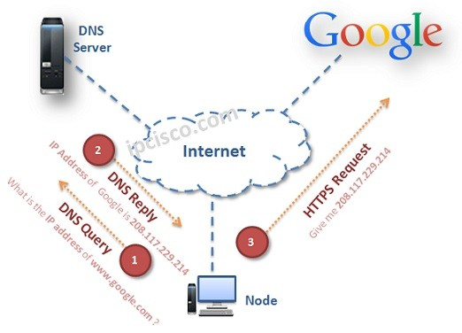

# Figure 19.

# When a request is received from the web client, the web server provides TCP/IP communication and exchanges information in accordance with the HTTP protocol.

# When requesting secure information, the web server may use an identity certificate and password. Protected web documents are provided only if users have the appropriate access rights.

# Processing a request from a web client (fig. 20).

# 

# 

# 

# Figure 20.

# Many web servers are integrated with databases. At the same time, the information stored in such databases becomes available to visitors to the server, taking into account access rights.

# The interaction of the browser with the DBMS server can be carried out in two main ways [11, 14]:

# - access to the DBMS server through the Web server;

# - access to the DBMS server directly (fig. 21).

# Client Server Communication

# Figure 21.

# One of the main features of Web-technologies is distributed information processing based on migrating programs.

# 2.3 The Hypertext Transfer Protocol HTTP

# The interaction between the Web client and the Web server is carried out in accordance with the HTTP. Web documents received by the navigator from the Web server are text files written in HTML.

# Management in HTTP is implemented as ASCII commands. To access this or that page, the user must specify its URL address to the browser program.

# The browser establishes a connection to the server using the HTTP protocol, then the page starts loading from the server, after which the connection is disconnected.

# The accepted Web-page is displayed in a browser window. HTTP (HyperText Transfer Protocol - RFC 1945, RFC 2616) is an application layer protocol for transmitting hypertext.

# Central to HTTP is the resource that the URI points to in a client request. Typically, these resources are files stored on the server.

# A feature of the HTTP protocol is the ability to specify in the request and response a way of representing the same resource in various parameters: format, encoding, language, etc.

# It is thanks to the possibility of specifying the method of encoding the message that the client and server can exchange *binary data*, although initially this protocol was designed to transmit symbolic information.

# Unlike many other protocols, HTTP is a memory*less* protocol. This means that the protocol does not store information about previous client requests and server responses.

# *Components using HTTP can independently store state information associated with recent requests and responses.* For example, a client web application sending requests can track response delays, and a web server can store the IP addresses and request headers of recent clients.

# All software for working with the HTTP protocol is divided into three main categories:

# *1.* *Servers* are providers of information storage and processing services (request processing).

# *2. Clients* - end users of server services (sending requests).

# *3. Proxies* to support the work of transport services.

# *The "classic" scheme of an HTTP session looks like this:*

# establish a TCP connection;

# customer request;

# server response;

# break TCP connection.

# Thus, the client sends a request to the server, receives a response from it, after which the interaction ceases. Typically, a client request is a request to submit an HTML document or some other resource, and the server response contains *the code for this resource.*

# *The HTTP request* sent by the client to the server includes the following components (fig. 22).

# status bar (sometimes the terms string-status or query string are also used to denote it);

# header fields;

# empty line;

# request body;

# the status bar, along with the header fields, is sometimes called the request header.

Customer request

Headline

Empty line

Request body

Status bar

# Header fields

Request method

Resource URL

Protocol version

HTTP

# Figure 22.

# HTTP is used in other application-level protocols, as well as for transferring from the server to the client any objects: images, scripts, CSS-files, data files.

# It also works in the opposite direction - to upload files to the server, submit forms, etc. There are similar protocols to HTTP, such as FTP and SMTP. To identify resources, the HTTP protocol uses global URLs.

# HTTP does not maintain its state between request-response pairs. HTTP components can store information. For example, cookies are stored on the client side, and sessions on the server side. The browser, in turn, can track response delays, and the server stores the IP addresses of client requests.

# 2.4 Securing the HTTP data transmission

# HTTP protocol is designed to transmit character data in an open (unencrypted) form. There are a number of extensions of the basic HTTP protocol aimed at increasing the security of Internet traffic from unauthorized access.

# The HTTPS protocol is an extension of the HTTP protocol in which data is "packed" into the cryptographic protocol SSL or TLS, providing protection for this data.

# SSL (Secure Sockets Layer) is a cryptographic protocol that provides secure data transfer over the Internet. Using it creates a secure connection between the client and server.

# SSL was originally developed by Netscape Communications. Based on the SSL 3.0 protocol, the RFC standard, called TLS was developed and adopted.

# TLS protocol uses public key encryption to authenticate the transmitter and receiver. TLS protocol supports reliable data transmission through the use of corrective codes and secure hash functions. For SSL to work, it requires an SSL certificate on the server [3].

# 2.5 Cookie mechanism

# The cookie mechanism allows the server to store information on the client’s computer and retrieve it from there.

# Cookies (literally - cookie) - a small piece of data sent by the web server and stored on the user's computer.

# A web client (usually a web browser) each time you try to open the page of the corresponding site sends this piece of data to the web server as part of an HTTP request.

# Cookies is used:

# to save data on the user side;

# user authentication;

# storage of personal preferences and user settings;

# tracking the status of the user's access session;

# user statistics information.

# Browser support for cookies (receiving, saving and subsequent sending to the server saved cookies) requires many sites with access restrictions, most online stores.

# Customization of the design and behavior of many websites to individual user preferences is also based on cookies.

**Reference**

1. Randy Connolly, Ricardo Hoar. Fundamentals of Web Development. – Pearson, 2015.

2. [Шевчук Е.В.](http://webirbis.ksu.kz/cgi-bin/irbis64r_12/cgiirbis_64.exe?LNG=&Z21ID=&I21DBN=IBIS&P21DBN=IBIS&S21STN=1&S21REF=1&S21FMT=full%3Cb%3E%3Cfont%20color=red%3Eweb%3C/font%3E%3C/b%3Er&C21COM=S&S21CNR=20&S21P01=0&S21P02=1&S21P03=A=&S21STR=%D0%A8%D0%B5%D0%B2%D1%87%D1%83%D0%BA%20,%20%D0%95.%20%D0%92.)  Information and Communication Technologies: учебно-методическое пособие. - Алматы: CyberSmith, 2017. - 107 p.

3. Learn Internet Technology: Internet Technology// <https://www.tutorialspoint.com/internet_technologies/internet_quick_guide.htm>

4. Evangeline Bishop. [Networking](http://docplayer.net/34387528-Networking-chapter-1-exploring-the-network.html)// <http://docplayer.net/34387528-Networking-chapter-1-exploring-the-network.html>

5. Система DNS// <https://performanceconnectivity.com/dns/>

6. <http://www.businessrole.net/business-ideas/benefits-of-dns-monitoring-to-a-business.html>

7. Система DNS// <https://lecturesclub.com/what-is-internet-domain-name-system/>

8. <https://artemsannikov.ru/cisco/ccnars/> CCNA: Introduction to Networks

9.<http://shodhganga.inflibnet.ac.in:8080/jspui/bitstream/10603/253062/9/09_chapter1.pdf>

10. Client-Server Technologies in a Web-Based Application// <https://www.101computing.net/client-server-technologies-in-a-web-based-application/>

11. Client Server Computing// <https://www.tutorialspoint.com/Client-Server-Computing>

12. Грамотная клиент-серверная архитектура: как правильно проектировать и разрабатывать web API

//<https://tproger.ru/articles/web-api/>

13. <https://ipcisco.com/lesson/domain-name-system-overview/>

14. Smart IOT// <http://www.smartiot.at/check-webserver-downtime/>

**Theme 3. Web applications**

# Plan:

# 1 Web applications concept

# 1.1Programs running on the client machine

# 1.2. Programs running on the server

# 2. Types of Web Applications

# 3. Web applications - migratory programs

# 3.1 Java technology

# 3.2 Scripting Technologies

# 3.3 ActiveX Technologies

# 4 Access Relational Databases

# 4.1 Access to the DBMS server through the Web server

# 4.2 Access to the DBMS server directly

# Web applications concept

# Web application - provides the generation of HTML-pages on the fly depending on the user's request. Email clients, social networks, search engines, online stores, online business programs, these are all web applications.

# The Web application is an application in which the client is a browser, and the server is a web server. The result of the web application is the web page displayed in the browser window. In this case, the Web application itself can run on both the client computer and the server computer.

# 3.1 Programs running on the client machine

# There are programs running on the client machine:

# 1) Static HTML Pages.

# 2) JavaScript scripts - a type of program designed to run on a client computer.

Static web pages are also known as flat or stationary web page. They are loaded on the client’s browser as exactly they are stored on the web server. Such web pages contain only static information. User can only read the information but can’t do any modification or interact with the information.

Static web pages are created using only HTML. Static web pages are only used when the information is no more required to be modified (fig. 23).

# internet_technologies_tutorial

# Figure 23.

# Scripts are separate sequences of actions created for automatic task execution. The source text of the script is part of the web page, so the JavaScript script is passed to the client along with the document in which it is included.

# When processing an HTML document, the browser detects the source text of the script and launches it for execution.

# To all programs that are transferred from the server to client machines and run for execution, one general requirement is presented: these programs should be prevented from accessing the resources of the computer on which they are running. This requirement is fully justified.

# After all, sending over the network and launching Java applets and JavaScript scripts is automatic without user intervention, so the work of these programs should be absolutely safe for the computer. In other words, the languages intended for creating programs running on the client machine must be completely unsuitable for writing viruses and similar programs.

# 3.2. Programs running on the server

# The code of the program running on the server is not transmitted to the client.

# When receiving a special request from the client, assuming the execution of such a program, the server starts it and passes the parameters included in the query.

*Dynamic web page* shows different information at different point of time. It is possible to change portions of a web page without loading the entire web page. It has been made possible using Ajax technology.

#### Server-side dynamic web page is created by using server-side scripting. There are server-side scripting parameters that determine how to assemble a new web page which also include setting up of more client-side processing.

#### Client-side dynamic web page is processed using client side scripting such as JavaScript. And then passed in to Document Object Model (DOM).

# The program prepares the results of its work in the form of an HTML document and passes it to the web server, and the latter, in turn, supplements the received data with an HTTP header and passes them to the client.

# To expand the capabilities of client-server interaction via the HTTP protocol, you can develop applications, plug-ins and scripts that expand the capabilities of the server - on the side of the web server (fig. 24).

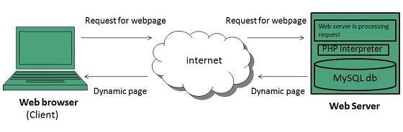

# Figure 24.

# *Plug-in* is an independently compiled program module dynamically connected to the main program, designed to expand or use its capabilities. Usually executed as shared libraries.

# *Script* is a program that automates some task that a user performs manually using program interfaces.

# *Server Scripts* are executed on the server before sending the web page to the user (written in PHP, Perl, Visual Basic, Java, Ruby or Python)

# *Web service* is a software system that has a URI identifier, and whose public interfaces are defined in the XML language.

# A web service is a unit of modularity when using a service-oriented application architecture [3, 4, 11].

# 3.3 Types of Web Applications

# Web applications can be divided into several types, depending on different combinations of its main components.

# 1. Backend (backend or server side of the application) runs on a remote computer, which can be located anywhere. It can be written in different programming languages: PHP, Python, Ruby, C# and others.

# If you create an application using only the server side, then as a result of any transitions between sections, form submissions, data updates, the server will generate a new HTML file and the page in the browser will reload.

# 2. Frontend (frontend or client part of the application) is executed in the user's browser. This part is written in the Javascript programming language.

# An application can consist only of a client part if it is not required to store user data for longer than one session. It can be, for example, photo editors or simple toys.

# 3. Single page application (SPA or single page application). A more interesting option is when both the backend and frontend are used. Using their interaction, you can create an application that will work without any page reloads in the browser.

# Or in a simplified version, when transitions between partitions cause reboots, but any actions in the partition do without them.

# 4. Python framework Django aka backend. A framework is a set of ready-made libraries and tools that help you create web applications.

# 5. Javascript frameworks aka frontend: Backbone Marionette, Angular, React, Vue and others.

# The client part of the application is scripts written in the Javascript (JS) programming language and executed in the user's browser.

# 3.4 Web applications - migratory programs

# The navigation program (browser) executed on the workstation performs the following actions:

# - visualizes (displays) Web pages and perform transitions to other resources

# - activate programs on the server

# - interprets and launches programs related to the Web-document, which are transmitted along with this document from the server.

# This type of distributed information processing allows you to concentrate the entire application system directly on the server.

# There are three main types of programs that can be associated with a Web document and transferred to a workstation for execution:

# - *Java applets* prepared and used using Java technology;

# - *Programs written in the scripting language* JavaScript, VBScript, VRML;

# - *software components ActiveX Controls*, relevant ActiveX technology.

# The presence of several varieties of migratory programs is explained by their various capabilities, as well as competition between the leading corporations in the field of software and network technologies - corporations Sun Microsystems, Netscape, Microsoft and others

# In addition to these, there are a number of other Web technologies:

# - CGI technology (Common Gateway Interface) - the use of interactive elements based on applications that provide the transfer of data flow from one object to another as part of the Internet resource.

# CGI technology is usually implemented by two methods: either using programs written in the PERL language, or using applications created usually using the C language and compiled directly on the server.

# - SSI (Server Side Includes) technology - a technology closely intertwined with CGI technology, allows you to include server files in pages, as well as set and use the values ​​of some parameters.

# - CSS technology (Cascading Style Sheets) - cascading style sheets are used to centralize the appearance of pages.

# - PHP (Personal Home Page Tools) - an interpreted language designed to make elements of a Web page interactive.

# - ASP (Active Server Page) - active server pages, i.e. the script is interpreted and executed directly on the server, after which a ready-made html-document with the results of the ASP script is sent to the user browser.

# - Flash - allows you to create animated images, screensavers. A special programming language is built into the Flash environment. The program modules written with its help are imported into the document as applets and inserted into the desired frame of the animation, where the image should be dynamically changed.

# - DHTML (Dynamic Hyper Text MakeUP Language) is an extension of the HTML standard and allows you to create Web documents that include interactive elements: a moving background, drop-down menus, buttons, etc.

# 3.4.1 Java technology

# Java technology was developed by Sun Microsystems in the early 90s due to the need to develop in computer programs oriented to use in a network environment and integration with a Web service.

# Such programs were initially presented with mobility requirements, implying independence from hardware and operating platforms, as well as the security and reliability of information processing.

# As a result, the Java programming language was developed, as well as a holistic technology for creating and using mobile programs, called Java technology.

# The Java language is a simple object-oriented programming language built on the basis of the C ++ language.

# A virtual Java processor provides an environment for executing Java programs.

# Translated Java programs designed to run on a workstation in a Web navigator environment are called Java applets or simply applets.

# In its structure, each applet is a small program in which several mandatory functions should be defined. The applet is downloaded over the network from the server and executed in the Web navigator environment (fig. 25). References to applets are located in Web documents, but applets are not directly part of Web documents. They are stored in separate files on the server.

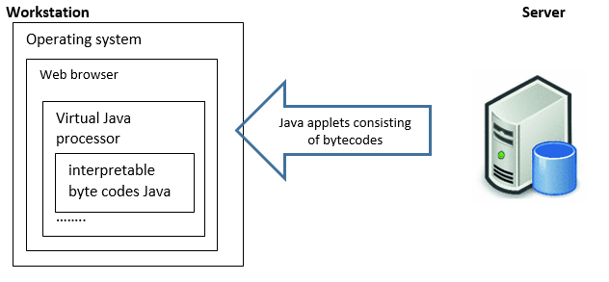

# Figure 25. Scheme of transfer and execution of machine-independent Java programs

# The independence of Java bytecodes from the hardware and operating platforms is achieved by the software implementation for each of these platforms only a virtual Java processor, which is designed to interpret applets.

# 3.4.2 Scripting Technologies

# In parallel with powerful Java technology, technologies for creating and using migrating programs based on the use of scripting languages appeared.

# The most important difference between such technologies and Java technology is the command-based interpretation of the source code of programs.

# The interpretation function of mobile programs written in a scripting language is assigned to the Web browser

# Scripting languages are often referred to as scripting languages (script - сценарий) or macro languages.

# The main representatives of scripting languages for writing migratory programs include:

# - JavaScript, developed jointly by Netscape and Sun Microsystems, as well as its similar language VBScript (Visual Basic Scripting) from Microsoft;

# - VRML (Virtual Reality Modeling Language) developed by Silicon Graphics.

# JavaScript is a simplified interpreted language with basic object-oriented features.

# The simplicity property is explained by the lack of a rigid type architecture and semantics.

# Object-oriented orientation is manifested in the possibilities of working with windows, the status bar, and other elements of the Web browser interface and network environment as objects in a hierarchy that can be accessed by name.

# JavaScript is poorer than the Java language, but much more convenient and efficient for a number of tasks related to processing Web documents and interacting with the user when viewing it. It has a large number of built-in functions and commands. Programs written using JavaScript can display dialog boxes, perform mathematical calculations, play various audio and video files, receive new documents, process clicks on buttons in forms, and much more.

# Using JavaScript, you can also set the attributes and properties of Java binary libraries, as well as plug-ins connected to a Web browser.

# JavaScript commands are embedded directly into the Web page and are executed by the Web browser during the loading of this page or during certain actions performed by the user when working with it

# The disadvantages of JavaScript technology include the low speed of JavaScript programs, which is an integral attribute of all interpreted programming languages.

# Microsoft's VBScript (Visual Basic Scripting) language is much like JavaScript. It is a subset of the Visual Basic language and is also intended for programming Web pages.

# Using it, you can make various objects interact on a Web page, including other types of software components, such as Java applets and ActiveX Controls software components.

# Unlike JavaScript and VBScript macro languages, the VRML language was developed by Silicon Graphics Corporation specifically to create interpreted programs that simulate three-dimensional virtual worlds. VRML interpreters are most often connected to web browsers as separate plug-ins. The source texts of VRML programs are drawn up as a separate VRML file and are called by reference from a Web document when viewed by a Web browser. Clicking on such a link leads to the opening of a separate window, allowing you to walk through a fragment of three-dimensional reality located in it.

# 3.4.3 ActiveX Technologies

# ActiveX refers to a set of technologies from Microsoft aimed at supplementing, integrating, and standardizing existing methods for presenting and processing information in computer networks built using a Web architecture.

# The main idea of ActiveX-technologies is to use the same method of access to all information resources of the network (fig. 26).

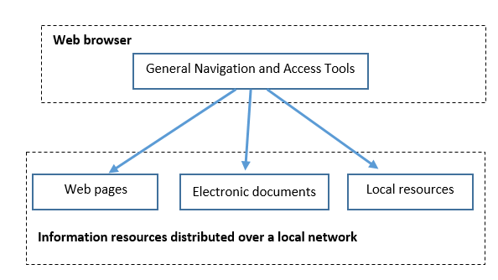

# Figure 26. Scheme of uniform access to network information resources

# ActiveX provides not only the development and execution of mobile programs, but also the implementation of a number of additional features, for example, calling from the Web browser functions to view and edit Word, Excel and Power-Point documents. ActiveX provides a set of API functions (Application Program Interface), implemented both for the client and for the server.

# ActiveX supports the following types of mobile programs that can be associated with a Web document and transferred to a workstation for execution (fig. 27):

# - software components ActiveX Controls;

# - Java applets;

# - Programs written in the scripting languages ​​JavaScript, VBScript (Visual Basic Scripting) and VRML.

# 

# Figure 27. Software migration in ActiveX technology

# Interaction of the IIS Web server with other applications, for example, with a database management system (DBMS), is provided due to the ISAPI (Internet Server API) and CGI (Common Gateway Interface) interfaces implemented in it.

# ActiveX Controls software components are regular executable programs that can be downloaded from a server for execution on a workstation. As with Java applets, links to these programs are located in Web documents [10-12].

# 3.4 Access Relational Databases

# In the client-server architecture based on Web technology, the Web server delivers information from various sources, and then using the Web browser provides it to the user.

# Direct integration of heterogeneous information is performed during the visualization and interpretation of Web documents, which is implemented by the Web navigator when interacting with the Web server, as well as other servers for providing information resources.

# The interaction of the Web browser with the database management system server (DBMS server) can be carried out in two main ways:

# - access to the DBMS server through the Web server;

# - access to the DBMS server directly.

# 3.4.1. Access to the DBMS server through the Web server

# To access the Web navigator to the DBMS server through the Web server, a system of software gateways is used (fig. 28)

# Upon receiving a request from a Web server, the software gateway acts as an intermediary between the Web server and the DBMS server.

# Software gateways are developed in accordance with certain standards that define how the Web server calls application programs or functions of dynamic libraries, as well as how to exchange information with these program objects.

# One of the most common standards of this type is the CGI (Common Gateway Interface), as well as its advanced specification, called FastCGI (Accelerated CGI).

# To access the Web browser to the DBMS server via the Web server according to the CGI standard, a CGI program is required that acts as a software gateway between the Web server and the DBMS server

# CGI applications work independently of the Web server, and they are launched by calling from a Web document when it is processed by a Web browser.

# The CGI program interacts with the Web server through a two-way exchange of environment variables through the standard input / output channels of this application.

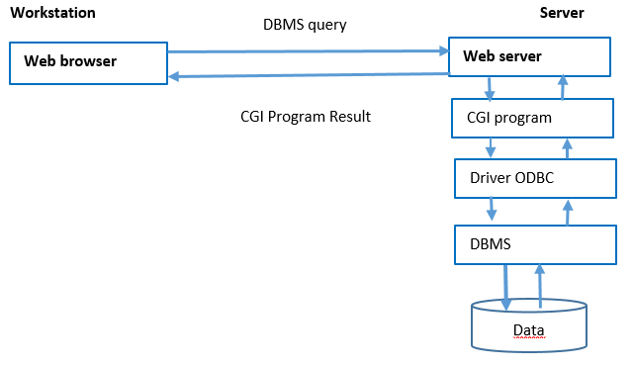

# Figure 28. DBMS access scheme via CGI program

# APIs and FastCGI

# In order to circumvent the problems associated with the speed of CGI, *application programming interfaces* (APIs) have been developed.

# Microsoft has developed the ISAPI (Internet Server API), and Netscape has developed the NSAPI (Netscape Server API).

# These interfaces are tightly integrated with the Web server, allowing you to maintain the availability of constantly used processes and data. Programs with the ISAPI interface are compiled into files of dynamically connected DLLs.

# 3.4.2 Access to the DBMS server directly

# To access the Web browser to the DBMS server, both Java applets and ActiveX Controls software components and specialized plug-ins connected to the browser can be used directly.

# To use Java applets to access various DBMS servers, a standard JDBC (Java DataBase Connectivity) interface has been developed (fig. 29).

# 

# Figure 29. DBMS access scheme using Java applet via JDBC interface

# The access of the Web browser to the DBMS server using the ActiveX Controls software components (fig. 30) implies, as in the case of Java applets, requesting, transferring, and executing the program on the workstation.

# In this case, interaction with the DBMS server should be performed through the ODBC interface.

# 

# Figure 30. DBMS Access Scheme Using ActiveX Controls Software Component

**Reference**

1. Randy Connolly, Ricardo Hoar. Fundamentals of Web Development. – Pearson, 2015.

2. [Шевчук Е.В.](http://webirbis.ksu.kz/cgi-bin/irbis64r_12/cgiirbis_64.exe?LNG=&Z21ID=&I21DBN=IBIS&P21DBN=IBIS&S21STN=1&S21REF=1&S21FMT=full%3Cb%3E%3Cfont%20color=red%3Eweb%3C/font%3E%3C/b%3Er&C21COM=S&S21CNR=20&S21P01=0&S21P02=1&S21P03=A=&S21STR=%D0%A8%D0%B5%D0%B2%D1%87%D1%83%D0%BA%20,%20%D0%95.%20%D0%92.)  Information and Communication Technologies: учебно-методическое пособие. - Алматы: CyberSmith, 2017. - 107 p.

3. Learn Internet Technology: Internet Technology// <https://www.tutorialspoint.com/internet_technologies/internet_quick_guide.htm>

4. Evangeline Bishop. [Networking](http://docplayer.net/34387528-Networking-chapter-1-exploring-the-network.html)// <http://docplayer.net/34387528-Networking-chapter-1-exploring-the-network.html>

5. Система DNS// <https://performanceconnectivity.com/dns/>

6. <http://www.businessrole.net/business-ideas/benefits-of-dns-monitoring-to-a-business.html>

7. Система DNS// <https://lecturesclub.com/what-is-internet-domain-name-system/>

8. <https://artemsannikov.ru/cisco/ccnars/> CCNA: Introduction to Networks

9.<http://shodhganga.inflibnet.ac.in:8080/jspui/bitstream/10603/253062/9/09_chapter1.pdf>

10. Client-Server Technologies in a Web-Based Application// <https://www.101computing.net/client-server-technologies-in-a-web-based-application/>

11. Client Server Computing// <https://www.tutorialspoint.com/Client-Server-Computing>

12. Грамотная клиент-серверная архитектура: как правильно проектировать и разрабатывать web API

//<https://tproger.ru/articles/web-api/>

13. <https://ipcisco.com/lesson/domain-name-system-overview/>

42. [Гоше Х.Д.](http://webirbis.ksu.kz/cgi-bin/irbis64r_12/cgiirbis_64.exe?LNG=&Z21ID=&I21DBN=IBIS&P21DBN=IBIS&S21STN=1&S21REF=3&S21FMT=fullwebr&C21COM=S&S21CNR=20&S21P01=0&S21P02=1&S21P03=A=&S21STR=%D0%93%D0%BE%D1%88%D0%B5,%20%D0%A5.%20%D0%94.) HTML5. Для профессионалов / Хуан Диего Гоше. - 2-е изд. - СПб.: Питер, 2015. - 559 с.: ил. - (Для профессионалов). - Пер. изд.: HTML5.For masterminds / J.D.Gauchat.

## 43. Types of Content Management Systems (CMS)// <https://www.ixiasoft.com/types-of-content-management-systems/>

# 44. Конструкторы сайтов// [https://www.plerdy.com/ ru/blog/website-builders-review/](https://www.plerdy.com/%20ru/blog/website-builders-review/)

## 45. Основы юзабилити// <https://convertmonster.ru/blog/uzabiliti-blog/osnovy-juzabiliti-sajta/>

46. Принципы и правила юзабилити// <https://webformyself.com/principy-i-pravila-yuzabiliti-sajta-dlya-masterov-veb-dizajna/>

**Theme 4. Web Resource Classification**

# *Plan:*

# 1.Basic concepts

# 2. Types of web resource classifications

# Classification Web Resources by Service Availability

# Classification Web Resources by Physical Location

# Classification of web resources by type of information presentation

# The classification of web resources by the features of the applied layout

# Display Technology Classification

# 3. Portals. Types of Portals

# 4.1 Basic concepts

# Most World Wide Web resources are hypertext. Hypertext documents hosted on the World Wide Web are called web pages.

# Several web pages, united by a common theme, design, as well as related links and usually located on the same web server, are called a website

# Portal - a multicomponent branched structure, composed of functionally self-contained sites of independent organizations or divisions of the corporate structure.

# Web sites are created using the HTML hypertext markup language, cascading style sheets (CSS) and scripts (scripts in JavaScript, PHP, etc.). HTML is used to create (markup) the structure of a document or web page, style sheets are used for external design (stylization, decoration) and positioning of document elements, and scripts are used to provide interactivity and dynamism of web pages, as well as to process data exchanged by a browser and web server.

# 4.2 Types of web resource classifications

# There are many different approaches to classifying web resources [2, 3]. The classification reflects not only the topic, but also the technology of the resource. A universal classification does not exist.

# Due to the variety of web resources in practice, it is convenient *to classify according to a specific defining attribute*, namely:

#  by the availability of services;

#  by physical location;

#  according to the scheme of presentation of information, its volume and category of tasks;

#  on display technology;

#  according to the features of the applied layout.

# Classification Web Resources by Service Availability

# According to the availability of services, web resources are divided into:

#  open - all services are fully accessible to any visitors and users;

#  half-open - you must register to access;

#  closed - completely closed official sites of organizations (including corporate sites), personal sites of individuals. Access to new users is usually given through so-called invites.

# Classification Web Resources by Physical Location:

#  publicly accessible Internet sites;

#  local sites - available only within the local network.

# *The classification of web resources according to the scheme of information presentation,* its volume and the category of tasks to be solved is shown in figure 31.

# 

# Figure 31. Classification of web resources by type of information presentation

# There are Informational resources:

# *Thematic site* - a site that provides specific narrowly thematic information on any topic.

# *Thematic portal* is a very large web resource that provides comprehensive information on specific topics.

# Internet representations:

# *Business card site* - contains the most common information about the site owner.

# *Representative website* - a business card website with expanded functionality: a detailed description of services, portfolio, reviews, feedback form, etc.

# *Corporate site* - contains complete information about the owner company, services / products, events in the life of the company. It differs from the business card site and the representative site in the completeness of the information provided, often contains various functional tools for working with content (search and filters, event calendars, photo galleries, corporate blogs, forums). It can be integrated with the internal information systems of the owner company. May contain closed sections for certain user groups - employees, dealers, counterparties, etc.

# *Product catalog* - the catalog contains detailed information on goods / services, certificates, technical and consumer data, expert reviews, etc., which cannot be placed on the price list.

# *Online store* - a site with a product catalog, with which the customer can order the goods he needs.

# *Promosite* - a site about a particular brand or product; such sites host comprehensive information about the brand and various promotions.

# *Quest site -* a web resource on which a competition is organized to solve sequentially interconnected logical puzzles.

# *Web service* - a site created to perform any tasks or provide services within the WWW network.

# *Bulletin board* - a resource on which it is possible to place a public announcement of goods or services, it is also possible to leave any information of a brief content.

# *A site directory* is a resource that hosts sites and blogs. Directories can help promote a resource that is hosted in a directory of sites.

# *Search services* - for example, Yahoo!, Google, Bing, Yandex.

# *Mail service* - for example, Mail.ru and Gmail.

# *File-sharing peer-to-peer service* - for example, Bittorrent.

# *Cloud storage* - for example, OneDrive.

# *Data editing service* - for example, Google Docs.

# *Photo hosting* - for example, Picnik, ImageShack, Panoramio, Photobucket.

# *Video hosting* - for example, YouTube, Dailymotion.

# *Social networks* - for example, Facebook, VKontakte.

# *Specialized social networks* - for example, MySpace, Flickr.

# *The classification of web resources by the features of the applied layout* is shown in figure 32.

# 

# Figure 32. Classification by features of the applied layout

# According to the display technology, web sites differ:

#  *Static* - consisting of static HTML pages that make up a single whole. The user is given the files in the form in which they are stored on the server.

#  *Dynamic* - consisting of dynamic HTML pages-templates, information, scripts and other things in the form of separate files.

# Content is generated upon request by special scripts (programs) based on other data from any source.

# Sites created using Flash technologies - the entire site is located on one web page intended exclusively for downloading a Flash file, and all navigation and content are implemented in the Flash movie itself

# 4.3 Types of Portals

# *Internet portal, or web portal* - a multicomponent branched structure, composed of functionally self-contained sites.

# The concept of web portals is to provide the maximum number of Internet services (for example, search, email, news feeds, etc.) in one place to attract the largest number of users (fig 33).

# 

# Figure 33.

**1) Classification by specialization of information**

# *A horizontal portal* (universal, general purpose, general portal) is a portal covering many topics, representing a set of services (serving, if possible, all topics) and focused on the widest possible audience - on the maximum coverage of its interests. The most famous horizontal portals: Yahoo! (English) Mail.ru (Russian); Yandex.

# Such portals, as a rule, combine a variety of functions, offer diverse content and various services (news, financial, entertainment, gaming, etc.).

# *Vertical portal* (niche portal) - a portal of a narrow thematic focus, providing various services for network users by certain interests and focused on the full coverage of a certain topic or field of activity.

# Examples of such portals can be, for example, travel agencies providing hotel reservation services, ticket booking and delivery, access to maps and information about automobile routes, etc., or B2B (business-to-business) type portals, allowing their customers to implement joint business operations (for example, select suppliers and purchase goods, conduct auctions, etc. – fig. 34).

# https://compress.ru/archive/cp/2001/6/39/2.gif

# Figure 34.

# If the topic of the vertical portal is quite interesting, an Internet community (community) can form around it - a more or less permanent group of people who systematically communicate with each other (for example, in a chat of such a portal).

**2) User Focus Classification**

# *Corporate portal* (English corporate portal, enterprise portal) - a set of information systems and databases of an enterprise, organization or institution, presented on the Internet.

# The corporate portal provides company employees (or its regular partners) with strictly defined access rights to the automated management system (information system for preparing decision-making, expert system, collaboration system, business process management system, etc.- fig.35).

# https://compress.ru/archive/cp/2001/6/39/3.gif

# Figure 35.

# The public portal (English public portal) is available to an unlimited circle of users.

# The public portal provides any visitor with any information and any services.

# As a rule, a public portal belongs to a company and is part of its business (for example, Mail.Ru). However, it cannot be attributed to corporate websites, as a result of which data on this company itself can rarely be seen on such a portal [15-17].

**Reference**

1. Randy Connolly, Ricardo Hoar. Fundamentals of Web Development. – Pearson, 2015.

2. [Шевчук Е.В.](http://webirbis.ksu.kz/cgi-bin/irbis64r_12/cgiirbis_64.exe?LNG=&Z21ID=&I21DBN=IBIS&P21DBN=IBIS&S21STN=1&S21REF=1&S21FMT=full%3Cb%3E%3Cfont%20color=red%3Eweb%3C/font%3E%3C/b%3Er&C21COM=S&S21CNR=20&S21P01=0&S21P02=1&S21P03=A=&S21STR=%D0%A8%D0%B5%D0%B2%D1%87%D1%83%D0%BA%20,%20%D0%95.%20%D0%92.)  Information and Communication Technologies: учебно-методическое пособие. - Алматы: CyberSmith, 2017. - 107 p.

3. Learn Internet Technology: Internet Technology// <https://www.tutorialspoint.com/internet_technologies/internet_quick_guide.htm>

4. Evangeline Bishop. [Networking](http://docplayer.net/34387528-Networking-chapter-1-exploring-the-network.html)// <http://docplayer.net/34387528-Networking-chapter-1-exploring-the-network.html>

5. Система DNS// <https://performanceconnectivity.com/dns/>

6. <http://www.businessrole.net/business-ideas/benefits-of-dns-monitoring-to-a-business.html>

7. Система DNS// <https://lecturesclub.com/what-is-internet-domain-name-system/>

8. <https://artemsannikov.ru/cisco/ccnars/> CCNA: Introduction to Networks

9.<http://shodhganga.inflibnet.ac.in:8080/jspui/bitstream/10603/253062/9/09_chapter1.pdf>

10. Client-Server Technologies in a Web-Based Application// <https://www.101computing.net/client-server-technologies-in-a-web-based-application/>

11. Client Server Computing// <https://www.tutorialspoint.com/Client-Server-Computing>

12. Грамотная клиент-серверная архитектура: как правильно проектировать и разрабатывать web API

//<https://tproger.ru/articles/web-api/>

13. <https://ipcisco.com/lesson/domain-name-system-overview/>

14. Smart IOT// <http://www.smartiot.at/check-webserver-downtime/>

15. [Susan Matveyeva](https://www.researchgate.net/profile/Susan_Matveyeva). A Role for Classification: The Organization of Resources on the Internet. [Wichita State University](https://www.researchgate.net/institution/Wichita_State_University)// <https://www.researchgate.net/publication/26507697_A_Role_for_Classification_The_Organization_of_Resources_on_the_Internet>

# 16. Виды (типы) сайтов и их классификация// <https://www.mosseo.ru/vidy-tipy-sajtov-i-ih-klassifikaciya/>

# 17. Классификация веб-ресурсов// <http://www.interface.ru/home.asp?artId=19035>

# Theme 5. Website structure

# Plan:

# 1 Basic elements of a web page

# 2 Types of positioning elements

# 3. The logical and physical structure of the site

# 5.1. Elements of a web page

# Any web page contains a set of standard elements that are essential components of each Internet resource. Of course, the range and number of such objects may vary depending on the thematic focus of the site [18]. In general, there are a header, body, footer (fig. 36).

# 

# Figure 36.

# Basic elements of a web page

# Most web pages contain certain basic components in certain positions that have become familiar to web users (Fig. 37) [19].

# 

# Figure 37.

# *Header*

# Title

# Search

# Advertising Banner

# Shopping Carts

# *Navigation: horizontal/ vertical*

# Slider

# Body

# Content / text box

# Footer

# Information about the site developer

# Attendance counter

# 

**Header**

# Headers provide site identity and global navigation, with search and perhaps other tools. Headers are the most visible component of site identity.

# Headers can be performed both in text and in graphic form, however, in both cases it should be located at the top of the document.

# The logo or site name (identity, Home link) is located on the title (first) page (fig. 38).

# http://24ikt.ru/html/6/pic/clip_image002.jpg

# 

# Figure 38.

# The site logo should be at the top of the page, usually in the top left or right. This is because the logo represents the entire site as a whole, and therefore it occupies the highest position in the logical hierarchy of the site.

# Directly below / above the heading of a document, as a rule, there is a space reserved for placing an advertising banner.

# Placing the banner exactly at the top of the web page in most cases is a prerequisite for registering the site in banner exchange services - systems that advertise the resource you created in exchange for showing other network members on the pages of your site.

# Search

# A header-based search box (fig. 39)

# 

# 

# 

# Figure 39.

**Shopping Carts (“Checkout baskets,” online shopping “carts”)**

# The shopping cart put in the Header, because that is where most people will look for (fig. 40).

# 

# Figure 40.

**Navigation**

Headers are the most frequent location for global navigation links that span the site.

The ideal arrangement is to use an html list of links, styled with Css to spread horizontally across a section of the header (fig. 41).

****

Figure 41.

# Navigation elements - hyperlinks linking this document with other sections of the site. Navigation elements can be made in the form of text strings, graphic objects - buttons, or active components, such as Java applets.

# Navigation elements are the same buttons that can respond to mouse movements, performing any simple actions when you hover over them (turning on the backlight, creating a “click” effect, changing the shape, etc.).

# The navigation elements should be arranged in such a way that they are always “in sight”, that is, so that the user does not have to “rewind” the page back if the text field occupies several physical screens in height, after which it takes a long time to look for links to other sections.

# The most well-established approach is to place navigation elements in the left border of the page and/or the top (fig. 42).

# 

Figure 42.

Tabs are another widely used, easily understood convention for global navigation (fig. 43).

# 

Figure 43.

**Breadcrumbs** (“*Хлебные крошки”, Navigation chain-навигационная цепочка*) is a site navigation element that represents a user path to the current page (fig. 44).

Breadcrumbs are usually presented at the top of the page, usually under the heading of the site:

*Main page / Section / Subsection / ... / Current page.*

*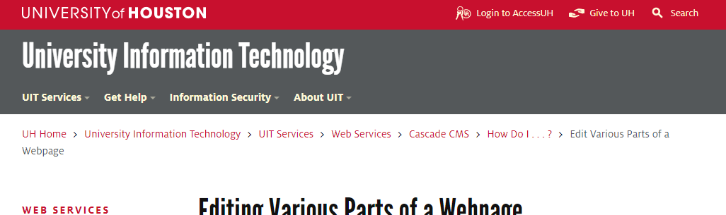*

Figure 44.

# Slider – it is a block on a page in which, with a set frequency, a demonstration of announcements of news, articles or images takes place (fig. 45).

# 

Figure 45.

# Content

# *The text field* (*Content*) is the main part of the document - the section where the semantic content of the page is placed: informative information text and illustrations (fig. 46).

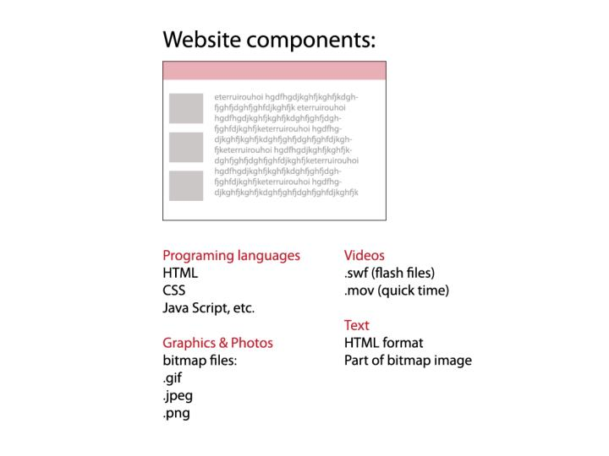

Figure 46.

# The location of the text field depends primarily on how the web designer will place the remaining elements of the document (fig. 47).

# http://24ikt.ru/html/6/pic/clip_image06.jpg

Figure 47.

# Footer

# At the bottom of the document, it is customary to publish information about the developer of the site and e-mail addresses, by which visitors to the resource can send their responses, suggestions and wishes to the page owners (fig. 48).

# http://24ikt.ru/html/6/pic/clip_image004_0001.jpg

# 

# 

Figure 48.

# 5.2 Types of positioning elements

# Web page template (layout) - designed to place elements on the page.

# In this example – fig. 49, part of the controls is embedded directly in the header. The main block of navigation elements is positioned relative to the left border of the document and at the top.

# Похожее изображение

# Figure 49.

# The text field is divided into two asymmetric columns, and the short announcements of the subject headings that make up the resource, including links to these sections, are placed on the right.

# The logo in this layout (fig. 50) is placed on one level with the title of the document, and the advertising banner is positioned relative to the center of the page.

# Картинки по запросу Basic elements of a web page

# Figure 50.

# Example layout of a web page with top positioning of navigation items (fig. 51).

# Похожее изображение

# Figure 51.

# In this case, all the page objects harmoniously "fit" into the specified width of the invisible table, while the preparation of the table itself is greatly simplified [19].

# 5.3 The logical and physical structure of the site

# Each Internet resource, from an amateur home page to a large information portal, contains several thematic sections connected by hyperlinks. As a rule, links to all sections of the site with brief announcements of their contents are provided on the first, so-called start page, which is named *index.htm (.html)*. If the thematic sections contain their own subsections, each of them also has its own start page, called *index.html*.

# *Note.* This file name is recommended to be assigned to all the start documents of the site, because otherwise, when accessing any section via an abbreviated URL without specifying the name of the start page (for example, http://www.mysite.ru/photos/ instead of http: // www .mysite.ru / photos / startpage.html) the browser does not display the web page itself, but a list of the files stored in this folder.

# A set of subject headings with documents distributed over the relevant sections and pre-designed hyperlinks between all pages of the resource is called the logical structure of the site.

# The physical structure, on the contrary, means an algorithm for placing physical files in the subdirectories of the folder in which your site is published [20].

# An example of a comparison of the logical and physical structures of the same Internet resource is shown in fig. 54.

**Logical structure** **Physical structure**

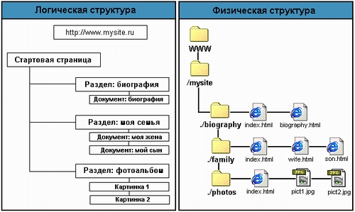

# Figure 54. Comparison of the logical and physical structure of the site

# The logical and physical structures may not coincide, since in the general case the physical structure of the resource is developed based on the convenience of placing files.

# *Note*. It is recommended to place all graphic images that are elements of the project in a separate folder with the name "Images" located in the root directory of the site. This approach will allow you to update HTML documents stored in other thematic sections without transferring graphics, use the same graphic files in all sections of the site and, if necessary, delete entire directories.

# In order for all hyperlinks on your home page or website to work correctly, all documents open correctly and the browser does not give errors when accessing any sections of the resource, several simple rules should be followed when creating its physical structure.

# *Note*. Assign directory names, names, and extensions to HTML documents and image files using only Latin characters and lowercase only. Try to ensure that the names of the files and directories you create do not exceed eight characters in length.

# From all that has been said, it becomes obvious that the physical structure of the site is hidden from visitors to your resource: they can only observe the logical structure, moreover, exactly as it is presented using navigation elements.

# This leads to a completely logical conclusion: the structure of the navigation system should, if not completely repeat, then at least match the logical structure of the site you developed.

**Reference**

1. Randy Connolly, Ricardo Hoar. Fundamentals of Web Development. – Pearson, 2015.

2. [Шевчук Е.В.](http://webirbis.ksu.kz/cgi-bin/irbis64r_12/cgiirbis_64.exe?LNG=&Z21ID=&I21DBN=IBIS&P21DBN=IBIS&S21STN=1&S21REF=1&S21FMT=full%3Cb%3E%3Cfont%20color=red%3Eweb%3C/font%3E%3C/b%3Er&C21COM=S&S21CNR=20&S21P01=0&S21P02=1&S21P03=A=&S21STR=%D0%A8%D0%B5%D0%B2%D1%87%D1%83%D0%BA%20,%20%D0%95.%20%D0%92.)  Information and Communication Technologies: учебно-методическое пособие. - Алматы: CyberSmith, 2017. - 107 p.

3. Learn Internet Technology: Internet Technology// <https://www.tutorialspoint.com/internet_technologies/internet_quick_guide.htm>

4. Evangeline Bishop. [Networking](http://docplayer.net/34387528-Networking-chapter-1-exploring-the-network.html)// <http://docplayer.net/34387528-Networking-chapter-1-exploring-the-network.html>

5. Система DNS// <https://performanceconnectivity.com/dns/>

6. <http://www.businessrole.net/business-ideas/benefits-of-dns-monitoring-to-a-business.html>

7. Система DNS// <https://lecturesclub.com/what-is-internet-domain-name-system/>

8. <https://artemsannikov.ru/cisco/ccnars/> CCNA: Introduction to Networks

9.<http://shodhganga.inflibnet.ac.in:8080/jspui/bitstream/10603/253062/9/09_chapter1.pdf>

10. Client-Server Technologies in a Web-Based Application// <https://www.101computing.net/client-server-technologies-in-a-web-based-application/>

11. Client Server Computing// <https://www.tutorialspoint.com/Client-Server-Computing>

12. Грамотная клиент-серверная архитектура: как правильно проектировать и разрабатывать web API

//<https://tproger.ru/articles/web-api/>

13. <https://ipcisco.com/lesson/domain-name-system-overview/>

14. Smart IOT// <http://www.smartiot.at/check-webserver-downtime/>

15. [Susan Matveyeva](https://www.researchgate.net/profile/Susan_Matveyeva). A Role for Classification: The Organization of Resources on the Internet. [Wichita State University](https://www.researchgate.net/institution/Wichita_State_University)// <https://www.researchgate.net/publication/26507697_A_Role_for_Classification_The_Organization_of_Resources_on_the_Internet>

# 16. Виды (типы) сайтов и их классификация// <https://www.mosseo.ru/vidy-tipy-sajtov-i-ih-klassifikaciya/>

# 17. Классификация веб-ресурсов// <http://www.interface.ru/home.asp?artId=19035>

# 18. [Patrick J. Lynch](http://patricklynch.net/), [Sarah Horton](http://sarahhortondesign.com/). Web Style Guide Online// <https://webstyleguide.com/wsg3/index.html>

# 19. [Designing Your Website](https://www.website.com/website-builder-and-web-design/designing-your-website/)// <https://www.website.com/website-builder-and-web-design/designing-your-website-header-body-and-footer>

# 20. Logical and Physical Data Structures// <https://www.w3computing.com/systemsanalysis/logical-physical-data-structures/>

# Theme 6. Website Development Process

# *Plan:*

# Website Development Steps

# Stage 1. Research and Planning

# Step 1. Defining the project goal

# Step 2. Creating a project idea

# Step 3 Development of the project structure (sitemap)

# Step 4. Planning and project management

# Stage 2: Design

# Step 1. Development of the project wireframe

# Step 2. Visual Design

# Step 3. Interactive and visual design principles

# Step 4. Web Design Trends

# Step 5. Content Creation

# Stage 3. MarkUp (Layout) and site development

# Step 1. Site layout

# Step 2. Development

# Stage 4. Testing and launch, support

# Site support: user reviews and regular updates

# Conditionally, the process of creating a website (web-project) can be divided into 4 stages (fig. 55) [21, 22]:

# 1. Research (discovery) and Planning

# 2. Design

# 3. Development

# 4. Testing and launch, support

# Figure 55. The web development process

# 6.1 Stage 1. Discovery (Research) and Planning

# Step 1.1. Defining the project goal

# The created Web site can be designed to solve one of the following tasks.

# • Attract new consumers.

# • Provide existing consumers with new means of purchasing goods.

# • Make catalogs of goods and services available on the Internet.

# • Provide the general public with company information.

# To find out the goals of the Web site, you need to find answers to questions from the customer:

# • What is the main purpose of the Web site?

# • Who are your competitors? advantages and disadvantages of their nodes?

# • Analyze competitors' sites: structure, sections, design.

# • What features are implemented in the competitor’s website?

# • Does the site have any features that distinguish it from other Web sites?

# • What are the short-term and long-term goals of creating a new site?

# • What information about your business do you want to make available to the general public through a Web site?

# • What products or services do you offer consumers?

# • What other sites would you like to link your site to through hypertext links?

# • How much information should be presented on the Web site?

# • Do you have a registered trademark? Should I put it on a Web site?

# • What resources are currently available (eg photographs, text files, logos, etc.)?

# • What main sections should a Web site contain?

# • How often do you expect to update the content of a Web site?

# • What are the estimated visitors to the Web site?

# The structure and design of the Web site depends on the *target audience*.

# A good Web site is considered to be the one whose contents will be understood by most users and whose appearance they will like.

# *The target audience* is one of the main factors determining the correlation of text, images, multimedia data and interactive elements in the Web site.

# Once you know the needs of the customer and determine the scale of the project, you must draw up a schedule for the project and budget.

# Step 1.2. Creating a project idea

# At this stage, it is necessary to determine the subject of the project (site, service).

# Next, in accordance with the selected topic, you must perform the following steps:

# 1) Content Definition:

# - Gather the appropriate materials: text, graphic.

# - Collect text, logos, photos, illustrations, audio files and other data.

# - Determine what information is most important and how it should be placed on the Web site.

# - Distribute data by topic.

# - Consider a way to present data.

# - Determine how much of the content of the node should be the text and how many images need to be presented on the node.

# - Determine whether additional materials, graphic data, tables or interactive components are needed?

# 2) Determining the size of the site:

# - Evaluate (determine) the amount of information and think about how to best distribute it within the site.

# - The amount of information determines the number of Web pages, their appearance and navigation tools.

# - Think about how to efficiently present data on a site.

# Step 1.3. Development of the project structure

# 3) Development of information architecture (logical structure) of the site

# Information architecture allows you to organize the content of the Web site and determines how the user gets access to information.

# The process of creating an information architecture begins with dividing information into categories and prioritizing data. To categorize data, evaluate how important the information should be.

# Ideally, a Web site should have a hierarchical structure. At the upper levels of the hierarchy, the most general categories should be presented. Subcategories located at the levels following them correspond to subtopics, and at the lower levels there are specific questions that interest users.

# This arrangement of information simplifies not only the user's work with the Web site, but also the process of creating the Web site.

# It is advisable to divide all the data into 5-7 categories. The process of dividing into categories is usually called the formation of blocks (chunking). The number of categories is limited in that it is difficult to create an interface representing more than 7 categories, and such a site will be overloaded with information [23].

# 4) Create a sitemap

# The site map should, at a minimum, provide links to the main areas of the website.

# Site maps act as a navigational aid by providing an overview of the site's areas in a single glance (fig. 56).

# Site maps may improve search engine optimization of a site by ensuring that all the pages can be found [24].

# Создание | Настройка - sitemap.xml Полтава - изображение 2

# Figure 56.

# Step 1.4. Planning and project management.

# - Development of project requirements

# - Determining the project development *team*

# - Budget definition

# - Development of a schedule of work and coordination with the customer

# - The formation of the physical structure of the site

# Special software used - MS Project Management

# 6.2 Stage 2. Design

# Step 2.1. Development of the project wireframe

# After determining the information structure of the project, you need to draw up a project wireframe (or mock-up).

# The wireframe is a visual representation of the future interface of the site. But, unlike the template, the wireframe does not contain design elements such as color, logos, etc.

# The wireframe describes which elements will be placed on the page and how they will be arranged. The wireframe is a kind of sketch of the future site. You can use one of the available online services to create layouts (fig. 57).

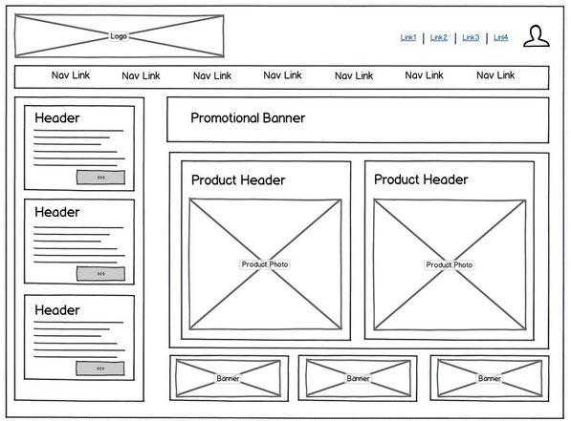

Figure 57.

# There are Wireframe Tools [24]:

* Gomockingbird;
* Balsamiq Mockups;
* Axure;
* Gliffy;
* iPhone mockup;
* InDesign;
* Photoshop;
* Dreamweaver.

# When developing a site, it is useful to familiarize yourself with examples of sites from other works [25]:

# <http://unmatchedstyle.com/gallery>

# [http://cssdrive.com](http://cssdrive.com/)

# <http://foundation.zurb.com/templates.html>

# <http://zurb.com/patterntap>

# Step 2.2. Visual Design (Design/ Visual Style)

# After creating a project wireframe, you can go directly to creating a design layout. At this stage, a page layout is created.

# The main purpose of the layout is to visualize the structure of the page, its contents, as well as display the main functionality.

# Unlike the wireframe, the layout uses design elements. The layout contains colors, logos and images.

# Determination of the color scheme of the project. One way to determine the primary color in a project is to compose a *mood board* (fig. 58).

# To do this, you need to write down all the terms related to the topic of the project, and then type each term in a search using Google or Yandex pictures. On the basis of the images found, write out the colors that are most often found on them (which colors are more). The found colors will make up the visual perception of our project and evoke the corresponding feelings in the user.

# F:\SPIRINA\ЛЕКЦИИ\WEB technology 2017\! Web Technology 2019\Web Tehcnology 2020\6 Theme\1\11.jpg

# Figure 58.

# To work with the selected color and compiling the site color palette, you can use the following tools [26, 27]:

# - Color Scheme Designer 3 (fig. 59)  (<http://colorschemedesigner.com/csd-3.5/>)

# In addition to choosing a color scheme, this service allows you to see an example of how the selected colors will look on the site.

# .F:\SPIRINA\ЛЕКЦИИ\WEB technology 2017\! Web Technology 2019\Web Tehcnology 2020\6 Theme\1\12.jpg

# Figure 59.

# - Adobe Color CC (fig. 60)  (<https://color.adobe.com/ru/>).

# F:\SPIRINA\ЛЕКЦИИ\WEB technology 2017\! Web Technology 2019\Web Tehcnology 2020\6 Theme\1\13.jpg

# Figure 60.

# This resource, unlike Color Scheme Designer 3, allows you to create palettes based on uploaded images. Also, this service has a large archive of palettes of other users.

# It is important to note that when choosing colors for a palette, you should always choose at least 2 contrasting colors. Achieving the right contrast between colors is a prerequisite for a good interactive design.

# Step 2.3. Interactive and visual design principles

# 1) «Call to Action» Elements

# The concept of a call to action refers to the interactive elements of a site: buttons, banners, etc.

# These elements are designed in such a way that the user would like to click on them. For example, it can be a button with a call to action (Click, Buy, Save), a bright banner with a tempting offer, a bright picture, etc.

# This concept fits well with the principle of AIDA (Attraction – Interest - Desire - Action) (fig. 61).

# F:\SPIRINA\ЛЕКЦИИ\WEB technology 2017\! Web Technology 2019\Web Tehcnology 2020\6 Theme\1\14.jpg

# Figure 61.

# This concept is used more often in the design of main pages, stock pages, etc., where it is necessary to push the user to a particular action: subscription, purchase, etc.

# 2) Visual principles Page view

# There are visual principles of pageview [28, 29]:

# a) page viewing scheme (the most natural way of eye movement on the page);

# b) visual guides.

# a) Page viewing scheme

# *Z-page view.* In accordance with the Z-scheme (pattern), page elements are usually arranged as follows: logo at the top left, menu at the top right, information blocks, pictures at the bottom left, a call to action button at the bottom right (fig. 62).

# F:\SPIRINA\ЛЕКЦИИ\WEB technology 2017\! Web Technology 2019\Web Tehcnology 2020\6 Theme\1\15 z.jpg

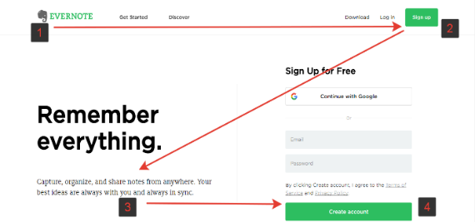

# Figure 62.

# The Z-pattern is well suited for simple designs, where there is a minimum of text and a few elements that you need to pay attention to. The Z-pattern can be applied when creating a *landing site* built around one or two key elements (fig. 63).

# https://miro.medium.com/max/700/1*HfJ72TZp2mAWxF-IBjwOYA.png

# Figure 63.

# *To create a Z-pattern.* Build the letter “Z” on the page. Ideally, people should first see the most important information, and then a little less important. Therefore, key elements must be placed on the scanning path and in the necessary order.

# *F-page view.* The F-pattern well describes user behavior only in the case of texts or content placed on a monotonous grid.

# *To create a F-pattern*:

# come up with a catchy title that reflects the content of the article;

# put important information in the first two paragraphs of the text;

# make less important information in the form of short paragraphs, subheadings, lists along the main axis F (fig. 64).

# https://miro.medium.com/max/600/0*RS1IkgtcLe3CdeyV.jpg

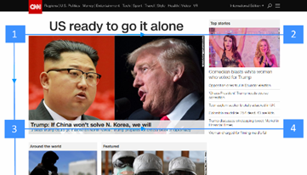

# Figure 64.

# Visual guides

# Visual guides are called decorative elements of a page that redirect the user's eyes to various design elements, shapes, buttons, etc.

# Arrows can serve as visual guides, the direction of the person’s gaze in the image, the direction of the index finger, in general, everything that can somehow point in one direction or another.

# In the image (fig. 65), the gaze involuntarily follows the index finger of a man, and his direct gaze involuntarily draws attention to himself at the first glance at the page.

# F:\SPIRINA\ЛЕКЦИИ\WEB technology 2017\! Web Technology 2019\Web Tehcnology 2020\6 Theme\1\16.jpg

# Figure 65.

# The same effect is demonstrated in the figure 66 with the superimposed heat map: in the first case, we are attracted mainly by the child's direct gaze (directly into the eyes), in the second case, the direction of the child's gaze and his posture involuntarily draw the user's gaze to the block on the right.

# F:\SPIRINA\ЛЕКЦИИ\WEB technology 2017\! Web Technology 2019\Web Tehcnology 2020\6 Theme\1\17.jpg

# Figure 66.

# Step 2.4. Web Design Trends

# When developing a website’s visual design, it is necessary to take into account modern web design trends.

# Step 2.5. Content Creation

# This step involves the preparation and processing of content:

# - Writing new content. This stage includes creating attractive and catchy headlines, writing and editing text, compiling existing texts, etc.;

# - Preparation of content for transfer to the site;

# - SEO-optimization.

# 6.3 Stage 3. MarkUp (Layout) and site development

# Step 3.1. Site layout

# Site layout is in accordance with the developed site map. The required type of site layout is selected.

# There are types of site MarkUp (layout):

# *1) Fixed and Rubber (Fluid) layout*

# A *fixed layout* means that regardless of the user's screen resolution, your site will always occupy the same width.

# The *“Rubber” (Fluid)* layout means that the page of the site will occupy all the available space on the user's screen, adjusting to the resolution (fig. 67).

# F:\SPIRINA\ЛЕКЦИИ\WEB technology 2017\! Web Technology 2019\Web Tehcnology 2020\6 Theme\1\3.jpg

# Figure 67.

# *2) Responsive Web Design, RWD:* it’s the concept fits into the concept of "rubber" and means that when you change the screen size, your site adapts to it

# *3) Adaptive Web Design, AWD* means that during development, you determine the basic resolutions (screen sizes) that your content will adapt to.

# In both cases, you should develop not one, but several layouts that will correspond to different screen resolutions. Often 3 layouts are created for the permissions of iPhone (Android Phone), iPad (Android Tablet) and Desktop.

# *A Modular (coordinate) grid* is also used for website layout.

# The modular grid means dividing the page into separate columns vertically and arranging the content, while developing the layout design, precisely along this grid.

# The most popular system is the modular grid 960 Grid System (<http://960.gs>), which divides the page as much as possible into 12, 16 and 24 columns.

# The maximum width of the grid is 960 pixels. This solution is based on the fact that most modern monitors, at the time of the grid creation, had a resolution of at least 1024 by 768 pixels. Creating a layout based on this grid, in the future, will help speed up the development process (layout) (fig. 68).

**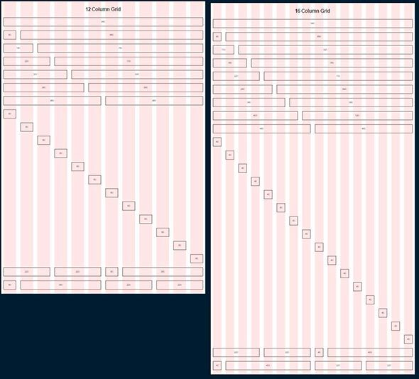**

# F:\2020 Лекции\Web Tehcnology 2020\6_7 Theme Process development site\1\5.jpg

# Figure 68.

# A modular grid is a kind of visual abstraction, a visual division of a page into equally wide columns with equal indents between them. This model can be visualized using guides or a separate layer on which these columns will be displayed.

# Step 3.2. Development

# Creating a page is done in stages:

# HTML layout (HTML code);

# CSS styles are added;

# and then, if necessary, scripts (JS) are written;

# necessary plugins and libraries are added.

# or

# use of content management systems CMS (WordPress, Drupal, Joomla, Bitrix);

# use of site builders.

# 6.4 Stage 4. Testing and launch

# Step 4.1. Testing:

# each link should be checked, each form and each script should be tested;

# the text should be checked by the spell checker to identify possible typos and errors;

# code validators are used to ensure that the code created in the previous step fully complies with modern web standards.

# There are *Online tools* testing:

# to verify html: https://validator.w3.org/

# for CSS validation: http://jigsaw.w3.org/css-validator/

# to check JS: http://www.jslint.com/

# After testing, the site can be uploaded to the server. Usually an FTP client is used for this. After downloading the site to the server, it is necessary to conduct another test in order to be sure that during the download there were no unexpected errors and all the files are safe and sound.

# Step 2. Site support: user reviews and regular updates

# It is important to be sure that everything works as planned, and users are satisfied with the final product. One must also be prepared to make changes quickly if necessary. The feedback system will allow you to identify problems encountered by site visitors. The most critical task in such cases will be to resolve the problems as quickly as possible. Otherwise, your users would rather prefer a different resource than put up with inconvenience.

# Also, do not forget to regularly update the CMS. Regular updates will save you from bugs and security issues.

# Theme 7. Web Design (Visual Design)

# *Plan:*

# Web Design (Visual Design)

# Principles of Web Design

# Web design trends of 2020

# After creating a project wireframe, you can go directly to creating a design layout. At this stage, a page layout is created.

# The main purpose of the layout is to visualize the structure of the page, its contents, as well as display the main functionality. Unlike the wireframe, the layout uses design elements. The layout contains colors, logos and images [3].

# During the visual design stage, the following steps are performed:

# 1) Determination of the color scheme of the project;

# 2) Choosing the trend of Web design;

# 3) Definition / selection of key features of the "chips" of the project. Ways to Make Website Remarkable and Visitor Friendly.

# 7.1 Principles of Web Design

# Good design is the result of a thorough study of the characteristics of the task and following the basic rules.

# The principles for selecting elements, composition and use of color basically coincide with the principles used in creating images on traditional media.

# To achieve good results when developing a Web site, you must adhere to the following principles of Web Design:

# • Convenience of perception. The text, images, and symbols used on the Web site should be understood by all users;

# • Consistency. All elements must be combined with each other so that the website is designed in the same style. It is necessary to choose the font style and font sizes for headings of various levels, use colors that are in harmony with each other, and graphic images should naturally supplement textual information.

# • Using Fonts. Fonts are one of the elements of graphic design. There are two ways to display fonts in a browser:

# - use of standard fonts;

# - development of original hand-drawn fonts (i.e. text as an image), for example, using the graphics program Adobe Photoshop. This method provides individuality, full control over the fonts; the appearance of characters is saved in any browser.

# *Use a minimum of fonts.* Ideally 1, maximum 2-3. The main thing is that there should be harmony in the text.

# *Forget about centering.* No need to align all text in the middle. Think of grids and guides.

# *Keep a balance of decorative elements.* Curls, circles look unusual, but you need to use them wisely.

# *Watch the sizes.* Some designers accentuate by increasing.

# • Simplicity*.* Do not overload Web pages with secondary information. Content should be presented in small portions that are easy to read. There should be empty spaces on the web pages; empty space - “white space” - thanks to this, the user's eyes are less tired.

# • Structure.Each Web page and the entire Web site should have a hierarchical structure that ensures the selection of the most important elements, the grouping of similar components. Information should be categorized and subcategory.

# *•* Using Metaphors and Themes

# A metaphor is a speech revolution, including hidden assimilation, figurative rapprochement of words on the basis of their figurative meaning.

# In Web design, a metaphor is a symbol for a concept or action. Metaphors can be literal or abstract. *A good metaphor guides the actions of the user and helps to unify the material presented on the Web site.* Metaphors should be familiar to users and be relevant to the concepts being expressed.

# *The purpose of using a metaphor* is to support the central theme of a Web site or a group of documents contained on it.

# Choosing and creating a metaphor is not an easy task, as metaphors are not relevant on all Web sites.

# A metaphor works well when it is a common symbol, for example, an image of a trash can on a Macintosh or a “basket” of a customer in an online store.

# *The theme of the site* is a visual or conceptual representation of time, place, style, environment, etc.

# The theme increases the applicability of the site and helps harmonize its elements.

*•* **Navigation chart**

The basis of the navigation scheme can serve as an information architecture - a site map. A navigation chart is a realistic plan for moving from one page to another.

***The basic rules for creating a navigation chart****:*

* minimize the number of hypertext links on the page (the number of links should not be more than ten). Navigation elements should not overload the user with information and create a problem of choice for him;
* place hyperlinks on different Web pages in the same position;
* ensure consistent use of navigation elements.

# *•* Color scheme development

# The colors chosen for the Web site should correspond to the image of the customer company and contribute to the perception of the idea (message) - the basic information presented on the Web site.

# *• Use a limited palette of harmonizing colors for background, text, elements*

# *• Use of contrasts for text, images.* Contrasts help the user perceive elements.

# *• The use of accents* is used to draw attention to the required components: blocks of text, diagrams, etc. using colors, fonts, sizes, composition [21-23].

# 7.2 Basic web design trends

# 1) The combination of bright colors

# Now it’s fashionable to use rich and vibrant color schemes (fig. 69).

# F:\SPIRINA\ЛЕКЦИИ\WEB technology 2017\! Web Technology 2019\Web Tehcnology 2020\6 Theme\1\2\111111029458346038760386.jpg



# 



# Figure 69.

# The main thing is the appropriate use and harmonious combination of shades, the use of additional techniques for their search.

# 2) Technology Duplex (дуплекс)

# Design in the framework of two colors and their midtones looks stylish and in general is very worthy.

# Such an innovative technique is often implemented when rebranding is necessary in a short time, leaving the whole concept and structure of the site unchanged (fig. 70).

# F:\SPIRINA\ЛЕКЦИИ\WEB technology 2017\! Web Technology 2019\Web Tehcnology 2020\6 Theme\1\2\7764555.jpg

# Figure 70.

# 3) Soft Multi-Tone Gradients

# *Gradient:* Soft transitions saturated or muted. The most stylish are two-color gradient transitions consisting of harmonious shades (fig. 71).

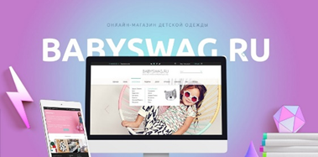



# Figure 71.

# 4) Textured Details

# To make web design interesting, you can use an additional texture mix (fig. 72).

# 

# Figure 72.

# 5) Minimalism

# The concept of minimalism allows you not to distract the user from the main thing - the study of basic information.

# Laconic minimalist design solutions are used for background and additional elements (fig. 73).

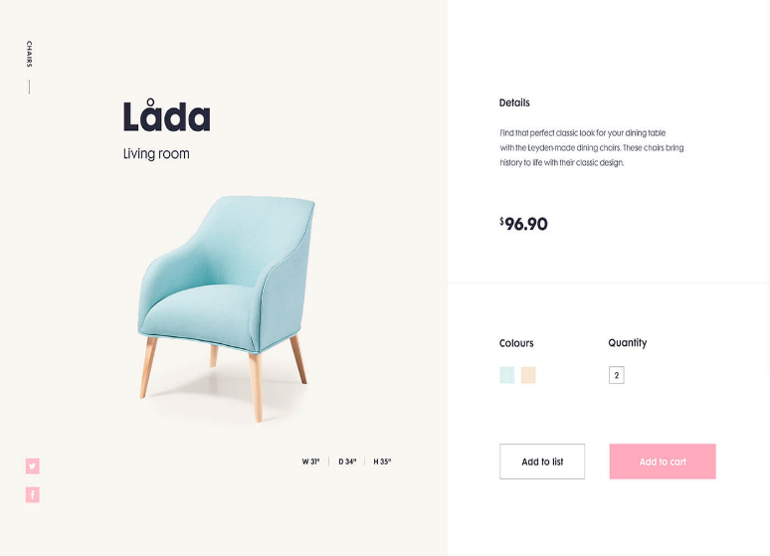

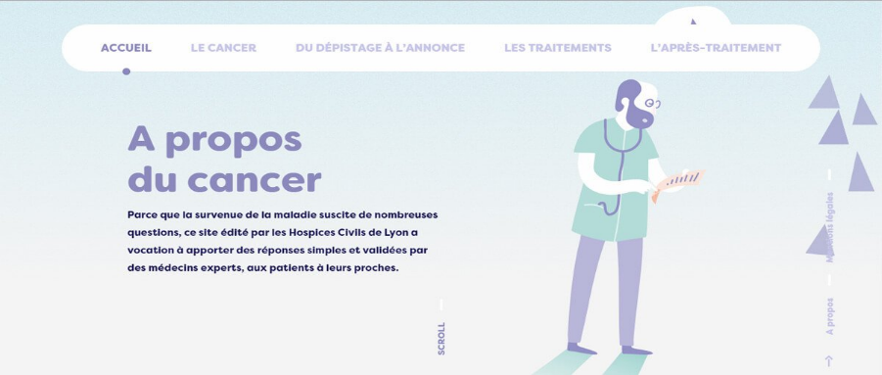

# Figure 73.

# A simple design can look better than a lot of heavyweight layouts.

# 6) Presence of Movement

# Three-dimensional typography, Gift-pictures, animation are widely used in modern website design.

# 3D typography makes the web space come to life, focuses the attention of visitors, sets design apart from others.

# Similar details are used in logos; cinemagraphic (when not everything comes to life in the picture, but only a separate element) (fig. 74).







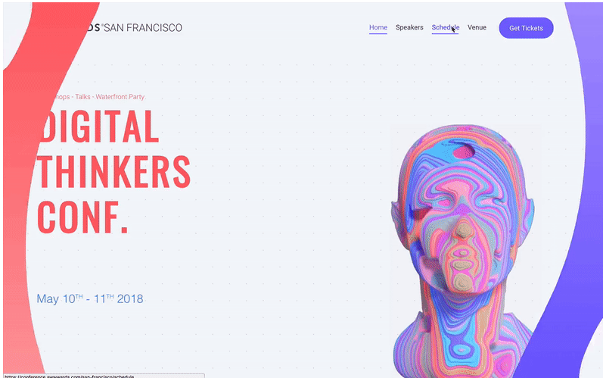

**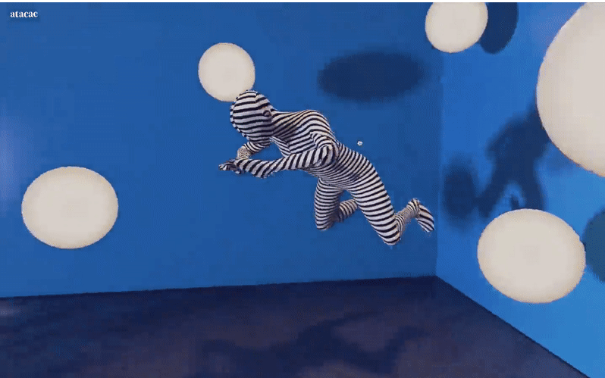**

# Figure 74.

# Cinemagraphic reception allows you to create the effect of watching a video [30].

# Animated scripts are everywhere in the web; they force platform users to take action. Therefore, 3D components increase competitiveness, conversion and help personalize the appearance of the website.

# 7) Easy Animation Over Background

# Moving bubbles, atoms, waves can make a resource interesting without a lot of time (fig. 75) [31].

# 

# Figure 75.

# 8) Volume of Objects

# With the help of well-chosen shadows, flat objects can be made voluminous and as attractive as possible, placed in a niche of the overall composition or moved forward from the background image (fig. 76).



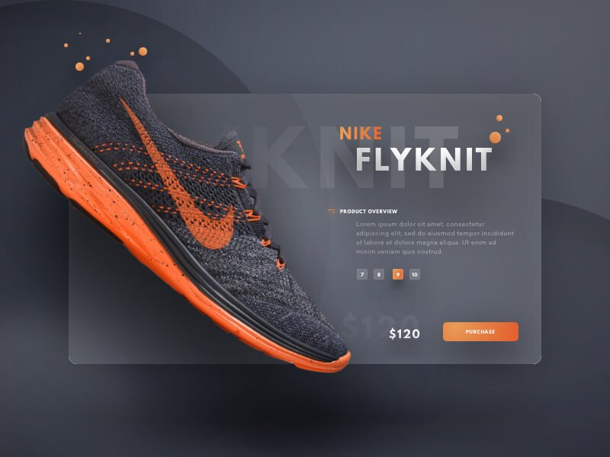

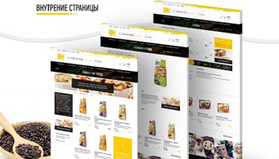

# Figure 76.

# 9) Quality Photo Material

# The key components of web design are elements that help convey information without words, including Photos (fig. 77).

# 

# 

# 

# 

# Figure 77.

# They look trendy:

# - extraordinary photos in an unusual setting;

# - photos combined with drawn elements;

# - pictures with real text blocks (signboards, plastic letters, stands, plates, posters);

# - real photos without processing and staging scenes (honesty in the photo is appreciated this year, at the peak of popularity, photos taken spontaneously in a relaxed atmosphere and natural setting);

# - unique panoramic photos on the main page;

# - color-gel photographs - a unique technique for creating unusual photos using colored light sources.

# 10) Creative Doodles

# Doodles are hand-drawn illustrations give the site a special charm, style and atmosphere. Rough lines, sloppy strokes, sloppy inscriptions can be found in the design (fig. 78).

# F:\SPIRINA\ЛЕКЦИИ\WEB technology 2017\! Web Technology 2019\Web Tehcnology 2020\6 Theme\1\2\1010.jpg

# Figure 78.

# 11) Strict Brutalism

# Brutal style (fig. 79):

# - apply square, rectangular shapes;

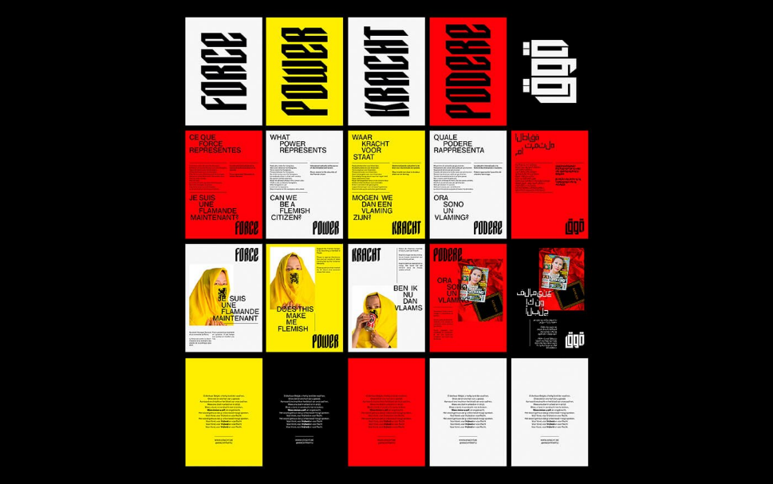

****

# Figure 79.

# - lack of smooth lines;

# - lack of many small elements;

# - all blocks are created in large size;

# - a discreet color palette is used (white, black, brown, gray);

# - classic bold fonts;

# - catchy large headers.

# 12) Soft Design Charm

# The opposite of brutality is an exquisite combination of flowing lines, soft shadows, pastel colors (fig. 80).

# F:\SPIRINA\ЛЕКЦИИ\WEB technology 2017\! Web Technology 2019\Web Tehcnology 2020\6 Theme\1\2\1212.jpg

# Figure 80.

# 13) Return from the Past

# This trend is characterized by (fig. 81):

# - Patterns and color palette, fashionable in the 80-90s,

# - sharp contrast

# - Acid tones of the interface, background, buttons.

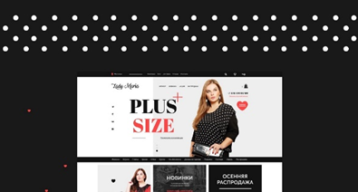



# Figure 81.

# 14) Creative Download Screen

# The transition between pages is an integral component of the behavior of the interested user.

# Web designers strive to make these seconds comfortable for the user (fig. 82).

# 

# Figure 82.

# To interest the visitor, they actively get rid of boring and outdated loading screens, introducing unusual options [32].

# 15) Use of Three-Dimensional Objects

# Useful interactive elements can make a web resource popular.

# 3D fitting rooms in online stores of clothes, shoes and accessories are a way to examine a thing in detail from all sides (fig. 83).



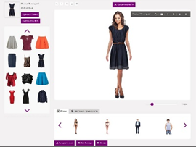

# F:\SPIRINA\ЛЕКЦИИ\WEB technology 2017\! Web Technology 2019\Web Tehcnology 2020\6 Theme\1\2\0789078809099.png

# Figure 83.

# This method is multifunctional, solves many problems [33, 34]:

# attracts the attention of buyers;

# increases profit (users are more likely to purchase a thing that they could carefully consider);

# makes the site exclusive, improving its appearance.

# 16) Parallax - Decoration with Sense

# *Parallax* means change, alternation. Parallax is the undoubted trend of web design [35, 36]. The smooth transition from one part of the image to another looks bewitching due to the unexpected change of picture (fig. 84).

# F:\SPIRINA\ЛЕКЦИИ\WEB technology 2017\! Web Technology 2019\Web Tehcnology 2020\6 Theme\1\2\332445666.png

# Figure 84.

# 17) Experimental Fonts

# Geometric, custom font: in addition to the type of font, experiments with text direction are also in fashion (fig. 85).

# 

# Figure 85.

# 18) Miniature Video Unit

# A video on an online resource is a fashionable way to present information.

# 

# 19) Panton - Color of the Year

# Ultraviolet light is recognized as color №1 in 2019. It is based on a combination of blue and purple (fig. 86).

# F:\SPIRINA\ЛЕКЦИИ\WEB technology 2017\! Web Technology 2019\Web Tehcnology 2020\6 Theme\1\2\1919.jpg

# Figure 86.

# The color of the year 2020 is Classic Blue (19-4052). A soothing presence that inspires calm, confidence and a sense of ownership (fig. 87).

# Pantone назвали цветом 2020 года «классический синий» — Jewellery Mag

# Figure 87.

# 20. Displacement to the party of interaction of elements of the site with the user

# Practicality is a trend without which a harmonious and visually appealing website will not be able to keep its visitors.

# Web design should be functional: adaptive, contain useful options (online chat, search) (fig. 88).

# F:\SPIRINA\ЛЕКЦИИ\WEB technology 2017\! Web Technology 2019\Web Tehcnology 2020\6 Theme\1\2\2020.jpg

# Figure 88.

# The presented trends are implemented in different ways, rarely intersect, since each of them is a self-sufficient idea for developing a worthwhile project.

# In some cases, mixing and creative processing of two or three of the described trends helps to create a truly memorable design.

# The choice of combinations depends on the idea and direction of the web resource, as well as the talent and vision of the web designer [37, 38].

**Reference**

1. Randy Connolly, Ricardo Hoar. Fundamentals of Web Development. – Pearson, 2015.

2. [Шевчук Е.В.](http://webirbis.ksu.kz/cgi-bin/irbis64r_12/cgiirbis_64.exe?LNG=&Z21ID=&I21DBN=IBIS&P21DBN=IBIS&S21STN=1&S21REF=1&S21FMT=full%3Cb%3E%3Cfont%20color=red%3Eweb%3C/font%3E%3C/b%3Er&C21COM=S&S21CNR=20&S21P01=0&S21P02=1&S21P03=A=&S21STR=%D0%A8%D0%B5%D0%B2%D1%87%D1%83%D0%BA%20,%20%D0%95.%20%D0%92.)  Information and Communication Technologies: учебно-методическое пособие. - Алматы: CyberSmith, 2017. - 107 p.

3. Learn Internet Technology: Internet Technology// <https://www.tutorialspoint.com/internet_technologies/internet_quick_guide.htm>

4. Evangeline Bishop. [Networking](http://docplayer.net/34387528-Networking-chapter-1-exploring-the-network.html)// <http://docplayer.net/34387528-Networking-chapter-1-exploring-the-network.html>

5. Система DNS// <https://performanceconnectivity.com/dns/>

6. <http://www.businessrole.net/business-ideas/benefits-of-dns-monitoring-to-a-business.html>

7. Система DNS// <https://lecturesclub.com/what-is-internet-domain-name-system/>

8. <https://artemsannikov.ru/cisco/ccnars/> CCNA: Introduction to Networks

9.<http://shodhganga.inflibnet.ac.in:8080/jspui/bitstream/10603/253062/9/09_chapter1.pdf>

10. Client-Server Technologies in a Web-Based Application// <https://www.101computing.net/client-server-technologies-in-a-web-based-application/>

11. Client Server Computing// <https://www.tutorialspoint.com/Client-Server-Computing>

12. Грамотная клиент-серверная архитектура: как правильно проектировать и разрабатывать web API

//<https://tproger.ru/articles/web-api/>

13. <https://ipcisco.com/lesson/domain-name-system-overview/>

14. Smart IOT// <http://www.smartiot.at/check-webserver-downtime/>

15. [Susan Matveyeva](https://www.researchgate.net/profile/Susan_Matveyeva). A Role for Classification: The Organization of Resources on the Internet. [Wichita State University](https://www.researchgate.net/institution/Wichita_State_University)// <https://www.researchgate.net/publication/26507697_A_Role_for_Classification_The_Organization_of_Resources_on_the_Internet>

# 16. Виды (типы) сайтов и их классификация// <https://www.mosseo.ru/vidy-tipy-sajtov-i-ih-klassifikaciya/>

# 17. Классификация веб-ресурсов// <http://www.interface.ru/home.asp?artId=19035>

# 18. [Patrick J. Lynch](http://patricklynch.net/), [Sarah Horton](http://sarahhortondesign.com/). Web Style Guide Online// <https://webstyleguide.com/wsg3/index.html>

# 19. [Designing Your Website](https://www.website.com/website-builder-and-web-design/designing-your-website/)// <https://www.website.com/website-builder-and-web-design/designing-your-website-header-body-and-footer>

# 20. Logical and Physical Data Structures// <https://www.w3computing.com/systemsanalysis/logical-physical-data-structures/>

21. Jennifer Niederst Robbins. Learning Web Design. - O’Reilly Media, 2012. – 621 p.

# 22. [Duncan Maund](https://www.linkedin.com/in/duncanmaund). WEB Design & Development Process Steps// <https://www.mediatopia.co.uk/blog/a-detailed-article-explaining-the-web-design-and-development-process>

23. [Website standards, guidelines and templates](https://www.forgov.qld.gov.au/web-publishing-standards-and-guidelines)// <https://www.forgov.qld.gov.au/cue-module2-checkpoint8-site-map>

# 24. Sitemap: development// [https://ukrmarket.net/ obyavlenie-sozdanie-nastroyka-sitemapxml-227352](https://ukrmarket.net/%20obyavlenie-sozdanie-nastroyka-sitemapxml-227352)

25. Процесс создания дизайна// <https://www.youtube.com/watch?v=r34XQDoZ0y0>

# 26. Color Scheme Designer 3//  <http://colorschemedesigner.com/csd-3.5/>

# 27. Adobe Color CC// <https://color.adobe.com/ru/>

# 28. Using F and Z patterns to create visual hierarchy in landing page designs// <https://99designs.com/blog/tips/visual-hierarchy-landing-page-designs/>

# 29. [Stephanie Mialki](https://instapage.com/author/stephanie-mialki). What Is the Z-Pattern Layout & When to Use It?// <https://instapage.com/blog/z-pattern-layout>

# 30. Cinemagraph// <http://cinemagraphs.com/>

# 31. <https://www.behance.net/gallery/58824773/Strong-Women>

# 32. <https://conference.awwwards.com/toronto/workshops>

# 33. <https://mindsparklemag.com/website/atacac-2017-yearbook/>

34. [https://www.volvocars.com/us/about/our-stories/ google-cardboard](https://www.volvocars.com/us/about/our-stories/%20google-cardboard)

# 35. <http://www.cyclemon.com/mobile/>

# 36. <http://milothemes.com/dex-mlp/demo-14/>

37. By Rob Stokes and the Creative Minds. eMarketing: The Essential Guide to Marketing in a Digital World - 6th Edition. - [Red&Yellow](https://www.redandyellow.co.za/blog/textbook/), 2018. - 318 p. (<https://www.redandyellow.co.za/content/uploads/2018/06/RedYellow_eMarketing_Textbook_6thEdition.pdf>)

38. Clint Eccher. Professional Web Design: Techniques and Templates. - Cengage Learning PTR, 2014.

# Theme 8. Website Development Tools

# *Plan:*

# 1 Classification of Web site development tools

# 2 Web client application development tools

# 3 Specialized programming languages

# 4. Web editors.

# 5. Graphic editors and multimedia systems

# 6. CMS - Content management system

# 7. Online site builders

# 8.1 Classification of Web site development tools

# There are various tools for developing Web sites, depending on the type and purpose of the resource being developed (fig. 89):

# - HTML;

# - CSS;

# - Javascript. Javascript frameworks;

# - Specialized programming languages;

# - Web Editors or HTML Editors;

# - CMS;

# - Online site builders, etc.

# internet_technologies_tutorial

# Figure 89.

# According to the technology of displaying content, sites differ:

# - *Static* - consisting of static HTML pages whose content does not change. The user is given the files in the form in which they are stored on the server. Development Tool – HTML;

# - *Dynamic* - consisting of dynamic HTML pages-templates, information, scripts and other things, in the form of separate files. Content is generated upon request by special scripts based on other data from any source;

# - Sites created *using Flash technologies* - the entire site is located on web pages intended for loading into a Flash file, and all navigation and content are implemented in the Flash movie itself [1, 39].

# 8.2 Web client application development tools

# There are Web client application development tools.

# HTML - Hypertext Markup Language - is a standardized document markup language, a tool for structuring and formatting documents on the Internet.

# Cascading style sheets CSS

# CSS technology (cascading style sheets) - cascading style sheets are used to format the appearance of web pages. Style sheets are the contents of CSS files. Style sheet rules determine the appearance of one or more page elements.

# While HTML structures the document, CSS gives the browser instructions on how to display a particular element — design, positioning.

# JavaScript

# JavaScript can be used to develop programs for a wide variety of platforms. In this language, you can write server-side scripts (using .NET or Node.js), ordinary applications (capable of working on any operating system), and extensions for applications, applications for mobile devices and command-line scripts.

# JavaScript is different from many other programming languages. It lacks classes, and functions are ordinary objects that are used to solve a variety of problems. Any browser includes a JavaScript interpreter, and JavaScript code can be embedded in HTML documents, in <script> tags, and when loading an HTML document, this code will be executed by the browser.

# Javascript frameworks: Angular, React, Vue, etc.

# JavaScript frameworks have become an integral part of every modern web project, the most commonly used are *Vue.js, React, Angular.*

# Javascript frameworks are primarily compared by page rendering (Rendering - displaying the final result). Modern architecture allows two types: execution on the client side (the page is rendered due to the power of the user's PC) or on the server side.

# Each of the frameworks has its own approach to the processing of DOM, which has an effect on the rendering of the final page displayed on the user's screen.

# *DOM* - Document Object Model - an object model of a document that allows you to read and change the content, design and even structure of html-documents.

# *Framework Vue.js and React* create a copy of the DOM, process it, and then compare the result with the original version. In the final document (that is, on the user's screen), only those parts of the page that are different from the processing results are replaced.

# This greatly speeds up page loading and rendering. Accordingly, the volume of traffic is reduced, which is especially important for users of mobile devices.

# *Framework Angular* version 1.x and higher takes a different approach to DOM processing. Here, there is a separation into two streams, with the browser (client side) responsible for rendering the DOM, and for the creation of directives, downloading code and services, the general stream (server part) [1, 39-42].

# 8.3 Specialized programming languages

# PHP is a server-side scripting language. PHP is a programming language specially designed for writing web-applications (scripts, scripts) that are executed on a Web server. The syntax of the language is largely based on the syntax of C, Java, and Perl. PHP scripts can be executed on the server as separate files, or can be integrated into html pages.

# Perl (Practical Extraction and Report Language) is an interpreted programming language designed to process textual information and write various system programs in the UNIX operating system.

# ASP (Active Server Page) - active server pages, i.e. the script is interpreted and executed directly on the server, after which a ready-made html document with the results of the ASP script is sent to the user browser [39].

# 8.4 Web editors

# Adobe Dreamweaver. Adobe Dreamweaver - software for creating professional websites. Adobe Dreamweaver contains an intuitive visual interface that allows you to create and edit websites and mobile applications.

# Dreamweaver supports the following programming languages: ActionScript, C #, CSS, XML, HTML, Java, JavaScript, PHP, Visual Basic, VBScript and others. Also has syntax highlighting. Dreamweaver provides a library of elements that can be used on web pages, such as a navigation bar, copyright descriptor, etc.

# The program has functions for adding multimedia tools to web pages and various types of files from Flash and Java to RealAudio, interactive elements such as search engines, forums, e-commerce systems. Interactive mode displays custom HTML elements, custom CSS properties, and more.

# Microsoft SharePoint Designer. Microsoft SharePoint Designer is a SharePoint site development program. The package includes a design editor, a development environment and a number of additional tools to facilitate the task of creating and configuring a corporate portal.

# Microsoft Office SharePoint Designer is used to create simple static or dynamic HTML pages, as well as active ASP.NET server pages (fig. 90).

# 

# Figure 90. Start window Microsoft SharePoint Designer

# Adobe Muse. Adobe Muse is a great choice for designers and those who are professionally designing web pages. The program has serious functionality (fig. 91).

# 

# Figure 91.

# Muse allows you to create responsive websites (landing pages and business cards) in HTML5. The site can be saved on your hard drive, uploaded to hosting or to some cloud. Muse supports templates. Adobe Muse has a library of ready-made gadgets.

# Bluefish Editor. Bluefish Editor is a powerful editor focused on programmers and web developers, with many options for writing websites, scripts and program code (fig. 92).

# 

# Figure 92.

# 8.5 Graphic editors and multimedia systems

# Graphic editors and multimedia systems are part of website development.

# Adobe Flash. Adobe Flash is a complete environment for the preparation of functional interactive content. The Flash platform is widely used to create attractive applications thanks to the rich possibilities of using video and audio materials, graphic objects and animations (fig. 93).

# 

# Figure 93.

# Original content can be created directly in Adobe Flash or imported from other Adobe programs, such as Photoshop or Illustrator, quickly creating animations and multimedia elements, as well as developing complex interactive projects in ActionScript 3.0.

# Flash is used to create multi-purpose sites, stand-alone applications or applications for devices running Android and iOS operating systems.

# Adobe Photoshop. Adobe Photoshop is the most popular and widespread image editing program.

# Adobe Photoshop is the benchmark for digital image quality, provides high performance, powerful graphics editing capabilities and an intuitive interface.

# 8.6 CMS - Content management system

# Content management system (CMS) - an information system or computer program used to support and organize the process of creating, editing and managing content (content)

# *Management system* - a program that provides tools for adding, editing, deleting information on a site or application.

# There are various management systems, among which there are free and paid, built on different technologies. In general, CMS are divided into:

# ECMS (Enterprise Content Management System) - a system for managing unstructured enterprise content. Such systems are designed to manage enterprise-wide content. ECMS have a deep internal classification by subject areas (HRM, DMS, CRM, ERP, etc.);

# WCMS (Web Content Management System) - a web content management system.

# Such CMS allow managing textual and graphic content of a site or application, providing the user with an interface for working with its contents, tools for storing and publishing information, automating the processes of placing information in databases and its output in HTML.

There are types of CMS: WordPress,Joomla!, Drupal, ModX, 1C-Bitrix, Magento, etc.

# WordPress. WordPress is a modern free CMS platform. WordPress is used to develop Internet resources of almost any type: from regular blogs to complex-structured news portals.

# Joomla! A Joomla-based website consists of several elements that together form a web page. The main are three elements - content, modules and template.

# Content is the backbone of a website. The content for the main part of the Joomla web page is loaded from the components. The template defines the appearance of the website. The template acts as a filter (or lens). He manages all aspects of the presentation of web pages. The template does not contain any content, but may include logos

# Drupal. Drupal is an open system that is used to create a website, as well as a platform for managing its content using additional extension modules.

# Drupal contains many software components of a powerful content management system: user login and registration tools; mechanisms for determining the types of users and content; various access rights; tools for creating, editing, organizing and managing data, etc.

# 1C-Bitrix. 1C-Bitrix is a commercial CMS, which is rightfully widely used in electronic commerce. CMS 1C-Bitrix is a multi-user system that provides the possibility of simultaneous work of several editors and a large number of authors with different access rights [43].

# 8.7 Online site builders

# There are various site builders: Wix, Weebly, uKit (uCoz), Google Sites, Webnode, Jimdo, uCraft, Webstarts, Tilda, WebFlow, etc.

# Distinguish between online-builders (constructor) and program-builders (constructors).

# The *online-builders* work completely in the browser, and the data is stored on its own server.

# Most often, the storage service is paid, and users are severely limited by the tariff plans of the service.

# The *program-builders* are installed on the computer as a program and offline work. Offline site constructors are similar to graphic editors - with the difference that the client receives an archive with the pages of the future website at the output. It can be uploaded to any hosting, buy a domain name - and, thus, published on the Internet [44].

# WIX. WIX is one of the most powerful and functional designers. There are enough opportunities to create forums, business card sites, one-page pages - landing pages, shops, blogs.

# The application allows customers to choose a design with ready-made functionality among more than 500 templates in the site designer using Drag & Drop technology (fig. 94).

# WIX

# Figure 94.

# Weebly. Weebly is the best website builder app for your blog, web site or online store. Unlike WIX, this constructor allows you to switch between themes directly in the editor. A more flexible drag & drop interface is the highlight of Weebly (fig. 95).

# Weebly

# Figure 95.

# Google sites. Custom website builder offers a choice of 6 templates, imbued with the spirit of minimalism in each pixel. Templates adapt to the screen of mobile devices. Editing on a mobile phone is the same as working with Google Docs (fig. 96).

# Google Sites

# Figure 96.

# uCraft. uCraft is a simple site builder that provides ample opportunity to customize your own business card website, with the prospect of further development and improvement (fig. 97).

# uCraft

# Figure 97.

**Reference**

1. Randy Connolly, Ricardo Hoar. Fundamentals of Web Development. – Pearson, 2015.

2. [Шевчук Е.В.](http://webirbis.ksu.kz/cgi-bin/irbis64r_12/cgiirbis_64.exe?LNG=&Z21ID=&I21DBN=IBIS&P21DBN=IBIS&S21STN=1&S21REF=1&S21FMT=full%3Cb%3E%3Cfont%20color=red%3Eweb%3C/font%3E%3C/b%3Er&C21COM=S&S21CNR=20&S21P01=0&S21P02=1&S21P03=A=&S21STR=%D0%A8%D0%B5%D0%B2%D1%87%D1%83%D0%BA%20,%20%D0%95.%20%D0%92.)  Information and Communication Technologies: учебно-методическое пособие. - Алматы: CyberSmith, 2017. - 107 p.

3. Learn Internet Technology: Internet Technology// <https://www.tutorialspoint.com/internet_technologies/internet_quick_guide.htm>

4. Evangeline Bishop. [Networking](http://docplayer.net/34387528-Networking-chapter-1-exploring-the-network.html)// <http://docplayer.net/34387528-Networking-chapter-1-exploring-the-network.html>

5. Система DNS// <https://performanceconnectivity.com/dns/>

6. <http://www.businessrole.net/business-ideas/benefits-of-dns-monitoring-to-a-business.html>

7. Система DNS// <https://lecturesclub.com/what-is-internet-domain-name-system/>

8. <https://artemsannikov.ru/cisco/ccnars/> CCNA: Introduction to Networks

9.<http://shodhganga.inflibnet.ac.in:8080/jspui/bitstream/10603/253062/9/09_chapter1.pdf>

10. Client-Server Technologies in a Web-Based Application// <https://www.101computing.net/client-server-technologies-in-a-web-based-application/>

11. Client Server Computing// <https://www.tutorialspoint.com/Client-Server-Computing>

12. Грамотная клиент-серверная архитектура: как правильно проектировать и разрабатывать web API

//<https://tproger.ru/articles/web-api/>

13. <https://ipcisco.com/lesson/domain-name-system-overview/>

14. Smart IOT// <http://www.smartiot.at/check-webserver-downtime/>

15. [Susan Matveyeva](https://www.researchgate.net/profile/Susan_Matveyeva). A Role for Classification: The Organization of Resources on the Internet. [Wichita State University](https://www.researchgate.net/institution/Wichita_State_University)// <https://www.researchgate.net/publication/26507697_A_Role_for_Classification_The_Organization_of_Resources_on_the_Internet>

# 16. Виды (типы) сайтов и их классификация// <https://www.mosseo.ru/vidy-tipy-sajtov-i-ih-klassifikaciya/>

# 17. Классификация веб-ресурсов// <http://www.interface.ru/home.asp?artId=19035>

# 18. [Patrick J. Lynch](http://patricklynch.net/), [Sarah Horton](http://sarahhortondesign.com/). Web Style Guide Online// <https://webstyleguide.com/wsg3/index.html>

# 19. [Designing Your Website](https://www.website.com/website-builder-and-web-design/designing-your-website/)// <https://www.website.com/website-builder-and-web-design/designing-your-website-header-body-and-footer>

# 20. Logical and Physical Data Structures// <https://www.w3computing.com/systemsanalysis/logical-physical-data-structures/>

21. Jennifer Niederst Robbins. Learning Web Design. - O’Reilly Media, 2012. – 621 p.

# 22. [Duncan Maund](https://www.linkedin.com/in/duncanmaund). WEB Design & Development Process Steps// <https://www.mediatopia.co.uk/blog/a-detailed-article-explaining-the-web-design-and-development-process>

23. [Website standards, guidelines and templates](https://www.forgov.qld.gov.au/web-publishing-standards-and-guidelines)// <https://www.forgov.qld.gov.au/cue-module2-checkpoint8-site-map>

# 24. Sitemap: development// [https://ukrmarket.net/ obyavlenie-sozdanie-nastroyka-sitemapxml-227352](https://ukrmarket.net/%20obyavlenie-sozdanie-nastroyka-sitemapxml-227352)

25. Процесс создания дизайна// <https://www.youtube.com/watch?v=r34XQDoZ0y0>

# 26. Color Scheme Designer 3//  <http://colorschemedesigner.com/csd-3.5/>

# 27. Adobe Color CC// <https://color.adobe.com/ru/>

# 28. Using F and Z patterns to create visual hierarchy in landing page designs// <https://99designs.com/blog/tips/visual-hierarchy-landing-page-designs/>

# 29. [Stephanie Mialki](https://instapage.com/author/stephanie-mialki). What Is the Z-Pattern Layout & When to Use It?// <https://instapage.com/blog/z-pattern-layout>

# 30. Cinemagraph// <http://cinemagraphs.com/>

# 31. <https://www.behance.net/gallery/58824773/Strong-Women>

# 32. <https://conference.awwwards.com/toronto/workshops>

# 33. <https://mindsparklemag.com/website/atacac-2017-yearbook/>

34. [https://www.volvocars.com/us/about/our-stories/ google-cardboard](https://www.volvocars.com/us/about/our-stories/%20google-cardboard)

# 35. <http://www.cyclemon.com/mobile/>

# 36. <http://milothemes.com/dex-mlp/demo-14/>

37. By Rob Stokes and the Creative Minds. eMarketing: The Essential Guide to Marketing in a Digital World - 6th Edition. - [Red&Yellow](https://www.redandyellow.co.za/blog/textbook/), 2018. - 318 p. (<https://www.redandyellow.co.za/content/uploads/2018/06/RedYellow_eMarketing_Textbook_6thEdition.pdf>)

38. Clint Eccher. Professional Web Design: Techniques and Templates. - Cengage Learning PTR, 2014.

39. [Прохоренок Н.А.](http://webirbis.ksu.kz/cgi-bin/irbis64r_12/cgiirbis_64.exe?LNG=&Z21ID=&I21DBN=IBIS&P21DBN=IBIS&S21STN=1&S21REF=3&S21FMT=fullwebr&C21COM=S&S21CNR=20&S21P01=0&S21P02=1&S21P03=A=&S21STR=%D0%9F%D1%80%D0%BE%D1%85%D0%BE%D1%80%D0%B5%D0%BD%D0%BE%D0%BA,%20%D0%9D.%20%D0%90.)   HTML, JavaScript, PHP и MySQL: джентльменский набор Web-мастера. - 3-е изд., перераб. и доп. - СПб.: БХВ-Петербург, 2011.

40. [Дронов В.А.](http://webirbis.ksu.kz/cgi-bin/irbis64r_12/cgiirbis_64.exe?LNG=&Z21ID=&I21DBN=IBIS&P21DBN=IBIS&S21STN=1&S21REF=1&S21FMT=fullwebr&C21COM=S&S21CNR=20&S21P01=0&S21P02=1&S21P03=A=&S21STR=%D0%94%D1%80%D0%BE%D0%BD%D0%BE%D0%B2,%20%D0%92.%20%D0%90.) HTML 5, CSS 3 и Web 2.0. Разработка современных Web-сайтов: практическое пособие. - СПб.: БХВ-Петербург, 2011. - 414 с.

41. Пьюривал Сэмми. Основы разработки веб-приложений (Learning Web App Development). - СПб: Питер, 2015 – 272 с.

42. [Гоше Х.Д.](http://webirbis.ksu.kz/cgi-bin/irbis64r_12/cgiirbis_64.exe?LNG=&Z21ID=&I21DBN=IBIS&P21DBN=IBIS&S21STN=1&S21REF=3&S21FMT=fullwebr&C21COM=S&S21CNR=20&S21P01=0&S21P02=1&S21P03=A=&S21STR=%D0%93%D0%BE%D1%88%D0%B5,%20%D0%A5.%20%D0%94.) HTML5. Для профессионалов / Хуан Диего Гоше. - 2-е изд. - СПб.: Питер, 2015. - 559 с.: ил. - (Для профессионалов). - Пер. изд.: HTML5.For masterminds / J.D.Gauchat.

## 43. Types of Content Management Systems (CMS)// <https://www.ixiasoft.com/types-of-content-management-systems/>

# 44. Конструкторы сайтов// [https://www.plerdy.com/ ru/blog/website-builders-review/](https://www.plerdy.com/%20ru/blog/website-builders-review/)

# 9. Website Usability

# *Plan:*

# 1. Usability concept

# 2. Usability Principles

# 3. Basic rules of site usability

# 9.1 Usability concept

# Usability (on russian «юзабилити») is a qualitative assessment of the simplicity and comfort of working with a site.

# The user should easily find the necessary information without losing functionality and numerous pages, and at the same time receive aesthetic pleasure from working with the resource.

# The usability of the website is evaluated according to 5 main quality criteria (fig. 98):

# 1. Orientation: how easy it is for new website visitors to take basic actions;

# 2. Efficiency: how quickly the user can navigate the site and perform the necessary actions;

# 3. Memorability: how easy it will be for the user to navigate the site after a long absence on the site;

# 4. Errors: the number of errors made by the site visitor, methods for eliminating these errors, and ease of eliminating the consequences of these erroneous actions;

# 5. Satisfaction: It is subjective degree of user satisfaction, emotional perception of the site:

# *content + design + navigation + display* *in the browser*

# 

# Figure 98.

# There is another concept – Usefulness. Usefulness is an indicator of the site’s functionality for the user: whether the website gives the user what he is looking for.

# In general, usability and usefulness are the two most important criteria for determining the practicality of something.

# But under certain conditions:

# 1. this site should be really needed by the visitor

# 2. The site interface should not prevent the user from performing the target action and getting what he wants.

# Here is a short formula to identify the practicality of your site:

# *Website usability = usability + Usefulness*

# *Website usability* it's the sum of usability and Usefulness.

# *The usefulness of the site* shows how the site has answers to your questions.

# *Usability* characterizes how easy and convenient it is to manage a website.

# The usability analysis is important in order to correct the flaws of the current site and increase sales, and more importantly - to develop a user-friendly site from the very beginning [1, 45].

# 9.2 Usability Principles

# Website usability development is based on the *main rule:* *"the simpler the better"*.

# The more familiar the structure and interface the user sees, the easier it is for him to navigate and the less time he will spend to find the desired section, because will feel more confident.

# There are basic usability principles:

# 1. Design is the key to trust in a site

# Do not overload the visual part with many details, colors and dynamic elements. A minimalistic design is desirable: in combination with uniqueness, you should consider the combination of background and font colors, the number and type of images.

# Properly thought out "appearance" of the site is the key to trust on the part of the consumer. Simplicity and accessibility of use, color combinations, style, images suitable for your target audience, quality of content, lack of errors - all this affects the attitude to the resource.

# The figure 99 shows an example of a site oversaturated with graphics. The design is replete with scattering color combinations, an abundance of pictures.

# 

# Figure 99.

# 2. Logical structured content

# One of the main factors of usability is the convenient perception of texts.

# There are *Content Options*: structure, design, information content, logical breakdown, optimization, lack of errors.

# The thoughtful structure of graphics and text is important: highlighting priority information, sequence of location (fig. 100).

# 

# Figure 100.

# 3. Location of important information

# Visitors look at the web page according to the Z-pattern or F-pattern (pattern): attention is concentrated in the upper left corner and is limited to the first few paragraphs of text in descending order.

# Therefore, the visitor will quickly find the necessary data if these schemes are used in the distribution of important information (fig. 101).

# image4.jpg

# Figure 101.

# 4. Communication with the user

# Successful registration, accepted order, non-existent page - the user should always be aware of what is happening (fig. 102).

# image7.jpg

# Figure 102.

# 5. Cancel action

# A person should have the opportunity to change his mind. For example, the VKontakte social network allows you to restore a page after it is deleted.

# Some online stores - change or delete an order after placing it, adjust the delivery and payment method.   All of these are components of the usability of a website.

# 6. Unobtrusive offer of help

# No need to insist on communication. Large pop-up windows with an offer to help in choosing, a colored bar with a phone number, occupying a third of the screen - such elements not only look intrusive, repel the visitor, but also cover part of the functionality (fig. 103, 104).

# 

*worse*

# Figure 103.

# 

*it's better*

# Figure 104.

# 7. Clear content

# Do not use specialized terms - speak more simply so that the user does not have to spend time interpreting an incomprehensible word. If you need narrow or professional terms - develop pop-ups - tips.

# 8. Refusal of drastic changes - do not change the usual names of sections or icons

# This applies to menu items, the name and type of buttons, their location.

# 9. Visibility. All the possibilities in sight

# A good solution is when the user sees all the sections that they can go to, because at any moment can quickly find out where it is and how to return back. Use the breadcrumbs.

# 10. Registration and order form: the more concise the better

# The more fields to fill in - the less the user wants to spend time on this. Moreover, the layout of the fields, labels, font selection can be ideal, but the length is short, which is inconvenient.

# 11. Search bar: Noticeably long search field

# The search button is the best assistant to the visitor. Especially when it comes to a large resource. The user should find the search string without difficulty. So that at the first acquaintance, he did not spend even a few seconds finding the corresponding line.

# 12. More free space

# Modern design is prone to minimalism: on the page - only the most important. If the page is filled with useful blocks, sections, remarks and other information, the visitor will be lost and will not understand where to direct his attention first.

# Summary

# no errors;

# quality text;

# site search;

# F- and Z-patterns of viewing pages on the site;

# use familiar elements or elements whose purpose is obvious;

# elements contained in web pages should act as expected by the user;

# a web site should support the work of most intended users;

# the user must receive confirmation of their actions;

# consistent use of color schemes, symbolic designations, and consistent placement of elements;

# within the framework of the web site, a unified principle of using navigational elements should be supported.

# Thus, usability is an important stage in the development of the site and it is necessary to follow the rules of web design and usability [1, 45, 46].

**Reference**

1. Randy Connolly, Ricardo Hoar. Fundamentals of Web Development. – Pearson, 2015.

2. [Шевчук Е.В.](http://webirbis.ksu.kz/cgi-bin/irbis64r_12/cgiirbis_64.exe?LNG=&Z21ID=&I21DBN=IBIS&P21DBN=IBIS&S21STN=1&S21REF=1&S21FMT=full%3Cb%3E%3Cfont%20color=red%3Eweb%3C/font%3E%3C/b%3Er&C21COM=S&S21CNR=20&S21P01=0&S21P02=1&S21P03=A=&S21STR=%D0%A8%D0%B5%D0%B2%D1%87%D1%83%D0%BA%20,%20%D0%95.%20%D0%92.)  Information and Communication Technologies: учебно-методическое пособие. - Алматы: CyberSmith, 2017. - 107 p.

3. Learn Internet Technology: Internet Technology// <https://www.tutorialspoint.com/internet_technologies/internet_quick_guide.htm>

4. Evangeline Bishop. [Networking](http://docplayer.net/34387528-Networking-chapter-1-exploring-the-network.html)// <http://docplayer.net/34387528-Networking-chapter-1-exploring-the-network.html>

5. Система DNS// <https://performanceconnectivity.com/dns/>

6. <http://www.businessrole.net/business-ideas/benefits-of-dns-monitoring-to-a-business.html>

7. Система DNS// <https://lecturesclub.com/what-is-internet-domain-name-system/>

8. <https://artemsannikov.ru/cisco/ccnars/> CCNA: Introduction to Networks

9.<http://shodhganga.inflibnet.ac.in:8080/jspui/bitstream/10603/253062/9/09_chapter1.pdf>

10. Client-Server Technologies in a Web-Based Application// <https://www.101computing.net/client-server-technologies-in-a-web-based-application/>

11. Client Server Computing// <https://www.tutorialspoint.com/Client-Server-Computing>

12. Грамотная клиент-серверная архитектура: как правильно проектировать и разрабатывать web API

//<https://tproger.ru/articles/web-api/>

13. <https://ipcisco.com/lesson/domain-name-system-overview/>

14. Smart IOT// <http://www.smartiot.at/check-webserver-downtime/>

15. [Susan Matveyeva](https://www.researchgate.net/profile/Susan_Matveyeva). A Role for Classification: The Organization of Resources on the Internet. [Wichita State University](https://www.researchgate.net/institution/Wichita_State_University)// <https://www.researchgate.net/publication/26507697_A_Role_for_Classification_The_Organization_of_Resources_on_the_Internet>

# 16. Виды (типы) сайтов и их классификация// <https://www.mosseo.ru/vidy-tipy-sajtov-i-ih-klassifikaciya/>

# 17. Классификация веб-ресурсов// <http://www.interface.ru/home.asp?artId=19035>

# 18. [Patrick J. Lynch](http://patricklynch.net/), [Sarah Horton](http://sarahhortondesign.com/). Web Style Guide Online// <https://webstyleguide.com/wsg3/index.html>

# 19. [Designing Your Website](https://www.website.com/website-builder-and-web-design/designing-your-website/)// <https://www.website.com/website-builder-and-web-design/designing-your-website-header-body-and-footer>

# 20. Logical and Physical Data Structures// <https://www.w3computing.com/systemsanalysis/logical-physical-data-structures/>

21. Jennifer Niederst Robbins. Learning Web Design. - O’Reilly Media, 2012. – 621 p.

# 22. [Duncan Maund](https://www.linkedin.com/in/duncanmaund). WEB Design & Development Process Steps// <https://www.mediatopia.co.uk/blog/a-detailed-article-explaining-the-web-design-and-development-process>

23. [Website standards, guidelines and templates](https://www.forgov.qld.gov.au/web-publishing-standards-and-guidelines)// <https://www.forgov.qld.gov.au/cue-module2-checkpoint8-site-map>

# 24. Sitemap: development// [https://ukrmarket.net/ obyavlenie-sozdanie-nastroyka-sitemapxml-227352](https://ukrmarket.net/%20obyavlenie-sozdanie-nastroyka-sitemapxml-227352)

25. Процесс создания дизайна// <https://www.youtube.com/watch?v=r34XQDoZ0y0>

# 26. Color Scheme Designer 3//  <http://colorschemedesigner.com/csd-3.5/>

# 27. Adobe Color CC// <https://color.adobe.com/ru/>

# 28. Using F and Z patterns to create visual hierarchy in landing page designs// <https://99designs.com/blog/tips/visual-hierarchy-landing-page-designs/>

# 29. [Stephanie Mialki](https://instapage.com/author/stephanie-mialki). What Is the Z-Pattern Layout & When to Use It?// <https://instapage.com/blog/z-pattern-layout>

# 30. Cinemagraph// <http://cinemagraphs.com/>

# 31. <https://www.behance.net/gallery/58824773/Strong-Women>

# 32. <https://conference.awwwards.com/toronto/workshops>

# 33. <https://mindsparklemag.com/website/atacac-2017-yearbook/>

34. [https://www.volvocars.com/us/about/our-stories/ google-cardboard](https://www.volvocars.com/us/about/our-stories/%20google-cardboard)

# 35. <http://www.cyclemon.com/mobile/>

# 36. <http://milothemes.com/dex-mlp/demo-14/>

37. By Rob Stokes and the Creative Minds. eMarketing: The Essential Guide to Marketing in a Digital World - 6th Edition. - [Red&Yellow](https://www.redandyellow.co.za/blog/textbook/), 2018. - 318 p. (<https://www.redandyellow.co.za/content/uploads/2018/06/RedYellow_eMarketing_Textbook_6thEdition.pdf>)

38. Clint Eccher. Professional Web Design: Techniques and Templates. - Cengage Learning PTR, 2014.

39. [Прохоренок Н.А.](http://webirbis.ksu.kz/cgi-bin/irbis64r_12/cgiirbis_64.exe?LNG=&Z21ID=&I21DBN=IBIS&P21DBN=IBIS&S21STN=1&S21REF=3&S21FMT=fullwebr&C21COM=S&S21CNR=20&S21P01=0&S21P02=1&S21P03=A=&S21STR=%D0%9F%D1%80%D0%BE%D1%85%D0%BE%D1%80%D0%B5%D0%BD%D0%BE%D0%BA,%20%D0%9D.%20%D0%90.)   HTML, JavaScript, PHP и MySQL: джентльменский набор Web-мастера. - 3-е изд., перераб. и доп. - СПб.: БХВ-Петербург, 2011.

40. [Дронов В.А.](http://webirbis.ksu.kz/cgi-bin/irbis64r_12/cgiirbis_64.exe?LNG=&Z21ID=&I21DBN=IBIS&P21DBN=IBIS&S21STN=1&S21REF=1&S21FMT=fullwebr&C21COM=S&S21CNR=20&S21P01=0&S21P02=1&S21P03=A=&S21STR=%D0%94%D1%80%D0%BE%D0%BD%D0%BE%D0%B2,%20%D0%92.%20%D0%90.) HTML 5, CSS 3 и Web 2.0. Разработка современных Web-сайтов: практическое пособие. - СПб.: БХВ-Петербург, 2011. - 414 с.

41. Пьюривал Сэмми. Основы разработки веб-приложений (Learning Web App Development). - СПб: Питер, 2015 – 272 с.

42. [Гоше Х.Д.](http://webirbis.ksu.kz/cgi-bin/irbis64r_12/cgiirbis_64.exe?LNG=&Z21ID=&I21DBN=IBIS&P21DBN=IBIS&S21STN=1&S21REF=3&S21FMT=fullwebr&C21COM=S&S21CNR=20&S21P01=0&S21P02=1&S21P03=A=&S21STR=%D0%93%D0%BE%D1%88%D0%B5,%20%D0%A5.%20%D0%94.) HTML5. Для профессионалов / Хуан Диего Гоше. - 2-е изд. - СПб.: Питер, 2015. - 559 с.: ил. - (Для профессионалов). - Пер. изд.: HTML5.For masterminds / J.D.Gauchat.

## 43. Types of Content Management Systems (CMS)// <https://www.ixiasoft.com/types-of-content-management-systems/>

# 44. Конструкторы сайтов// [https://www.plerdy.com/ ru/blog/website-builders-review/](https://www.plerdy.com/%20ru/blog/website-builders-review/)

## 45. Основы юзабилити// <https://convertmonster.ru/blog/uzabiliti-blog/osnovy-juzabiliti-sajta/>

46. Принципы и правила юзабилити// <https://webformyself.com/principy-i-pravila-yuzabiliti-sajta-dlya-masterov-veb-dizajna/>