Министерство образования и науки Республики Казахстан

Карагандинский университет имени академика Е.А. Букетова

Факультет математики и информационных технологий

Кафедра алгебры, мат. логики и геометрии им. профессора Т.Г. Мустафина

**Есенбаева Гульсим Ахмадиевна**

**Курс лекций**

**по дисциплине «Актуальные проблемы классической механики**

**(на английском)»**

Образовательная программа: «7М05402 Механика»

Караганда 2022

The Ministry of Education and Science of the Republic of Kazakhstan

Buketov Karaganda University

The Faculty of Mathematics and Information Technologies

The Chair of Algebra, Mathematical Logic and Geometry

named after Professor Mustafin T.G.

**Yessenbayeva Gulsim Akhmadievna**

**The course of lectures**

**on the discipline «Actual problems of classical mechanics (in English)»**

Educational program: «7M05402 Mechanics»

Karaganda 2022

**CONTENT**

|  |  |
| --- | --- |
| Introduction  Lecture 1. How Materials Carry Load. Linear-Elastic Response and Factor of Safety  Lecture 2. Extension of bars. Thermal Strain. Torsion of a circular shaft  Lecture 3. Аrea Moment of inertia. Pure shear and power transmission  Lecture 4. Equivalent force systems. Internal loads. Internal forces. Shear Load and Bending Moment Diagrams. Pure Bending  Lecture 5. Shear Stress in Beams. Beams with axial loads. Stress-element and plane stress  Lecture 6. Mohr’s Circle. Hooke’s law and volumetric strain for plane-stress  Lecture 7. Pressure vessels. Beam Deflection  Lecture 8. Deflection of beams by superposition. Buckling of Columns  Lecture 9. Lévy’s problem - the triangular dam  Lecture 10. Kirsch’s problem - the circular bore hole / tunnel  Lecture 11. Boussinesq’s problem - concentrated load acting on an elastic semi-space | 4  5  16  26  38  50  60  70  89  98  107  125 |

**Introduction**

The discipline «Actual problems of classical mechanics (in English)» is destined to undergraduates under the educational program «7M05402 – Mechanics».

The purpose of studying the discipline «Actual problems of classical mechanics (in English)» is to form undergraduates' knowledge about the basic principles, provisions, calculation methods and problems of classical mechanics.

The course of lectures consists of an introduction, eleven lectures and a list of recommended literature.

The structure of each lecture can be described as follows.

The lecture plan contains the main sections and points of the lecture material.

The content of the lecture presents the main provisions, assumptions, characteristics, criteria, properties, equations of the material presented. The material of the lectures is supplemented with figures with explanations.

To self-control the assimilation of the lecture material, undergraduates need to answer the questions given at the end of the lecture material.

The lecture ends with a list of recommended literature.

The list of recommended literature is given at the end of each lecture, which meets the requirements for the design of the lecture course at the Buketov Karaganda University.

The course of lectures «Actual problems of classical mechanics (in English)» involves the study of lectures by undergraduates in the following order.

It is necessary to familiarize with the content of the lecture, then to study the presented formulas and equations in order to understand the presented lecture material. If the lecture contains examples, then you should solve them in writing. And finally you should answer the questions for self-control.

It should be borne in mind that the course of lectures is not an original scientific research, does not pretend to provide exhaustive information, but aims to give students an idea of the main content of the discipline «Actual problems of classical mechanics (in English)».

**Lecture 1**

**Lecture topic: How Materials Carry Load. Linear-Elastic Response and Factor of Safety**

**The plan**

**1. How Materials Carry Load**

1.1. Basic modes of loading a material: Tension, compression and shear

1.2. Basic modes of deformation of a material: Extension, contraction, shearing

1.3. Tensile behavior different materials

1.4. Brittle versus ductile behavior

1.5. Different types of response

1.6. Bearing Stress

**2. Hooke's law. Linear-Elastic Response and Factor of Safety**

2.1. Linear-elastic response

2.2. The relation between the elastic moduli

2.3. Factor of safety

**1. How Materials Carry Load**

**1.1. *Basic modes of loading a material: Tension, compression and shear***

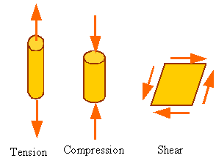

*Stress*

Loads applied on a material are distributed over a surface. For example, the point load shown in the following figure might actually be a uniformly distributed load that has been replaced by its equivalent point load.

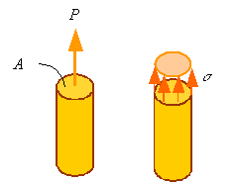

Stress is the load applied per unit area of the surface it is applied on. *Normal stress*is the stress normal to a surface and is denoted by the symbol "http://emweb.unl.edu/NEGAHBAN/Em325/01-How-Materials-carry-load/How%20Materials%20Carry%20Load_files/image006.gif" (*sigma*). In the above figure the normal stress is uniform over the surface of the bar and is given by

http://emweb.unl.edu/NEGAHBAN/Em325/01-How-Materials-carry-load/How%20Materials%20Carry%20Load_files/image008.gif

*Shear stress* is the stress tangent to a surface. If in the following figure the shear stress http://emweb.unl.edu/NEGAHBAN/Em325/01-How-Materials-carry-load/How%20Materials%20Carry%20Load_files/image010.gif (*tau)* that results in the shear load *V* is uniformly distributed over the surface, then the shear stress can be calculated by dividing the shear force by the area it is applied on.

http://emweb.unl.edu/NEGAHBAN/Em325/01-How-Materials-carry-load/How%20Materials%20Carry%20Load_files/image012.gif

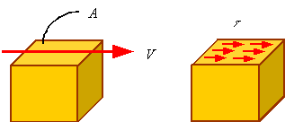

The units of stress are the units of load divided by the units of area. In the SI system the unit of stress is "Pa" and in the U.S. system it is "Psi". Pa and Psi are related to the basic units through the following relations

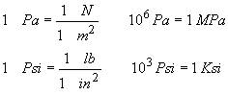

**1.2. *Basic modes of deformation of a material: Extension, contraction, shearing***

Material element can be extended, compressed, or sheared. The following figure shows how the square section to the left changes its shape during extension, contraction and shearing.

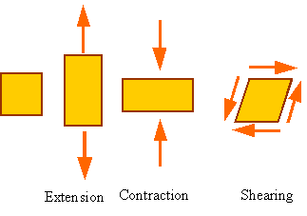

*Strain*

Strain is the way engineers represent the distortion of a body. *Axial strain*(normal strain) in a bar is a measure of the extension of a bar per unit length of the bar before deformation. The following figure shows a bar of initial length *l*o that is extended by the application of a load to the length *l*.

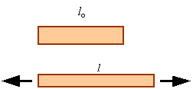

The axial strain, denoted by http://emweb.unl.edu/NEGAHBAN/Em325/01-How-Materials-carry-load/How%20Materials%20Carry%20Load_files/image022.gif (*epsilon*), in a homogeneously deforming bar is calculated by dividing the amount the bar extends by its initial length. This yield the equation

http://emweb.unl.edu/NEGAHBAN/Em325/01-How-Materials-carry-load/How%20Materials%20Carry%20Load_files/image024.gif

A positive axial strain represents extension and a negative axial strain represents a contraction. Strain has no units since it is one length divided by another length.

Shear strain, denoted by http://emweb.unl.edu/NEGAHBAN/Em325/01-How-Materials-carry-load/How%20Materials%20Carry%20Load_files/image026.gif (*gamma*), is a measure of how the angle between orthogonal lines drawn on an undeformed body changes with deformation. In the following figure the square has been sheared into a parallelogram.

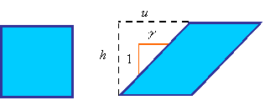

The shear strain is calculated from the equation

http://emweb.unl.edu/NEGAHBAN/Em325/01-How-Materials-carry-load/How%20Materials%20Carry%20Load_files/image030.gif

As can be seen from the following figure, the shear strain is equal to the tangent of the change in angle or the two orthogonal sides.

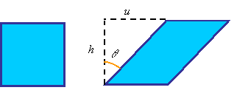

http://emweb.unl.edu/NEGAHBAN/Em325/01-How-Materials-carry-load/How%20Materials%20Carry%20Load_files/image034.gif

The difference between http://emweb.unl.edu/NEGAHBAN/Em325/01-How-Materials-carry-load/How%20Materials%20Carry%20Load_files/image035.gif and http://emweb.unl.edu/NEGAHBAN/Em325/01-How-Materials-carry-load/How%20Materials%20Carry%20Load_files/image037.gif becomes less and less as the angle http://emweb.unl.edu/NEGAHBAN/Em325/01-How-Materials-carry-load/How%20Materials%20Carry%20Load_files/image038.gif (in radians) becomes small. This is since the tangent of an angle, given in radians, can be approximated by the angle for small values of the angle. In most structural materials the shearing is small and we can use the approximation

http://emweb.unl.edu/NEGAHBAN/Em325/01-How-Materials-carry-load/How%20Materials%20Carry%20Load_files/image040.gif.

**1.3. *Tensile behavior different materials***

A typical tensile test one tries to induce uniform extension of the gage section of a tensile specimen. The gage section of the tensile specimen is normally of uniform rectangular or circular cross-section. The following figure shows a typical dog-bone sample. The two ends are used for fixing into the grips, which apply the load. As can be seen from the free-body diagram to the right, the load in the gage section is the same as the load applied by the grips.

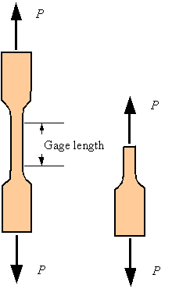

Using extensometers to measure the change of length in the gage section and a load cells to measure the load applied by the grips on the sample one calculates the axial strain and normal stress (knowing the initial gage length and cross-sectional area of the gage section). The result is a stress-strain diagram, a diagram of how stress is changing in the sample as a function of the strain for the given loading. A typical stress-strain diagram for mild steel is shown below.

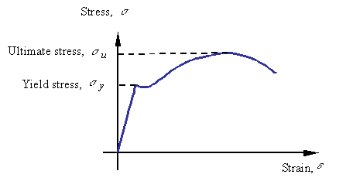

The different regions of the are response denoted by their characteristics as follows

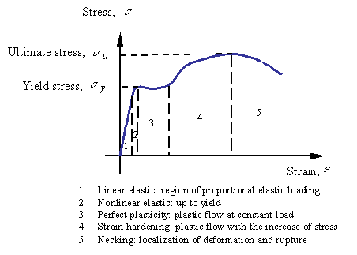

**1.4. *Brittle versus. Ductile behavior***

*Brittle materials fail at small strains and in tension.* Examples of such materials are glass, cast iron, and ceramics. *Ductile materials fail at large strains and in shear.* Examples of ductile materials are mild steel, aluminum and rubber. The ductility of a material is characterized by the strain at which the material fails. An alternate measure is the percent reduction in cross-sectional area at failure.

**1.5. *Different types of response***

*Elastic response:*

If the loading and unloading stress-strain plot overlaps each other the response is elastic. The response of steel below the yield stress is considered to be elastic.

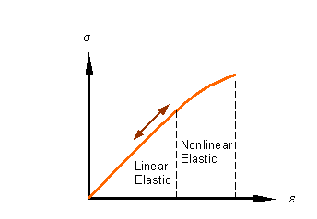

*Elastic-plastic response*

After loading beyond the yield point, the material no longer unloads along the loading path. There is a permanent stretch in the sample after unloading. The strain associated with this permanent extension is called the plastic strain (http://emweb.unl.edu/NEGAHBAN/Em325/01-How-Materials-carry-load/How%20Materials%20Carry%20Load_files/image050.gif on the figure). As shown in the figure, the unloading path is parallel to the initial linear elastic loading path.

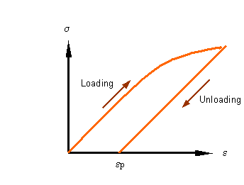

*Viscoelastic response*

Most plastics when loaded continue to deform over time even without increasing the load. This continues extension under constant referred to as *creep*. If held at constant strain, the load required to hold the strain decreases with time. The decrease in load over time at constant stretch is referred to as *relaxation.*

**1.6. *Bearing Stress***

Even though bearing stress is not a fundamental type of stress, it is a useful concept for the design of connections in which one part pushes against another. The compressive load divided by a characteristic area perpendicular to it yields the bearing stress which is denoted by http://emweb.unl.edu/NEGAHBAN/Em325/01-How-Materials-carry-load/How%20Materials%20Carry%20Load_files/image054.gif. Therefore, in form, the bearing stress is no different from the compressive axial stress and is given by

http://emweb.unl.edu/NEGAHBAN/Em325/01-How-Materials-carry-load/How%20Materials%20Carry%20Load_files/image056.gif

where *F* is the compressive load and *A* is a characteristic area perpendicular to it.

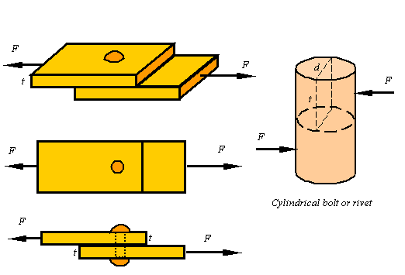

For example, if two plates are connected by a bolt or rivet as shown, each plate pushes against the side of the bolt with load *F*. It is not clear what the contact area between the bolt and the plate is since it depends on the size of the bolt and the shape of the deformation that results. Also, the distribution of the load on the bolt varies from point to point, but as a first approximation one can use the shown rectangle of area *A*=*td* to get a representative bearing stress for the bolt as

http://emweb.unl.edu/NEGAHBAN/Em325/01-How-Materials-carry-load/How%20Materials%20Carry%20Load_files/image060.gif.

**2. Hooke's law. Linear-Elastic Response and Factor of Safety**

**2.1. *Linear-elastic response***

*Hooke’s law*

In the linear elastic portion of the response of material one can model the response by *Hooke’s law:*

|  |
| --- |
| Hooke’s law for extension:http://emweb.unl.edu/NEGAHBAN/Em325/02-Linear-Elastic-Materials/Linear%20elastic%20materials_files/image002.gif  Hooke’s law for shear:  http://emweb.unl.edu/NEGAHBAN/Em325/02-Linear-Elastic-Materials/Linear%20elastic%20materials_files/image004.gif |

where *E* is the *elastic modulus* (also known as Young’s modulus), and *G* is the *shear modulus.* The elastic and shear moduli are material constants characterizing the stiffness of the material.

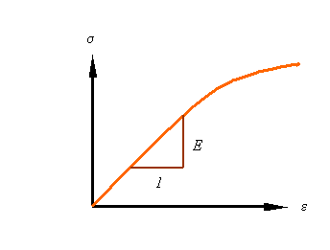

*Poisson’s Ratio*

Another material parameter is *Poisson’s ratio* that characterizes the contraction in the lateral directions when a material is extended. The symbol  (*nu*) is used for the poison ration, which is negative the ratio of the lateral strain to axial strain.

http://emweb.unl.edu/NEGAHBAN/Em325/02-Linear-Elastic-Materials/Linear%20elastic%20materials_files/image008.gif

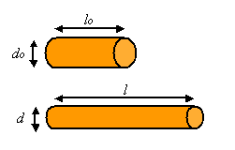

http://emweb.unl.edu/NEGAHBAN/Em325/02-Linear-Elastic-Materials/Linear%20elastic%20materials_files/image012.gif

http://emweb.unl.edu/NEGAHBAN/Em325/02-Linear-Elastic-Materials/Linear%20elastic%20materials_files/image014.gif

*Volumetric strain during extension*

During the extension of a bar the volumetric strain can be calculated as the ratio of the change in volume to the original volume. Denoting the volumetric strain as *e*, the initial volume as *V*o and the final volume as *V*, one can calculate the volumetric strain from

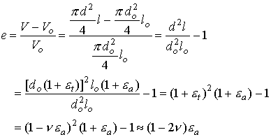

The last step is contingent on the axial strain being small relative to unity.

**2.2. *The relation between the elastic moduli***

For an isotropic elastic material (i.e., an elastic material for which the properties are the same along all directions) there are only two independent material constants. The relation between these three moduli are given by the equation

http://emweb.unl.edu/NEGAHBAN/Em325/02-Linear-Elastic-Materials/Linear%20elastic%20materials_files/image018.gif

**2.3. *Factor of safety***

The factor of safety denoted by *n* is the ratio of the load the structure can carry divided by the load it is required to take.

http://emweb.unl.edu/NEGAHBAN/Em325/02-Linear-Elastic-Materials/Linear%20elastic%20materials_files/image020.gif

Therefore, the factor of safety is a number greater than unity (*n*>1). The *allowable stress* for a given material is the maximum stress the material can take (normally the ultimate or yield stress) divided by the factor of safety.

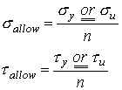.

**Questions for self-control**

1. What are the basic modes of loading a material?

2. What are the basic modes of deformation of a material?

3. How is the tensile behaviour of different materials defined?

4. How is the factor of safety calculated?

5. What is the formula for determining the relation between the elastic moduli?

**The basic literature**

1. Ralph H. Abraham and Jerrold E. Marsden. Foundations of Mechanics. -Wesley, 1978.

2. V. I. Arnold. Mathematical Methods of Classical Mechanics. - Springer Verlag, 1980.

3. Lothar Nordheim. The Principles of Mechanics. Vol. 2. - Springer, 1972.

4. Jean-Marie Souriau. Structure des Systèmes Dynamiques. - Dunod Université, Paris, 1970. (English translation: Birkhäuser Boston, 1998.)

5. E. C. G. Sudarshan and N. Mukunda. Classical Dynamics: A Modern Perspective. - John Wiley & Sons, 1974.

6. V. I. Arnold, V. V. Kozlov and A. I. Neishtadt. Mathematical Aspects of Classical and Celestial Mechanics. Dynamical Systems III. - Springer Verlag, 1988.

7. Giovanni Gallavotti. The Elements of Mechanics. - Springer Verlag, 1983.

8. F. R. Gantmakher. Lectures on analytical mechanics. - Fizmatgiz, 1960. (English translation by G. Yankovsky. - Mir Publishing, 1970.)

9. Herbert Goldstein. Classical Mechanics. 2nd edition. - Wesley, 1980.

10. Jorge V. José and Eugene J. Saletan. Classical Dynamics: A Contemporary Approach. - Cambridge University Press, 1998.

11. Cornelius Lanczos. The Variational Principles of Mechanics. 4th edition. - University of Toronto Press, 1970; Dover Publications, 1982.

12. Пронина Р.Ф. Пособие по переводу английской научно-технической литературы. - М.: Высшая школа, 1973.

13. Циммерман М., Веденеева К. Русско-английский научно-технический словарь переводчика. - М.: Наука, 1991.

14. Арушанян О.Б. Русско-английский словарь по прикладной математике и механике. (Russian-English dictionary of applied mathematics and mechanics). – М.: МГУ, 2012.

15. Пумпянский А.Л. Чтение и перевод английской научно-технической литературы: Лексика, грамматика, фонетика, упражнения /Худ. обл. М. В. Драко.— М.: ООО «Попурри», 1997.— 608 с.

**The supplementary literature**

1. L. D. Landau and E. M. Lifshitz. Mechanics. 3rd edition. Course of Theoretical Physics. Vol. 1. - Pergamon Press, 1976.

2. Jerrold E. Marsden and Tudor S. Ratiu. Introduction to Mechanics and Symmetry. - Springer Verlag, 1994.

3. Florian Scheck. Mechanics, From Newton's Laws to Deterministic Chaos. 2nd edition. - Springer-Verlag, 1994.

4. E. T. Whittaker. A Treatise on Analytical Dynamics. - Cambridge University Press, 1937.

5. Walter Thirring. A Course in Mathematical Physics 1: Classical Dynamical Systems, translated by Evans M. Harell, - Springer-Verlag, 1978.

6. Англо-русский словарь математических терминов: около 20000 терминов / под ред. П. С. Александрова. - Изд.3-е, стер. - М.: Мир, 2001.

7. Голденков М. Современный активный English. ЧеРо. – М: Физматлит, 2002.-448с.

**The list of periodicals**

1. Английский язык: Прил. к газете "1 сентября".

2. Иностранные языки в высшей школе.

**The source list on electronic media**

1. Кутателадзе С.С. Russian-English in writing. Изд. института математики. – Новосибирск, 2000.

2. Игнатьев-Каллэхэм Л. Русско-английский политехнический словарь. - М.: Уайли, 1995.

3. A.J. Lohwater's Russian-English dictionary of the mathematical sciences / R.P. Boas (ed.). American Mathematical Society, 1990.

4. Сосинский А. Б. Как написать математическую статью по-английски. — М: Изд-во «Факториал Пресс», 2000. — 112 с.

**The Internet sources**

1. http://ru.wikipedia.org

2. <http://lingualeo.com/>

**Lecture 2**

**Lecture topic: Extension of bars. Thermal Strain. Torsion of a circular shaft**

**The plan**

**1. Extension of bars**

1.1. Uniform bars

1.2. Non-uniform bars

**2. Thermal Strain**

2.1. Linear coefficient of thermal expansion

2.2. Volumetric coefficient of thermal expansion

2.3. Combining thermal and mechanical loads

**3. Torsion of a circular shaft**

3.1. Basic kinematics of torsion

3.2. The shear stress

3.3. Calculating the torque from the shear stress

3.4. Total twist in a bar

**1. Extension of bars**

**1.1. *Uniform bars***

Consider the problem of calculating the extension http://emweb.unl.edu/NEGAHBAN/Em325/04-Extension-of-bars/Extension%20of%20bars_files/image002.gif due to the application of an axial load *P* on a uniform bar as shown in the figure.

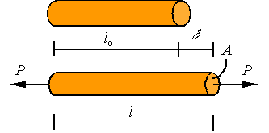

A bar is considered uniform if its cross-sectional area and elastic modulus are constant along the length of the bar. For such a bar under axial loading, the stress and strain along the bar are constants and given by the expressions

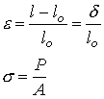

Assuming small strains and substituting these expressions into Hooke’s law http://emweb.unl.edu/NEGAHBAN/Em325/04-Extension-of-bars/Extension%20of%20bars_files/image008.gif, one arrives at the equation for the extension of the bar given as

http://emweb.unl.edu/NEGAHBAN/Em325/04-Extension-of-bars/Extension%20of%20bars_files/image010.gif

**1.2. *Non-uniform bars***

A bar with a varying cross-sectional area is an example of non-uniform bar. In general, one can have varying cross section, elastic modulus, and axial load in a bar. Such situations may result in varying stress and strain along the bar. This, in turn, requires a more in depth analysis to evaluate the extension of the bar. First, let us setup the kinematics of the deformation. As shown in the figure, in a typical situation one would have an initial unloaded configuration (top) and a configuration after loading (bottom).

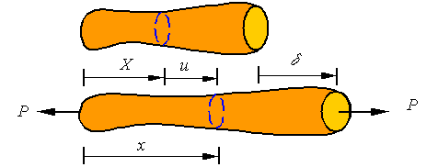

A typical cross-section that is at location *X* in the initial configuration, ends up in location *x* in the current configuration by being displaced a distance *u* from its original location. Each cross section can be displaced a different amount and may have a different cross-sectional area. Therefore, the displacement and cross-sectional area are each a function of the location along the bar (i.e., u(*X*) and *A*(*X*)). A typical segment of length http://emweb.unl.edu/NEGAHBAN/Em325/04-Extension-of-bars/Extension%20of%20bars_files/image014.gif of the bar is shown in the following figure.

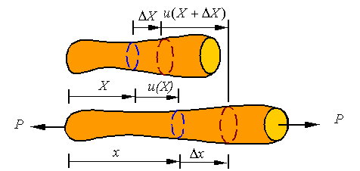

The average strain in this segment of the bar is given by the expression

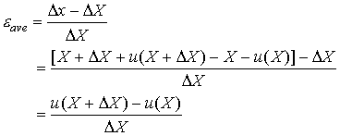

One can take a limit as http://emweb.unl.edu/NEGAHBAN/Em325/04-Extension-of-bars/Extension%20of%20bars_files/image019.gif goes to zero to define the strain at each point of the bar by

http://emweb.unl.edu/NEGAHBAN/Em325/04-Extension-of-bars/Extension%20of%20bars_files/image021.gif

The extension of any segment of the bar is the difference between the displacement of one end minus the displacement of the other end. This expression for strain can be integrated to get the extension. Let us say we are looking for the extension of the segment between *X*1 and *X*2. This would be given by integrating the strain to get

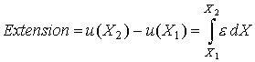

The total extension http://emweb.unl.edu/NEGAHBAN/Em325/04-Extension-of-bars/Extension%20of%20bars_files/image025.gif of a bar of initial length *L* is given by the expression

http://emweb.unl.edu/NEGAHBAN/Em325/04-Extension-of-bars/Extension%20of%20bars_files/image027.gif

As shown in the figure below, the bar might have a distributed load *w* applied on it in addition to point loads. As a result, the load and cross-sectional area might both vary with location in the bar so we will denote the load in the section at *X* by *P*(*X*) and the cross-sectional area by *A*(*X*). Therefore, the axial stress is given by

http://emweb.unl.edu/NEGAHBAN/Em325/04-Extension-of-bars/Extension%20of%20bars_files/image029.gif

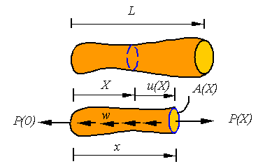

Since the material can change along the bar, the elastic modulus may also be a function of location along the bar. From Hooke’s law it follows that the strain at each point of the bar is given by

http://emweb.unl.edu/NEGAHBAN/Em325/04-Extension-of-bars/Extension%20of%20bars_files/image033.gif

Therefore the total extension in a non-uniform bar is given by

http://emweb.unl.edu/NEGAHBAN/Em325/04-Extension-of-bars/Extension%20of%20bars_files/image035.gif

This expression reduces to the one for a uniform bar when the argument of the integral is constant.

**2. Thermal Strain**

**2.1. *Linear coefficient of thermal expansion***

An unloaded uniform bar will extend due to a uniform change in the temperature. This extension http://emweb.unl.edu/NEGAHBAN/Em325/05-Thermal-strain/Thermal%20strain_files/image002.gif is linearly proportional to the temperature change and the strain associated with it is given by the relation

http://emweb.unl.edu/NEGAHBAN/Em325/05-Thermal-strain/Thermal%20strain_files/image004.gif

where http://emweb.unl.edu/NEGAHBAN/Em325/05-Thermal-strain/Thermal%20strain_files/image006.gif is the *linear coefficient of thermal expansion* and http://emweb.unl.edu/NEGAHBAN/Em325/05-Thermal-strain/Thermal%20strain_files/image008.gif is the rise in temperature.

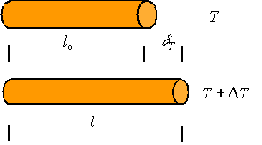

The strain is given by the extension divided by the original length through the standard relation

http://emweb.unl.edu/NEGAHBAN/Em325/05-Thermal-strain/Thermal%20strain_files/image012.gif

Combining this and the above expression one gets the relation for the extension of a uniform bar under a uniform change in temperature as

http://emweb.unl.edu/NEGAHBAN/Em325/05-Thermal-strain/Thermal%20strain_files/image014.gif

For a non-uniform bar or a non-uniform temperature distribution in the bar, one needs to integrate the strain using the expression for extension of a non-uniform bar to get

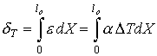

**2.2. *Volumetric coefficient of thermal expansion***

The volumetric strain http://emweb.unl.edu/NEGAHBAN/Em325/05-Thermal-strain/Thermal%20strain_files/image018.gif is linearly proportional to the change in temperature and is given by the relation

http://emweb.unl.edu/NEGAHBAN/Em325/05-Thermal-strain/Thermal%20strain_files/image020.gif

where the coefficient of proportionality http://emweb.unl.edu/NEGAHBAN/Em325/05-Thermal-strain/Thermal%20strain_files/image022.gif is the *volumetric coefficient of thermal expansion*.

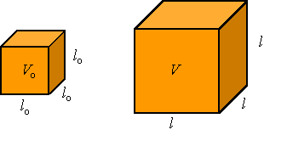

The volumetric coefficient of thermal expansion  is related to the linear  coefficient of thermal expansion through the relation between the volumetric strain and the axial strain. The volumetric strain *e* is given as the change in volume divided by the original volume

http://emweb.unl.edu/NEGAHBAN/Em325/05-Thermal-strain/Thermal%20strain_files/image026.gif

For a cube of isotropic material (a material which behaves the same along all different directions) with initial sides of length *l*o, the initial volume is http://emweb.unl.edu/NEGAHBAN/Em325/05-Thermal-strain/Thermal%20strain_files/image028.gif and since each side extends an amount http://emweb.unl.edu/NEGAHBAN/Em325/05-Thermal-strain/Thermal%20strain_files/image030.gif, the new volume is http://emweb.unl.edu/NEGAHBAN/Em325/05-Thermal-strain/Thermal%20strain_files/image032.gif. Substituting these expressions into the above relation one gets for small thermal strains the approximate relation

http://emweb.unl.edu/NEGAHBAN/Em325/05-Thermal-strain/Thermal%20strain_files/image034.gif

Therefore, for small thermal strains in an isotropic material the relation between the linear coefficient of thermal expansion and the volumetric coefficient of thermal expansion is given by

http://emweb.unl.edu/NEGAHBAN/Em325/05-Thermal-strain/Thermal%20strain_files/image036.gif.

**2.3. *Combining thermal and mechanical loads***

Since we only are considering linear theories, it is assumed that the thermal and mechanical effects are additive in the sense that the total strain http://emweb.unl.edu/NEGAHBAN/Em325/05-Thermal-strain/Thermal%20strain_files/image038.gif in a bar is the addition of the thermal strain http://emweb.unl.edu/NEGAHBAN/Em325/05-Thermal-strain/Thermal%20strain_files/image040.gif and the mechanical strain http://emweb.unl.edu/NEGAHBAN/Em325/05-Thermal-strain/Thermal%20strain_files/image042.gif. For a uniform bar under both uniform thermal and mechanical loading, this can be written as

http://emweb.unl.edu/NEGAHBAN/Em325/05-Thermal-strain/Thermal%20strain_files/image044.gif

which results in the total extension being given by

http://emweb.unl.edu/NEGAHBAN/Em325/05-Thermal-strain/Thermal%20strain_files/image046.gif

In the case of non-uniform members, one simply integrated the expression for strain once for the thermal strain and then again for the mechanical strain to get, respectively, the expression for the extension due to thermal expansion and the expression for the extension due to mechanical loading. Again, the sum of these expressions is the total extension of the bar.

**3. Torsion of a circular shaft**

**3.1. *Basic kinematics of torsion***

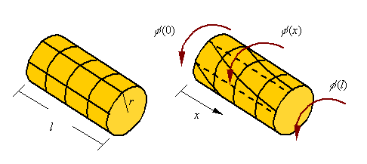

It is assumed that when twisted each cross-section in a circular bar rotates as a rigid body. If the amount of rotation of each cross-section is given by the function http://emweb.unl.edu/NEGAHBAN/Em325/06-Torsion/torsion_files/image004.gif, the total twist http://emweb.unl.edu/NEGAHBAN/Em325/06-Torsion/torsion_files/image006.gif in the bar of length *l* shown is given

http://emweb.unl.edu/NEGAHBAN/Em325/06-Torsion/torsion_files/image008.gif

During the torsion of a bar, axial lines drawn on the surface of a bar become helical and circumferential lines remain circumferential. Therefore, as can be seen in the figure, material elements are sheared in the process. This shear strain must be accompanied by a shear stress (from Hook’s law we knowhttp://emweb.unl.edu/NEGAHBAN/Em325/06-Torsion/torsion_files/image010.gif).

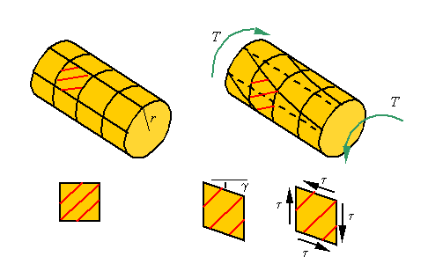

The shear strain can be related to the rotation of the cross sections. If over an increment of length http://emweb.unl.edu/NEGAHBAN/Em325/06-Torsion/torsion_files/image014.gif, the cross section rotates an amount http://emweb.unl.edu/NEGAHBAN/Em325/06-Torsion/torsion_files/image016.gif, then as can be seen in the figure the shear strain is given by

http://emweb.unl.edu/NEGAHBAN/Em325/06-Torsion/torsion_files/image018.gif

Therefore, at the limit one can write

http://emweb.unl.edu/NEGAHBAN/Em325/06-Torsion/torsion_files/image020.gif

As a result, the shear strain starts at zero at the center and reaches a maximum at the outer radius.

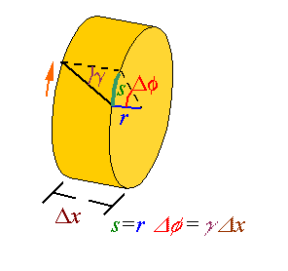

**3.2. *The shear stress***

The shear stress, through Hook’s law, is related to the shear strain. Therefore, the shear stress is given by

http://emweb.unl.edu/NEGAHBAN/Em325/06-Torsion/torsion_files/image024.gif

Again, like the shear strain, the shear stress is zero at the core of the bar and increases linearly to a maximum at the outer surface.

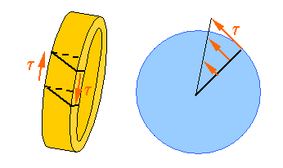

**3.3. *Calculating the torque from the shear stress***

The torque transmitted through the cross-section of a bar is the resultant of the moments created by the shear stresses on the cross-section.

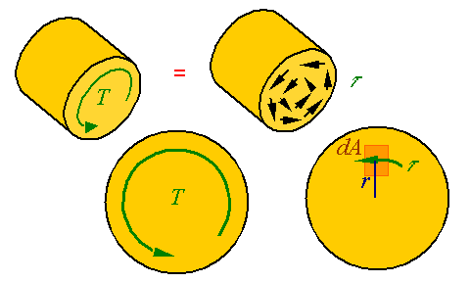

The differential shear load *dV* that results from the shear stress applied over the area *dA* of the cross section is http://emweb.unl.edu/NEGAHBAN/Em325/06-Torsion/torsion_files/image030.gif. The moment created by such a shear load is *dM = rdV*. The equivalent torque T on the cross section is the resultant of all the moments crated by the shear stresses so that

**http://emweb.unl.edu/NEGAHBAN/Em325/06-Torsion/torsion_files/image032.gif**

Using the expression for shear stress in terms of twist in the bar we get

**http://emweb.unl.edu/NEGAHBAN/Em325/06-Torsion/torsion_files/image034.gif**

where *Ip*is the polar area moment of inertia of the cross section. Using this relation, the expression for shear stress in terms of the torque follows from

http://emweb.unl.edu/NEGAHBAN/Em325/06-Torsion/torsion_files/image036.gif

**3.4. *Total twist in a bar***

The total twist in a bar is given by

http://emweb.unl.edu/NEGAHBAN/Em325/06-Torsion/torsion_files/image038.gif

The twist per unit length in terms of the torque is given by

*http://emweb.unl.edu/NEGAHBAN/Em325/06-Torsion/torsion_files/image040.gif*

Therefore, the total twist can be calculated from

http://emweb.unl.edu/NEGAHBAN/Em325/06-Torsion/torsion_files/image042.gif

In *the case of a uniform bar* for which the http://emweb.unl.edu/NEGAHBAN/Em325/06-Torsion/torsion_files/image044.gifis constant one can move the argument out and integrate to get

http://emweb.unl.edu/NEGAHBAN/Em325/06-Torsion/torsion_files/image046.gif.

**Questions for self-control**

1. How is the extension of non-uniform bars defined?

2. How are the linear coefficient of thermal expansion and the volumetric coefficient of thermal expansion calculated?

3. What is the basic kinematics of torsion?

4. How is the shear stress defined?

5. How is the calculation of the torque from the shear stress performed?

**The basic literature**

1. Ralph H. Abraham and Jerrold E. Marsden. Foundations of Mechanics. -Wesley, 1978.

2. V. I. Arnold. Mathematical Methods of Classical Mechanics. - Springer Verlag, 1980.

3. Lothar Nordheim. The Principles of Mechanics. Vol. 2. - Springer, 1972.

4. Jean-Marie Souriau. Structure des Systèmes Dynamiques. - Dunod Université, Paris, 1970. (English translation: Birkhäuser Boston, 1998.)

5. E. C. G. Sudarshan and N. Mukunda. Classical Dynamics: A Modern Perspective. - John Wiley & Sons, 1974.

6. V. I. Arnold, V. V. Kozlov and A. I. Neishtadt. Mathematical Aspects of Classical and Celestial Mechanics. Dynamical Systems III. - Springer Verlag, 1988.

7. Giovanni Gallavotti. The Elements of Mechanics. - Springer Verlag, 1983.

8. F. R. Gantmakher. Lectures on analytical mechanics. - Fizmatgiz, 1960. (English translation by G. Yankovsky. - Mir Publishing, 1970.)

9. Herbert Goldstein. Classical Mechanics. 2nd edition. - Wesley, 1980.

10. Jorge V. José and Eugene J. Saletan. Classical Dynamics: A Contemporary Approach. - Cambridge University Press, 1998.

11. Cornelius Lanczos. The Variational Principles of Mechanics. 4th edition. - University of Toronto Press, 1970; Dover Publications, 1982.

12. Пронина Р.Ф. Пособие по переводу английской научно-технической литературы. - М.: Высшая школа, 1973.

13. Циммерман М., Веденеева К. Русско-английский научно-технический словарь переводчика. - М.: Наука, 1991.

14. Арушанян О.Б. Русско-английский словарь по прикладной математике и механике. (Russian-English dictionary of applied mathematics and mechanics). – М.: МГУ, 2012.

15. Пумпянский А.Л. Чтение и перевод английской научно-технической литературы: Лексика, грамматика, фонетика, упражнения /Худ. обл. М. В. Драко.— М.: ООО «Попурри», 1997.— 608 с.

**The supplementary literature**

1. L. D. Landau and E. M. Lifshitz. Mechanics. 3rd edition. Course of Theoretical Physics. Vol. 1. - Pergamon Press, 1976.

2. Jerrold E. Marsden and Tudor S. Ratiu. Introduction to Mechanics and Symmetry. - Springer Verlag, 1994.

3. Florian Scheck. Mechanics, From Newton's Laws to Deterministic Chaos. 2nd edition. - Springer-Verlag, 1994.

4. E. T. Whittaker. A Treatise on Analytical Dynamics. - Cambridge University Press, 1937.

5. Walter Thirring. A Course in Mathematical Physics 1: Classical Dynamical Systems, translated by Evans M. Harell, - Springer-Verlag, 1978.

6. Англо-русский словарь математических терминов: около 20000 терминов / под ред. П. С. Александрова. - Изд.3-е, стер. - М.: Мир, 2001.

7. Голденков М. Современный активный English. ЧеРо. – М: Физматлит, 2002.-448с.

**The list of periodicals**

1. Английский язык: Прил. к газете "1 сентября".

2. Иностранные языки в высшей школе.

**The source list on electronic media**

1. Кутателадзе С.С. Russian-English in writing. Изд. института математики. – Новосибирск, 2000.

2. Игнатьев-Каллэхэм Л. Русско-английский политехнический словарь. - М.: Уайли, 1995.

2. A.J. Lohwater's Russian-English dictionary of the mathematical sciences / R.P. Boas (ed.). American Mathematical Society, 1990.

3. Сосинский А. Б. Как написать математическую статью по-английски. - М: Изд-во «Факториал Пресс», 2000. — 112 с.

**The Internet sources**

1. http://ru.wikipedia.org

2. <http://lingualeo.com/>

**Lecture 3**

**Lecture topic: Аrea Moment of inertia.** **Pure shear and power transmission**

**The plan**

**1. Аrea Moment of inertia**

**2. Pure shear and power transmission**

2.1. Pure shear

2.2. Strain in pure shear

2.3. Transmission of power

**1. Аrea Moment of inertia**

The area moment of inertia is the second moment of area around a given axis. For example, given the axis *O-O* and the shaded area shown, one calculates the second moment of the area by adding together http://emweb.unl.edu/NEGAHBAN/Em325/12-Area%20Moment%20of%20Inertia/Area%20Moment%20of%20inertia_files/image002.gif for all the elements of area *dA* in the shaded area.

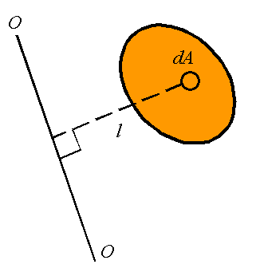

The *area moment of inertia, denoted by I,* can, therefore, be calculated from

http://emweb.unl.edu/NEGAHBAN/Em325/12-Area%20Moment%20of%20Inertia/Area%20Moment%20of%20inertia_files/image006.gif

If we have a rectangular coordinate system as shown, one can define the *area moment of inertial around the x-axis, denoted by Ix,*and the *area moment of inertia about the y-axis, denoted by Iy.* These are given by

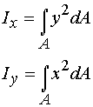

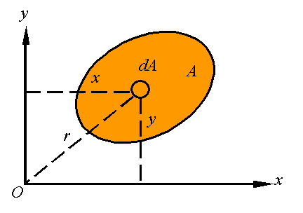

The *polar area moment of inertia, denoted by JO*, is the area moment of inertia about the *z*-axis given by

http://emweb.unl.edu/NEGAHBAN/Em325/12-Area%20Moment%20of%20Inertia/Area%20Moment%20of%20inertia_files/image012.gif

Note that since http://emweb.unl.edu/NEGAHBAN/Em325/12-Area%20Moment%20of%20Inertia/Area%20Moment%20of%20inertia_files/image014.gif one has the relation

http://emweb.unl.edu/NEGAHBAN/Em325/12-Area%20Moment%20of%20Inertia/Area%20Moment%20of%20inertia_files/image016.gif

The *radius of gyration* is the distance *k*away from the axis that all the area can be concentrated to result in the same moment of inertia. That is,

http://emweb.unl.edu/NEGAHBAN/Em325/12-Area%20Moment%20of%20Inertia/Area%20Moment%20of%20inertia_files/image018.gif

For a given area, one can define the radius of gyration around the *x*-axis, denoted by *k*x, the radius of gyration around the *y*-axis, denoted by *k*y, and the radius of gyration around the *z*-axis, denoted by *k*O. These are calculated from the relations

http://emweb.unl.edu/NEGAHBAN/Em325/12-Area%20Moment%20of%20Inertia/Area%20Moment%20of%20inertia_files/image020.gif

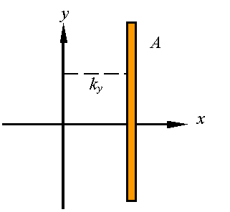

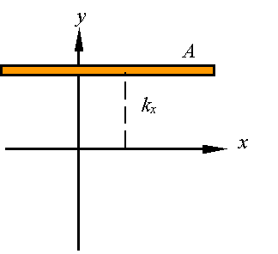

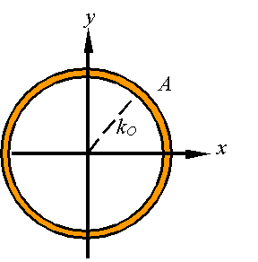

It can easily to show from

http://emweb.unl.edu/NEGAHBAN/Em325/12-Area%20Moment%20of%20Inertia/Area%20Moment%20of%20inertia_files/image028.gif

that

http://emweb.unl.edu/NEGAHBAN/Em325/12-Area%20Moment%20of%20Inertia/Area%20Moment%20of%20inertia_files/image030.gif

The *parallel axis theorem* is a relation between the moment of inertia about an axis passing through the centroid and the moment of inertia about any parallel axis.

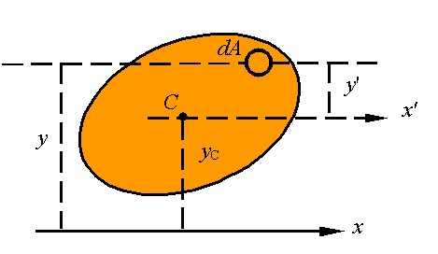

Note that from the picture we have

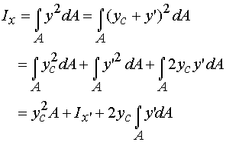

Since 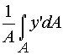 gives the distance of the centroid above the *x*'-axis, and since the this distance is zero, one must conclude that the integral in the last term is zero so that the parallel axis theorem states that

http://emweb.unl.edu/NEGAHBAN/Em325/12-Area%20Moment%20of%20Inertia/Area%20Moment%20of%20inertia_files/image038.gif

where x' must pass through the centroid of the area. In this same way, one can show that

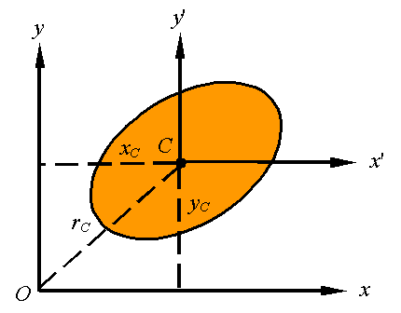

http://emweb.unl.edu/NEGAHBAN/Em325/12-Area%20Moment%20of%20Inertia/Area%20Moment%20of%20inertia_files/image042.gif

In general, one can use the parallel axis theorem for any two parallel axes as long as one passes through the centroid. As shown in the picture, this is written as

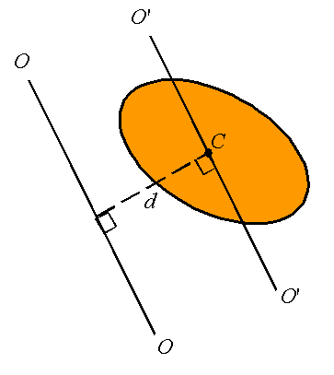

http://emweb.unl.edu/NEGAHBAN/Em325/12-Area%20Moment%20of%20Inertia/Area%20Moment%20of%20inertia_files/image046.gif

where http://emweb.unl.edu/NEGAHBAN/Em325/12-Area%20Moment%20of%20Inertia/Area%20Moment%20of%20inertia_files/image048.gif is the moment of inertia about the axis *O'-O'*passing through the centroid, *I* is the moment of inertia about the axis *O-O,*and *d* is the perpendicular distance between the two parallel axis.

The moment of inertia of *composite bodies* can be calculated by adding together the moment of inertial of each of its sections. The only thing to remember is that all moments of inertia must be evaluated bout the same axis. Therefore, for example,

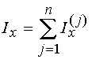

To calculate the area moment of inertia of the composite body constructed of the three segments shown, one evaluates the moment of inertial of each part about the *x*-axis and adds the three together.

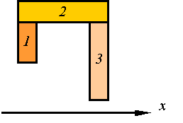

**2. Pure shear and power transmission**

**2.1. *Pure shear***

Consider the material element loaded in pure shear as shown in the figure

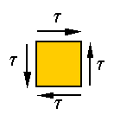

Stress on an inclined plane in this element is neither pure shear nor pure tension, it is a combination of both. Let http://emweb.unl.edu/NEGAHBAN/Em325/08-Pure-shear/Pure-shear_files/image004.gif and http://emweb.unl.edu/NEGAHBAN/Em325/08-Pure-shear/Pure-shear_files/image006.gif denote, respectively, the shear and normal stresses on the surface that makes an angle http://emweb.unl.edu/NEGAHBAN/Em325/08-Pure-shear/Pure-shear_files/image008.gif with the vertical, as shown in the following figure.

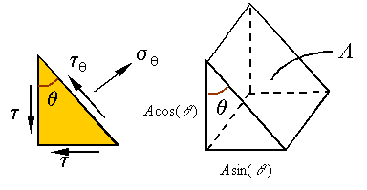

One can use equilibrium to calculate these stresses. If the area of the inclined surface is *A*, then the area of the vertical surface will be http://emweb.unl.edu/NEGAHBAN/Em325/08-Pure-shear/Pure-shear_files/image012.gif and the area of the horizontal surface will be http://emweb.unl.edu/NEGAHBAN/Em325/08-Pure-shear/Pure-shear_files/image014.gif, as shown in the above figure. The load on each surface can be calculated using the stresses and the areas they are applied on. Therefore, the free-body-diagram can be drawn as follows.

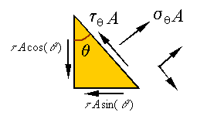

The sum of forces along the incline yields

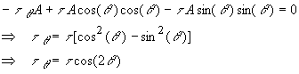

The sum of forces along the normal to the incline yields

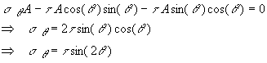

As can be seen from these equations, the *maximum shear stress*  is http://emweb.unl.edu/NEGAHBAN/Em325/08-Pure-shear/Pure-shear_files/image022.gif and occurs when http://emweb.unl.edu/NEGAHBAN/Em325/08-Pure-shear/Pure-shear_files/image024.gif or in other words when

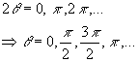

Note that these surfaces are the original vertical and horizontal surfaces on which the pure shear was applied. The *maximum normal stress* is http://emweb.unl.edu/NEGAHBAN/Em325/08-Pure-shear/Pure-shear_files/image027.gifand occurs when http://emweb.unl.edu/NEGAHBAN/Em325/08-Pure-shear/Pure-shear_files/image029.gif or in other words when

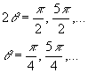

The *minimum normal stress* is http://emweb.unl.edu/NEGAHBAN/Em325/08-Pure-shear/Pure-shear_files/image033.gifand occurs when http://emweb.unl.edu/NEGAHBAN/Em325/08-Pure-shear/Pure-shear_files/image035.gif or in other words when

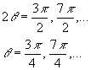

Note that the maximum and minimum normal stresses occur on surfaces which are 90o from one and other, and which are 45o from the vertical and horizontal lines. Also, note that the shear stress is zero at the angles where we have the maximum and minimum normal stresses. One can draw this on a diagram representing the stress on an element that is cut from the original as follows

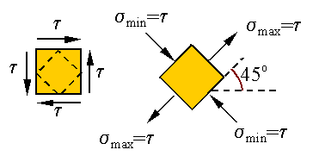

Since in torsion material elements that have sides that are along and perpendicular to the axis of the bar are subjected to pure shear, we can conclude that the surfaces of maximum tensile stress scribes a 45ohelix  as shown below.

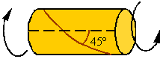

Ductile materials fail in shear and, therefore, a shaft made from a ductile material and under torsion will have a break surface that is perpendicular to the axis of the bar. Brittle materials fail in tension and, therefore, a shaft made of a brittle material and under torsion will break on a surface that is in the shape of a 45ohelix as shown above.

**2.2. *Strain in pure shear***

As shown above, the state of stress described as pure shear can be replaced by a state of stress that is a combination of tension and compression as follows

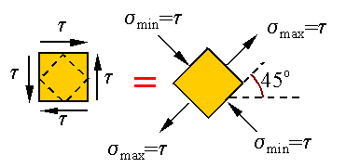

Let us consider a linear elastic material. Since the theory is linear, we can consider the following equivalence

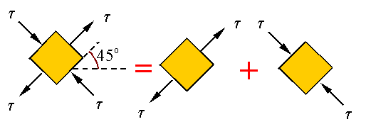

Therefore, the strains can be calculated based on the superposition of those resulting from the tension and compression. If the square originally has sides of length *a*, then we will have

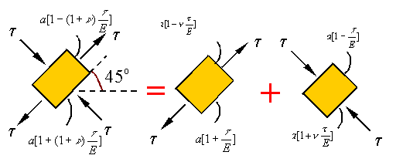

where  we have used Hooke's law http://emweb.unl.edu/NEGAHBAN/Em325/08-Pure-shear/Pure-shear_files/image049.giffor calculating the stretch along the axis of the load in each of the uniaxial extensions and we have used Poisson's ratio to calculate the transverse strain. Let us now look at how the shear and extension are related. Take  to denote the total axial strain given by

http://emweb.unl.edu/NEGAHBAN/Em325/08-Pure-shear/Pure-shear_files/image051.gif

The following figure shows the deformation of both the original pure shear element and the 45o element. In this figure gives the angle of shear which for small strains is approximately equal to the shear strain.

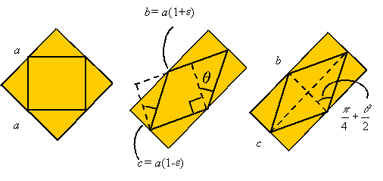

From the figure we can see that

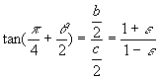

We can expand the tangent function using the identity

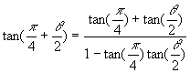

Assuming small angle , we get the

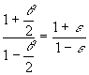

For small angles we know that http://emweb.unl.edu/NEGAHBAN/Em325/08-Pure-shear/Pure-shear_files/image061.gif, so that we get

http://emweb.unl.edu/NEGAHBAN/Em325/08-Pure-shear/Pure-shear_files/image063.gif

This relation can be used to relate the shear modulus to the elastic modulus and Poisson ratio since we can substitute from above into the equation and use Hooke's law for shear to get

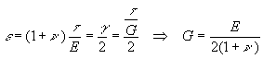

Note that this expression states that the shear modulus, the elastic modulus, and Poisson's ratio are not independent. One can calculate the third given any two.

**2.3. *Transmission of power***

Power is the rate at which work is being done. If *P* denotes power and *W* denotes work, then the relation between power and work can be written as

http://emweb.unl.edu/NEGAHBAN/Em325/08-Pure-shear/Pure-shear_files/image067.gif

The torque *T* applied on a shaft rotating with an angular velocity has a power given by the expression

http://emweb.unl.edu/NEGAHBAN/Em325/08-Pure-shear/Pure-shear_files/image069.gif

In this expression the angular velocity is in *radians per unit time*. The angular velocity is related to the frequency *f* by the relation

http://emweb.unl.edu/NEGAHBAN/Em325/08-Pure-shear/Pure-shear_files/image071.gif

Therefore, one can write

http://emweb.unl.edu/NEGAHBAN/Em325/08-Pure-shear/Pure-shear_files/image073.gif

Power can be given in terms of horsepower by the expression

http://emweb.unl.edu/NEGAHBAN/Em325/08-Pure-shear/Pure-shear_files/image075.gif

where *n* is in rpm (rounds per minute) and *T* is in lb-ft.

The *work done by a constant torque* over a given time interval can be calculated by integrating the power to get

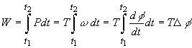

In this expression http://emweb.unl.edu/NEGAHBAN/Em325/08-Pure-shear/Pure-shear_files/image079.gif  is the total angle of rotation over the given time interval.

**Questions for self-control**

1. What is the area moment of inertia?

2. How is the pure shear determined?

3. How is the strain in pure shear defined?

4. What is the transmission of power?

5. How is the work done by a constant torque calculated?

**The basic literature**

1. Ralph H. Abraham and Jerrold E. Marsden. Foundations of Mechanics. -Wesley, 1978.

2. V. I. Arnold. Mathematical Methods of Classical Mechanics. - Springer Verlag, 1980.

3. Lothar Nordheim. The Principles of Mechanics. Vol. 2. - Springer, 1972.

4. Jean-Marie Souriau. Structure des Systèmes Dynamiques. - Dunod Université, Paris, 1970. (English translation: Birkhäuser Boston, 1998.)

5. E. C. G. Sudarshan and N. Mukunda. Classical Dynamics: A Modern Perspective. - John Wiley & Sons, 1974.

6. V. I. Arnold, V. V. Kozlov and A. I. Neishtadt. Mathematical Aspects of Classical and Celestial Mechanics. Dynamical Systems III. - Springer Verlag, 1988.

7. Giovanni Gallavotti. The Elements of Mechanics. - Springer Verlag, 1983.

8. F. R. Gantmakher. Lectures on analytical mechanics. - Fizmatgiz, 1960. (English translation by G. Yankovsky. - Mir Publishing, 1970.)

9. Herbert Goldstein. Classical Mechanics. 2nd edition. - Wesley, 1980.

10. Jorge V. José and Eugene J. Saletan. Classical Dynamics: A Contemporary Approach. - Cambridge University Press, 1998.

11. Cornelius Lanczos. The Variational Principles of Mechanics. 4th edition. - University of Toronto Press, 1970; Dover Publications, 1982.

12. Пронина Р.Ф. Пособие по переводу английской научно-технической литературы. - М.: Высшая школа, 1973.

13. Циммерман М., Веденеева К. Русско-английский научно-технический словарь переводчика. - М.: Наука, 1991.

14. Арушанян О.Б. Русско-английский словарь по прикладной математике и механике. (Russian-English dictionary of applied mathematics and mechanics). – М.: МГУ, 2012.

15. Пумпянский А.Л. Чтение и перевод английской научно-технической литературы: Лексика, грамматика, фонетика, упражнения /Худ. обл. М. В. Драко.— М.: ООО «Попурри», 1997.— 608 с.

**The supplementary literature**

1. L. D. Landau and E. M. Lifshitz. Mechanics. 3rd edition. Course of Theoretical Physics. Vol. 1. - Pergamon Press, 1976.

2. Jerrold E. Marsden and Tudor S. Ratiu. Introduction to Mechanics and Symmetry. - Springer Verlag, 1994.

3. Florian Scheck. Mechanics, From Newton's Laws to Deterministic Chaos. 2nd edition. - Springer-Verlag, 1994.

4. E. T. Whittaker. A Treatise on Analytical Dynamics. - Cambridge University Press, 1937.

5. Walter Thirring. A Course in Mathematical Physics 1: Classical Dynamical Systems, translated by Evans M. Harell, - Springer-Verlag, 1978.

6. Англо-русский словарь математических терминов: около 20000 терминов / под ред. П. С. Александрова. - Изд.3-е, стер. - М.: Мир, 2001.

7. Голденков М. Современный активный English. ЧеРо. – М: Физматлит, 2002.-448с.

**The list of periodicals**

1. Английский язык: Прил. к газете "1 сентября".

2. Иностранные языки в высшей школе.

**The source list on electronic media**

1. Кутателадзе С.С. Russian-English in writing. Изд. института математики. – Новосибирск, 2000.

2. Игнатьев-Каллэхэм Л. Русско-английский политехнический словарь. - М.: Уайли, 1995.

2. A.J. Lohwater's Russian-English dictionary of the mathematical sciences / R.P. Boas (ed.). American Mathematical Society, 1990.

3. Сосинский А. Б. Как написать математическую статью по-английски. - М: Изд-во «Факториал Пресс», 2000. — 112 с.

**The Internet sources**

1. http://ru.wikipedia.org

2. <http://lingualeo.com/>

**Lecture 4**

**Lecture topic: Equivalent force systems. Internal loads. Internal forces. Shear Load and Bending Moment Diagrams. Pure Bending**

**The plan**

**1. Equivalent force systems: Distributed loads**

1.1. Replacing distributed loads by a resultant load and resultant couple applied at a given point *O*

1.2. Replacing a distributed load by single resultant load

**2. Internal loads: Shear force, normal force, and bending moment. Internal forces**

**3. Shear Load and Bending Moment Diagrams**

3.1. Equilibrium of forces

3.2. Equilibrium of moments

3.3. Point loads and point moments

3.4. Drawing shear force and bending moment diagrams

**4. Pure Bending**

4.1. Kinematics of pure bending

4.2. Stress distribution in pure bending

4.3. Axial load and the location of the neutral axis

4.4. Bending moment and its relation to radius of curvature

**1. Equivalent force systems: Distributed loads**

|  |
| --- |
| **http://emweb.unl.edu/NEGAHBAN/Em325/09-Distributed-loads/Equivalent%20force%20systems-distributed%20loads_files/image002.gif** |

**1.1. *Replacing distributed loads by a resultant load and resultant couple applied at a given point*** *O*

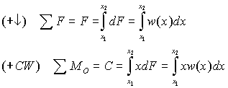

|  |
| --- |
| **http://emweb.unl.edu/NEGAHBAN/Em325/09-Distributed-loads/Equivalent%20force%20systems-distributed%20loads_files/image006.gif** |

**1.2. *Replacing a distributed load by single resultant load***

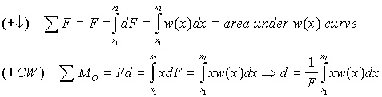

***Note:***Since the equation for *d*is the same as that for determining the centroid of the area under the *w(x)*curve, it follows that *F*must pass through the centroid of the area under the curve *w(x).*

|  |
| --- |
| **http://emweb.unl.edu/NEGAHBAN/Em325/09-Distributed-loads/Equivalent%20force%20systems-distributed%20loads_files/image010.gif** |

**2. Internal loads: Shear force, normal force, and bending moment. Internal forces**

As one can calculate the forces and moments transmitted through joints between members, one can also calculate the internal forces which one part of a member exerts on another. To calculate these internal forces, simply draw a free-body diagram of only part of the member, cutting through the member at the point you are interested in knowing the forces and moments. For example, consider the following member

|  |
| --- |
| http://emweb.unl.edu/NEGAHBAN/Em325/10-Internal-loads/Internal%20forces_files/image002.gif |

If you are interested in knowing the forces and moments that are transmitted through the member at point *D*, you can draw the free-body-diagram of the portion to the left of *D*to get

|  |
| --- |
| http://emweb.unl.edu/NEGAHBAN/Em325/10-Internal-loads/Internal%20forces_files/image004.gif |

For the body to be in equilibrium one must have

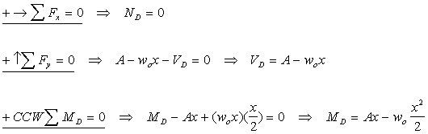

In this example, http://emweb.unl.edu/NEGAHBAN/Em325/10-Internal-loads/Internal%20forces_files/image008.gif is the axial force exerted by the right side of the bar on the left side of the bar at *D*, http://emweb.unl.edu/NEGAHBAN/Em325/10-Internal-loads/Internal%20forces_files/image010.gif is the shear load exerted by the right side of the bar on the left side of the bar at *D*, http://emweb.unl.edu/NEGAHBAN/Em325/10-Internal-loads/Internal%20forces_files/image012.gif is the bending moment exerted by the right side of the bar on the left side of the bar at *D*.

The example shows the basic elements of how one find the internal forces at a given point in a member. Like any other constraint, one must introduce a force or a moment for every way in which the motion of one side of the point is restricted by the other side. For example, in the above the right side of *D* restricts the left side from freely moving along the axial direction, and the transverse to the axial direction, and also restricts free rotation. Consequently, two forces and one moment are introduced to enforce the restriction.

***Note:***the forces and moment applied by the left-hand side onto the right-hand side are equal in magnitude but opposite in direction to the forces and moments applied by the right-hand side on the left-hand side.

**3. Shear Load and Bending Moment Diagrams**

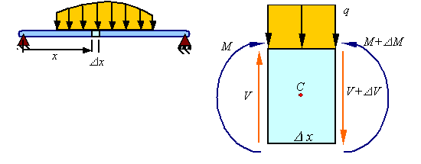

**3.1. *Equilibrium of forces***

The equilibrium of forces in the vertical direction in the segment shown of the member results in

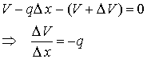

Taking the limit as http://emweb.unl.edu/NEGAHBAN/Em325/10a-shear-and-bending-moment/Shear%20stress%20in%20beams_files/image006.gif gives

http://emweb.unl.edu/NEGAHBAN/Em325/10a-shear-and-bending-moment/Shear%20stress%20in%20beams_files/image008.gif

Therefore, for continuous shear loads, the change in shear is related to the integral of the distributed load.

**3.2. *Equilibrium of moments***

The equilibrium of moments around the centroid *C* for the section shown yields

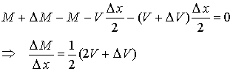

Taking the limit as http://emweb.unl.edu/NEGAHBAN/Em325/10a-shear-and-bending-moment/Shear%20stress%20in%20beams_files/image011.gif gives

http://emweb.unl.edu/NEGAHBAN/Em325/10a-shear-and-bending-moment/Shear%20stress%20in%20beams_files/image013.gif

Therefore, for continuous moments,  the change in moment is related to the integral of the shear load (the area under the shear diagram is related to the change in moment).

**3.3. *Point loads and point moments***

When there is a point load *F*o and a point moment *M*o applied at a point in the beam, the point load results in a jump in the value of the shear load *V* and the point moment results in a jump in the value of the bending moment *M*.

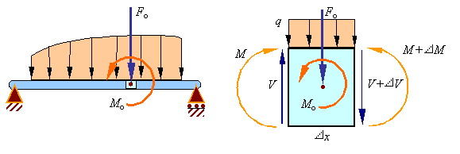

Equilibrium of forces on the element requires that

http://emweb.unl.edu/NEGAHBAN/Em325/10a-shear-and-bending-moment/Shear%20stress%20in%20beams_files/image017.gif

Taking a limit as *x* goes to zero results in the relation for the jump in the shear load due to an applied downward point load of *F*o to be given by

http://emweb.unl.edu/NEGAHBAN/Em325/10a-shear-and-bending-moment/Shear%20stress%20in%20beams_files/image019.gif

Equilibrium of moments on the element requires that

http://emweb.unl.edu/NEGAHBAN/Em325/10a-shear-and-bending-moment/Shear%20stress%20in%20beams_files/image021.gif

Taking a limit as *x* goes to zero results in the relation for the jump in the bending moment due to an applied counter-clockwise point moment of *M*o to be given by

http://emweb.unl.edu/NEGAHBAN/Em325/10a-shear-and-bending-moment/Shear%20stress%20in%20beams_files/image023.gif

Therefore, there will be a discontinuity at each applied point load in the shear diagram and a discontinuity at each applied couple in the moment diagram.

**3.4. *Drawing shear force and bending moment diagrams***

The shear load and bending moment diagrams are constructed by integrating the distributed load to get the shear diagram (adding jumps at all point loads), and integrating the shear diagram to get the bending moment (adding jumps at all point couples). The following is an example of one shear load and bending moment diagram.

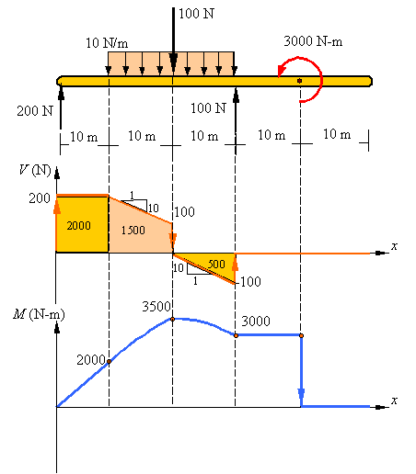

***Notes***

1. First draw the free-body-diagram of the beam with sufficient room under it for the shear and moment diagrams (if needed, solve for support reactions first).

2. Draw the shear diagram under the free-body-diagram. The distributed load is the slope of the shear diagram and each point load represents a jump in the shear diagram. Label all the loads on the shear diagram

3. Draw the moment diagram below the shear diagram. The shear load is the slope of the moment and point moments result in jumps in the moment diagram. The area under the shear diagram equals the change in moment over the segment considered (up to any jumps due to point moments). Label the value of the moment at all important points on the moment diagram.

**4. Pure Bending**

**4.1. *Kinematics of pure bending***

When a bar is subjected to a pure bending moment as shown in the figure it is observed that axial lines bend to form circumferential lines and transverse lines remain straight and become radial lines.

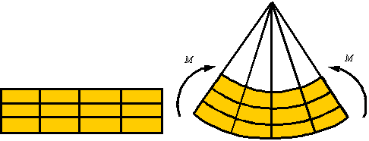

In the process of bending there are axial line that do not extend or contract. The surface descrived by the set of lines that do not extend or contract is called the neutral surface. Lines on one side of the neutral surface extend and on the other contract since the arc length is smaller on one side and larger on the other side of the neutral surface. The figure shows the netral surface in both the initial and the bent configuration.

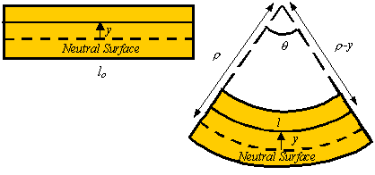

The axial strain in a line element a distance *y* above the neutral surface is given by

http://emweb.unl.edu/NEGAHBAN/Em325/11-Bending/Bending_files/image006.gif

where  is the radius to the neutral surface.

**4.2. *Stress distribution in pure bending***

By Hooke’s law, the axial stress is given in terms of the axial strain by the relation

http://emweb.unl.edu/NEGAHBAN/Em325/11-Bending/Bending_files/image008.gif

Therefore, the axial stress is zero on the neutral surface and increases linearly as one moves away from the neutral axis.

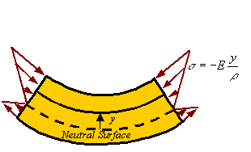

**4.3. *Axial load and the location of the neutral axis***

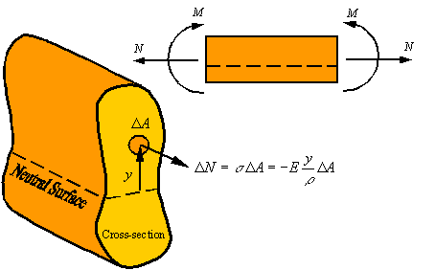

*There is zero axial load in a member under pure bending.* Therefore, the axial load generated by the stress should be zero. The axial load http://emweb.unl.edu/NEGAHBAN/Em325/11-Bending/Bending_files/image014.gif  generated by the stress http://emweb.unl.edu/NEGAHBAN/Em325/11-Bending/Bending_files/image016.gif applied on the area http://emweb.unl.edu/NEGAHBAN/Em325/11-Bending/Bending_files/image018.gif of the cross section is given by the approximate relation

http://emweb.unl.edu/NEGAHBAN/Em325/11-Bending/Bending_files/image020.gif

The total load on the cross section can be calculated by integrating this relation over the cross section. This yields

http://emweb.unl.edu/NEGAHBAN/Em325/11-Bending/Bending_files/image022.gif

Since the axial load is zero during pure bending, one concludes that for pure bending

http://emweb.unl.edu/NEGAHBAN/Em325/11-Bending/Bending_files/image024.gif

The reader recalls that the location of the centroid of an area is calculated from the relation

http://emweb.unl.edu/NEGAHBAN/Em325/11-Bending/Bending_files/image026.gif

Therefore, for the axial load to be zero, *the neutral axis must pass through the centroid of the cross section*(i.e., *y*c=0). In the event that the axial load is not zero, the location of the neutral axis relative to the centroid of the cross section can be calculated from the relation

http://emweb.unl.edu/NEGAHBAN/Em325/11-Bending/Bending_files/image028.gif

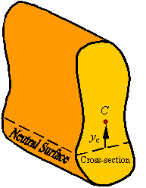

**4.4. *Bending moment and its relation to radius of curvature***



The bending moment http://emweb.unl.edu/NEGAHBAN/Em325/11-Bending/Bending_files/image033.gif about the neutral surface that is created by the normal load http://emweb.unl.edu/NEGAHBAN/Em325/11-Bending/Bending_files/image035.gif  resulting from the normal stress http://emweb.unl.edu/NEGAHBAN/Em325/11-Bending/Bending_files/image037.gif  acting on the area http://emweb.unl.edu/NEGAHBAN/Em325/11-Bending/Bending_files/image039.gif of the cross section can be calculated by

http://emweb.unl.edu/NEGAHBAN/Em325/11-Bending/Bending_files/image041.gif

Integrating over the cross section to get the total moment transmitted through the cross section gives

http://emweb.unl.edu/NEGAHBAN/Em325/11-Bending/Bending_files/image043.gif

Recalling that the integral in this relation is the area moment of inertial *I* about the neutral axis (the line resulting from the intersection of the cross section and the neutral surface), *the relation between the bending moment M and radius of curvature  of the neutral axis of the beam* becomes

http://emweb.unl.edu/NEGAHBAN/Em325/11-Bending/Bending_files/image045.gif

From this relation one can calculate the expression for stress as a function of the bending moment by substituting in the expression for axial stress this relation for the radius of curvature. This gives

http://emweb.unl.edu/NEGAHBAN/Em325/11-Bending/Bending_files/image047.gif

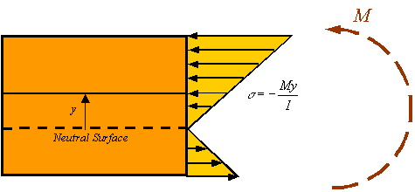

As can be seen in the figure, the maximum and minimum normal stresses occur in the material that is furthest away from the neutral surface (either at the top or bottom of the bar depending on the actual direction of the moment).

**Questions for self-control**

1. What are called equivalent force systems?

2. What is the physical meaning of the shear force?

3. What are the differences between the shear force and the normal force?

4. What is the algorithm for replacing a distributed load by single resultant load?

5. What are the bending moment and its relation to radius of curvature?

**The basic literature**

1. Ralph H. Abraham and Jerrold E. Marsden. Foundations of Mechanics. -Wesley, 1978.

2. V. I. Arnold. Mathematical Methods of Classical Mechanics. - Springer Verlag, 1980.

3. Lothar Nordheim. The Principles of Mechanics. Vol. 2. - Springer, 1972.

4. Jean-Marie Souriau. Structure des Systèmes Dynamiques. - Dunod Université, Paris, 1970. (English translation: Birkhäuser Boston, 1998.)

5. E. C. G. Sudarshan and N. Mukunda. Classical Dynamics: A Modern Perspective. - John Wiley & Sons, 1974.

6. V. I. Arnold, V. V. Kozlov and A. I. Neishtadt. Mathematical Aspects of Classical and Celestial Mechanics. Dynamical Systems III. - Springer Verlag, 1988.

7. Giovanni Gallavotti. The Elements of Mechanics. - Springer Verlag, 1983.

8. F. R. Gantmakher. Lectures on analytical mechanics. - Fizmatgiz, 1960. (English translation by G. Yankovsky. - Mir Publishing, 1970.)

9. Herbert Goldstein. Classical Mechanics. 2nd edition. - Wesley, 1980.

10. Jorge V. José and Eugene J. Saletan. Classical Dynamics: A Contemporary Approach. - Cambridge University Press, 1998.

11. Cornelius Lanczos. The Variational Principles of Mechanics. 4th edition. - University of Toronto Press, 1970; Dover Publications, 1982.

12. Пронина Р.Ф. Пособие по переводу английской научно-технической литературы. - М.: Высшая школа, 1973.

13. Циммерман М., Веденеева К. Русско-английский научно-технический словарь переводчика. - М.: Наука, 1991.

14. Арушанян О.Б. Русско-английский словарь по прикладной математике и механике. (Russian-English dictionary of applied mathematics and mechanics). – М.: МГУ, 2012.

15. Пумпянский А.Л. Чтение и перевод английской научно-технической литературы: Лексика, грамматика, фонетика, упражнения /Худ. обл. М. В. Драко.— М.: ООО «Попурри», 1997.— 608 с.

**The supplementary literature**

1. L. D. Landau and E. M. Lifshitz. Mechanics. 3rd edition. Course of Theoretical Physics. Vol. 1. - Pergamon Press, 1976.

2. Jerrold E. Marsden and Tudor S. Ratiu. Introduction to Mechanics and Symmetry. - Springer Verlag, 1994.

3. Florian Scheck. Mechanics, From Newton's Laws to Deterministic Chaos. 2nd edition. - Springer-Verlag, 1994.

4. E. T. Whittaker. A Treatise on Analytical Dynamics. - Cambridge University Press, 1937.

5. Walter Thirring. A Course in Mathematical Physics 1: Classical Dynamical Systems, translated by Evans M. Harell, - Springer-Verlag, 1978.

6. Англо-русский словарь математических терминов: около 20000 терминов / под ред. П. С. Александрова. - Изд.3-е, стер. - М.: Мир, 2001.

7. Голденков М. Современный активный English. ЧеРо. – М: Физматлит, 2002.-448с.

**The list of periodicals**

1. Английский язык: Прил. к газете "1 сентября".

2. Иностранные языки в высшей школе.

**The source list on electronic media**

1. Кутателадзе С.С. Russian-English in writing. Изд. института математики. – Новосибирск, 2000.

2. Игнатьев-Каллэхэм Л. Русско-английский политехнический словарь. - М.: Уайли, 1995.

2. A.J. Lohwater's Russian-English dictionary of the mathematical sciences / R.P. Boas (ed.). American Mathematical Society, 1990.

3. Сосинский А. Б. Как написать математическую статью по-английски. - М: Изд-во «Факториал Пресс», 2000. — 112 с.

**The Internet sources**

1. http://ru.wikipedia.org

2. <http://lingualeo.com/>

**Lecture 5**

**Lecture topic: Shear Stress in Beams. Beams with axial loads. Stress-element and plane stress**

**The plan**

**1. Shear Stress in Beams**

1.1. The shear stress calculation algorithm

1.2. Calculating the first moment of the area

1.3. Shear stress along a slanted direction

**2. Beams with axial loads**

2.1. Eccentric axial load

**3. Stress-element and plane stress**

3.1. General stress state at a point

3.2. Plane stress

3.3. Stress on an inclined surface in stress

3.4. Elements selected along different coordinate directions

**1. Shear Stress in Beams**

**1.1. *The shear stress calculation algorithm***

Consider a segment of the beam shown. The shear load on the vertical surfaces are generated by shear stress that can be calculated by the following process.



To calculate the shear stress generated from the shear load V consider removing the segment of the beam shown in red.

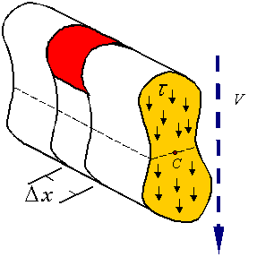

By symmetry of stress, shear stresses on the cross section results in equal shear stresses on the plane perpendicular to the cross section as shown. This shear stress results in a shear load *F*s.

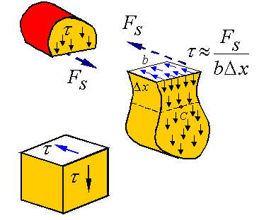

The side view of this segment, showing only axial loads, will look as follows

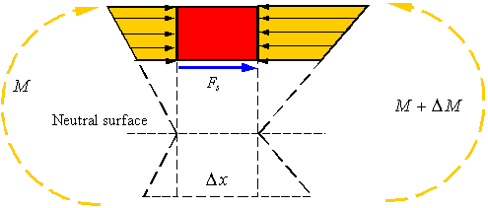

As can be seen, the difference in the bending moment on the two sides of the segment results in the normal stresses being different. The shear load *F*s is the element that brings the segment into equilibrium. The axial load due to the normal stresses created by the bending moment can be calculated by integrating the normal stress over the area *A*\* of the cross section.

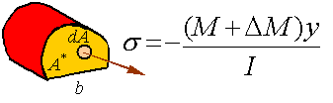

Therefore, equilibrium in the axial direction for this segment is written as

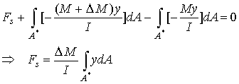

The integral in this expression is the first moment of the area *A*\* about the neutral axis. This first moment will be denoted by *Q* so that

http://emweb.unl.edu/NEGAHBAN/Em325/13-Shear-stress-in-beams/Shear%20stress%20in%20beams_files/image014.gif

The shear stress can now be calculated from the shear load by dividing it by the area it is applied on to get

http://emweb.unl.edu/NEGAHBAN/Em325/13-Shear-stress-in-beams/Shear%20stress%20in%20beams_files/image016.gif.

Taking the limit as http://emweb.unl.edu/NEGAHBAN/Em325/13-Shear-stress-in-beams/Shear%20stress%20in%20beams_files/image018.gif gives

http://emweb.unl.edu/NEGAHBAN/Em325/13-Shear-stress-in-beams/Shear%20stress%20in%20beams_files/image020.gif,

where we note that http://emweb.unl.edu/NEGAHBAN/Em325/13-Shear-stress-in-beams/Shear%20stress%20in%20beams_files/image022.gif.

**1.2. *Calculating the first moment of the area***

The first moment of the area can be calculated from the relation

http://emweb.unl.edu/NEGAHBAN/Em325/13-Shear-stress-in-beams/Shear%20stress%20in%20beams_files/image024.gif,

where *A*\* is the area of the part of the cross section that is considered, http://emweb.unl.edu/NEGAHBAN/Em325/13-Shear-stress-in-beams/Shear%20stress%20in%20beams_files/image026.gif is the vertical distance from the centroid of the cross section to the centroid of *A*\*.

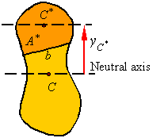

For composite areas, the first moment of area can be calculated for each part and then added together. The equation for *Q*in this case is

http://emweb.unl.edu/NEGAHBAN/Em325/13-Shear-stress-in-beams/Shear%20stress%20in%20beams_files/image030.gif.

**1.3. *Shear stress along a slanted direction***

The procedure presented does not require that the segment be cut with a surface parallel to the neutral surface. Therefore, one can remove a segment with the lower surface being at an oblique angle to the neutral surface so that the cross section will look as shown.

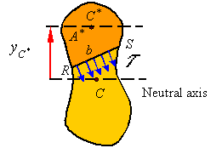

The shear calculated in this way is the average shear stress perpendicular to the line *RS* of width *b*.

**2. Beams with axial loads**

Consider the case where a beam has both an axial load and a bending moment. If the axial load passes through the neutral axis for pure bending, the axial load will not contribute to additional bending and one can consider the loading as a linear superposition of pure bending and uniform extension.

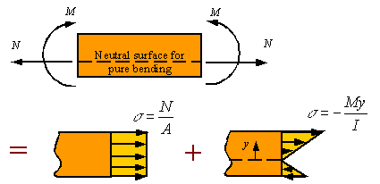

**2.1. *Eccentric axial load***

If the axial load is applied such that its line of action is not on the neutral surface for pure bending, then this axial load results in bending. Such an eccentric load can be replaced by an equivalent that is on the neutral surface and bending moment as shown in the figure.

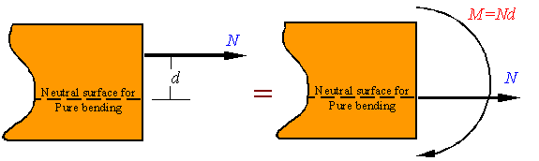

Once the equivalent system is constructed, then one can use the above method of superposition to calculate the stress.

**3. Stress-element and plane stress**

**3.1. *General stress state at a point***

At each point in a loaded material body the stress can be characterized by a stress element which shows the shear and normal stresses on a cube. The figure shows such an element taken from a body under three dimensional loading.

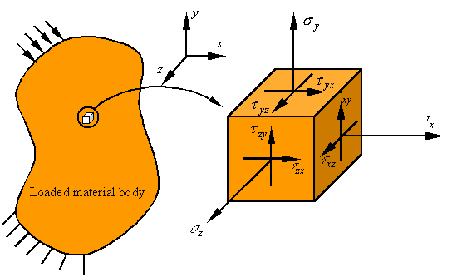

The first subscript on the shear stress denotes the normal to the surface on which the shear stress is applied, and the second index refers to the direction of the shear stress. It can be shown that the “stress is symmetric,” meaning that

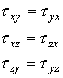

**3.2. *Plane stress***

The state of stress referred to as plane stress is characterized by one surface

being free of traction. Taking the surface with normal along the *z*-direction to be the free surface, the state of stress for plane stress can be drawn as follows.

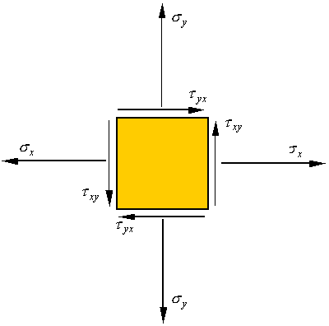

**3.3. *Stress on an inclined surface in stress***

Consider the plane stress element shown. If a section from this element is separated as shown, the normal and shear stress on this surface can be calculated by the following process.

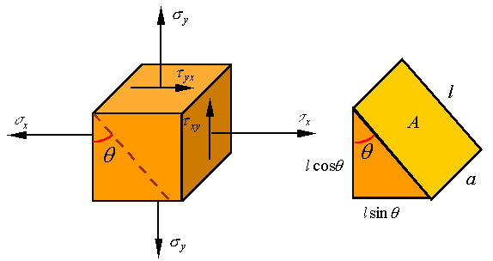

If the area of the surface exposed by the cut is *A*, then the area of the surface to the left will be http://emweb.unl.edu/NEGAHBAN/Em325/15-Plane-stress/plane%20stress_files/image010.gif and the area of the surface at the bottom will be http://emweb.unl.edu/NEGAHBAN/Em325/15-Plane-stress/plane%20stress_files/image012.gif. The stresses on these surfaces are shown on the left below, and the load on the surfaces (stress times area) are shown on the right below.

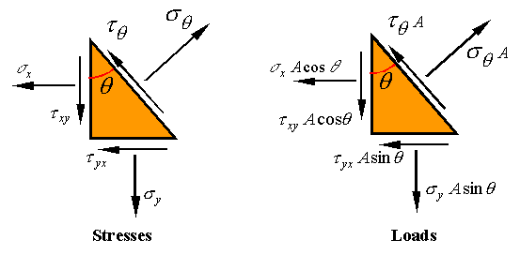

Equilibrium of forces in the direction normal to the inclined surface requires that

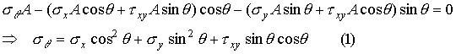

where we have used the fact that stress is symmetric to replace http://emweb.unl.edu/NEGAHBAN/Em325/15-Plane-stress/plane%20stress_files/image018.gif by http://emweb.unl.edu/NEGAHBAN/Em325/15-Plane-stress/plane%20stress_files/image020.gif. Equilibrium in the direction tangent to the inclined surface requires that

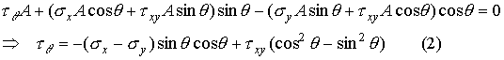

One can use the following trig identities to reorganize these expressions.

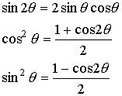

The result of using these identities is

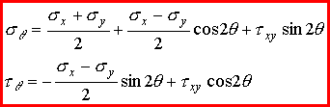

**3.4. *Elements selected along different coordinate directions***

If in place of the *x*-*y* coordinate system the stress element is oriented along the *x*\*-*y*\* coordinate directions, the normal and shear stresses on the element will look as follows.

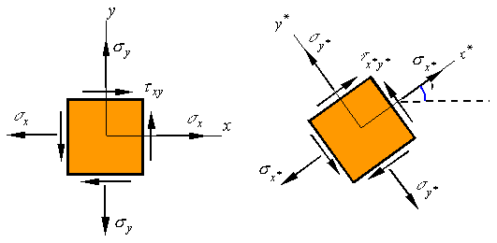

This new coordinate system is rotated an angle http://emweb.unl.edu/NEGAHBAN/Em325/15-Plane-stress/plane%20stress_files/image030.gif counter-clockwise from the original system. Each surface of this new element is an inclined surface for which one can calculate the stresses using the above equations. Note that the orientation of each of the four surfaces are given below.

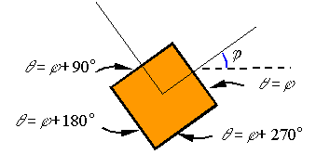

Substitution of these angles into the equations for normal and shear stress on inclined surfaces results in

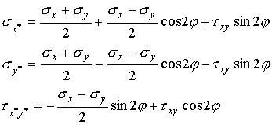

Note that the sum of the two normal stresses results in the relation

http://emweb.unl.edu/NEGAHBAN/Em325/15-Plane-stress/plane%20stress_files/image036.gif

which states that the sum of the two normal stresses on a stress element should be the same irrespective of the coordinate directions selected.

**Questions for self-control**

1. What is the shear stress along a slanted direction?

2. What is the physical meaning of the eccentric axial load?

3. How is the first moment of the area calculated?

4. How is the shear stress calculation algorithm defined?

5. How are stresses on an inclined surface determined?

**The basic literature**

1. Ralph H. Abraham and Jerrold E. Marsden. Foundations of Mechanics. -Wesley, 1978.

2. V. I. Arnold. Mathematical Methods of Classical Mechanics. - Springer Verlag, 1980.

3. Lothar Nordheim. The Principles of Mechanics. Vol. 2. - Springer, 1972.

4. Jean-Marie Souriau. Structure des Systèmes Dynamiques. - Dunod Université, Paris, 1970. (English translation: Birkhäuser Boston, 1998.)

5. E. C. G. Sudarshan and N. Mukunda. Classical Dynamics: A Modern Perspective. - John Wiley & Sons, 1974.

6. V. I. Arnold, V. V. Kozlov and A. I. Neishtadt. Mathematical Aspects of Classical and Celestial Mechanics. Dynamical Systems III. - Springer Verlag, 1988.

7. Giovanni Gallavotti. The Elements of Mechanics. - Springer Verlag, 1983.

8. F. R. Gantmakher. Lectures on analytical mechanics. - Fizmatgiz, 1960. (English translation by G. Yankovsky. - Mir Publishing, 1970.)

9. Herbert Goldstein. Classical Mechanics. 2nd edition. - Wesley, 1980.

10. Jorge V. José and Eugene J. Saletan. Classical Dynamics: A Contemporary Approach. - Cambridge University Press, 1998.

11. Cornelius Lanczos. The Variational Principles of Mechanics. 4th edition. - University of Toronto Press, 1970; Dover Publications, 1982.

12. Пронина Р.Ф. Пособие по переводу английской научно-технической литературы. - М.: Высшая школа, 1973.

13. Циммерман М., Веденеева К. Русско-английский научно-технический словарь переводчика. - М.: Наука, 1991.

14. Арушанян О.Б. Русско-английский словарь по прикладной математике и механике. (Russian-English dictionary of applied mathematics and mechanics). – М.: МГУ, 2012.

15. Пумпянский А.Л. Чтение и перевод английской научно-технической литературы: Лексика, грамматика, фонетика, упражнения /Худ. обл. М. В. Драко.— М.: ООО «Попурри», 1997.— 608 с.

**The supplementary literature**

1. L. D. Landau and E. M. Lifshitz. Mechanics. 3rd edition. Course of Theoretical Physics. Vol. 1. - Pergamon Press, 1976.

2. Jerrold E. Marsden and Tudor S. Ratiu. Introduction to Mechanics and Symmetry. - Springer Verlag, 1994.

3. Florian Scheck. Mechanics, From Newton's Laws to Deterministic Chaos. 2nd edition. - Springer-Verlag, 1994.

4. E. T. Whittaker. A Treatise on Analytical Dynamics. - Cambridge University Press, 1937.

5. Walter Thirring. A Course in Mathematical Physics 1: Classical Dynamical Systems, translated by Evans M. Harell, - Springer-Verlag, 1978.

6. Англо-русский словарь математических терминов: около 20000 терминов / под ред. П. С. Александрова. - Изд.3-е, стер. - М.: Мир, 2001.

7. Голденков М. Современный активный English. ЧеРо. – М: Физматлит, 2002.-448с.

**The list of periodicals**

1. Английский язык: Прил. к газете "1 сентября".

2. Иностранные языки в высшей школе.

**The source list on electronic media**

1. Кутателадзе С.С. Russian-English in writing. Изд. института математики. – Новосибирск, 2000.

2. Игнатьев-Каллэхэм Л. Русско-английский политехнический словарь. - М.: Уайли, 1995.

2. A.J. Lohwater's Russian-English dictionary of the mathematical sciences / R.P. Boas (ed.). American Mathematical Society, 1990.

3. Сосинский А. Б. Как написать математическую статью по-английски. - М: Изд-во «Факториал Пресс», 2000. — 112 с.

**The Internet sources**

1. http://ru.wikipedia.org

2. <http://lingualeo.com/>

**Lecture 6**

**Lecture topic: Mohr’s Circle.** **Hooke’s law and volumetric strain for plane-stress**

**The plan**

**1. Mohr's circle for plane stress**

1.1. Mohr’s circle for plane stress

1.2. Locating points on Mohr’s circle

1.3. Principal stresses

1.4. Out of plane stresses

**2. Hooke’s law and volumetric strain for plane-stress**

2.1. Hooke’s law for plane-stress

**1. Mohr's circle for plane stress**

**1.1. *Mohr’s circle for plane stress***

Consider the state of plane-stress shown in the figure.

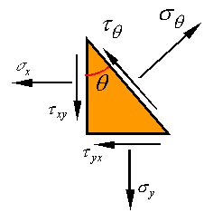

If negative the shear stress http://emweb.unl.edu/NEGAHBAN/Em325/16-Mohr's-circle/Mohr's%20circle_files/image004.gif is plotted against the normal stress http://emweb.unl.edu/NEGAHBAN/Em325/16-Mohr's-circle/Mohr's%20circle_files/image006.gif for each angle http://emweb.unl.edu/NEGAHBAN/Em325/16-Mohr's-circle/Mohr's%20circle_files/image008.gif of the incline, the resulting plot will be a circle of radius R and with its center located at http://emweb.unl.edu/NEGAHBAN/Em325/16-Mohr's-circle/Mohr's%20circle_files/image010.gif. This can be directly shown by examining the equations for http://emweb.unl.edu/NEGAHBAN/Em325/16-Mohr's-circle/Mohr's%20circle_files/image011.gif and http://emweb.unl.edu/NEGAHBAN/Em325/16-Mohr's-circle/Mohr's%20circle_files/image012.gif.

z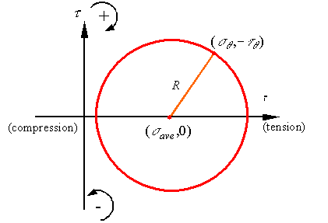

This circle is called Mohr’s circle and is a powerful tool for visualizing the possible states of stress at a material point. For example, at a glance one can see that the maximum normal stress at the point is the average stress plus the radius, the minimum normal stress at the point is the average stress minus the radius and the maximum shear stress at the point is equal to the radius.

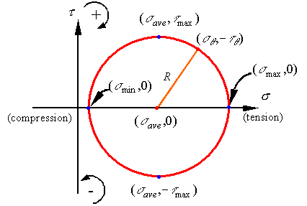

The equations to calculate these stresses are

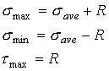

where

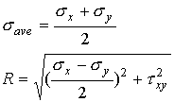

As can be seen the maximum and minimum normal stresses occur on surfaces that have zero shear stress, but the maximum shear stress occurs on a surface that has a normal stress equal to the average normal stress.

The convention for positive and negative shear stress on the Mohr’s circle is given on the axis and in terms of the direction of the shear stress on the stress element is shown in the following figure.

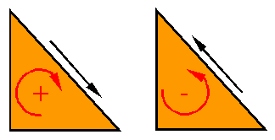

**1.2. *Locating points on Mohr’s circle***

One can locate points on Mohr’s circle by locating the point representing the surface normal to the *x*-axis, which has the coordinates http://emweb.unl.edu/NEGAHBAN/Em325/16-Mohr's-circle/Mohr's%20circle_files/image024.gif, and then going along the circle an angle of http://emweb.unl.edu/NEGAHBAN/Em325/16-Mohr's-circle/Mohr's%20circle_files/image026.gif to get to the state of stress on the surface with an incline angle of http://emweb.unl.edu/NEGAHBAN/Em325/16-Mohr's-circle/Mohr's%20circle_files/image028.gif.

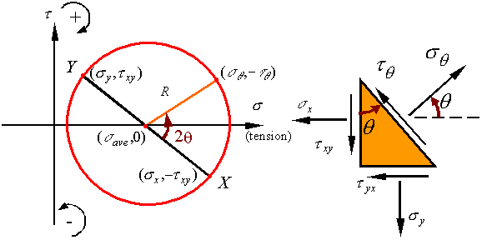

On Mohr’s circle, point  *X* represent the surface with normal along the *x*-direction and point *Y* represents the surface with normal along the *y*-direction. Since these surfaces are 90o apart on the stress element, on Mohr’s circle they are 180o apart (i.e., they end up on opposite sides of the circle).

**1.3. *Principal stresses***

Principal stresses referrer to the maximum and minimum normal stresses. As can be seen on Mohr’s circle, the principal normal stresses occur on surfaces which have no shear stress. Also, the maximum shear stress is 90o away from the maximum normal stress on Mohr’s circle so that it is on a surface oriented 45o away from the surface on which the maximum normal stress occurs.

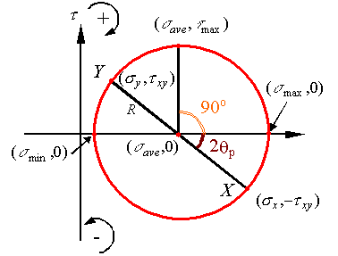

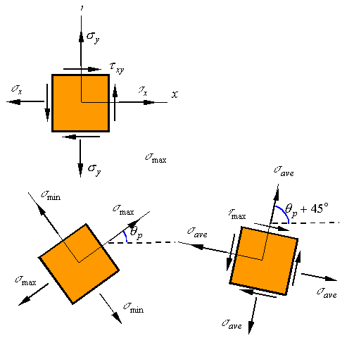

**1.4. *Out of plane stresses***

Consider the stress element shown where upon a state of plane stress a normal stress http://emweb.unl.edu/NEGAHBAN/Em325/16-Mohr's-circle/Mohr's%20circle_files/image036.gif is added in the third direction. Since this added stress is along a direction perpendicular to the plane stress, it does not interact with the in-plane stress (the stresses in the *x-y* plane) and all the results obtained for plane stress still hold. We can now rotate the stress element around the *z*-axis to get an element along the principal directions (only normal stresses remain).

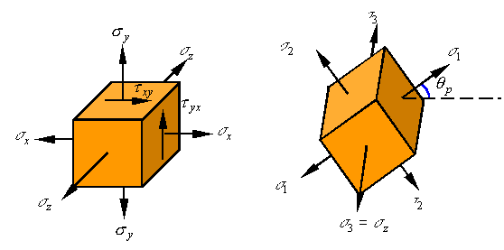

Each two of the resulting directions now represents a simple state of plane stress for which shear stresses are zero. One can draw the three Mohr’s circles which result from each pair of directions to get the following Mohr’s circles. One can show that all states of stress fall between the three circles (the shaded area).

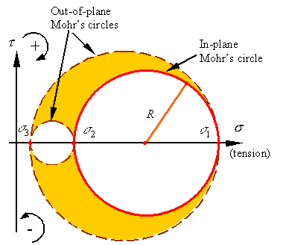

The absolute maximum and minimum normal stresses depend on the relative values of the three principal stresses http://emweb.unl.edu/NEGAHBAN/Em325/16-Mohr's-circle/Mohr's%20circle_files/image042.gif, http://emweb.unl.edu/NEGAHBAN/Em325/16-Mohr's-circle/Mohr's%20circle_files/image044.gif, and http://emweb.unl.edu/NEGAHBAN/Em325/16-Mohr's-circle/Mohr's%20circle_files/image046.gif (and need not be as shown in the figure). Also the maximum shear stress will equal the radius of the largest circle.

**2. Hooke’s law and volumetric strain for plane-stress**

**2.1. *Hooke’s law for plane-stress***

Consider the state of plane-stress shown in the figure.

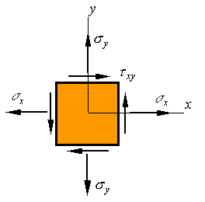

One can consider this state as a linear superposition of the following three loading states:

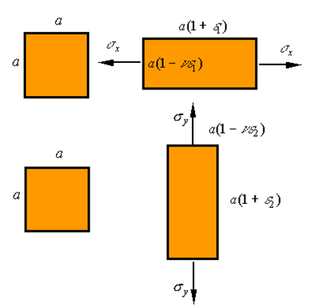

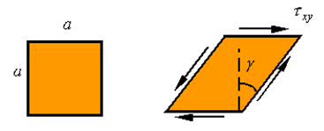

From our expressions for Hooke’s law for uniaxial extension and shear we have

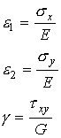

The total strain in the *x*-direction is http://emweb.unl.edu/NEGAHBAN/Em325/17-Hooke's-law-for-plane-stress/Hooke's%20law%20for%20plane%20stress_files/image008.gif, the total strain in the *y*-direction is http://emweb.unl.edu/NEGAHBAN/Em325/17-Hooke's-law-for-plane-stress/Hooke's%20law%20for%20plane%20stress_files/image010.gif, and the total shear strain is http://emweb.unl.edu/NEGAHBAN/Em325/17-Hooke's-law-for-plane-stress/Hooke's%20law%20for%20plane%20stress_files/image012.gif. Therefore the expression for *Hooke’s law in plane stress* is given as

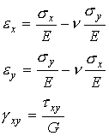

These expressions can be inverted to obtain stress in terms of strain. The result is the following form of Hooke’s law.

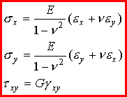

**Questions for self-control**

1. What is Mohr's circle for plane stress?

2. What are the locating points on Mohr’s circle?

3. How are principal stresses calculated?

4. What is Hooke’s law for plane-stress?

5. How is the volumetric strain for plane-stress defined?

**The basic literature**

1. Ralph H. Abraham and Jerrold E. Marsden. Foundations of Mechanics. -Wesley, 1978.

2. V. I. Arnold. Mathematical Methods of Classical Mechanics. - Springer Verlag, 1980.

3. Lothar Nordheim. The Principles of Mechanics. Vol. 2. - Springer, 1972.

4. Jean-Marie Souriau. Structure des Systèmes Dynamiques. - Dunod Université, Paris, 1970. (English translation: Birkhäuser Boston, 1998.)

5. E. C. G. Sudarshan and N. Mukunda. Classical Dynamics: A Modern Perspective. - John Wiley & Sons, 1974.

6. V. I. Arnold, V. V. Kozlov and A. I. Neishtadt. Mathematical Aspects of Classical and Celestial Mechanics. Dynamical Systems III. - Springer Verlag, 1988.

7. Giovanni Gallavotti. The Elements of Mechanics. - Springer Verlag, 1983.

8. F. R. Gantmakher. Lectures on analytical mechanics. - Fizmatgiz, 1960. (English translation by G. Yankovsky. - Mir Publishing, 1970.)

9. Herbert Goldstein. Classical Mechanics. 2nd edition. - Wesley, 1980.

10. Jorge V. José and Eugene J. Saletan. Classical Dynamics: A Contemporary Approach. - Cambridge University Press, 1998.

11. Cornelius Lanczos. The Variational Principles of Mechanics. 4th edition. - University of Toronto Press, 1970; Dover Publications, 1982.

12. Пронина Р.Ф. Пособие по переводу английской научно-технической литературы. - М.: Высшая школа, 1973.

13. Циммерман М., Веденеева К. Русско-английский научно-технический словарь переводчика. - М.: Наука, 1991.

14. Арушанян О.Б. Русско-английский словарь по прикладной математике и механике. (Russian-English dictionary of applied mathematics and mechanics). – М.: МГУ, 2012.

15. Пумпянский А.Л. Чтение и перевод английской научно-технической литературы: Лексика, грамматика, фонетика, упражнения /Худ. обл. М. В. Драко.— М.: ООО «Попурри», 1997.— 608 с.

**The supplementary literature**

1. L. D. Landau and E. M. Lifshitz. Mechanics. 3rd edition. Course of Theoretical Physics. Vol. 1. - Pergamon Press, 1976.

2. Jerrold E. Marsden and Tudor S. Ratiu. Introduction to Mechanics and Symmetry. - Springer Verlag, 1994.

3. Florian Scheck. Mechanics, From Newton's Laws to Deterministic Chaos. 2nd edition. - Springer-Verlag, 1994.

4. E. T. Whittaker. A Treatise on Analytical Dynamics. - Cambridge University Press, 1937.

5. Walter Thirring. A Course in Mathematical Physics 1: Classical Dynamical Systems, translated by Evans M. Harell, - Springer-Verlag, 1978.

6. Англо-русский словарь математических терминов: около 20000 терминов / под ред. П. С. Александрова. - Изд.3-е, стер. - М.: Мир, 2001.

7. Голденков М. Современный активный English. ЧеРо. – М: Физматлит, 2002.-448с.

**The list of periodicals**

1. Английский язык: Прил. к газете "1 сентября".

2. Иностранные языки в высшей школе.

**The source list on electronic media**

1. Кутателадзе С.С. Russian-English in writing. Изд. института математики. – Новосибирск, 2000.

2. Игнатьев-Каллэхэм Л. Русско-английский политехнический словарь. - М.: Уайли, 1995.

2. A.J. Lohwater's Russian-English dictionary of the mathematical sciences / R.P. Boas (ed.). American Mathematical Society, 1990.

3. Сосинский А. Б. Как написать математическую статью по-английски. - М: Изд-во «Факториал Пресс», 2000. — 112 с.

**The Internet sources**

1. http://ru.wikipedia.org

2. <http://lingualeo.com/>

**Lecture 7**

**Lecture topic: Pressure vessels. Beam Deflection**

**The plan**

**1. Pressure vessels**

1.1. Spherical pressure vessels

1.2. Cylindrical pressure vessels

**2. Deflection of beams**

2.1. Curvature of a line

2.2. The beam deflection equation

2.4. Example 1

2.5. Example 2: A beam with two segments

2.6. Example 3: Statically indeterminate beams

**1. Pressure vessels**

**1.1. *Spherical pressure vessels***

Consider the stresses on one half of the thin spherical pressure vessel of inner radius *r* and wall thickness *t*.

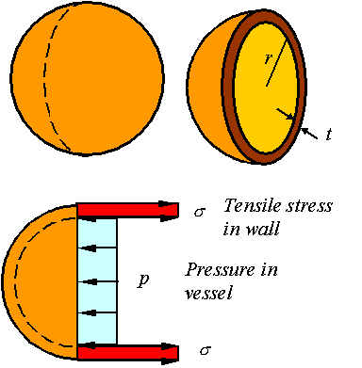

Static equilibrium requires that the load generated from the tensile stress in the wall be equal to the load applied by the pressure. Since the vessel is thin, the load due to the tensile stress in the wall is http://emweb.unl.edu/NEGAHBAN/Em325/18-Pressure-vessels/Pressure%20vessels_files/image004.gif. The load due to the pressure in the vessel is http://emweb.unl.edu/NEGAHBAN/Em325/18-Pressure-vessels/Pressure%20vessels_files/image006.gif. Balancing these gives the expression for the stress in a spherical vessel as

http://emweb.unl.edu/NEGAHBAN/Em325/18-Pressure-vessels/Pressure%20vessels_files/image008.gif

Due to symmetry in the spherical pressure vessel, the stress in all directions tangent to the surface of the vessel is the same. Depending on weather one takes a stress element from the inside or outside surface of the vessel, one will get one of the two following states of stress.

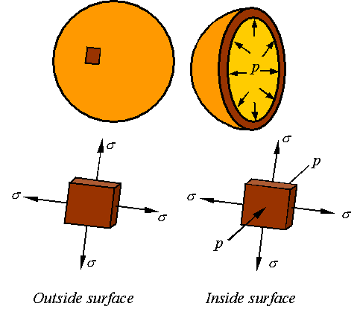

*Maximum stress on the outside surface*

The in and out-of-plane Mohr’s circles for a stress element taken from the outside surface of the pressure vessel will look as follows.

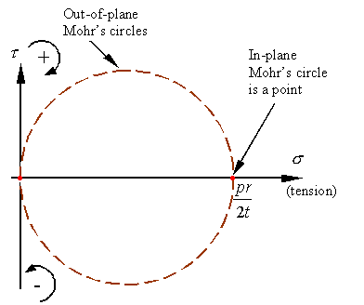

As can be seen, the maximum and minimum normal stresses and maximum shear stress are

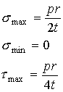

As can also be seen, the maximum shear stress is on a 45o out-of-plane incline as shown in the figure.

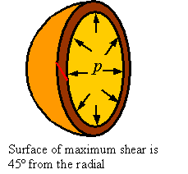

*Maximum stress on the inside surface*

The in and out-of-plane Mohr’s circles for a stress element taken from the inside surface of the pressure vessel will look as follows.

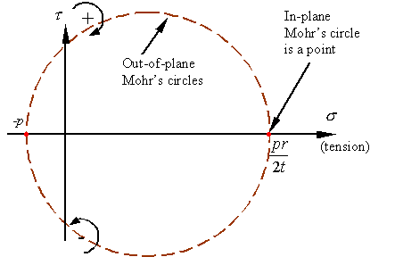

As can be seen, the maximum and minimum normal stresses and maximum shear stress are

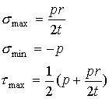

The maximum shear stress is on a 45o out-of-plane inclined surface as shown in the figure.



**1.2. *Cylindrical pressure vessels***

Consider the stresses in a thin cylindrical pressure vessel of inner radius *r* and wall thickness *t*.

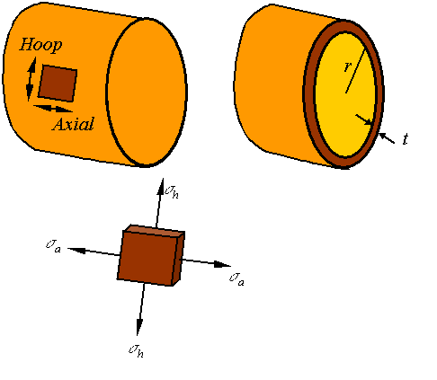

Unlike the spherical pressure vessel for which the stress in all directions tangent to the sphere were the same, for a cylindrical pressure vessel the stress http://emweb.unl.edu/NEGAHBAN/Em325/18-Pressure-vessels/Pressure%20vessels_files/image025.gif along the axial direction is different from the stress http://emweb.unl.edu/NEGAHBAN/Em325/18-Pressure-vessels/Pressure%20vessels_files/image027.gif along the hoop direction.

*Axial stress*

To calculate the axial stress consider the stresses on a cross section of the cylinder as shown in the figure.

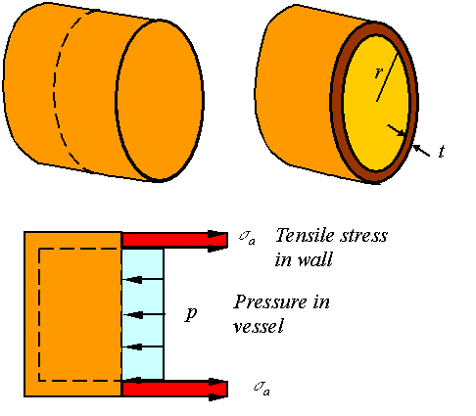

Static equilibrium requires that the load generated from the tensile stress in the wall to be equal to the load applied by the pressure. Since the vessel is thin, the load due to the tensile stress in the wall is http://emweb.unl.edu/NEGAHBAN/Em325/18-Pressure-vessels/Pressure%20vessels_files/image031.gif. The load due to the pressure in the vessel is http://emweb.unl.edu/NEGAHBAN/Em325/18-Pressure-vessels/Pressure%20vessels_files/image033.gif. Balancing these gives the expression for the stress in a spherical vessel as

http://emweb.unl.edu/NEGAHBAN/Em325/18-Pressure-vessels/Pressure%20vessels_files/image035.gif

*Hoop stress*

To calculate the hoop stress consider the stresses on a section of the cylinder as shown in the figure.

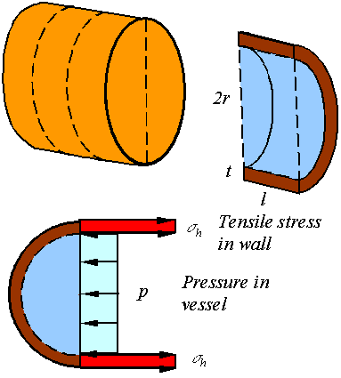

Static equilibrium requires that the load generated from the tensile stress in the wall to be equal to the load applied by the pressure. The load due to the tensile stress in the wall is http://emweb.unl.edu/NEGAHBAN/Em325/18-Pressure-vessels/Pressure%20vessels_files/image039.gif. The load due to the pressure in the vessel is http://emweb.unl.edu/NEGAHBAN/Em325/18-Pressure-vessels/Pressure%20vessels_files/image041.gif. Balancing these gives the expression for the stress in a spherical vessel as

http://emweb.unl.edu/NEGAHBAN/Em325/18-Pressure-vessels/Pressure%20vessels_files/image043.gif

*Maximum stresses on the inside and outside surface*

The stress elements taken from the inside and outside surfaces of the cylindrical pressure vessel look as follows.

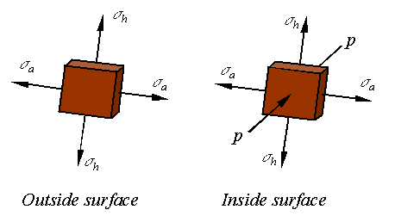

The in and out-of-plane Mohr’s circles for a stress element taken from the outside surface of the pressure vessel will look as follows.

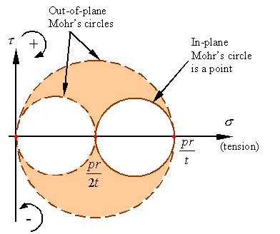

As can be seen, the maximum and minimum normal stresses and maximum shear stress are

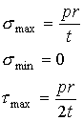

The Mohr’s circles for an element from inside the pressure vessel will look as follows.

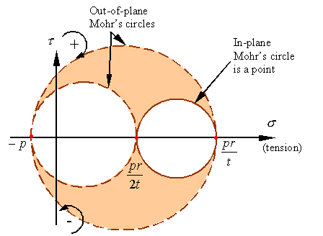

As can be seen, the maximum and minimum normal stresses and maximum shear stress on the inner surface of the vessel is given by

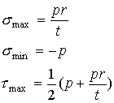

The maximum shear stress is on the inner surface of the vessel and oriented on a surface that is 45o out of plane (similar to the spherical vessel).

**2. Deflection of beams**

**2.1. *Curvature of a line***

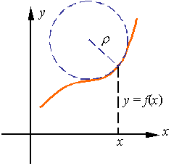

The radius of curvature http://emweb.unl.edu/NEGAHBAN/Em325/19-deflection%20of%20beams/Beam%20equation_files/image004.gif, which is the radius of the circle that best “fits” a line at a given point, is the reciprocal of the curvature http://emweb.unl.edu/NEGAHBAN/Em325/19-deflection%20of%20beams/Beam%20equation_files/image006.gif of the line. From calculus we know that the curvature http://emweb.unl.edu/NEGAHBAN/Em325/19-deflection%20of%20beams/Beam%20equation_files/image007.gif of a line described by the function *y* = *f(x*) is given by the relation

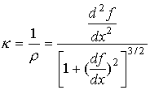

**2.2. *The beam deflection equation***

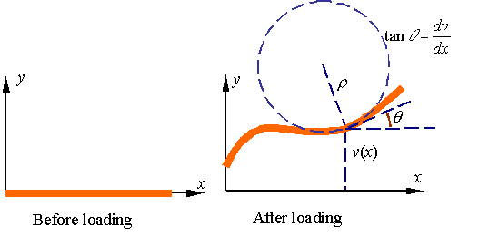

A beam under load deflects and bends. As shown in the figure, if the deflection of the beam is given by the displacement function *v* in terms of location *x*, from calculus we conclude that the curvature http://emweb.unl.edu/NEGAHBAN/Em325/19-deflection%20of%20beams/Beam%20equation_files/image012.gif of the beam is given

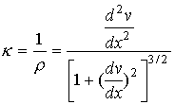

If the slope http://emweb.unl.edu/NEGAHBAN/Em325/19-deflection%20of%20beams/Beam%20equation_files/image016.gif of the curve describing the loaded beam is at all points small relative to unity then http://emweb.unl.edu/NEGAHBAN/Em325/19-deflection%20of%20beams/Beam%20equation_files/image018.gif and one can set the denominator of the expression for curvature equal to one. As a result, one obtains the approximate relation

http://emweb.unl.edu/NEGAHBAN/Em325/19-deflection%20of%20beams/Beam%20equation_files/image020.gif

From the study of pure bending we know the relation between the radius of curvature and the applied bending moment to be given by the expression

http://emweb.unl.edu/NEGAHBAN/Em325/19-deflection%20of%20beams/Beam%20equation_files/image022.gif

Combining the relation for curvature from calculus and that obtained from mechanics of materials yields the *beam equation:*

http://emweb.unl.edu/NEGAHBAN/Em325/19-deflection%20of%20beams/Beam%20equation_files/image024.gif

As the derivation implies, the beam equation in this form only hold for beams that at all points have small slope angles. This restriction can be removed by avoiding the approximation and using the full expression for curvature, but this not necessary for many applications that result in only small changes in the shape of the beam.

**2.3. *Uniform beams***

For beams with constant *EI*, one can easily differentiate the beam equation twice to get

http://emweb.unl.edu/NEGAHBAN/Em325/19-deflection%20of%20beams/Beam%20equation_files/image026.gif

This follows from the relations http://emweb.unl.edu/NEGAHBAN/Em325/19-deflection%20of%20beams/Beam%20equation_files/image028.gif and http://emweb.unl.edu/NEGAHBAN/Em325/19-deflection%20of%20beams/Beam%20equation_files/image030.gif that was obtained when we studied the shear and bending moment in beams. This expression can be integrated four times to get displacement *v* as a function of position *x*. The resulting expression will contain four constants of integration that are evaluated from imposing four boundary conditions. In general the process follows the following sequence:

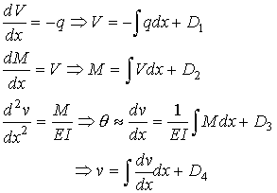

The four constants of integration are *D*1, *D*2, *D*3, and *D*4.

**2.4. *Example 1***

As an example, let us evaluate the deflection of a cantilevered beam of length *l* loaded by the application of a uniform load *q*o.

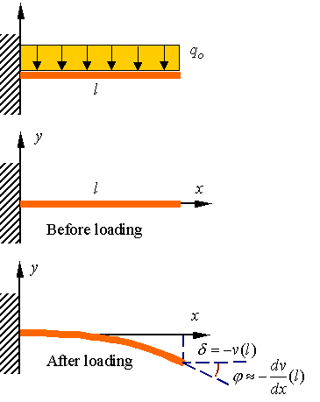

The equations are

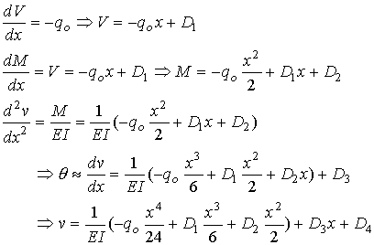

The boundary conditions on this beam are as follows. The slope and displacement at the left end must be zero since the support does not allow this end to move or rotate. The shear force and bending moment must be zero at the right end since it is free.

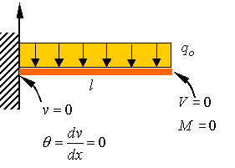

These boundary conditions require that

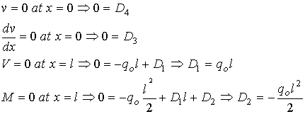

Therefore, the equations for the beam become

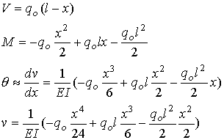

The slope and deflection at the right end is given by

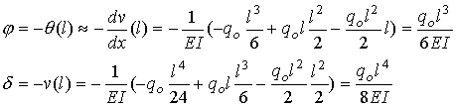

The support reactions at the left end can directly be calculated from the equations for the shear and bending moments by substituting zero for the value of *x*. This results in

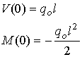

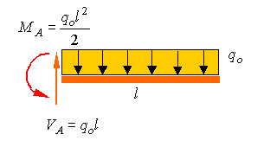

**2.5. *Example 2: A beam with two segments***

In the following simply supported beam we look at a beam that has two segments (from A to B and from B to C), on each the segments the functions are continuous but the shear load has a jump due to the point load P when you go from one segment to the other. As a result one has different constants of integration for each segment.

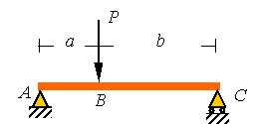

Since the distributed load is equal to zero in both segments of the beam, the equations will be the similar up to the values of the integration constants. The equations for the first  segment are as follows.

*From A to B (0<x<a):*

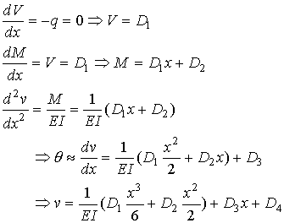

The equations are similar in the second segment, up to the integration constants. These equations are as follows.

*From B to C (a<x<a+b):*

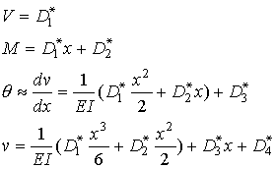

The boundary conditions at the two ends are as shown in the figure. As can be seen, the supports at the two ends impose a zero displacement condition and since the ends are free to rotate, the moment at each end is also zero. In addition to these four boundary conditions there are four continuity conditions at point *B*.

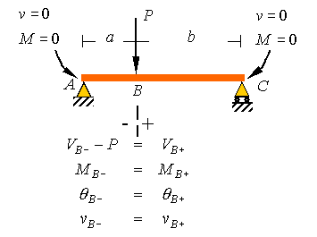

In addition to these four boundary conditions there are four *continuity conditions* at point *B*. Due to the point load, the shear load will have a jump at this point, but the other three variable do not change.

All together, we will have eight conditions that will be used to solve for the eight constants of integration.

These conditions are as follows, where

*l* = *a*+*b*.

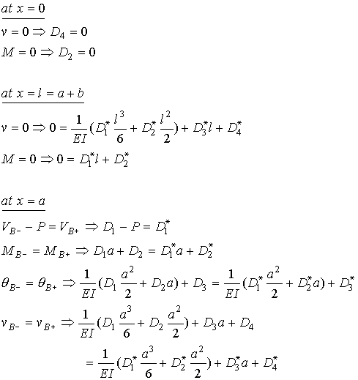

Once the eight constants *D*i and *D*i* are determined from these eight conditions, back substitution into the above equations gives the equations for the deflection of the beam in each of the two regions.

**2.6. *Example 3: Statically indeterminate beams***

Consider the cantilever beam of the first example now propped up using a support at the right end. An examination of the free-body-diagram of the beam immediately indicates that the beam is statically indeterminate since we have four unknown support reactions and can only write three equilibrium equations.

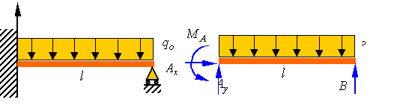

Since the distributed load on the beam is the same as in the first example, the equations for this beam will be similar to the first problem, but with different constants of integration. The equations are therefore given by the following set.



The boundary conditions for the left end are the same as the first example, but the boundary conditions on the right end require zero displacement and zero moment.

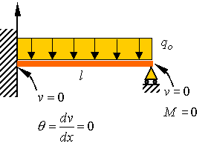

These four constraints are written as follows.

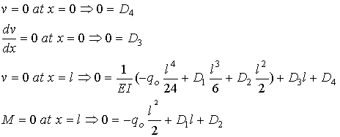

Solving these equations for the unknown constants of integration gives the following relations.

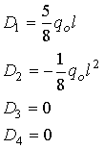

Substitution back into the original equations gives the following four equations for the beam.

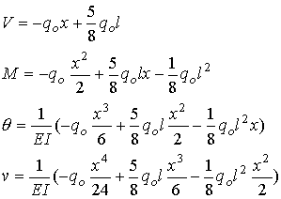

The support reactions can be calculated from the following relations.

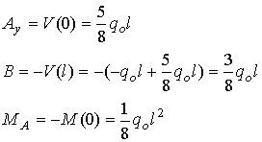

**Questions for self-control**

1. What spherical pressure vessels do you know?

2. What are cylindrical pressure vessels?

3. What is the beam deflection equation?

4. What are the main differences between spherical pressure vessels and the cylindrical pressure vessels?

5. How is the deflection of the beam with two segments calculated?

**The basic literature**

1. Ralph H. Abraham and Jerrold E. Marsden. Foundations of Mechanics. -Wesley, 1978.

2. V. I. Arnold. Mathematical Methods of Classical Mechanics. - Springer Verlag, 1980.

3. Lothar Nordheim. The Principles of Mechanics. Vol. 2. - Springer, 1972.

4. Jean-Marie Souriau. Structure des Systèmes Dynamiques. - Dunod Université, Paris, 1970. (English translation: Birkhäuser Boston, 1998.)

5. E. C. G. Sudarshan and N. Mukunda. Classical Dynamics: A Modern Perspective. - John Wiley & Sons, 1974.

6. V. I. Arnold, V. V. Kozlov and A. I. Neishtadt. Mathematical Aspects of Classical and Celestial Mechanics. Dynamical Systems III. - Springer Verlag, 1988.

7. Giovanni Gallavotti. The Elements of Mechanics. - Springer Verlag, 1983.

8. F. R. Gantmakher. Lectures on analytical mechanics. - Fizmatgiz, 1960. (English translation by G. Yankovsky. - Mir Publishing, 1970.)

9. Herbert Goldstein. Classical Mechanics. 2nd edition. - Wesley, 1980.

10. Jorge V. José and Eugene J. Saletan. Classical Dynamics: A Contemporary Approach. - Cambridge University Press, 1998.

11. Cornelius Lanczos. The Variational Principles of Mechanics. 4th edition. - University of Toronto Press, 1970; Dover Publications, 1982.

12. Пронина Р.Ф. Пособие по переводу английской научно-технической литературы. - М.: Высшая школа, 1973.

13. Циммерман М., Веденеева К. Русско-английский научно-технический словарь переводчика. - М.: Наука, 1991.

14. Арушанян О.Б. Русско-английский словарь по прикладной математике и механике. (Russian-English dictionary of applied mathematics and mechanics). – М.: МГУ, 2012.

15. Пумпянский А.Л. Чтение и перевод английской научно-технической литературы: Лексика, грамматика, фонетика, упражнения /Худ. обл. М. В. Драко.— М.: ООО «Попурри», 1997.— 608 с.

**The supplementary literature**

1. L. D. Landau and E. M. Lifshitz. Mechanics. 3rd edition. Course of Theoretical Physics. Vol. 1. - Pergamon Press, 1976.

2. Jerrold E. Marsden and Tudor S. Ratiu. Introduction to Mechanics and Symmetry. - Springer Verlag, 1994.

3. Florian Scheck. Mechanics, From Newton's Laws to Deterministic Chaos. 2nd edition. - Springer-Verlag, 1994.

4. E. T. Whittaker. A Treatise on Analytical Dynamics. - Cambridge University Press, 1937.

5. Walter Thirring. A Course in Mathematical Physics 1: Classical Dynamical Systems, translated by Evans M. Harell, - Springer-Verlag, 1978.

6. Англо-русский словарь математических терминов: около 20000 терминов / под ред. П. С. Александрова. - Изд.3-е, стер. - М.: Мир, 2001.

7. Голденков М. Современный активный English. ЧеРо. – М: Физматлит, 2002.-448с.

**The list of periodicals**

1. Английский язык: Прил. к газете "1 сентября".

2. Иностранные языки в высшей школе.

**The source list on electronic media**

1. Кутателадзе С.С. Russian-English in writing. Изд. института математики. – Новосибирск, 2000.

2. Игнатьев-Каллэхэм Л. Русско-английский политехнический словарь. - М.: Уайли, 1995.

2. A.J. Lohwater's Russian-English dictionary of the mathematical sciences / R.P. Boas (ed.). American Mathematical Society, 1990.

3. Сосинский А. Б. Как написать математическую статью по-английски. - М: Изд-во «Факториал Пресс», 2000. — 112 с.

**The Internet sources**

1. http://ru.wikipedia.org

2. <http://lingualeo.com/>

**Lecture 8**

**Lecture topic: Deflection of beams by superposition. Buckling of Columns**

**The plan**

**1. Beam deflection by superposition of solutions**

1.1. Basic idea

1.2. Example

**2. Buckling of Columns**

2.1. Basic idea

2.2. Buckling in a simply supported column

2.3. Different supports

**1. Beam deflection by superposition of solutions**

**1.1. *Basic idea***

Since the beam deflection equation is linear, any combination of solutions to this equation is itself a solution to the beam equation. By adding known solutions of the beam equation together, one can construct new solutions to the beam equation. In this way one can construct a variety of solutions to fit a large number of boundary conditions. Tables of solutions to the beam deflection equation can be found in most textbooks.

The key issue in construction of solutions using the method of superposition is that one select a set of knows solutions that in combination can satisfy the boundary conditions of the problem under consideration. Clearly this method is only useful when we can find solutions that when combined are capable of satisfying the boundary conditions of the problem under consideration.

**1.2. *Example***

Consider the propped up cantilever beam show in the figure.

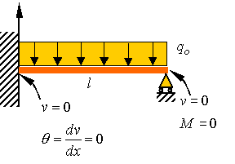

The boundary conditions for this problem are indicated on the figure above. One can consider this problem as the summation of the two problems shown in the figure

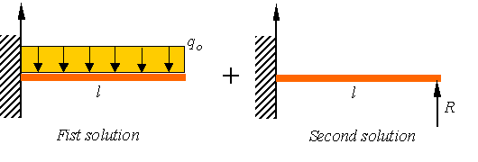

Clearly both solutions satisfy the zero displacement and zero slop condition at the left side. Both solution satisfy the zero moment condition on the right side. We simply need to make the combined solution satisfy the zero displacement solution at the right tend of the beam. This can be done by selecting the reaction force *R* in the second solution large enough so that the combined solution does has zero displacement at the right side of the bar.

For the first solution the deflection downward of the right end is given by

http://emweb.unl.edu/NEGAHBAN/Em325/20-deflection%20of%20beams%20by%20superposition/Beam%20deflection%20by%20superposition_files/image006.gif

For the second solution the deflection downward is given by

http://emweb.unl.edu/NEGAHBAN/Em325/20-deflection%20of%20beams%20by%20superposition/Beam%20deflection%20by%20superposition_files/image008.gif

To satisfy the zero displacement condition at the right end in the original problem, we set the total displacement equal to zero and solve for the support reaction *R*. That is

http://emweb.unl.edu/NEGAHBAN/Em325/20-deflection%20of%20beams%20by%20superposition/Beam%20deflection%20by%20superposition_files/image010.gif

This yields the unknown reaction force at the right support as

http://emweb.unl.edu/NEGAHBAN/Em325/20-deflection%20of%20beams%20by%20superposition/Beam%20deflection%20by%20superposition_files/image012.gif

The solutions for the upward displacement of for each solution is given as

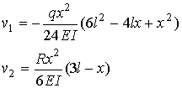

Combining the two solutions and substituting for the support reaction yields the solution to the propped up cantilever as

http://emweb.unl.edu/NEGAHBAN/Em325/20-deflection%20of%20beams%20by%20superposition/Beam%20deflection%20by%20superposition_files/image016.gif

**2. Buckling of Columns**

**2.1. *Basic idea***

Consider a column that is constructed from two pin-connected links with a torsional spring connected between the two links as shown in the figure. As long as the two bars AB and BC are perfectly aligned, the system is in equilibrium and one theoretically can increase the load until the beams fail in compression.

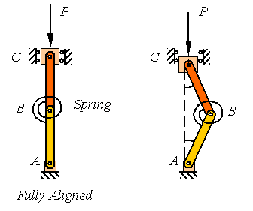

In reality, the two members can never be perfectly aligned so the system supports the load by the aid of the torsional spring and takes a shape such as shown in the right figure above.

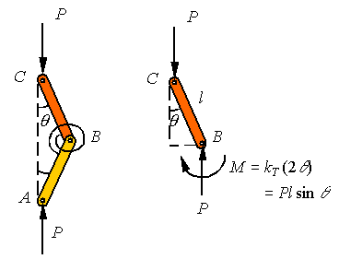

Since the member *ABC* is a two-force member, the loads applied at *A* and *C* must be equal and along the line connecting *A* to *C* as shown in the above left figure. The free-body-diagram of AB shown on the right side of the figure above indicates that for equilibrium to hold, the miss-alignment angle http://emweb.unl.edu/NEGAHBAN/Em325/21-Buckling%20of%20columns/Buckling%20of%20columns_files/image006.gif must increase until the moment in the torsional spring increases to balance the couple developed by the two vertical forces. This requires that

http://emweb.unl.edu/NEGAHBAN/Em325/21-Buckling%20of%20columns/Buckling%20of%20columns_files/image008.gif

where *kT* is the stiffness of the torsional spring and the reader notes that the torsional spring is twisted twice the miss-alignment angle http://emweb.unl.edu/NEGAHBAN/Em325/21-Buckling%20of%20columns/Buckling%20of%20columns_files/image009.gif. Assuming small miss-alignment angles so that one can replace http://emweb.unl.edu/NEGAHBAN/Em325/21-Buckling%20of%20columns/Buckling%20of%20columns_files/image011.gif by http://emweb.unl.edu/NEGAHBAN/Em325/21-Buckling%20of%20columns/Buckling%20of%20columns_files/image012.gif, one gets

http://emweb.unl.edu/NEGAHBAN/Em325/21-Buckling%20of%20columns/Buckling%20of%20columns_files/image014.gif

Obviously, http://emweb.unl.edu/NEGAHBAN/Em325/21-Buckling%20of%20columns/Buckling%20of%20columns_files/image016.gif is a solution to this equation. This solution represents the trivial solution that reflects the perfectly aligned system. But, this system has a non-trivial solution where the term in the parenthesis becomes zero to require

http://emweb.unl.edu/NEGAHBAN/Em325/21-Buckling%20of%20columns/Buckling%20of%20columns_files/image018.gif

The load calculated in this way is called the critical load, designated by the subscript “cr”. For loads smaller than the critical load, the system will have accelerations that are consistent with bringing the system back into alignment. For loads above this critical load the system has accelerations consistent with increasing the miss-alignment angle, resulting in the collapse of the system. Therefore, the system is considered to be capable of carrying loads up to the critical load.

**2.2. *Buckling in a simply supported column***

Consider the pin-connected column *AB* of length *L* as shown in the following figure. Similar to the example above, if the column is fully aligned, the applied compressive load *P* can be increased until one reaches the compressive strength of the material. Yet, in reality the column will fail due to buckling as shown in the figure on the right long before this load is reached.

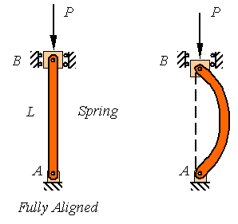

The analysis of the buckling of a continuous column is similar to the example given above to motivate the problem. Since the column is a two-force member, the reaction loads at the two pins are equal and directed along the line connecting the two pins as shown in the figure to the left below. The free-body-diagram of a segment of the column is also drown below and it is clear from this diagram that for the member to be in equilibrium the bending moment must balance the couple created by the misalignment of the two loads.

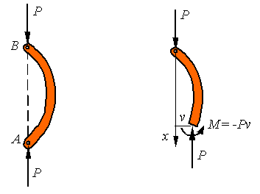

Designating the out of plane displacement of the column by *v*, the bending moment must be *M=-Pv*. One can combine this with the beam deflection equation

http://emweb.unl.edu/NEGAHBAN/Em325/21-Buckling%20of%20columns/Buckling%20of%20columns_files/image024.gif

to get the equation for the column as

http://emweb.unl.edu/NEGAHBAN/Em325/21-Buckling%20of%20columns/Buckling%20of%20columns_files/image026.gif

This is a second order homogeneous ordinary differential equation with constant coefficients that has a solution of the form

http://emweb.unl.edu/NEGAHBAN/Em325/21-Buckling%20of%20columns/Buckling%20of%20columns_files/image028.gif

where *C*1 and *C*2are constants to be fit to the boundary conditions and http://emweb.unl.edu/NEGAHBAN/Em325/21-Buckling%20of%20columns/Buckling%20of%20columns_files/image030.gif must be restricted to satisfy the differential equation. The boundary conditions for this pin-supported column are that the displacement is zero at both supports. Therefore,

http://emweb.unl.edu/NEGAHBAN/Em325/21-Buckling%20of%20columns/Buckling%20of%20columns_files/image032.gif

Obviously, if both *C*1 and *C*2are zero one obtains the trivial solution *v*=0 for the fully aligned beam. For the beam to have a nontrivial solution (buckled solution), one must select http://emweb.unl.edu/NEGAHBAN/Em325/21-Buckling%20of%20columns/Buckling%20of%20columns_files/image034.gif that results in requirement that http://emweb.unl.edu/NEGAHBAN/Em325/21-Buckling%20of%20columns/Buckling%20of%20columns_files/image036.gif that yield

http://emweb.unl.edu/NEGAHBAN/Em325/21-Buckling%20of%20columns/Buckling%20of%20columns_files/image038.gif

for any integer *n*. This results in the solution

http://emweb.unl.edu/NEGAHBAN/Em325/21-Buckling%20of%20columns/Buckling%20of%20columns_files/image040.gif

As can be seen from the figure, different values of *n* represent different modes of buckling.

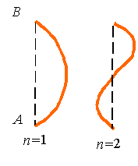

In addition to the boundary conditions, the solution must satisfy the differential equation. Substitution of this solution into the differential equation gives

http://emweb.unl.edu/NEGAHBAN/Em325/21-Buckling%20of%20columns/Buckling%20of%20columns_files/image044.gif

Reorganization yields

http://emweb.unl.edu/NEGAHBAN/Em325/21-Buckling%20of%20columns/Buckling%20of%20columns_files/image046.gif

Clearly, if C1 is zero, one arrives at the trivial solution *v*=0 that satisfies the differential equation, and which is associated with the fully aligned beam, but there is a non-trivial solution when the term in the round parentheses goes to zero. Therefore, to get a nontrivial solution to the buckling problem, the axial load must satisfy the relation

http://emweb.unl.edu/NEGAHBAN/Em325/21-Buckling%20of%20columns/Buckling%20of%20columns_files/image048.gif,

which results in the expression for the critical load given by

http://emweb.unl.edu/NEGAHBAN/Em325/21-Buckling%20of%20columns/Buckling%20of%20columns_files/image050.gif

Obviously, the smallest critical load is associated with *n*=1. Therefore, the column will buckle at the load associated with the first buckling mode if the column is not restricted from taking the shape associated with this mode.

**2.3. *Different supports***

The buckling of columns with a variety of different support conditions are shown in the following figure and can be analyzed using similar procedures to the simply supported column studied above.

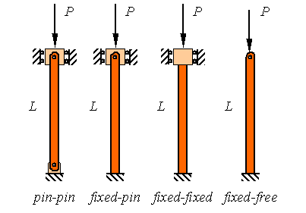

The results for the other columns are similar to the pin-pin supported column analyzed above with only the replacement of the actual length of the column with an effective length. If *L* is the actual length of the column and *L*e is the effective length of the column, then the critical buckling load for the column is given by

http://emweb.unl.edu/NEGAHBAN/Em325/21-Buckling%20of%20columns/Buckling%20of%20columns_files/image054.gif

where the effective length *L*e is given by

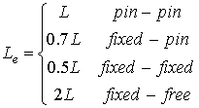.

**Questions for self-control**

1. What is the beam deflection?

2. What are the basics of the superposition of solutions?

3. What is the buckling in a simply supported column?

4. How are different supports performed?

5. What is the critical load?

**The basic literature**

1. Ralph H. Abraham and Jerrold E. Marsden. Foundations of Mechanics. -Wesley, 1978.

2. V. I. Arnold. Mathematical Methods of Classical Mechanics. - Springer Verlag, 1980.

3. Lothar Nordheim. The Principles of Mechanics. Vol. 2. - Springer, 1972.

4. Jean-Marie Souriau. Structure des Systèmes Dynamiques. - Dunod Université, Paris, 1970. (English translation: Birkhäuser Boston, 1998.)

5. E. C. G. Sudarshan and N. Mukunda. Classical Dynamics: A Modern Perspective. - John Wiley & Sons, 1974.

6. V. I. Arnold, V. V. Kozlov and A. I. Neishtadt. Mathematical Aspects of Classical and Celestial Mechanics. Dynamical Systems III. - Springer Verlag, 1988.

7. Giovanni Gallavotti. The Elements of Mechanics. - Springer Verlag, 1983.

8. F. R. Gantmakher. Lectures on analytical mechanics. - Fizmatgiz, 1960. (English translation by G. Yankovsky. - Mir Publishing, 1970.)

9. Herbert Goldstein. Classical Mechanics. 2nd edition. - Wesley, 1980.

10. Jorge V. José and Eugene J. Saletan. Classical Dynamics: A Contemporary Approach. - Cambridge University Press, 1998.

11. Cornelius Lanczos. The Variational Principles of Mechanics. 4th edition. - University of Toronto Press, 1970; Dover Publications, 1982.

12. Пронина Р.Ф. Пособие по переводу английской научно-технической литературы. - М.: Высшая школа, 1973.

13. Циммерман М., Веденеева К. Русско-английский научно-технический словарь переводчика. - М.: Наука, 1991.

14. Арушанян О.Б. Русско-английский словарь по прикладной математике и механике. (Russian-English dictionary of applied mathematics and mechanics). – М.: МГУ, 2012.

15. Пумпянский А.Л. Чтение и перевод английской научно-технической литературы: Лексика, грамматика, фонетика, упражнения /Худ. обл. М. В. Драко.— М.: ООО «Попурри», 1997.— 608 с.

**The supplementary literature**

1. L. D. Landau and E. M. Lifshitz. Mechanics. 3rd edition. Course of Theoretical Physics. Vol. 1. - Pergamon Press, 1976.

2. Jerrold E. Marsden and Tudor S. Ratiu. Introduction to Mechanics and Symmetry. - Springer Verlag, 1994.

3. Florian Scheck. Mechanics, From Newton's Laws to Deterministic Chaos. 2nd edition. - Springer-Verlag, 1994.

4. E. T. Whittaker. A Treatise on Analytical Dynamics. - Cambridge University Press, 1937.

5. Walter Thirring. A Course in Mathematical Physics 1: Classical Dynamical Systems, translated by Evans M. Harell, - Springer-Verlag, 1978.

6. Англо-русский словарь математических терминов: около 20000 терминов / под ред. П. С. Александрова. - Изд.3-е, стер. - М.: Мир, 2001.

7. Голденков М. Современный активный English. ЧеРо. – М: Физматлит, 2002.-448с.

**The list of periodicals**

1. Английский язык: Прил. к газете "1 сентября".

2. Иностранные языки в высшей школе.

**The source list on electronic media**

1. Кутателадзе С.С. Russian-English in writing. Изд. института математики. – Новосибирск, 2000.

2. Игнатьев-Каллэхэм Л. Русско-английский политехнический словарь. - М.: Уайли, 1995.

2. A.J. Lohwater's Russian-English dictionary of the mathematical sciences / R.P. Boas (ed.). American Mathematical Society, 1990.

3. Сосинский А. Б. Как написать математическую статью по-английски. - М: Изд-во «Факториал Пресс», 2000. — 112 с.

**The Internet sources**

1. http://ru.wikipedia.org

2. <http://lingualeo.com/>

**Lecture 9**

**Lecture topic: Levy’s problem - the triangular dam**

**The plan**

**1. The Saint-Venant’s equations**

1.1. The Saint-Venant‘s equations

1.2. The model. Simplifying hypothesis. The planar deformation state

**2. Equations of equilibrium. Airy’s potential**

2.1. Equations of equilibrium. Airy’s potential

2.2. Boundary conditions. The final shape of the dam

**1. The Saint-Venant’s equations**

**1.1. *The Saint-Venant‘s equations***

Differentiating a certain element of the strain tensor

,

it follows, for example, that

.

Hence

. (1)

Also,

, (2)

. (3)

In a similar way, it follows that

. (4) - (6)

The above equations (1) - (6) represent the Saint-Venant’s equations of compatibility.

**1.2. *The model. Simplifying hypothesis. The planar deformation state***

A horizontal dam of infinite length is considered. The cross-section is represented by a rectangular triangle OAB (Fig. 1). The length of the base is AB=l and the height is OA=h. On OA catheter is acting the hydrostatic pressure of a liquid (water) having the specific weight equal to γ. As a result, the dam is deformed. The dam is represented by an elastic homogeneous, isotropic material. Its specific weight is equal to Γ and its elastic constants are E and ν.

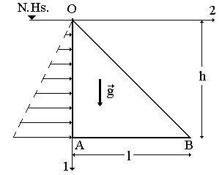

Fig. 1. A vertical cross section through the dam. N.Hs. is the free surface of the water, acting on OA side by a pressure linearly increasing with depth.

Because the shape of the dam, the displacement vector has the components like

.

It follows the strain tensor components are like

.

Hence the strain matrix is

.

It corresponds to a *planar state of the strain* (the plane here being 1-2).

The components of the stress tensor are



Hence the stress matrix is

. (7)

Because the component 33 of the stress has a non-zero value, eq. (7) shows that the stress state corresponding to a planar state of the strain is not generally a planar one too.

**2.** **Equations of equilibrium. Airy’s potential**

**2.1. *Equations of equilibrium. Airy’s potential***

The only body force acting on the dam is its weight. The equations of equilibrium are

. (8)

Because the presence of , eqs. (8) represent a non-homogeneous system. In the beginning, the homogeneous system is solved, i.e.

. (9)

Using an unknown function , the first equation of (9) is verified for

.

In the same way, the second equation of (9) is verified for

.

It follows that

.

i.e. the unknown functions are

.

The unknown function  represents the Airy’s potential. It allows one to obtain the next expressions for the components of the stress tensor when the body force are absent:

. (10)

From (7), the trace of the stress tensor can be written using Laplace’s operator in 1-2 coordinates

.

The components of the strain tensor are obtained using the reversed Hooke’s law

. (11)

Using (11) and (1) it follows



or

.

Because , it follows that Airy’s potential is a solution of the bi-harmonic equation

. (12)

Because the trace of a tensor is an invariant, eq. (12) holds too in the general case of the orthogonal curvilinear co-ordinates. However, eq. (10) has to be modified.

**2.2. *Boundary conditions. The final shape of the dam***

On the side OA of the dam is acting the hydrostatic pressure. It follows that

.

On the side OB of the dam is acting the negligible atmospheric pressure. It follows that

.

where the outer pointing normal at the dam is

.

On the side OA, for , it follows that

. (13)

On the side OB it follows for  that

. (14)

Eqs. (13) - (14) represent 4 boundary conditions, suggesting a solution of the bi-harmonic equation (12) which depends on 4 unknown coefficients denoted by , i.e.

.

Using (10), the solution of the homogeneous system is

.

A particular solution of the non-homogeneous system (8) is

.

It follows the general solution of (8) is

. (15)

Replacing (15) into (13) - (14) it follows that

.

It follows that



and

,

where

.

Hence

,

where

.

It follows that

,

where the unknown function follows to be found. In the same manner,

.

But

.

Hence

,

where is an arbitrary constant. It follows

.

Hence, the displacement field is

. (16)

The last terms into (16) represent a rigid roto-translation.

It should be outlined that the above boundary conditions on stress values on the sides OA and OB are not complete ones. As a result, the unknown constants are present in (16). Boundary conditions on stress values (or displacements) on the side AB are required in order to obtain an unique solution of the problem.

For example, consider the case when the points A and B are fixed ones. It follows

.

An arbitrary point placed initially on the side AB has the initial coordinates . Its final position is

.

Elementary computations show that

.

If

,

the final shape of the side AB is a concave parabolic segment. Because the possibility of the water to flow below the dam, that situation is not recommended in real cases. Therefore, it is asked to



or

.

For example, assuming that it follows that .

*Exercise.* Obtain the final shape of the dam in the above hypothesis.

**Questions for self-control**

1. How is Levy's problem formulated?

2. How is the planar deformation state calculated?

3. How are Saint-Venant‘s equations determined?

4. What is Airy’s potential?

5. What are the basics of simplifying hypothesis?

**The basic literature**

1. Aki, K., Richards, P.G., 1980. Quantitative Seismology, Freeman and Co., New York.

2. Beju, I., Soos, E., Teodorescu, P.P., 1977, Euclidean Tensorial Calculus - in Romanian, Ed.tehnicã, Bucharest.

3. Filonenco-Borodici, M.M., 1952, Theory of Elasticity, Ed.tehnicã, Bucharest

4. Ivan, M., 1996, Seismology (in Romanian), v.I, Ed.Universitãtii Bucuresti.

5. Ivan, M., 1997a. A finite element algorithm for computing the flexure of the crustal, *in press*, Studii si cercetari de GEOFIZICA 35.

6. Ivan, M., 1997b. Aperiodic motion of a crustal microplate, *in press*, Revue Roumaine de Géophysique 41.

7. Jaeger, J.C., Cook, N.G.W., 1969, Fundamental of Rock Mechanics, Methuen and Co. London.

8. Nowacki, W., 1961. Dynamika budowli (in Polish), Arkadi, Warszawa.

9. Ranalli, G., 1987, Rheology of the Earth, Allen & Uniwin Inc., Boston.

10. Rîjic, I.M., Gradstein, I.S., 1955, Tables of integrals, sums, series and products, -in Romanian, Ed.tehnicã, Bucharest.

11. Sokolnikoff, I.S., Redheffer, R.M., 1958, Mathematics of Physics and Modern Engineering, McGraw-Hill Book Co., Inc., New York.

12. Timoshenko, S., Woinowsky-Krieger, S. 1959. Theory of plates and shells, Mc-Graw-Hill, New York.

13. Timoshenko, S.P., Gere, J.M., 1961, Theory of elastic stability, McGraw-Hill, New York.

14. Turcotte, D.L., Schubert, G. 1982. Geodynamics, John Wiley and Sons, New York.

15. Wahr, J., 1996, Gravity and Geodesy - Class Notes, Samizdat Press.

**The supplementary literature**

1. Ralph H. Abraham and Jerrold E. Marsden. Foundations of Mechanics. -Wesley, 1978.

2. V. I. Arnold. Mathematical Methods of Classical Mechanics. - Springer Verlag, 1980.

3. Lothar Nordheim. The Principles of Mechanics. Vol. 2. - Springer, 1972.

4. Jean-Marie Souriau. Structure des Systèmes Dynamiques. - Dunod Université, Paris, 1970. (English translation: Birkhäuser Boston, 1998.)

5. E. C. G. Sudarshan and N. Mukunda. Classical Dynamics: A Modern Perspective. - John Wiley & Sons, 1974.

6. V. I. Arnold, V. V. Kozlov and A. I. Neishtadt. Mathematical Aspects of Classical and Celestial Mechanics. Dynamical Systems III. - Springer Verlag, 1988.

7. Giovanni Gallavotti. The Elements of Mechanics. - Springer Verlag, 1983.

8. F. R. Gantmakher. Lectures on analytical mechanics. - Fizmatgiz, 1960. (English translation by G. Yankovsky. - Mir Publishing, 1970.)

9. Herbert Goldstein. Classical Mechanics. 2nd edition. - Wesley, 1980.

10. Jorge V. José and Eugene J. Saletan. Classical Dynamics: A Contemporary Approach. - Cambridge University Press, 1998.

11. Cornelius Lanczos. The Variational Principles of Mechanics. 4th edition. - University of Toronto Press, 1970; Dover Publications, 1982.

12. Пронина Р.Ф. Пособие по переводу английской научно-технической литературы. - М.: Высшая школа, 1973.

13. Циммерман М., Веденеева К. Русско-английский научно-технический словарь переводчика. - М.: Наука, 1991.

14. Арушанян О.Б. Русско-английский словарь по прикладной математике и механике. (Russian-English dictionary of applied mathematics and mechanics). – М.: МГУ, 2012.

15. Пумпянский А.Л. Чтение и перевод английской научно-технической литературы: Лексика, грамматика, фонетика, упражнения /Худ. обл. М. В. Драко.— М.: ООО «Попурри», 1997.— 608 с.

16. L. D. Landau and E. M. Lifshitz. Mechanics. 3rd edition. Course of Theoretical Physics. Vol. 1. - Pergamon Press, 1976.

17. Jerrold E. Marsden and Tudor S. Ratiu. Introduction to Mechanics and Symmetry. - Springer Verlag, 1994.

18. Florian Scheck. Mechanics, From Newton's Laws to Deterministic Chaos. 2nd edition. - Springer-Verlag, 1994.

19. E. T. Whittaker. A Treatise on Analytical Dynamics. - Cambridge University Press, 1937.

20. Walter Thirring. A Course in Mathematical Physics 1: Classical Dynamical Systems, translated by Evans M. Harell, - Springer-Verlag, 1978.

21. Англо-русский словарь математических терминов: около 20000 терминов / под ред. П. С. Александрова. - Изд.3-е, стер. - М.: Мир, 2001.

22. Голденков М. Современный активный English. ЧеРо. – М: Физматлит, 2002.-448с.

**The list of periodicals**

1. Английский язык: Прил. к газете "1 сентября".

2. Иностранные языки в высшей школе.

**The source list on electronic media**

1. Кутателадзе С.С. Russian-English in writing. Изд. института математики. – Новосибирск, 2000.

2. Игнатьев-Каллэхэм Л. Русско-английский политехнический словарь. - М.: Уайли, 1995.

3. A.J. Lohwater's Russian-English dictionary of the mathematical sciences / R.P. Boas (ed.). American Mathematical Society, 1990.

4. Сосинский А. Б. Как написать математическую статью по-английски. — М: Изд-во «Факториал Пресс», 2000. — 112 с.

**The Internet sources**

1. http://ru.wikipedia.org

2. <http://lingualeo.com/>

**Lecture 10**

**Lecture topic: Kirsch’s problem - the circular bore hole / tunnel**

**The plan**

**1. The planar state of deformation in cylindrical coordinate system**

1.1. The model

1.2. The planar state of deformation in cylindrical coordinate system

1.3. The circle of MOHR

1.4. Airy’s potential in cylindrical coordinates. The biharmonic equation

1.5. The divergence of a tensor in cylindrical coordinates

1.6. The gradient of a vector and the strain tensor in cylindrical coordinates

1.7. The biharmonic equation in cylindrical coordinates

**2. Boundary conditions for the stress elements on the wall of the circular cavity**

2.1. The stress elements. Conditions at infinity for the stress elements

2.2. Strain and displacement vector. Conditions at infinity

2.3. Boundary conditions for the stress elements on the wall of the circular cavity

2.4. The final shape of the wall

**1. The planar state of deformation in cylindrical coordinate system**

**1.1. *The model***

It is assumed that the whole 3-dimensional space is represented by an elastic, homogeneous, isotropic medium, having the elastic constants denoted by  and , respectively and . A co-ordinate system having the third axis positive upward will be used. The initial state of the stress is represented by the homogeneous tensor , corresponding to a planar state of deformation, i.e.

,

where the components  have constant values. The mass forces are ignored, hence the equilibrium equation



is identically satisfied.

Suppose that a circular, infinite bore hole / tunnel is performed along the third axis, its material being instantly removed. The origin of the coordinate system is placed at the centre of the cavity. On the wall of the bore hole is acting now the atmospheric pressure (or the pressure of the drilling mud), denoted by . Consequently, a new (non-homogeneous) stress value is obtained and the circular shape of the bore hole is changing too. It follows to obtain the new stress, denoted by , and the new shape of the bore hole in the final equilibrium stage, where

.

It is also assumed that the deformation is an elastic one, i.e. the stress perturbation  is related to the strain tensor by

. (1)

The unknown components of the displacement vector are supposed to correspond to a planar deformation state, i.e.

. (2)

Because the symmetry of the problem, the cylindrical co-ordinate system  will be used, having the unit vectors denoted by (see Fig. 1).

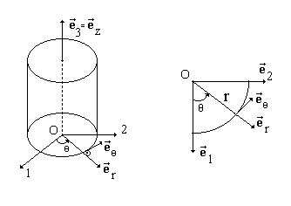

Fig. 1. The cylindrical coordinate system

**1.2. *The planar sate of deformation in cylindrical coordinate system***

With respect to Fig. 1 it follows that

 (3)

Hence the matrix for passing from the Cartesian coordinates to cylindrical co-ordinates is

.

It represents a rotation of angle equal to in a positive (counter clockwise) sense. From (1) and (2) it follows that the stress matrix in Cartesian coordinates is

.

Let the stress matrix in cylindrical coordinates be

.

It follows that

. (4)

By performing the computations in (4), it follows

, (5)

, (6)

, (7)

.

**1.3. *The circle of Mohr***

Suppose the Cartesian co-ordinate system is selected in order its axes to be along the first two eigen vectors of the stress tensor. In that case, and  are eigenvalues of the stress tensor and . From equations (5) - (7) it follows that

, (8)

and an identical relation obtained by replacing  with . Eq. (8) shows that  and  are placed on a circle of radius equal to . Suppose now that  (or ) (i.e. the radial stress component, usually denoted by ) and  (i.e. the tangential stress, usually denoted by ) are obtained at various angles and the Mohr’s circle represented by eq. (8) is obtained. Its radius and its position of the centre allow one to obtain graphically the eigenvalues of the stress tensor. Further discussion will be presented in relation to the empirical failure criteria of materials.

**1.4. *Airy’s potential in cylindrical coordinates. The biharmonic equation***

Consider the representation of the stress components with the Airy’s potential in Cartesian coordinates, i.e.

, (9)

where the Airy’s potential verifies the bi-harmonic equation

.

In the beginning, the derivatives in eq. (9) will be evaluated by using the polar coordinates

.

Than, a representation of the stress components in cylindrical coordinates with the help of the Airy’s potential will be obtained from (5) - (7).

But

.

It follows

.

In the same way,

.

Also,

.

In the same way

,

.

Hence

,

.

From eqs. (5) - (7) it follows

. (10)

**1.5. *The divergence of a tensor in cylindrical coordinates***

In the case of the cylindrical coordinates, the square of the elementary arc is equal to

.

Hence the differential parameters of Lam are

,

the orthogonal curvilinear coordinates are equal to

,

and the unit vectors are

.

It follows that

.

Substituting the above results in the main formula (Ivan 1996) it follows the next formula for the divergence of a tensor in cylindrical coordinates

. (11)

**1.6. *The gradient of a vector and the strain tensor in cylindrical coordinates***

Substituting the above results in the main formula (Ivan 1996) it follows the next formula for the gradient of a vector in cylindrical coordinates

.

The components of the strain tensor  are

.

For the particular displacement field represented by (2), the components of the vector are

.

Hence

.

It is the case of a planar state of deformation, i.e.

,

and all the strain elements are functions of  and .

Consequently, the stress is

, (12)

all the components of the stress being too functions of  and , according to Hooke’s reversed law. It follows from (11) the next equations of equilibrium are obtained in the absence of mass forces:

,

.

**1.7. *The biharmonic equation in cylindrical coordinates***

By using the main formula (Ivan 1996), it follows the Laplace operator in cylindrical coordinates is

.

The Airy’s potential is also a function of and . Hence the Airy’s potential is the solution of the bi-harmonic equation

, (13)

where the Laplace operator in polar coordinates is

. (14)

It should be noted that the singular point  is avoided in (14) because , where is the radius of the bore hole.

It follows to solve (13) by using (14) in order to derive the Airy’s potential. The stress components will be obtained from (10), imposing the boundary conditions on the wall of the bore hole. The components of the strain will be derived by using the Hooke’s reversed law. The displacement vector will be obtained from the definition of strain elements, allowing one to find the final shape of the deformed bore hole wall.

Consider the Fourier expansion of the Airy’s potential, having the coefficients equal to functions of r

.

It follows

,

,

.

Hence



and

. (15)

By using (15), the bi-harmonic (13) is verified if

, (16)

and if the functions are the solutions of the next differential equation

. (17)

Because  is a function of only, eq. (16) is

.

Hence

.

But



Hence

.

Finally, denoting again the constants, it follows

.

In order to solve eq. (17), a solution of the form

. (18)

is considered. Substituting (18) in (17), it follows that the exponent is the solution of the algebraic equation

,

having the roots

.

Hence the Airy’s potential is

, (19)

where the unknown coefficients  follows to be obtained.

**2. Boundary conditions for the stress elements on the wall of the circular cavity**

**2.1. *The stress elements. Conditions at infinity for the stress elements***

By using (19) and (10), it follows

.

At great distances from the cylindrical cavity, the elastic perturbation has to vanish, i.e.

.

It follows



Hence the Airy’s potential is

 (20)

and

. (21)

From (20), it follows that

,

,

.

Hence

. (22)

From (22), it follows that

.

Also,

.

Hence

. (23)

From (23), it follows that

.

**2.2. *Strain and displacement vector. Conditions at infinity***

From (12) and Hooke’s reversed law it follows that

,

i.e.

.

Hence

. (24)

Integrating (24) it follows

.

From



it follows that

.

Hence

.

Finally

. (25)

In the same way,

.

It follows

. (26)

Substituting (25), (21) and (22) into (26) and integrating with respect to , it follows after some computations that

, (27)

Form the condition

it follows the unknown function is subject to the condition

. (28)

But

,

or

. (29)

Substituting (23), (25) and (27) into (29), it follows after some computations that

,

i.e. . From (28) it follows that and, finally,

.

**2.3. *Boundary conditions for the stress elements on the wall of the circular cavity***

Using the previous results, the final expressions of the plane elements of the stress are equal to





and

.

The cavity wall has the outer normal (with respect to the rock domain) equal to and radius equal to . In the case of a bore hole, let be the difference between the mud pressure and the pressure of the fluid contained by the porous rock (usually, because the atmospheric pressure is negligible, it follows in the case of a tunnel that ). It follows the final stress satisfies the next boundary condition

.

Hence

.

With no loss of generality, it can be assumed that the stress at infinity is along its main axes, i.e. . Hence

.

Hence



and

,

.

It follows that



and

.

Hence

.

By using (5) – (7) for , the expressions of the final stress are equal to

,



and

.

In real cases, the value of the stress at infinity are positive ones for compression.

**2.4. *The final shape of the wall***

Consider again the case when the direction of the horizontal axes of the co-ordinate system is along the corresponding eigen vectors of the initial stress . In that case, . Using the above results, it follows the displacement vector for the points initially placed on the wall of the circular cavity is

.

Consider an arbitrary point on the wall of the bore hole. In the initial state, it has the polar coordinates . Its position vector with respect to the centre of the circle is

.

Using (3) the position vector in the final stage is

.

Hence

.

After elementary computations, it follows

.

Taking into account that , it follows the final shape of the cavity is an ellipse of equation

,

where the semi-axes of the ellipse are equal to

.

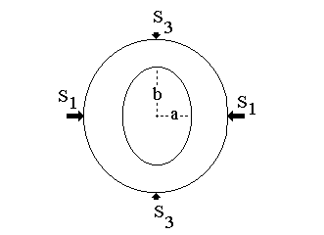

Fig. 2. The shape of the borehole (tunnel) in the initial state (the circle) and in the final state (the ellipse), corresponding to a compressive stress

In real cases, the initial stress  is usually a compressive one, i.e. (see Fig. 2)

,

where the maximum compressive stress and the minimum compressive stress  have positive values. It follows here that the major semi-axis corresponds to the minimum stress and .

**Questions for self-control**

1. What is the planar state of deformation in cylindrical coordinate system?

2. What is the circle of Mohr used for?

3. Where does the divergence of a tensor in cylindrical coordinates apply?

4. Where is the biharmonic equation in cylindrical coordinates performed?

5. How are boundary conditions for the stress elements on the wall of the circular cavity calculated?

**The basic literature**

1. Aki, K., Richards, P.G., 1980. Quantitative Seismology, Freeman and Co., New York.

2. Beju, I., Soos, E., Teodorescu, P.P., 1977, Euclidean Tensorial Calculus - in Romanian, Ed.tehnicã, Bucharest.

3. Filonenco-Borodici, M.M., 1952, Theory of Elasticity, Ed.tehnicã, Bucharest

4. Ivan, M., 1996, Seismology (in Romanian), v.I, Ed.Universitãtii Bucuresti.

5. Ivan, M., 1997a. A finite element algorithm for computing the flexure of the crustal, *in press*, Studii si cercetari de GEOFIZICA 35.

6. Ivan, M., 1997b. Aperiodic motion of a crustal microplate, *in press*, Revue Roumaine de Géophysique 41.

7. Jaeger, J.C., Cook, N.G.W., 1969, Fundamental of Rock Mechanics, Methuen and Co. London.

8. Nowacki, W., 1961. Dynamika budowli (in Polish), Arkadi, Warszawa.

9. Ranalli, G., 1987, Rheology of the Earth, Allen & Uniwin Inc., Boston.

10. Rîjic, I.M., Gradstein, I.S., 1955, Tables of integrals, sums, series and products, -in Romanian, Ed.tehnicã, Bucharest.

11. Sokolnikoff, I.S., Redheffer, R.M., 1958, Mathematics of Physics and Modern Engineering, McGraw-Hill Book Co., Inc., New York.

12. Timoshenko, S., Woinowsky-Krieger, S. 1959. Theory of plates and shells, Mc-Graw-Hill, New York.

13. Timoshenko, S.P., Gere, J.M., 1961, Theory of elastic stability, McGraw-Hill, New York.

14. Turcotte, D.L., Schubert, G. 1982. Geodynamics, John Wiley and Sons, New York.

15. Wahr, J., 1996, Gravity and Geodesy - Class Notes, Samizdat Press.

**The supplementary literature**

1. Ralph H. Abraham and Jerrold E. Marsden. Foundations of Mechanics. -Wesley, 1978.

2. V. I. Arnold. Mathematical Methods of Classical Mechanics. - Springer Verlag, 1980.

3. Lothar Nordheim. The Principles of Mechanics. Vol. 2. - Springer, 1972.

4. Jean-Marie Souriau. Structure des Systèmes Dynamiques. - Dunod Université, Paris, 1970. (English translation: Birkhäuser Boston, 1998.)

5. E. C. G. Sudarshan and N. Mukunda. Classical Dynamics: A Modern Perspective. - John Wiley & Sons, 1974.

6. V. I. Arnold, V. V. Kozlov and A. I. Neishtadt. Mathematical Aspects of Classical and Celestial Mechanics. Dynamical Systems III. - Springer Verlag, 1988.

7. Giovanni Gallavotti. The Elements of Mechanics. - Springer Verlag, 1983.

8. F. R. Gantmakher. Lectures on analytical mechanics. - Fizmatgiz, 1960. (English translation by G. Yankovsky. - Mir Publishing, 1970.)

9. Herbert Goldstein. Classical Mechanics. 2nd edition. - Wesley, 1980.

10. Jorge V. José and Eugene J. Saletan. Classical Dynamics: A Contemporary Approach. - Cambridge University Press, 1998.

11. Cornelius Lanczos. The Variational Principles of Mechanics. 4th edition. - University of Toronto Press, 1970; Dover Publications, 1982.

12. Пронина Р.Ф. Пособие по переводу английской научно-технической литературы. - М.: Высшая школа, 1973.

13. Циммерман М., Веденеева К. Русско-английский научно-технический словарь переводчика. - М.: Наука, 1991.

14. Арушанян О.Б. Русско-английский словарь по прикладной математике и механике. (Russian-English dictionary of applied mathematics and mechanics). – М.: МГУ, 2012.

15. Пумпянский А.Л. Чтение и перевод английской научно-технической литературы: Лексика, грамматика, фонетика, упражнения /Худ. обл. М. В. Драко.— М.: ООО «Попурри», 1997.— 608 с.

16. L. D. Landau and E. M. Lifshitz. Mechanics. 3rd edition. Course of Theoretical Physics. Vol. 1. - Pergamon Press, 1976.

17. Jerrold E. Marsden and Tudor S. Ratiu. Introduction to Mechanics and Symmetry. - Springer Verlag, 1994.

18. Florian Scheck. Mechanics, From Newton's Laws to Deterministic Chaos. 2nd edition. - Springer-Verlag, 1994.

19. E. T. Whittaker. A Treatise on Analytical Dynamics. - Cambridge University Press, 1937.

20. Walter Thirring. A Course in Mathematical Physics 1: Classical Dynamical Systems, translated by Evans M. Harell, - Springer-Verlag, 1978.

21. Англо-русский словарь математических терминов: около 20000 терминов / под ред. П. С. Александрова. - Изд.3-е, стер. - М.: Мир, 2001.

22. Голденков М. Современный активный English. ЧеРо. – М: Физматлит, 2002.-448с.

**The list of periodicals**

1. Английский язык: Прил. к газете "1 сентября".

2. Иностранные языки в высшей школе.

**The source list on electronic media**

1. Кутателадзе С.С. Russian-English in writing. Изд. института математики. – Новосибирск, 2000.

2. Игнатьев-Каллэхэм Л. Русско-английский политехнический словарь. - М.: Уайли, 1995.

3. A.J. Lohwater's Russian-English dictionary of the mathematical sciences / R.P. Boas (ed.). American Mathematical Society, 1990.

4. Сосинский А. Б. Как написать математическую статью по-английски. — М: Изд-во «Факториал Пресс», 2000. — 112 с.

**The Internet sources**

1. http://ru.wikipedia.org

2. <http://lingualeo.com/>

**Lecture 11**

**Lecture topic: Boussinesq’s problem - concentrated load acting on an elastic semi-space**

**The plan**

**1. The equations of Beltrami and Mitchell**

1.1. The equations of Beltrami and Mitchell

1.2. The model

1.3. The equations of equilibrium and strain tensor in spherical coordinates

**2. Laplace operator in spherical co-ordinates. Legendre’s polynomials**

2.1. Laplace operator in spherical coordinates. Legendre’s polynomials

2.2. The displacement field

2.3. Boundary conditions for the stress elements. The final solution

**1. The equations of Beltrami and Mitchell**

**1.1. *The equations of Beltrami and Mitchell***

It follows to obtain the partial derivative equations for the stress tensor in the particular case of an elastic, homogeneous, isotropic media. In the beginning, the next symmetric tensor is evaluated

. (1)

Using the equilibrium equation, it follows that

.

Hence

.

The Hooke’s reversed law gives

, (2)

so

,

where

, . (3)

But

.

Hence

.

Expression (1) becomes

,

Because the tensor  is a symmetric one, it follows that

. (4)

The tensor in the first parenthesis of (4) has components equal to



Hence

. (5)

Using (5) and (4), the expression (1) becomes

. (6)

Applying the 3-dimensional Laplace operator Δ in (4), it follows

. (7)

Replacing (7) into (6) gives

,

i.e.

. (8)

But

 (9)

Applying the trace operator in (8) and using eqs. (9) gives

.

It follows the trace of the stress tensor verifies the relation

. (10)

Replacing (10) into (8) gives

. (11)

Eqs. (10) - (11) represents the equations of Beltrami and Mitchell, having as unknowns only the elements of the stress tensor. Together with appropriate conditions (in tensions) on the boundary of the elastic body, they allow one to solve the corresponding linear static problem.

*Particular cases*

a) Suppose that



i.e. a vector potential exists having the property that

,

From (10) it follows that the traces of both stress and strain tensors are harmonic functions

, (12)

b) Suppose that

, where , (13)

it follows that

,

i.e. eq. (12) is verified and eq. (11) gives

. (14)

Applying the Laplace operator Δ to eq. (14), it follows that the stress tensor is the solution of the þi-harmonic equation

.

In most real cases, the volume forces are neglected (or they are represented only by the weight of the body, satisfying eq. (13). It follows the elastic linear problem involve solving harmonic and bi-harmonic equations.

**1.2. *The model***

A coordinate system having the third vertical axis positive downward is used. The semi-space is represented by an elastic, homogeneous, isotropic medium having the elastic coefficients and (or  and respectively). In the origin of the co-ordinate system is acting a vertical force having the magnitude equal to . It follows to find the stress and the displacements. Spherical coordinates will be used (Fig. 1):

.

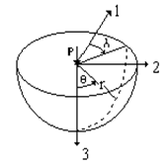

Fig. 1. The spherical co-ordinate system and a vertical force of magnitude equal to P acting at the origin

Because symmetry, the displacement vector has the components like

. (15)

It follows the components of both stress and strain tensors are functions of and  only.

**1.3. *The equations of equilibrium and strain tensor in spherical coordinates***

The Lamé differential parameters for spherical coordinates are

.

The generalised curvilinear coordinates are

.

The unit vectors of the axis are

.

By using, for example, (Ivan, 1996), the divergence of a symmetric tensorin spherical coordinates is

 (16)

In the same way, the gradient of a vector in spherical coordinates is



The components of the strain tensor are



In the particular case of eqs. (15), it follows

. (17)

Hence



By using (16), the equilibrium equations in the absence of the volume forces are

,

or

 (18)

**2. Laplace operator in spherical coordinates. Legendre’s polynomials**

**2.1. *Laplace operator in spherical coordinates. Legendre’s polynomials***

Using, for example, the gradient of a scalar function in spherical coordinates is

.

Also, the Laplace operator is

.

Consider the Laplace equation

. (19)

for the particular case when the unknown function has the form . Equation (19) becomes

. (20)

By using the method of separation of the variables, a solution for eq. (20) has the form

,

where  and are two unknown functions. Eq. (20) becomes

, (21)

where is a constant. From (21) it follows that

.  (22)

In a general case, the function  can be developed in power series. Let’s look for a particular solution having the form where  is a natural number. It follows from (22) that

.

Then the particular solution of eq. (22) can be expressed with the aid of two arbitrary constants as

.

Because  has to approach finite values for  , it has to take .

The second relation (21) gives

. (23)

By performing the substitution eq. (23) becomes

, (24)

The solution of (24) is represented by the Legendre polynomials denoted by  So,

.

Because the trace of the stress tensor is a solution of the harmonic equation (12), it follows that the general solution for that trace in the case of the Boussinesq problem is

. (25)

According to eq. (3), a similar solution exists for the trace of strain tensor.

**2.2. *The displacement field***

We look for a displacement field having the form

, (26)

where  and  are two unknown functions following to be obtained. Substituting (26) into (17) it follows that

.

It follows that the trace of the strain tensor is

. (27)

A comparison of (27) to (25) shows that

, (28)

where  is a constant remaining to be obtained. Hence



By using Hooke’s law, it follows that

 (29)

Substituting (29) into the first equilibrium equation (29) and using (28), it follows after elementary computations that

.

Hence



where is an integration constant. Because

,

where  is a new integration constant, it follows that

. (30)

For , the logarithmic term into (30) leads to infinite radial displacements. That can be avoided by taking

.

Hence

. (31)

and

. (32)

Substituting eq. (31) into eq. (28), it follows that



Hence

.

Because the tangential displacements has to be finite ones for , it follows that

 (33)

By substituting eqs. (31) and (33) into eq. (29) it follows that

 (34)

Substituting eqs. (34) into the second equilibrium equation (18) it can be seen that the last one is identically verified.

**2.3. *Boundary conditions for stress elements. The final solutions***

Eqs. (32) and (34) contain the unknown coefficients  and . These constants follow to be obtained taking into account that the force P concentrated in the origin of the coordinate system is acting on the elastic semi-space. It can be seen that the points of the horizontal plane have the co-latitude.

The unit vectors of the spherical coordinate system are related to the same vectors of the rectangular coordinate system by

 (35)

where the orthogonal matrix is

. (36)

The outer pointing unit vector normal to the elastic semi-space is equal to

. (37)

The resulting exterior force acting on the elastic semi-space is vanishing for all the points of the horizontal plane , excepting the origin, i.e.

. (38)

Substituting (37) into (38) forgives

. (39)

By using (33), the first eq. (39) becomes an identity and the second one leads to

.

So, eqs. (32) and (34) give

, .

Consider an elastic hemisphere having the centre at the origin of the co-ordinate system. The curved surface of the hemisphere has the outer pointing normal equal to . On that surface, the rest of the elastic body (i.e. the semi-space minus the hemisphere) is acting on the hemisphere with a total force equal to

,

where is the surface element and the unit vectors are obtained with (35). It follows that



Because the hemisphere is into an equilibrium state, it follows that

,

Hence

.

Finally, the non-zero components of the stress tensor are equal to

,

,

.

The non-zero components of the displacement vector are



Using eq. (36), the components of the stress tensor into the Cartesian base can be obtained as

.

Also, the components of the displacement vector into the Cartesian base are

.

Of particular importance in real life are the components

.

The Bousinesq problem has a great importance in Geomechanics, in relation to the computation of a building foundation. The above solution derived for a concentrated vertical force can be used in the case of arbitrary vertical forces (spread on a certain domain) by assuming the principle of the superposition.

**Questions for self-control**

1. What are the equations of Beltrami and Mitchell?

2. How is the Laplace operator in spherical coordinates calculated?

3. How are the equations of equilibrium and strain tensor in spherical coordinates written?

4. How is the displacement field defined?

5. What boundary conditions for the stress elements do you know?

**The basic literature**

1. Aki, K., Richards, P.G., 1980. Quantitative Seismology, Freeman and Co., New York.

2. Beju, I., Soos, E., Teodorescu, P.P., 1977, Euclidean Tensorial Calculus - in Romanian, Ed.tehnicã, Bucharest.

3. Filonenco-Borodici, M.M., 1952, Theory of Elasticity, Ed.tehnicã, Bucharest

4. Ivan, M., 1996, Seismology (in Romanian), v.I, Ed.Universitãtii Bucuresti.

5. Ivan, M., 1997a. A finite element algorithm for computing the flexure of the crustal, *in press*, Studii si cercetari de GEOFIZICA 35.

6. Ivan, M., 1997b. Aperiodic motion of a crustal microplate, *in press*, Revue Roumaine de Géophysique 41.

7. Jaeger, J.C., Cook, N.G.W., 1969, Fundamental of Rock Mechanics, Methuen and Co. London.

8. Nowacki, W., 1961. Dynamika budowli (in Polish), Arkadi, Warszawa.

9. Ranalli, G., 1987, Rheology of the Earth, Allen & Uniwin Inc., Boston.

10. Rîjic, I.M., Gradstein, I.S., 1955, Tables of integrals, sums, series and products, -in Romanian, Ed.tehnicã, Bucharest.

11. Sokolnikoff, I.S., Redheffer, R.M., 1958, Mathematics of Physics and Modern Engineering, McGraw-Hill Book Co., Inc., New York.

12. Timoshenko, S., Woinowsky-Krieger, S. 1959. Theory of plates and shells, Mc-Graw-Hill, New York.

13. Timoshenko, S.P., Gere, J.M., 1961, Theory of elastic stability, McGraw-Hill, New York.

14. Turcotte, D.L., Schubert, G. 1982. Geodynamics, John Wiley and Sons, New York.

15. Wahr, J., 1996, Gravity and Geodesy - Class Notes, Samizdat Press.

**The supplementary literature**

1. Ralph H. Abraham and Jerrold E. Marsden. Foundations of Mechanics. -Wesley, 1978.

2. V. I. Arnold. Mathematical Methods of Classical Mechanics. - Springer Verlag, 1980.

3. Lothar Nordheim. The Principles of Mechanics. Vol. 2. - Springer, 1972.

4. Jean-Marie Souriau. Structure des Systèmes Dynamiques. - Dunod Université, Paris, 1970. (English translation: Birkhäuser Boston, 1998.)

5. E. C. G. Sudarshan and N. Mukunda. Classical Dynamics: A Modern Perspective. - John Wiley & Sons, 1974.

6. V. I. Arnold, V. V. Kozlov and A. I. Neishtadt. Mathematical Aspects of Classical and Celestial Mechanics. Dynamical Systems III. - Springer Verlag, 1988.

7. Giovanni Gallavotti. The Elements of Mechanics. - Springer Verlag, 1983.

8. F. R. Gantmakher. Lectures on analytical mechanics. - Fizmatgiz, 1960. (English translation by G. Yankovsky. - Mir Publishing, 1970.)

9. Herbert Goldstein. Classical Mechanics. 2nd edition. - Wesley, 1980.

10. Jorge V. José and Eugene J. Saletan. Classical Dynamics: A Contemporary Approach. - Cambridge University Press, 1998.

11. Cornelius Lanczos. The Variational Principles of Mechanics. 4th edition. - University of Toronto Press, 1970; Dover Publications, 1982.

12. Пронина Р.Ф. Пособие по переводу английской научно-технической литературы. - М.: Высшая школа, 1973.

13. Циммерман М., Веденеева К. Русско-английский научно-технический словарь переводчика. - М.: Наука, 1991.

14. Арушанян О.Б. Русско-английский словарь по прикладной математике и механике. (Russian-English dictionary of applied mathematics and mechanics). – М.: МГУ, 2012.

15. Пумпянский А.Л. Чтение и перевод английской научно-технической литературы: Лексика, грамматика, фонетика, упражнения /Худ. обл. М. В. Драко.— М.: ООО «Попурри», 1997.— 608 с.

16. L. D. Landau and E. M. Lifshitz. Mechanics. 3rd edition. Course of Theoretical Physics. Vol. 1. - Pergamon Press, 1976.

17. Jerrold E. Marsden and Tudor S. Ratiu. Introduction to Mechanics and Symmetry. - Springer Verlag, 1994.

18. Florian Scheck. Mechanics, From Newton's Laws to Deterministic Chaos. 2nd edition. - Springer-Verlag, 1994.

19. E. T. Whittaker. A Treatise on Analytical Dynamics. - Cambridge University Press, 1937.

20. Walter Thirring. A Course in Mathematical Physics 1: Classical Dynamical Systems, translated by Evans M. Harell, - Springer-Verlag, 1978.

21. Англо-русский словарь математических терминов: около 20000 терминов / под ред. П. С. Александрова. - Изд.3-е, стер. - М.: Мир, 2001.

22. Голденков М. Современный активный English. ЧеРо. – М: Физматлит, 2002.-448с.

**The list of periodicals**

1. Английский язык: Прил. к газете "1 сентября".

2. Иностранные языки в высшей школе.

**The source list on electronic media**

1. Кутателадзе С.С. Russian-English in writing. Изд. института математики. – Новосибирск, 2000.

2. Игнатьев-Каллэхэм Л. Русско-английский политехнический словарь. - М.: Уайли, 1995.

3. A.J. Lohwater's Russian-English dictionary of the mathematical sciences / R.P. Boas (ed.). American Mathematical Society, 1990.

4. Сосинский А. Б. Как написать математическую статью по-английски. — М: Изд-во «Факториал Пресс», 2000. — 112 с.

**The Internet sources**

1. http://ru.wikipedia.org

2. <http://lingualeo.com/>