Қазақстан Республикасы Ғылым және жоғары білім министрлігі
Е.А. Бөкетов атындағы Қарағанды университеті

Математика және ақпараттық технологиялар факультеті

Профессор Т.Ғ.Мұстафин атындағы алгебра, математикалық логика және геометрия кафедрасы

Есенбаева Гульсим Ахмадиевна

«Кәсіби терминология және механика бойынша ағылшын ғылыми-техникалық әдебиеттерін аудару негіздері (ағылшынша)» пәні бойынша
Дәрістер курсы

білім беру бағдарламасы: «7M05402 Механика»

Қарағанды 2024
The Ministry of Education and Science of the Republic of Kazakhstan
Karaganda University of the name of academician E.A. Buketov

The Faculty of Mathematics and Information Technologies

The Chair of Algebra, Mathematical Logic and Geometry
named after Professor Mustafin T.G.

Yessenbayeva Gulsim Akhmadievna

The course of lectures
on the discipline «Professional terminology and basics of English scientific and technical literature translation on mechanics (in English)»

Educational program: «7M05402 Mechanics»

Karaganda 2024

CONTENT

Introduction  Lecture 1. Introduction to the Subject Area. The Subject of Mechanics and Its History  Lecture 2. Signs, Symbols, and Terms of Mechanics, Their Reading and Meaning  Lecture 3. The Basic Categorical Conceptual Apparatus of Mechanics and Its Features  Lecture 4. The Principal Terms and Phrases of Mechanics, Their Translation Methods  Lecture 5. The Main Structures of Mechanics. Rules for Reading Mathematical Formulas of Mechanics  Lecture 6. Translating Scientific and Technical Texts. Basic Principles of Translation  Lecture 7. Theoretical Issues of Translation, Nature and Concept of Scientific Texts  Lecture 8. Translation of Terms in Scientific and Technical Texts.  Lexical Problems of Translation  Lecture 9. Translating Scientific and Technical Style. Scientific Translation and Scientific Language  Lecture 10. How to Write an Article on Mechanics in English | 4  5  19  31  43  55  67  80  93  106  119

Introduction

The discipline «Professional terminology and basics of English scientific and technical literature translation on mechanics (in English)» is destined to master's students under the educational program «7M05402 - Mechanics».

This discipline is intended for the study of professional foreign terminology on mechanics, the analysis of terminology in a scientific and technical style, aspects of scientific and technical translation, and the basics of communication in the professional field of mechanics.

The purpose of studying the discipline is to obtain fundamental knowledge on professional foreign terminology on mechanics and on the main aspects of scientific and technical translation of mechanical texts; the development of skills of analysis and use of terminology in scientific and technical style and characteristics of scientific and technical language when reading and translating specialized literature on mechanics; the formation of communicative competence in the process of foreign language interaction in the professional sphere.

In this discipline, master's students study the basic theoretical principles, professional terminology for working with foreign scientific, technical and educational literature on mechanics; study the basics of reading and translating foreign scientific and technical literature on mechanics for working with reference materials, documents and periodicals in the specialty in English.

When studying this discipline, master's students learn to apply the acquired knowledge when reading and translating foreign scientific and technical literature, when conducting written and oral business communication in English, which will give them the opportunity to effectively interact in a professional and scientific foreign language environment.

The course of lectures consists of an introduction and ten lectures with references.

The structure of each lecture can be described as follows. The lecture plan contains the main sections and points of the lecture material. The content of the lecture presents the main provisions, assumptions, characteristics, criteria, properties and explanations of the material presented. The lecture material is supplemented with figures and tables with explanations.

References are given at the end of each lecture, which meets the requirements for the design of the lecture course at Karaganda University of the name of academician E.A. Buketov.

It should be borne in mind that the course of lectures is not an original scientific research, does not pretend to provide exhaustive information, but aims to give master students an idea of the main content of the discipline «Professional terminology and basics of English scientific and technical literature translation on mechanics (in English)».

Lecture 1

Lecture topic: Introduction to the Subject Area. The Subject of Mechanics and Its History
Lecture plan

1. Mechanics as a Science
2. History of Mechanics
3. Grammar Patterns: Demonstratives. Pronouns

1. Mechanics as a Science
Mechanics is a science concerned with physical bodies subjected to forces or displacements. Mechanics is the area concerned with the relationships between force, matter, and motion among physical objects.
In Newtonian Mechanics space, time and mass are absolute concepts independent of each other. Force, however, is not independent of the other three. The force acting on a body is related to the mass of the body and the variation of its velocity with time.
The object of the study of mechanics is the movement, so it is a very extensive study area. For all types of movements, their common sign is the change in the position of one body compared to the other body. Changing the position of a body relative to any other body, and changing the position of some parts of a body relative to the rest of that body, it is called mechanical motion. The basic task of mechanics is to determine the position of the given body at each moment of time, that is, to know the laws for the movement of the body.
Types of mechanics. There are three basic types of mechanics: Classical Mechanics, Quantum Mechanics and Relativistic Mechanics (fig. 1.1).

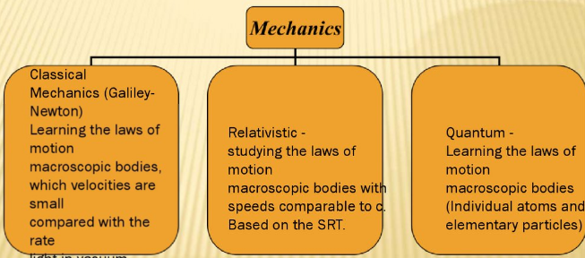

Figure 1.1. Basic types of mechanics

Classical mechanics is important as it gives the foundation for most of physics. The theory, based on Newton’s laws of motion, provides essentially an exact description of almost all macroscopic phenomena.
Classical mechanics deals with the question of how an object moves when it is subjected to various forces, and also with the question of what forces act on an object which is not moving.
The theory requires modification for
1. microscopic systems, e.g. atoms, molecules, nuclei - use quantum mechanics;
2. particles travelling at speeds close to the speed of light - use relativistic mechanics.
These other theories must reduce to classical mechanics in the limit of large bodies travelling at speed much less than the speed of light.
The word «classical» indicates that we are not discussing phenomena on the atomic scale and we are not discussing situations in which an object moves with a velocity which is an appreciable fraction of the velocity of light. The description of atomic phenomena requires quantum mechanics, and the description of phenomena at very high velocities requires Einstein’s Theory of Relativity.
The laws of classical mechanics enable us to calculate the trajectories of baseballs and bullets, space vehicles, and planets as they move around the sun. Using these laws we can predict the position-versus-time relation for a cylinder rolling down an inclined plane or for an oscillating pendulum, and can calculate the tension in the wire when a picture is hanging on a wall.
Classical mechanics is the mathematical science that studies the displacement of bodies under the action of forces.
Classical mechanics is usually divided into sub-disciplines:
1. Statics
2. Dynamics
3. Kinematics
4. Kinetics (fig. 1.2)

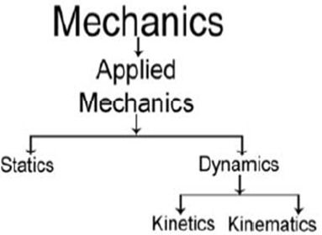

Figure 1.2. Sub-disciplines of Classical Mechanics

The practical importance of the subject hardly requires demonstration in a world which contains automobiles, buildings, airplanes, bridges, and ballistic missiles. Even for the person who does not have any professional reason to be interested in any of these mundane things, there is a compelling intellectual reason to study classical mechanics: this is the example par excellence of a theory which explains an incredible multitude of phenomena on the basis of a minimal number of simple principles.
Statics is a part of mechanics which studies bodies at rest while they are under the influence of forces, Statics is the study of forces in the absence of changes in motion or energy. Statics - systems at rest and in equilibrium,
Statics is the branch of classical mechanics that is concerned with the analysis of force and torque acting on a physical system that does not experience an acceleration, but rather is in equilibrium with its environment.
Statics studies objects that are either at rest, or in constant motion, that is a motion with constant velocity as to its magnitude and direction. Statics studies the equilibrium conditions in bodies extensive, that is, it determines what the measurements or the intensity of forces and torques must be so that a body of non-negligible dimensions can remain in equilibrium. In the study of statics, Newton's laws are widely used.
The methods and results of the science of statics have proved especially useful in designing buildings, bridges, and dams, as well as cranes and other similar mechanical devices. To be able to calculate the dimensions of such structures and machines, architects and engineers must first determine the forces that act on their interconnected parts. Statics provides the analytical and graphical procedures needed to identify and describe these unknown forces.
Statics assumes that
1) the bodies with which it deals are perfectly rigid,
2) that the sum of all the forces acting on a body at rest has to be zero (i.e., the forces involved balance one another)
3) and that there must be no tendency for the forces to turn the body about any axis.
These three conditions are independent of one another, and their expression in mathematical form comprises the equations of equilibrium. There are three equations, and so only three unknown forces can be calculated.
If more than three unknown forces exist, it means that there are more components in the structure or machine than are required to support the applied loads or that there are more restraints than are needed to keep the body from moving.
Such unnecessary components or restraints are termed redundant (e.g., a table with four legs has one redundant leg) and the system of forces is said to be statically indeterminate.
The number of equations available in statics is limited because of a neglect of the deformations of loaded bodies, a direct consequence of the underlying premise that any solid body under consideration is ideally rigid and immutable as to shape and size under all conditions.
Dynamics is a part of mechanics which studies the movement of bodies under the influence of forces. Dynamics is the branch of mechanics that deals with both motion and force together. Dynamics - details of the force law are specified, e.g. gravitational force, force due to a stretched spring. Dynamics studies objects with acceleration.
The study of the causes of motion and changes in motion is dynamics. In other words the study of forces and why objects are in motion. Dynamics includes the study of the effect of torques on motion.
At dynamics the causes that gave rise to some movement are studied. In this sense, we study the forces that act on a body, the amounts of movement, the mechanical energy, the impulse and the quantities related to rotational movements, such as the torque it's the time angular.
Dynamics based on Newton's laws is called classical dynamics. Classical dynamics describes the movement of bodies with speeds ranging from fractions of millimeters per second to kilometers per second.
Generally speaking, researchers involved in dynamics study how a physical system might develop or alter over time and study the causes of those changes. In addition, Isaac Newton established the undergirding physical laws which govern dynamics in physics. By studying his system of mechanics, dynamics can be understood. In particular dynamics is mostly related to Newton's second law of motion. However, all three laws of motion are taken into consideration, because these are interrelated in any given observation or experiment.
The bases of the study of the dynamics are the three laws in Newton, based on them, the other equations of the subarea are derived, and also from kinematics.
Dynamics may be broken down into kinematics and kinetics.
Kinematics is a part of mechanics which studies the movements of bodies. Kinematics is the study of motion without regard to the forces or energies that may be involved. It is the simplest branch of mechanics. Kinematics - systems in motion, often accelerating.
Kinematics is a part of mechanics which treats of the geometrical aspects of the bodies, without taking into account their inertia, i.e., mass or the forces acting on them.
Kinematics is the field of mechanics that studies the movement of bodies without taking into account the causes of this movement. In other words, we study situations that occur from the moment a body starts its state of movement.
Kinematics (Greek κινειν,kiein, to move) is a branch of mechanics which describes the motion of objects without the consideration of the masses or forces that bring about the motion. In contrast, dynamics is concerned with the forces and interactions that produce or affect the motion.
Kinematics studies how the position of an object changes with time. Position is measured with respect to a set of coordinates. Velocity is the rate of change of position. Acceleration is the rate of change of velocity. Velocity and Acceleration are the two principal quantities which describe how position changes.
Kinematics is an introduction to dynamics, insofar as the fundamental concepts and relationships of Kinematics have to be understood before studying the motion of bodies taking into account the action of forces.
On the other hand, the methods of Kinematics are in themselves of practical importance, for example in studying the transmission of motion in mechanisms.

By motion in Kinematics is meant the relative displacement with time of a body in space with respect to other bodies. In order to locate a moving body or particle we assume a coordinate system, which we call the frame of reference or reference system, to be fixed relative to the body with respect to which the motion is being considered.
If the coordinates of all the points of a body remain constant within a given frame of reference, the body is said to be at rest relative to that reference system. If, on the other hand, the coordinates of any points of the body change with time, the body is said to be in motion relative to the given frame of reference.
Kinetics is a branch of classical mechanics that concerns the effect of forces and torques on the motion of bodies having mass. Kinetics deals with the forces and moments involved in making the body move along with the measurement of various parameters describing the motion.
Kinetics is the study of the relationships between the forces acting on the body and how those forces affect motion. But kinematics is the geometry of the motion of objects which includes displacement, velocity and acceleration.
The study is often referred to as the geometry of motion, and it models these motions mathematically using algebra. The systems in kinematics are modeled to calculate such things as speeds and ratios. An example model of bodies in a system is the gears in a vehicle's transmission.
A more detailed classification of the sections of mechanics is shown in Figure 1.3.
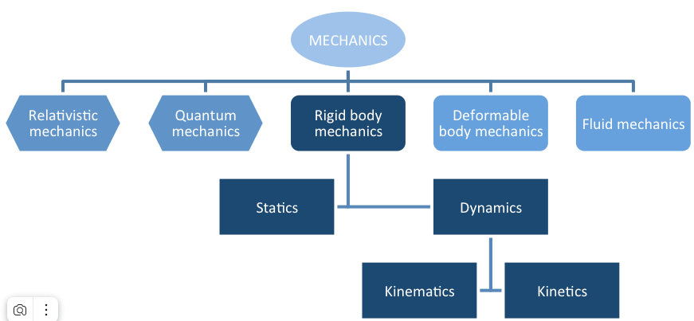

Figure 1.3. Sub-disciplines of Mechanics

The following areas are included as part of the field of classical mechanics:
- Newtonian mechanics, involves the original theory of motion (kinematics) and forces (dynamics)
- Lagrangian mechanics, a theoretical formalism, based on the principle of conservation of energy
- Hamiltonian mechanics, another theoretical formalism, based on the principle of the least action
- Celestial mechanics, the motion of heavenly bodies, such as planets, comets, stars, and galaxies
- Astrodynamics, for the navigation of spacecraft and similar objects
- Solid mechanics, involving study of elasticity and the properties of (semi-)rigid bodies
- Acoustics, dealing with sound (or density variation propagation) in solids, fluids, and gases.
- Statics, dealing with semi-rigid bodies in mechanical equilibrium
- Fluid mechanics, or the study of the motion of fluids
- Soil mechanics, or the study of the mechanical behavior of soils
- Continuum mechanics, involving the mechanics of continua (both solid and fluid)
- Hydraulics, dealing with the mechanical properties of liquids
- Fluid statics, dealing with liquids in equilibrium
- Applied / Engineering mechanics, for technological applications
- Biomechanics, studying biological materials
- Biophysics, studying the physical processes in living organisms
- Statistical mechanics, dealing with assemblies of particles too large to be described in a deterministic way
- Relativistic or Einsteinian mechanics, dealing with universal gravitation
Now let's move on to Quantum Mechanics. Quantum mechanics is a field of physics that deals with extremely tiny objects. It leads to some unexpected conclusions about the physical universe, which may look weird at first. Many of the equations of classical mechanics, which explains how objects move at common sites and speed, are useless at the scale of atoms and electrons.
Objects exist in a given place at a specific moment in classical mechanics. Objects in quantum physics, on the other hand, live in a haze of possibility, with a certain chance of existing at point A, another chance at point B, and so on.
Quantum mechanics is a science dealing with the behaviour of matter and light on the atomic and subatomic scale. It attempts to describe and account for the properties of molecules and atoms and their constituents - electrons, protons, neutrons, and other more esoteric particles such as quarks and gluons. These properties include the interactions of the particles with one another and with electromagnetic radiation (i.e., light, X-rays, and gamma rays).
The following areas are categorized as being part of the field of quantum mechanics:
- Particle physics, related to the motion, structure, and reactions of particles
- Nuclear physics, related to the motion, structure, and reactions of atomic nuclei
- Condensed matter physics, involving the study of quantum gases, solids, and liquids
- Quantum statistical mechanics, dealing with large assemblies of particles
In addition to the above areas, there is the "theory of fields," which constitutes a separate discipline in physics, formally treated as distinct from mechanics, whether classical fields or quantum fields. But in actual practice, subjects belonging to mechanics and fields are closely interwoven. Thus, for instance, forces that act on particles are frequently derived from fields (electromagnetic or gravitational), and particles generate fields by acting as sources. In fact, in quantum mechanics, particles themselves are fields, as described theoretically by the wave function.
Relativistic mechanics is a science concerned with the motion of bodies whose relative velocities approach the speed of light c, or whose kinetic energies are comparable with the product of their masses m and the square of the velocity of light, or mc². Such bodies are said to be relativistic, and when their motion is studied, it is necessary to take into account Einstein’s special theory of relativity. As long as gravitational effects can be ignored, which is true so long as gravitational potential energy differences are small compared with mc², the effects of Einstein’s general theory of relativity may be safely ignored.
Relativistic mechanics, science concerned with the motion of bodies whose relative velocities approach the speed of light c, or whose kinetic energies are comparable with the product of their masses m and the square of the velocity of light, or mc2.
Such bodies are said to be relativistic, and when their motion is studied, it is necessary to take into account Einstein’s special theory of relativity. As long as gravitational effects can be ignored, which is true so long as gravitational potential energy differences are small compared with mc2, the effects of Einstein’s general theory of relativity may be safely ignored.
The foundations of relativistic mechanics are the postulates of special relativity and general relativity. The unification of special relativity with quantum mechanics is relativistic quantum mechanics.

2. History of Mechanics
Theoretical expositions of mechanics has its origins in Ancient Greece, for instance, in the writings of Aristotle and Archimedes. During the early modern period, scientists such as Galileo Galilei, Johannes Kepler, Christiaan Huygens, and Isaac Newton laid the foundation for what is now known as classical mechanics (fig. 1.4).
The history of mechanics is one of the most important branches of the history of science. From earliest times man has sought to develop tools that would enable him to add to his power of action or to defend himself against the dangers threatening him. Thus he was unconsciously led to consider the problems of mechanics.
So we see the first scholars of ancient times thinking about these problems and arriving more or less successfully at a solution. The motion of the stars which, from the Chaldean shepherds to the great Greek and Hellenistic astronomers, was one of the first preoccupations of human thought, led to the discovery of the true laws of dynamics.
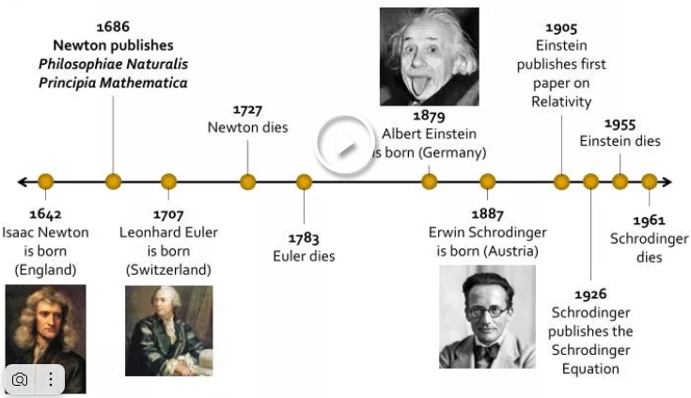

Figure 1.4. Brief history of mechanics

Statics is a the subdivision of mechanics that is concerned with the forces that act on bodies at rest under equilibrium conditions. Its foundations were laid more than 2,200 years ago by the ancient Greek mathematician Archimedes and others while studying the force-amplifying properties of simple machines such as the lever and the axle.
The Statics of Archimedes. Unlike Aristotle, whose mechanics is integrated into a theory of physics which goes so far as to incorporate a system of the world, Archimedes (287-212 B.C.) made of statics an autonomous theoretical science, based on postulates of experimental origin and afterwards supported by mathematically rigorous demonstrations, at least in appearance.
Here we shall follow the treatise On the Equilibrium of Planes or on the Centres of Gravity of Planes in which Archimedes discussed the principle of the lever.
The foundations of quantum mechanics were established during the first half of the twentieth century by Max Planck, Werner Heisenberg, Louis de Broglie, Albert Einstein, Niels Bohr, Erwin Schrödinger, Max Born, John von Neumann, Paul Dirac, Wolfgang Pauli and others.
Quantum mechanics evolved over decades, starting as a collection of contentious mathematical explanations for experiments that classical physics couldn’t explain. It began about the same time as Albert Einstein’s theory of relativity, a different mathematical breakthrough in physics that describes the motion of objects at high speeds. Unlike relativity, the beginnings of quantum mechanics cannot be traced back to a single scientist. Rather, between 1900 and 1930, a group of scientists worked together to provide the groundwork for three innovative concepts that eventually acquired recognition and experimental confirmation (fig. 1.5).

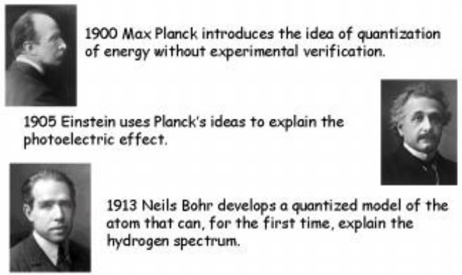

Figure 1.5. A very brief history of quantum mechanics

Quantum mechanics is now considered a foundational-level theory that encompasses and supersedes classical mechanics. However, classical mechanics is useful for calculations of macroscopic processes, while quantum mechanics helps explain and predict processes at the molecular, atomic, and subatomic levels.
Studies in mechanics have made vital contributions to various fields of engineering. They include mechanical engineering, aerospace engineering, civil engineering, structural engineering, materials engineering, and biomedical engineering. Thus, knowledge of mechanics has led to many practical applications.
Mechanics is the original discipline of physics and was formerly part of "natural philosophy," dealing with forces and motion in the macroscopic world as perceived by the human eye. This discipline has developed into a huge body of knowledge about important aspects of the natural world. Modern mechanics encompasses the movement of all matter in the universe under the four fundamental interactions (or forces): gravity, the strong and weak interactions, and the electromagnetic interaction.
Mechanics also constitutes a central part of technology, the application of physical knowledge for human purposes. In this sense, the discipline is often known as engineering or applied mechanics, and it is used to design and analyze the behaviour of structures, mechanisms, and machines. Important aspects of the fields of mechanical engineering, aerospace engineering, civil engineering, structural engineering, materials engineering, biomedical engineering and biomechanics were spawned from the study of mechanics.
The major division of the discipline of mechanics is one that separates classical mechanics from quantum mechanics. Historically, classical mechanics came first, while quantum mechanics is a comparatively recent formulation.
Classical mechanics originated with Isaac Newton's Laws of motion in Principia Mathematica, while quantum mechanics did not appear until 1900. Both are commonly held to constitute the most certain knowledge that exists about physical nature.
Classical mechanics has especially often been viewed as a model for other so-called exact sciences. Essential in this respect is the relentless use of mathematics in theories, as well as the decisive role played by experiment in generating and testing them.
Quantum mechanics is of a wider scope, as it encompasses classical mechanics as a sub-discipline that is applicable under certain restricted circumstances. According to the correspondence principle, there is no contradiction or conflict between the two subjects, each simply pertains to specific situations.
Quantum mechanics has superseded classical mechanics at the foundational level and is indispensable for the explanation and prediction of processes at molecular, atomic, and subatomic levels. However, for macroscopic processes, classical mechanics is able to solve problems that are unmanageably difficult in quantum mechanics and hence remains useful and well used.
Analogous to the quantum reformation of classical mechanics, Einstein's general and special theories of relativity have expanded the scope of mechanics beyond the mechanics of Newton and Galileo, and made fundamental corrections to them, that become significant and even dominant as speeds of material objects approach the speed of light, which cannot be exceeded.
Relativistic corrections are also needed for quantum mechanics, although relativity has not been fully integrated with it yet. This is one of the hurdles that have to be overcome in developing a Grand Unified Theory.

3. Grammar Patterns: Demonstratives. Pronouns

Table 1.1
Demonstratives: this, that, these, those
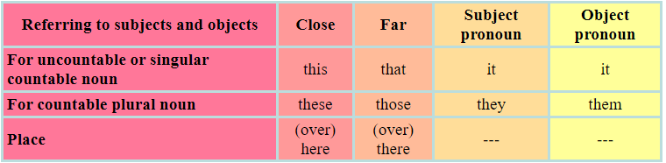

This is how to use this, that, these, those:
1) We use this, that, these, those to identify and refer to things that the listener(s) can see, hear, smell, touch or taste now.
- Look at that car. It's a BMW.
When you use demonstratives and pronouns make sure that the other person knows what you are talking about. That is their functions.
2) We use this and these to talk about people or things near us and we may add the words here or over here. We use that and those to talk about people or things that are farther away and we may add the words there or over there.
- This is my bag here. And that is her bag over there.
3) Demonstratives can be used to express emotions. This and these express positive feelings while that and those negative feelings. They express metaphorical distance or closeness.
- Are you going to meet that female friend of yours again? (dislike, jealousy)
- I love this new teacher.
- These (hats) are wonderful.
4) Use "that" and "those" to refer back to something that somebody said or did or obvious from the context of the conversation but cannot be sensed now (intangibles)
A: I am very angry with my boss.
B: Why is that?
5) Demonstratives can be used when we talk about time related things. We can use demonstratives in time phrases; sometimes without prepositions:
A: I saw you this morning.
B: Yes, I saw you in the morning, too.
6) When we introduce people personally, we use demonstratives first, instead of the pronouns he, she or they. After the first reference we use personal pronouns. It is not rude to use this or that to refer to someone at introduction.
- This is Oscar. (Don't say, "He is Oscar.")
7) This, that, these, those can function as "determiners" or "pronouns". They function as "determiners" when they come before nouns in noun phrases.
- This pen is red.
- Those big melons are mine.
- Whose are these old books?
8) We can use demonstratives to refer to shared, common knowledge or new information. You can use "that" or "those" instead of "the" to refer to shared or common knowledge in a story or explanation.
- Those workers are just young man.
9) You can use "this" instead of "a" or "an" to refer to something important or recent, or to introduce a new element in a story.
- This car just came out of nowhere.
10)Use this and that with singular and uncountable nouns. Use these and those with plural nouns. However, use singular demonstratives if the first word in a list of words requires singular demonstrative, even if the second, third etc. words are plural.
- This is my pen and books.
- These are my books and pen.
- That is my phone, wallet, bag and shoes.
- Those are my shoes, phone, wallet and bag.

Table 1.2
Personal Pronouns
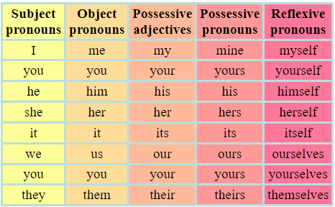

Table 1.3
Other pronouns
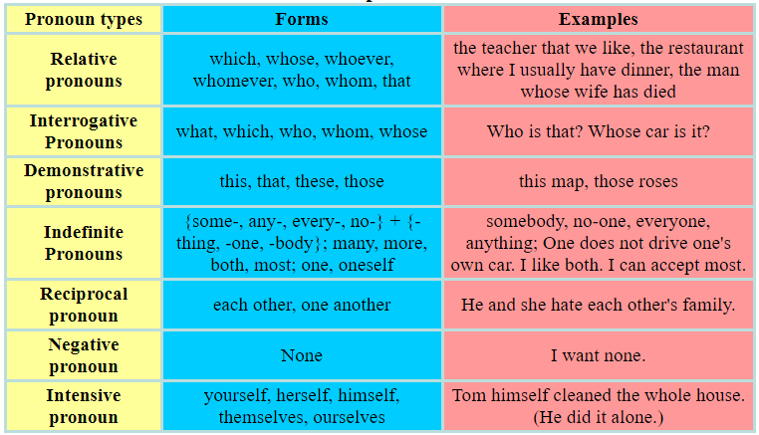

References
Primary sources
1. Kibble Tom W.B., Berkshire Frank H. Classical Mechanics. - 5th Edition. – London: Imperial College Press, 2004. – 478 p.
2. Englert Berthold-Georg. Lectures on Classical Mechanics. – Singapore, 2015. – 376 p.
3. Müller-Kirsten Harald J.W. Classical Mechanics and Relativity. – London: World Scientific Publishing Co Pte Ltd, 2017. – 560 p.
4. Lurie A.I. Theory of Elasticity. - Springer Science & Business Media, 2010. – 1050 p.
5. Martin H. Sadd. Elasticity. Theory, Applications and Numtrics. – Amsterdam: Boston:Elsevier, 2005. – 461 p.
6. Darryl D Holm. - Geometric Mechanics. - London, 2011. – 468 p.
7. Papastavridis John G. - Elementary Mechanics. - In 2 Volumes. – USA, 2019. – 1680 p.
8. Бизюк Л.К., Зенченко В.А., Потапова Н.Л., Тригубкина С.Н. Learn higher mathematics in English. – Минск : БГУ, 2015. – 96 с.
9. Прокошева И.И. Основные математические понятия в английском языке: Методические указания. – Оренбург: ГОУ ВПО ОГУ, 2003. - 50 с.
10. Downing Douglas. Dictionary of Mathematics Terms. - Third Edition. - Barron’s Educational Series, Inc. Prior editions. 2009. – 394 p.
11. Clapham Christopher, Nicholson James. The Concise Oxford Dictionary of Mathematics. – Fourth edition. - New York: Oxford University Press Inc., 2009. – 875 p.
12. Кудинова Ю.С., Никрошкина С.В. Английский язык для инженеров-механиков: уч. пособие. - Новосибирск: Изд-во НГТУ, 2019. – 94 с.

Secondary sources
13. Kai S Lam. Fundamental Principles of Classical Mechanics. - Pomona, USA, 2014. – 592 p.
14. Harald Iro. A Modern Approach to Classical Mechanics, - 2nd Edition. – Austria, 2015. – 528 p.
15. Atanackovic Teodor M., Ardeshir Guran. Theory of Elasticity for Scientists and Engineers. - Springer Science & Business Media, 2000. – 374 p.
16. Nekovar Jan. Mathematical English (a brief summary). – Universite Paris, 2011. – 30 p.
17. Schwartzman Steven. The Words of Mathematics: An Etymological Dictionary of Mathematical Terms Used in English. - MAA, 1994. – 261 p.
18. Янушкевич Л.М. English for mechanical engineers: пособие. - Минск: БНТУ, 2019. – 198 с.

Online sources
19. Shapiro Joel A. Classical Mechanics. – 2010. – 272 p. [Electronic resource] https://www.physics.rutgers.edu/~shapiro/507/book.pdf
20. Theory of elasticity. [Electronic resource]
http://limba.wil.pk.edu.pl/kpmoc/images/stories/kpmoc/pracownicy/PSz/TSiP/ToE.pdf
21. Elasticity Theory, Energy, and Forces. [Electronic resource]
https://www.tf.uni-kiel.de/matwis/amat/def_en/kap_5/backbone/r5_2_1.html
22. “Math Vocabulary” – The Language of Mathematics. – 2023. [Electronic resource]
https://www.eslbuzz.com/math-vocabulary-the-language-of-mathematics/
23. Math.Glossary. [Electronic resource] https://mandober.gitbook.io/math-debrief/900-index/990-appendix/math.glossary#theorem
24. Reading Math in English. [Presentation]
https://www.powershow.com/view4/81c9dd-NWNmO/Reading_Maths_in_English_powerpoint_ppt_presentation#google_vignette
25. English grammar tables and examples. [Electronic resource]
https://www.englishconversationcoursetutorhk.com/english_grammar_tables_e.php

Lecture 2

Lecture topic: Signs, Symbols, and Terms of Mechanics, Their Reading and Meaning

Lecture plan
1. Basic Symbols, Terms and Word-Groups of Mechanics and Their Meanings
2. Mathematical Operation Signs and Terms
3. Grammar Patterns: English Tenses (Present)

1. Basic Symbols, Terms and Word-Groups of Mechanics and Their Meanings
1.1. Stress
Loads applied on a material are distributed over a surface. For example, the point load shown in the following figure might actually be a uniformly distributed load that has been replaced by its equivalent point load.
Stress is the load applied per unit area of the surface it is applied on.
Normal stress is the stress normal to a surface and is denoted by the symbol σ (sigma). In the above figure the normal stress is uniform over the surface of the bar and is given by
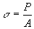
Shear stress is the stress tangent to a surface. If in the following figure the shear stress τ (tau) that results in the shear load V is uniformly distributed over the surface, then the shear stress can be calculated by dividing the shear force by the area it is applied on.
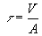
The units of stress are the units of load divided by the units of area. In the SI system the unit of stress is "Pa" and in the U.S. system it is "Psi". Pa and Psi are related to the basic units through the following relations
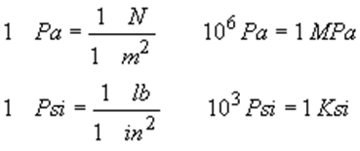
Bearing Stress. Even though bearing stress is not a fundamental type of stress, it is a useful concept for the design of connections in which one part pushes against another. The compressive load divided by a characteristic area perpendicular to it yields the bearing stress which is denoted by σ_{b}.
Therefore, in form, the bearing stress is no different from the compressive axial stress and is given by
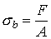
where F is the compressive load and A is a characteristic area perpendicular to it.
For example, if two plates are connected by a bolt or rivet as shown, each plate pushes against the side of the bolt with load F (fig. 2.1).
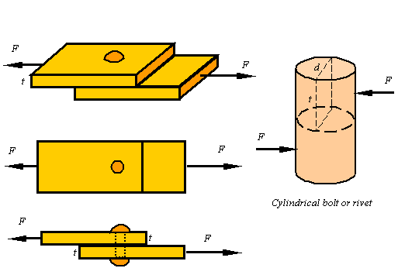
Figure 2.1. Bearing Stress

It is not clear what the contact area between the bolt and the plate is since it depends on the size of the bolt and the shape of the deformation that results. Also, the distribution of the load on the bolt varies from point to point, but as a first approximation one can use the shown rectangle of area A=td to get a representative bearing stress for the bolt as
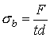.

1.2 Loading Modes
In general, an object can be loaded in any direction relative to the crack. The sketch at the right shows a force vector at such a random orientation. It is mostly perpendicular to the crack, but also contains components that produce in-plane and out-of-plane shear.
When this occurs, the logical thing to do is partition the force into its fundamental components. This process leads to the three loading modes shown below.
Mode I loading occurs most often and produces the most damage. Because of this, it naturally receives the most attention in research, structural design, failure analysis, etc. It is commonly called the Opening Mode.
Mode II corresponds to shearing of the crack face due to in-plane shear stresses. Mode II loading influences the crack growth direction in a way that minimizes further Mode II loading while maximizing Mode I.
Mode III is the Tearing Mode for obvious reasons. It is driven by out-of-plane shear stresses, and does not seem to occur as often as the other two (fig. 2.2).

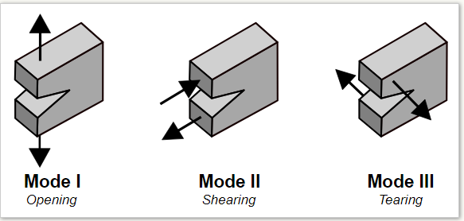

Figure 2.2. Loading Modes

Basic modes of loading a material are compression, tension, shear, torsion, bending
Material element can be extended, compressed, or sheared. The following figure shows how the square section to the left changes its shape during extension, contraction and shearing (fig. 2.3).

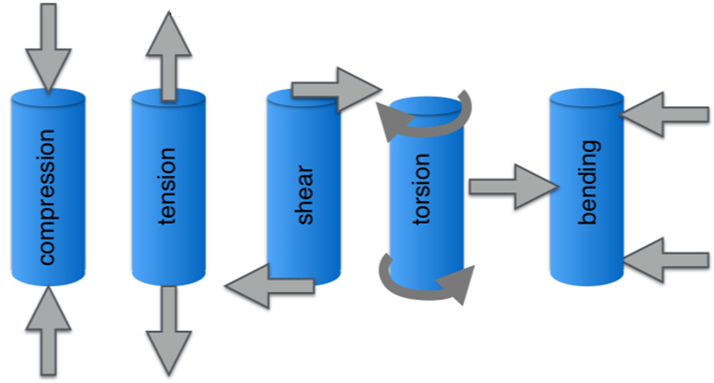
Figure 2.3. Basic modes of loading

1.3. Strain
Strain is the way engineers represent the distortion of a body. Axial strain (normal strain) in a bar is a measure of the extension of a bar per unit length of the bar before deformation. The following figure shows a bar of initial length lo that is extended by the application of a load to the length l (fig. 2.4).
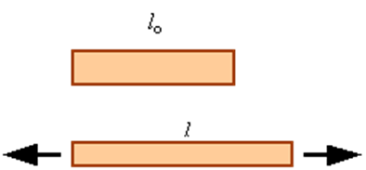

Figure 2.4. Axial strain
The axial strain, denoted by ɛ (epsilon), in a homogeneously deforming bar is calculated by dividing the amount the bar extends by its initial length. This yield the equation
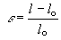
A positive axial strain represents extension and a negative axial strain represents a contraction. Strain has no units since it is one length divided by another length.
Shear strain, denoted by γ (gamma), is a measure of how the angle between orthogonal lines drawn on an undeformed body changes with deformation. In the following figure the square has been sheared into a parallelogram (fig. 2.5).

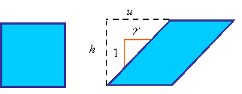
Figure 2.5. Shear strain

The shear strain is calculated from the equation
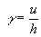
As can be seen from the following figure, the shear strain is equal to the tangent of the change in angle or the two orthogonal sides (fig. 2.5).

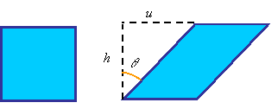
Figure 2.6. Shear strain

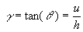
The difference between γ and θ becomes less and less as the angle θ (in radians) becomes small. This is since the tangent of an angle, given in radians, can be approximated by the angle for small values of the angle. In most structural materials the shearing is small and we can use the approximation
.
Volumetric strain during extension: During the extension of a bar the volumetric strain can be calculated as the ratio of the change in volume to the original volume. Denoting the volumetric strain as e, the initial volume as V_{o} and the final volume as V, one can calculate the volumetric strain from
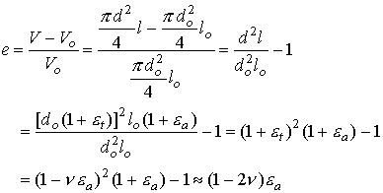
The last step is contingent on the axial strain being small relative to unity.

1.4. Hooke's Law. Poisson’s Ratio
Hooke’s law: In the linear elastic portion of the response of material one can model the response by Hooke’s law:
Hooke’s law for extension:
Hooke’s law for shear:
where E is the elastic modulus (also known as Young’s modulus), and G is the shear modulus. The elastic and shear moduli are material constants characterizing the stiffness of the material.
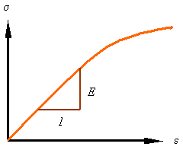
Poisson’s Ratio: Another material parameter is Poisson’s ratio that characterizes the contraction in the lateral directions when a material is extended.
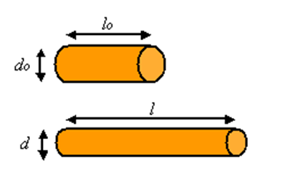
Figure 2.7. Poisson’s ratio
The symbol ν (nu) is used for the poison ration, which is negative the ratio of the lateral strain to axial strain.
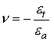, 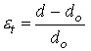, 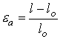.

1.5. The Relation between the Elastic Moduli. Factor of Safety
The relation between the elastic moduli: For an isotropic elastic material (i.e., an elastic material for which the properties are the same along all directions) there are only two independent material constants. The relation between these three moduli are given by the equation
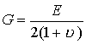
Factor of safety: The factor of safety denoted by n is the ratio of the load the structure can carry divided by the load it is required to take.
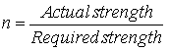
Therefore, the factor of safety is a number greater than unity (n>1). The allowable stress for a given material is the maximum stress the material can take (normally the ultimate or yield stress) divided by the factor of safety.
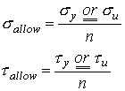.

2. Mathematical Operation Signs and Terms
In mechanics, as in other technical sciences, the language of mathematics is widely used. Knowledge of symbols, terms, word-groups of mathematics, and rules for reading mathematical formulas in English is also necessary for a mechanic as knowledge of mechanics itself.
Now let's study the mathematical relation signs, elementary mathematical symbols, amd their reading and writing in English (Tables 2.1 – 2.3).

Table 2.1
Relation signs
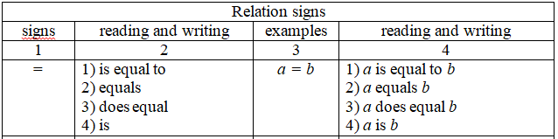

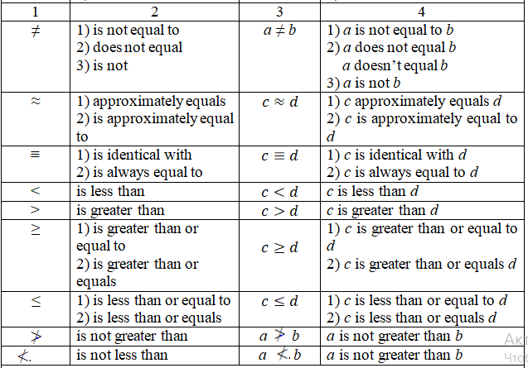

Table 2.2
Elementary mathematical symbols
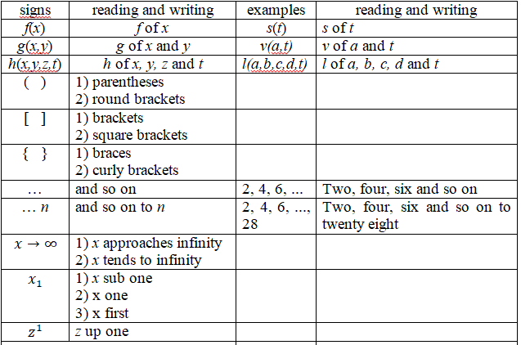

Table 2.3
Elementary mathematical symbols
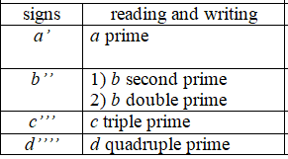

Arithmetic operations are the building blocks for all mathematical processes and methods. These types of operations are part of the “arithmetic” branch of math. Arithmetic operations are the basic mathematical operations used for calculation. Arithmetic Operations are the backbone of Mathematics.
There are four basic arithmetic operations, namely, Addition, Subtraction, Multiplication, and Division. These four basic arithmetic operations are very helpful in solving complex calculations such as problems of mechanics, etc.
Arithmetic operations strip math down to the basics that we use in mechanics, whether we realize it or not.
The four basic Arithmetic operations are presented by Table 2.4.

Table 2.4
Operation signs and terms
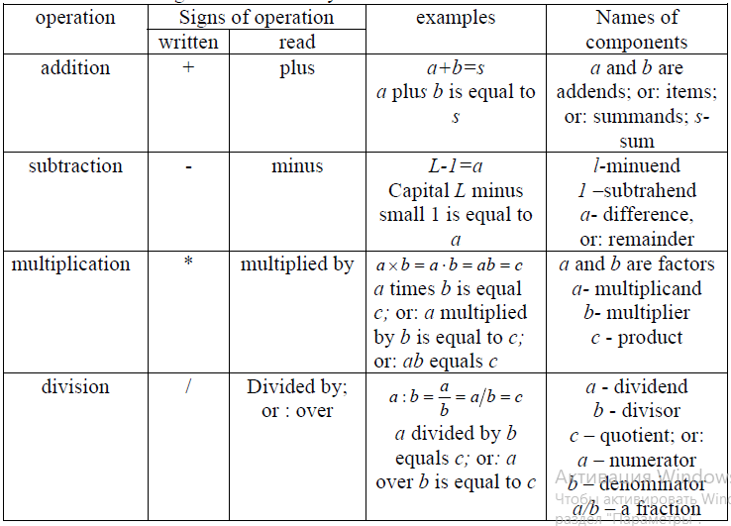
3. Grammar Patterns: English Tenses (Present)
In English, there are twelve verb tenses to talk about present, past, and future events. While this might seem a lot, mastering all of them will allow you to express your thoughts more precisely in spoken English and make your writing more advanced.
It is more convenient to study and repeat the material about English times if the material is presented in tables. Now let's study the Present tense (Tables 2.5 – 2.9).

Table 2.5
Active verb tenses summary
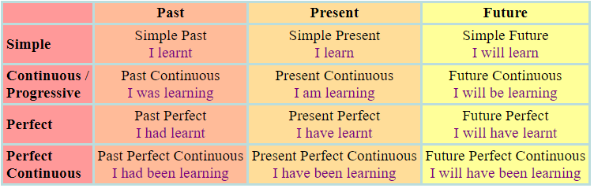

There are four present tenses in English: the present simple, the present continuous or progressive, present perfect and present perfect continuous.

Table 2.6
Simple Present Tense
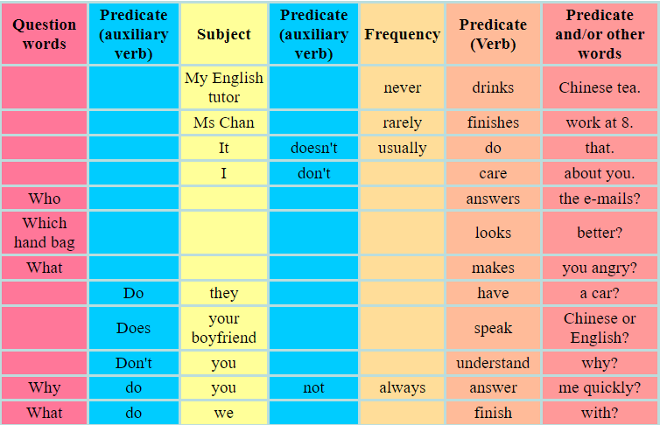
Time words for Simple Present Tense: never, always, every day, normally, often, seldom, rarely, sometimes, usually

Table 2.7
Present Continuous Tense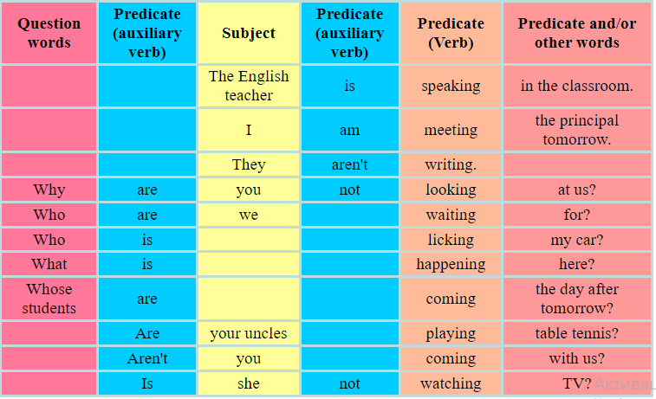
Time words for Present Continuous Tense: now, at the moment, just, just now, Listen!, Look!, right now, (or a future time for future plan).

Table 2.8
Present Perfect Tense
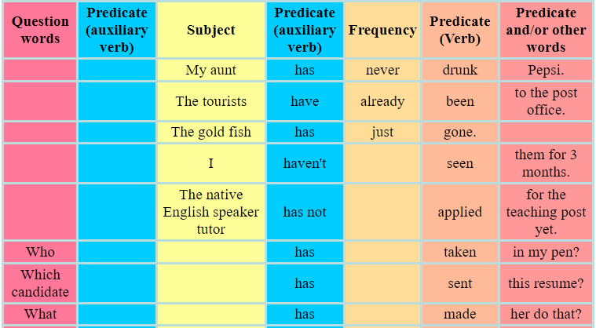
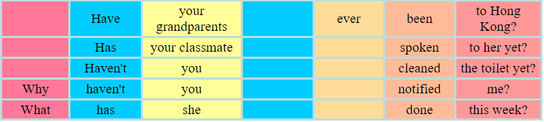

Time words for Present Perfect Tense: already, ever, just, never, not yet, so far, till now, up to now, this morning, for two years, since 2012.

Table 2.9
Present Perfect Continuous Tense
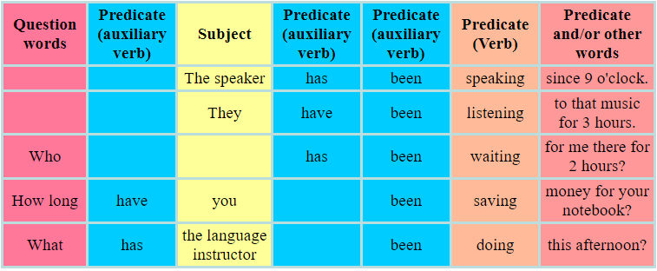

Time words for Present Perfect Continuous Tense: all day, for six years, since April, how long?, the whole week.

References
Primary sources
1. Kibble Tom W.B., Berkshire Frank H. Classical Mechanics. - 5th Edition. – London: Imperial College Press, 2004. – 478 p.
2. Englert Berthold-Georg. Lectures on Classical Mechanics. – Singapore, 2015. – 376 p.
3. Müller-Kirsten Harald J.W. Classical Mechanics and Relativity. – London: World Scientific Publishing Co Pte Ltd, 2017. – 560 p.
4. Lurie A.I. Theory of Elasticity. - Springer Science & Business Media, 2010. – 1050 p.
5. Martin H. Sadd. Elasticity. Theory, Applications and Numtrics. – Amsterdam: Boston:Elsevier, 2005. – 461 p.
6. Darryl D Holm. - Geometric Mechanics. - London, 2011. – 468 p.
7. Papastavridis John G. - Elementary Mechanics. - In 2 Volumes. – USA, 2019. – 1680 p.
8. Бизюк Л.К., Зенченко В.А., Потапова Н.Л., Тригубкина С.Н. Learn higher mathematics in English. – Минск : БГУ, 2015. – 96 с.
9. Прокошева И.И. Основные математические понятия в английском языке: Методические указания. – Оренбург: ГОУ ВПО ОГУ, 2003. - 50 с.
10. Downing Douglas. Dictionary of Mathematics Terms. - Third Edition. - Barron’s Educational Series, Inc. Prior editions. 2009. – 394 p.
11. Clapham Christopher, Nicholson James. The Concise Oxford Dictionary of Mathematics. – Fourth edition. - New York: Oxford University Press Inc., 2009. – 875 p.
12. Кудинова Ю.С., Никрошкина С.В. Английский язык для инженеров-механиков: уч. пособие. - Новосибирск: Изд-во НГТУ, 2019. – 94 с.
Secondary sources
13. Kai S Lam. Fundamental Principles of Classical Mechanics. - Pomona, USA, 2014. – 592 p.
14. Harald Iro. A Modern Approach to Classical Mechanics, - 2nd Edition. – Austria, 2015. – 528 p.
15. Atanackovic Teodor M., Ardeshir Guran. Theory of Elasticity for Scientists and Engineers. - Springer Science & Business Media, 2000. – 374 p.
16. Nekovar Jan. Mathematical English (a brief summary). – Universite Paris, 2011. – 30 p.
17. Schwartzman Steven. The Words of Mathematics: An Etymological Dictionary of Mathematical Terms Used in English. - MAA, 1994. – 261 p.
18. Янушкевич Л.М. English for mechanical engineers: пособие. - Минск: БНТУ, 2019. – 198 с.
Online sources
19. Shapiro Joel A. Classical Mechanics. – 2010. – 272 p. [Electronic resource] https://www.physics.rutgers.edu/~shapiro/507/book.pdf
20. Theory of elasticity. [Electronic resource]
http://limba.wil.pk.edu.pl/kpmoc/images/stories/kpmoc/pracownicy/PSz/TSiP/ToE.pdf
21. Elasticity Theory, Energy, and Forces. [Electronic resource]
https://www.tf.uni-kiel.de/matwis/amat/def_en/kap_5/backbone/r5_2_1.html
22. “Math Vocabulary” – The Language of Mathematics. – 2023. [Electronic resource]
https://www.eslbuzz.com/math-vocabulary-the-language-of-mathematics/
23. Math.Glossary. [Electronic resource] https://mandober.gitbook.io/math-debrief/900-index/990-appendix/math.glossary#theorem
24. Reading Math in English. [Presentation]
https://www.powershow.com/view4/81c9dd-NWNmO/Reading_Maths_in_English_powerpoint_ppt_presentation#google_vignette
25. English grammar tables and examples. [Electronic resource]
https://www.englishconversationcoursetutorhk.com/english_grammar_tables_e.php

Lecture 3

Lecture topic: The Basic Categorical Conceptual Apparatus of Mechanics and its Features

Lecture plan

1. Foundational Terms and Expressions of Mechanics
2. Terms for Numbers and How to Read and Write Numbers in English
3. Grammar Patterns: English Tenses (Past)

1. Foundational Terms and Expressions of Mechanics
1.1. Extension of bars

a) Uniform bars
Consider the problem of calculating the extension δ = l - l₀ due to the application of an axial load P on a uniform bar as shown in the figure 3.1.

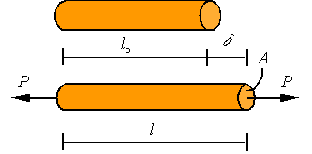
Figure 3.1. Extension of a uniform bar

A bar is considered uniform if its cross-sectional area and elastic modulus are constant along the length of the bar. For such a bar under axial loading, the stress and strain along the bar are constants and given by the expressions
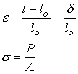
Assuming small strains and substituting these expressions into Hooke’s law , one arrives at the equation for the extension of the bar given as
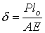

b) Non-uniform bars
A bar with a varying cross-sectional area is an example of non-uniform bar. In general, one can have varying cross section, elastic modulus, and axial load in a bar. Such situations may result in varying stress and strain along the bar. This, in turn, requires a more in depth analysis to evaluate the extension of the bar. First, let us setup the kinematics of the deformation. As shown in the figure 3.2, in a typical situation one would have an initial unloaded configuration (top) and a configuration after loading (bottom).

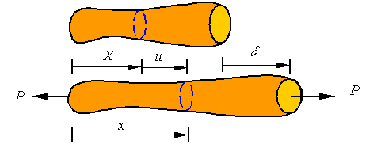
Figure 3.2. Extension of a non-uniform uniform bar

A typical cross-section that is at location X in the initial configuration, ends up in location x in the current configuration by being displaced a distance u from its original location. Each cross section can be displaced a different amount and may have a different cross-sectional area. Therefore, the displacement and cross-sectional area are each a function of the location along the bar (i.e., u(X) and A(X)). A typical segment of length ΔX of the bar is shown in the following figure 3.3.

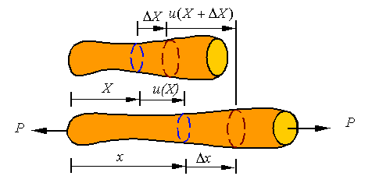
Figure 3.3. Typical segment of length ΔX of the bar

The average strain in this segment of the bar is given by the expression
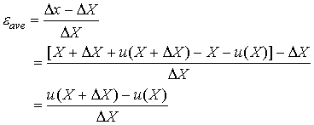
One can take a limit as goes to zero to define the strain at each point of the bar by
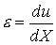
The extension of any segment of the bar is the difference between the displacement of one end minus the displacement of the other end. This expression for strain can be integrated to get the extension. Let us say we are looking for the extension of the segment between X₁ and X₂. This would be given by integrating the strain to get
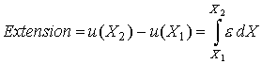
The total extension of a bar of initial length L is given by the expression
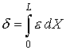
As shown in the figure below, the bar might have a distributed load w applied on it in addition to point loads. As a result, the load and cross-sectional area might both vary with location in the bar so we will denote the load in the section at X by P(X) and the cross-sectional area by A(X). Therefore, the axial stress is given by
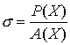
Since the material can change along the bar, the elastic modulus may also be a function of location along the bar. From Hooke’s law it follows that the strain at each point of the bar is given by
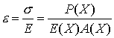
Therefore the total extension in a non-uniform bar is given by
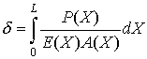
This expression reduces to the one for a uniform bar when the argument of the integral is constant.

1.2. Thermal Strain

Linear coefficient of thermal expansion
An unloaded uniform bar will extend due to a uniform change in the temperature (fig. 3.4). This extension is linearly proportional to the temperature change and the strain associated with it is given by the relation
where α is the linear coefficient of thermal expansion and ΔT is the rise in temperature.

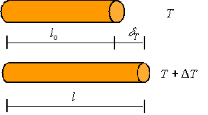
Figure 3.4. Thermal expansion

The strain is given by the extension divided by the original length through the standard relation
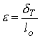
Combining this and the above expression one gets the relation for the extension of a uniform bar under a uniform change in temperature as
For a non-uniform bar or a non-uniform temperature distribution in the bar, one needs to integrate the strain using the expression for extension of a non-uniform bar to get
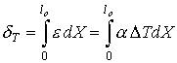

1.3. Torsion of a circular shaft
We consider a torsion of a circular shaft (fig. 3.5).
a) Basic kinematics of torsion
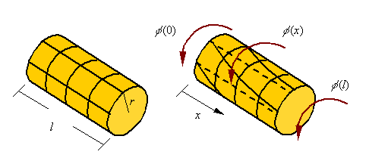
Figure 3.5. Torsion of a circular shaft

It is assumed that when twisted each cross-section in a circular bar rotates as a rigid body. If the amount of rotation of each cross-section is given by the function , the total twist in the bar of length l shown is given
During the torsion of a bar, axial lines drawn on the surface of a bar become helical and circumferential lines remain circumferential. Therefore, as can be seen in the figure 3.6, material elements are sheared in the process. This shear strain must be accompanied by a shear stress (from Hook’s law we know).
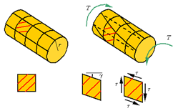
Figure 3.6. Torsion of a circular shaft

The shear strain can be related to the rotation of the cross sections. If over an increment of length Δx, the cross section rotates an amount , then as can be seen in the figure 3.7 the shear strain is given by
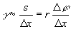
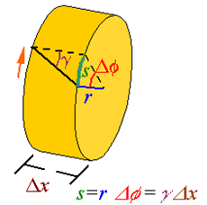
Figure 3.7. Torsion of a circular shaft

Therefore, at the limit one can write
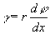
As a result, the shear strain starts at zero at the center and reaches a maximum at the outer radius.
b) The shear stress
The shear stress, through Hook’s law, is related to the shear strain. Therefore, the shear stress is given by
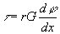
Again, like the shear strain, the shear stress is zero at the core of the bar and increases linearly to a maximum at the outer surface (fig. 3.8).
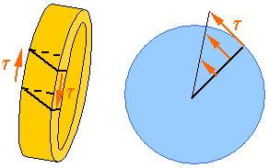
Figure 3.8. The shear stress

c) Calculating the torque from the shear stress
The torque transmitted through the cross-section of a bar is the resultant of the moments created by the shear stresses on the cross-section.
The differential shear load dV that results from the shear stress applied over the area dA of the cross section is . The moment created by such a shear load is dM = rdV. The equivalent torque T on the cross section is the resultant of all the moments crated by the shear stresses so that
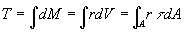
Using the expression for shear stress in terms of twist in the bar we get
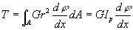
where I_{p} is the polar area moment of inertia of the cross section. Using this relation, the expression for shear stress in terms of the torque follows from
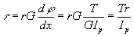

2. Terms for Numbers and How to Read and Write Numbers in English
2.1. Numbers and numerals
Numbers have different types and functions and they have their names in English (fig. 3.9).
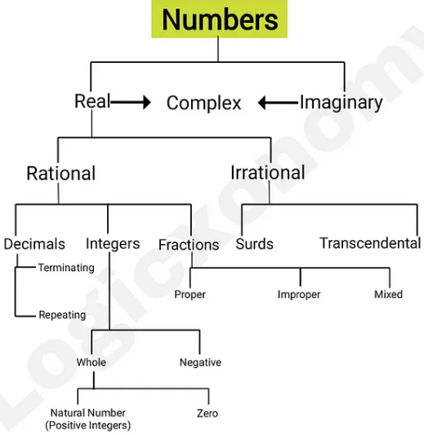
Figure 3.9. Numbers

Prime number [praim], even number [ˈiːvən], odd number [ɒd], digit [ˈdɪʤɪt], numeral [ˈnjuːmərəl] ,
cardinal (adj) number (cardinal numeral) or cardinal (noun),
ordinal (adj) number (ordinal numeral) or ordinal (noun);
one – first, two – second, three – third, five – fifth, eight – eighth, nine – ninth, twelve – twelfth, twenty - twentieth

2.2. Common fractions
A common fraction is a fraction in which numerator and denominator are both integers. They are also sometimes referred to as vulgar, or simple, or ordinary fractions (fig. 3.10).
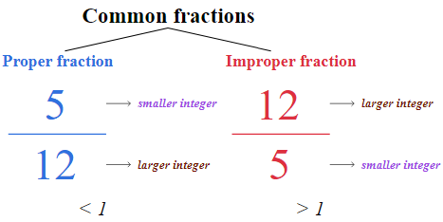
Figure 3.10. Common fractions`
How to read common fractions in English and Operating with such fractions are shown in Table 3.1.

Table 3.1
Operating with common fractions
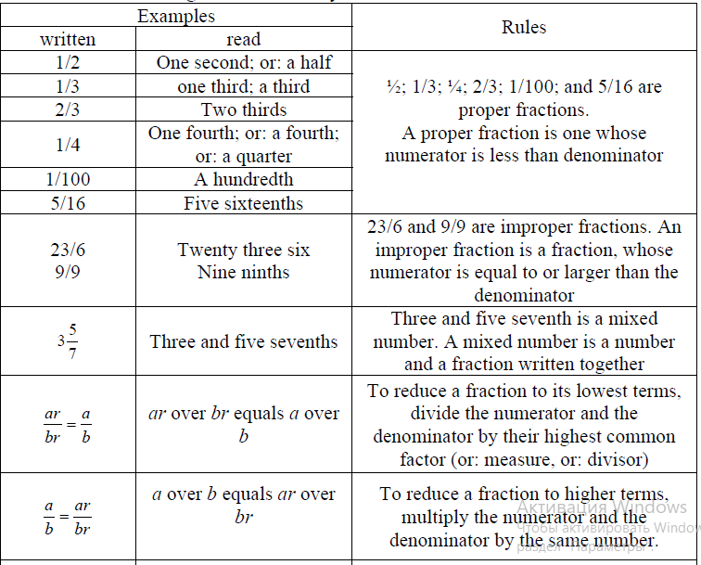
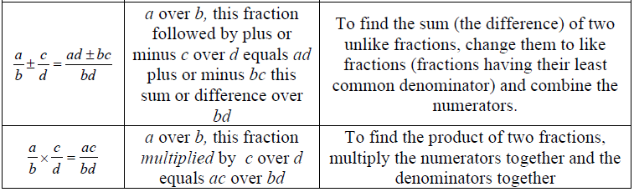
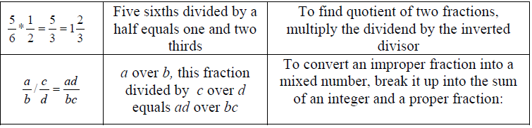

2.3. Decimal fractions
Now let’s talk about the decimals in English (decimal fractions). Decimals are regularly used in everyday English, but more specifically in scientific and technical English, in order to indicate with precision quantities that are not a complete number. Decimal fractions are an integral part of the Number System, which brings the gap between whole numbers and fractions. Decimal Fractions are developed as means to represent the various quantities in the real world with more precision.
They are not difficult to use. In Russian we separate the integer from the fraction with a comma by such fractions. In English, for the same procedure we use point. Note that the decimal point is precisely that; a point, never a comma.
After the decimal point figures are expressed digit by digit. The fractions of each digit are read separately. The words hundred, thousand and so on are never used after the decimal point.
By the way, a dot in English have one option — point, and е «0» has two options — «nought» in British English (UK) and «zero» in all forms of English including American English (USA).
Before a decimal point, for a quantity less than 1, one (a decimal fraction) normally begins «nought point…» in British English or «zero point ....» in American English and all forms of English.
If an integer part is represented by zero in decimal, then it is often not read.
The digits to the left of the decimal point are usually read as a cardinal number, and the digits to the right of the decimal point are usually read as separate digits.
Conclusion. The decimal point (not a comma) separates the integer (the whole) from the fraction in decimal fractions in English. Decimals are written in figures (digits). When pronouncing decimals we use the word "point" to represent the dot. The numbers following the dot are pronounced separately (digit by digit) (Table 3.2).

Table 3.2
How to read decimal fractions in English
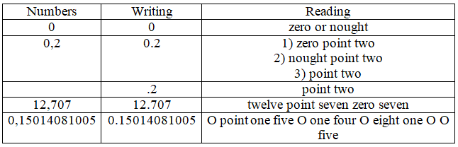

For example: When you have the number 1.36 we say "One point three six."
For example: 546.132 can be read as "five hundred forty-six point one-three-two".
3. Grammar Patterns: English Tenses (Past)
Time words for Simple Past Tense: yesterday, 4 minutes ago, in 2000, the other day, last Friday, the day before yesterday, in October (Table 3.3).

Table 3.3
Simple Past Tense
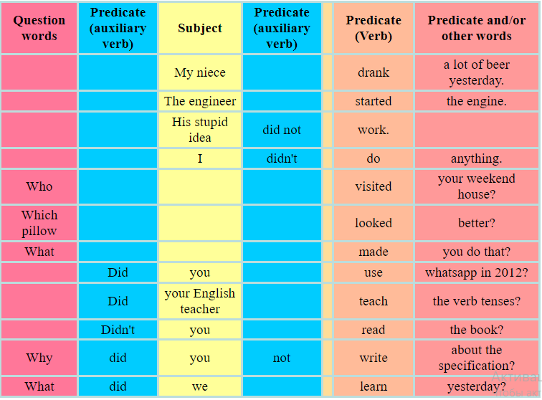

Time words for Past Continuous Tense: at that moment, at 5 o'clock, a clause with simple past tense, a clause with another simple continuous tense (Table 3.4).

Table 3.4
Past Continuous Tense
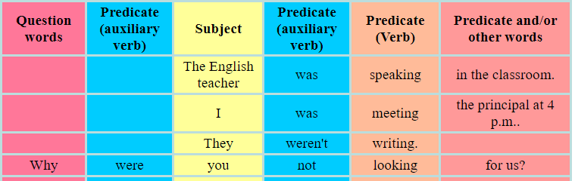

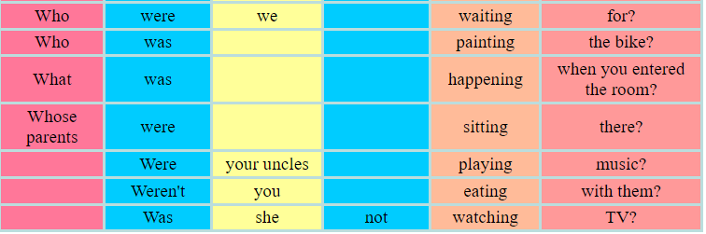

Time words for Past Perfect Tense: before, when (Table 3.5).

Table 3.5
Past Perfect Tense
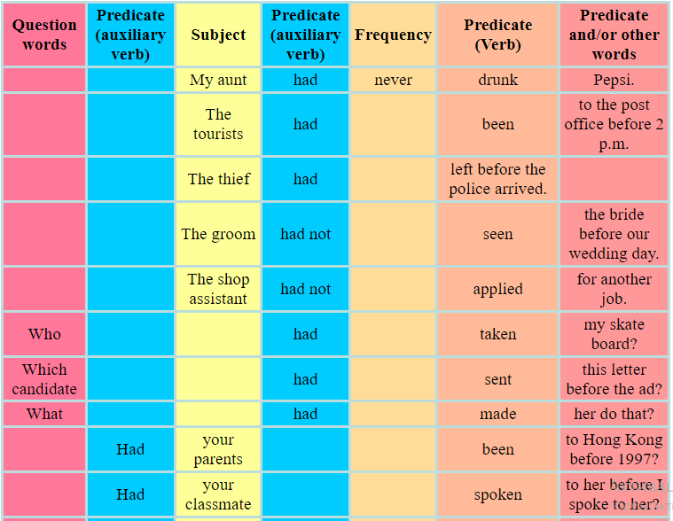
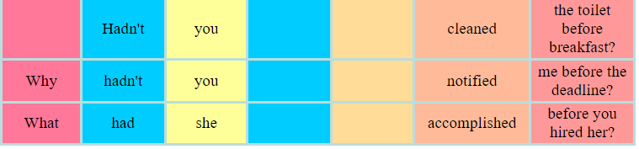
So, Past tenses refer to an action or state that has occurred in the past. These are used to describe actions that have already been completed at the time of speaking, or an event that happened in the past. These can also refer to actions which are no longer taking place at the time of speaking.

References
Primary sources
1. Kibble Tom W.B., Berkshire Frank H. Classical Mechanics. - 5th Edition. – London: Imperial College Press, 2004. – 478 p.
2. Englert Berthold-Georg. Lectures on Classical Mechanics. – Singapore, 2015. – 376 p.
3. Müller-Kirsten Harald J.W. Classical Mechanics and Relativity. – London: World Scientific Publishing Co Pte Ltd, 2017. – 560 p.
4. Lurie A.I. Theory of Elasticity. - Springer Science & Business Media, 2010. – 1050 p.
5. Martin H. Sadd. Elasticity. Theory, Applications and Numtrics. – Amsterdam: Boston:Elsevier, 2005. – 461 p.
6. Darryl D Holm. - Geometric Mechanics. - London, 2011. – 468 p.
7. Papastavridis John G. - Elementary Mechanics. - In 2 Volumes. – USA, 2019. – 1680 p.
8. Бизюк Л.К., Зенченко В.А., Потапова Н.Л., Тригубкина С.Н. Learn higher mathematics in English. – Минск : БГУ, 2015. – 96 с.
9. Прокошева И.И. Основные математические понятия в английском языке: Методические указания. – Оренбург: ГОУ ВПО ОГУ, 2003. - 50 с.
10. Downing Douglas. Dictionary of Mathematics Terms. - Third Edition. - Barron’s Educational Series, Inc. Prior editions. 2009. – 394 p.
11. Clapham Christopher, Nicholson James. The Concise Oxford Dictionary of Mathematics. – Fourth edition. - New York: Oxford University Press Inc., 2009. – 875 p.
12. Кудинова Ю.С., Никрошкина С.В. Английский язык для инженеров-механиков: уч. пособие. - Новосибирск: Изд-во НГТУ, 2019. – 94 с.

Secondary sources
13. Kai S Lam. Fundamental Principles of Classical Mechanics. - Pomona, USA, 2014. – 592 p.
14. Harald Iro. A Modern Approach to Classical Mechanics, - 2nd Edition. – Austria, 2015. – 528 p.
15. Atanackovic Teodor M., Ardeshir Guran. Theory of Elasticity for Scientists and Engineers. - Springer Science & Business Media, 2000. – 374 p.
16. Nekovar Jan. Mathematical English (a brief summary). – Universite Paris, 2011. – 30 p.
17. Schwartzman Steven. The Words of Mathematics: An Etymological Dictionary of Mathematical Terms Used in English. - MAA, 1994. – 261 p.
18. Янушкевич Л.М. English for mechanical engineers: пособие. - Минск: БНТУ, 2019. – 198 с.

Online sources
19. Shapiro Joel A. Classical Mechanics. – 2010. – 272 p. [Electronic resource] https://www.physics.rutgers.edu/~shapiro/507/book.pdf
20. Theory of elasticity. [Electronic resource]
http://limba.wil.pk.edu.pl/kpmoc/images/stories/kpmoc/pracownicy/PSz/TSiP/ToE.pdf
21. Elasticity Theory, Energy, and Forces. [Electronic resource]
https://www.tf.uni-kiel.de/matwis/amat/def_en/kap_5/backbone/r5_2_1.html
22. “Math Vocabulary” – The Language of Mathematics. – 2023. [Electronic resource]
https://www.eslbuzz.com/math-vocabulary-the-language-of-mathematics/
23. Math.Glossary. [Electronic resource] https://mandober.gitbook.io/math-debrief/900-index/990-appendix/math.glossary#theorem
24. Reading Math in English. [Presentation]
https://www.powershow.com/view4/81c9dd-NWNmO/Reading_Maths_in_English_powerpoint_ppt_presentation#google_vignette
25. English grammar tables and examples. [Electronic resource]
https://www.englishconversationcoursetutorhk.com/english_grammar_tables_e.php

Lecture 4

Lecture topic: The Principal Terms and Phrases of Mechanics, Their Translation Methods

Lecture plan

1. Fundamental Terms and Word Combinations of Mechanics

2. Roots and Powers, Their Writing and Reading in English

3. Grammar Patterns: Causative Verbs, Articles, Determiners

1. Fundamental Terms and Word Combinations of Mechanics
1.1. Аrea Moment of Inertia
The area moment of inertia is a geometrical property of an area that measures how its points are distributed with regard to an arbitrary axis, providing measures of how efficiently the cross-sectional shape can resist bending caused by loading.
The area moment of inertia is also called the second moment of inertia, second moment of area, or second area moment.
The first thing to note is that the area moment of inertia is not a unique property of a cross-section. It measures the resistance to bending or twisting about a particular axis, and hence its value changes depending on where we place this reference axis.
The area moment of inertia is the second moment of area around a given axis (fig. 4.1). For example, given the axis O-O and the shaded area shown, one calculates the second moment of the area by adding together l²dA for all the elements of area dA in the shaded area.

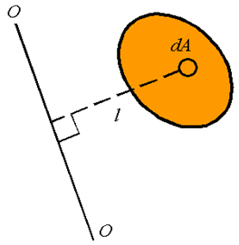
Figure 4.1. Аrea moment of inertia

The area moment of inertia, denoted by I, can, therefore, be calculated from
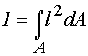
If we have a rectangular coordinate system as shown, one can define the area moment of inertial around the x-axis, denoted by I_{x}, and the area moment of inertia about the y-axis, denoted by I_{y}. (fig. 4.2). These are given by
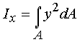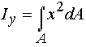

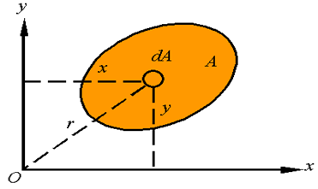
Figure 4.2. The area moments of inertial around the x-axis and the y-axis

The polar area moment of inertia, denoted by J_{O}, is the area moment of inertia about the z-axis given by
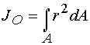
Note that one has the relation
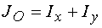
The radius of gyration is the distance k away from the axis that all the area can be concentrated to result in the same moment of inertia. That is,
For a given area, one can define the radius of gyration around the x-axis, denoted by k_{x}, the radius of gyration around the y-axis, denoted by k_{y}, and the radius of gyration around the z-axis, denoted by k_{O}. (fig. 4.3). These are calculated from the relations
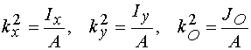

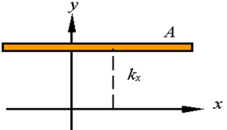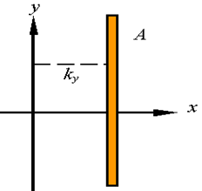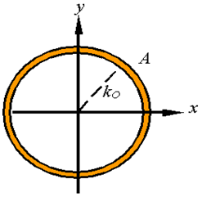

Figure 4.3. The radii of gyration around the x-axis,
around the y-axis, around the z-axis

It can easily to show from
that
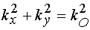
The parallel axis theorem is a relation between the moment of inertia about an axis passing through the centroid and the moment of inertia about any parallel axis.
Since the distance of the centroid above the x'-axis is zero, one must conclude that the parallel axis theorem states that
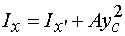
where x' must pass through the centroid of the area (fig. 4.4).

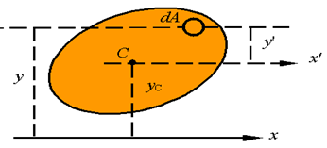
Figure 4.4. The parallel axis theorem

In this same way, one can show that (fig. 4.5)
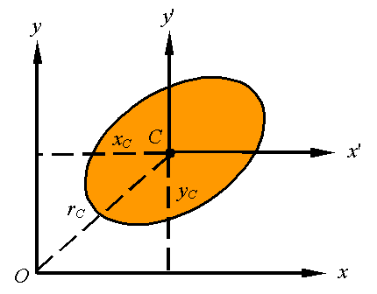
Figure 4.5. The parallel axis theorem

In general, one can use the parallel axis theorem for any two parallel axes as long as one passes through the centroid. As shown in the picture 4.6, this is written as
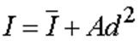
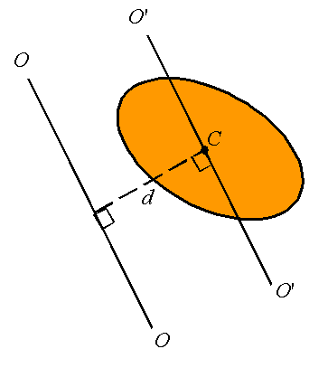
Figure 4.6. The parallel axis theorem for any two parallel axes as long as one passes through the centroid

where is the moment of inertia about the axis O'-O' passing through the centroid, I is the moment of inertia about the axis O-O, and d is the perpendicular distance between the two parallel axis.
The moment of inertia of composite bodies can be calculated by adding together the moment of inertial of each of its sections. The only thing to remember is that all moments of inertia must be evaluated bout the same axis.
To calculate the area moment of inertia of the composite body constructed of the three segments shown, one evaluates the moment of inertial of each part about the x-axis and adds the three together (fig. 4.7).

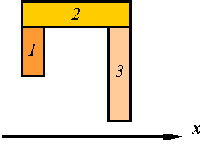
Figure 4.7. The composite body constructed of the three segments

1.2. Pure shear
Consider the material element loaded in pure shear as shown in the figure 4.8.
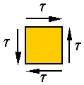
Figure 4.8. The material element loaded in pure shear

Stress on an inclined plane in this element is neither pure shear nor pure tension, it is a combination of both. Let and denote, respectively, the shear and normal stresses on the surface that makes an angle θ with the vertical, as shown in the following figure 4.9.
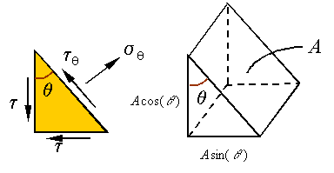
Figure 4.9. The load on each surface can be calculated using the stresses and the areas

One can use equilibrium to calculate these stresses. If the area of the inclined surface is A, then the area of the vertical surface will be and the area of the horizontal surface will be , as shown in the above figure. The load on each surface can be calculated using the stresses and the areas they are applied on figure 4.10. Therefore, the free-body-diagram can be drawn as follows
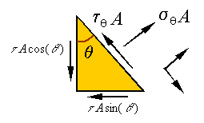
Figure 4.10. Calculation of the load on each surface by using the stresses and the areas

Note that these surfaces are the original vertical and horizontal surfaces on which the pure shear was applied. The maximum normal stress is and occurs when or in other words when
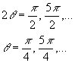
The minimum normal stress is and occurs when or in other words when
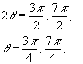
Note that the maximum and minimum normal stresses occur on surfaces which are 90º from one and other, and which are 45º from the vertical and horizontal lines. Also, note that the shear stress is zero at the angles where we have the maximum and minimum normal stresses. One can draw this on a diagram representing the stress on an element that is cut from the original as follows (fig. 4.11)
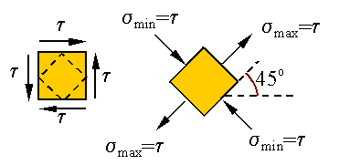
Figure 4.11. Calculation of the load on each surface by using the stresses and the areas
2. Roots and Powers, Their Writing and Reading in English
2.1. Roots
Where a root is not preceded by an index, it is assumed to have an implied index of two and notate a square root. This should be read aloud as "square root of" followed by the expression shown within the radical symbol.
Where a root is preceded by an index of three this should be read aloud as "cubed root of" followed by the expression shown within the radical symbol.
For a root with an index with a number greater than four, the expressions should be read starting with the index as "the xth root of". If the radical index is a variable then it should be read as "x root of y".
Verbose transcription: where the reader may be unable to distinguish when the index and root has finished, then read aloud "Index" prior to the root index and end root after the variable (Tables 4.1and 4.2).

Table 4.1
How to Read and Write Roots
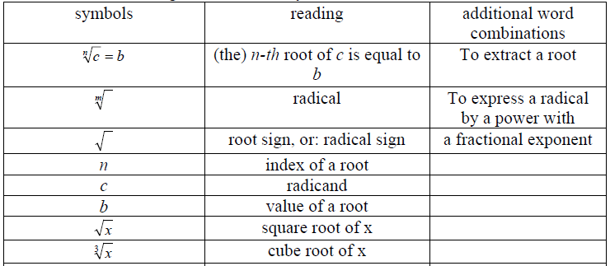

Table 4.2
Irrational Expressions 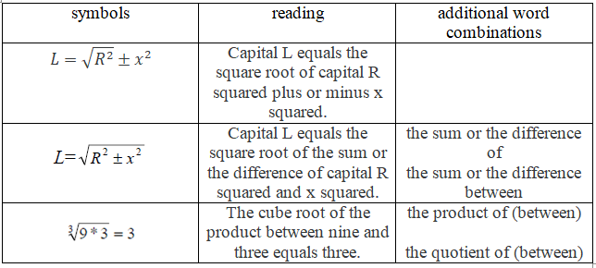
2.2. Powers
The power of a number says how many times to use the number in a multiplication, or a power is the answer that you get when you multiply a number by itself. In other words, power, is a mathematical concept of expressing a number multiplied by itself by a certain definite number of times. The powers of numbers are also called exponents.
Exponentiation is a mathematical operation, written as B^{n}, involving two numbers, the base B and the exponent n. B is called the «base number», and n is called the «power exponent» or the «exponent». In other words, the number in the subscript is known as an "exponent."
The exponent is usually shown as a superscript to the right of the base. In that case, B^{n} is called "B raised to the nth power", "B raised to the power of n", or "the n-th power of B". A number, B, to the power of two is also referred to as B squared. The number B to the power of three is called B cubed (Table 4.3).

Table 4.3
How to Read and Write Powers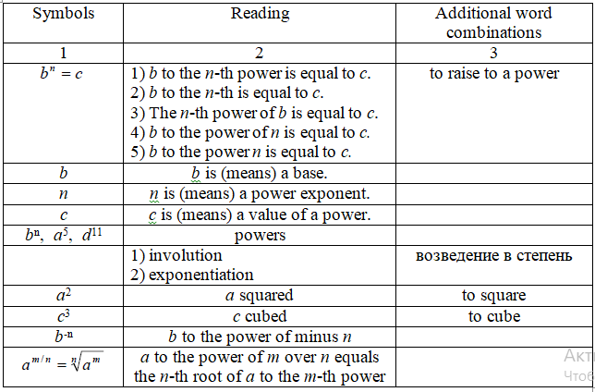
Exponentiation is a common mathematical operation. Raising a number to a power is needed for calculations like finding roots, logarithms, and exponential functions.

3. Grammar Patterns: Causative Verbs, Articles, Determiners
3.1. Causative Verbs
Causatives are main verbs that cause people or objects to do something or cause things to change (Table 4.4).
Table 4.4
Causatives
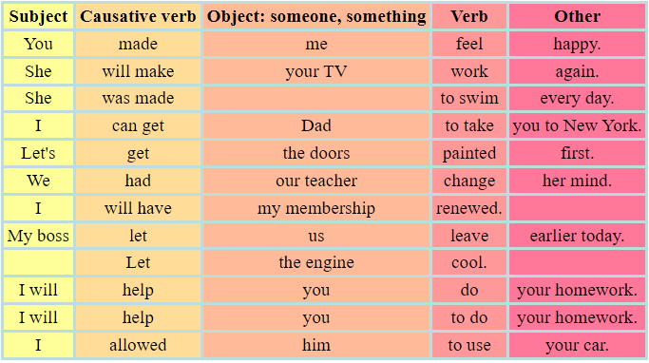

The most common causatives are:
make + base form of the verb,
to be made (passive causative) + infinitive,
get + infinitive (after a person),
get + past participle (after an object),
have + base form of the verb (after a person),
have + past participle (after an object),
let + base form of the verb,
help + base form of the verb or infinitive; the base form of the verb is more common.
allow + infinitive,
Other causative verbs are: authorise, cause, enable, force, give someone permission, give someone the right, hold, keep, permit, and require.

3.2. Articles
Articles are very important words in English and so is their knowledge. Articles in English are used before the noun to limit or define the uses of the noun in the context of the sentences. They impart effectiveness and accuracy to the nouns. In fact, articles are used as demonstrative adjectives and determiners before nouns. Articles also help indicate whether a noun is definite (referring to a specific or known item) or indefinite (referring to a non-specific or generic item).
Articles in English are the used only before nouns to limit or define their nouns uses in the context of the sentence. An article is a short monosyllabic word that is used before a noun to define it. As they are used to identify nouns, they are also used as adjectives. They are of three types: “A, An, The” (Tables 4.5 and 4.6).

Table 4.5
Articles - definite and indefinite
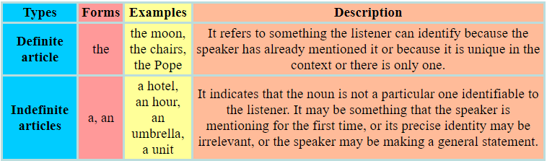

Table 4.6
Specific and general - article usage
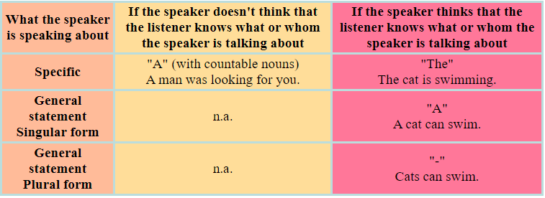

The table above shows general rules. However, there are exceptions. For example, with a lot of institutions we use "the" even if the other person does not know which specific one I am talking about: I am going to the theatre / to the swimming pool / to the cinema / to the market, etc.
What do the following sentences mean?
I am manager.
I am the manager.
I am a manager.
1. "I am manager." This sentence is wrong. Usually you cannot use a countable noun in singular form without a determiner. A noun phrase usually consists of a determiner and a noun as a minimum.
"I am a manager" and "I am the manager" both have valid syntax, that is, they can be correct. Whether they are really correct depends on the situation.
2, "I am the manager." Here the speaker assumes that the listener knows the context, that is, what organisation the speaker is talking about. For instance, if the speaker has already mentioned her own company or they are in her office now, the speaker can say, "I am the manager," meaning I am the manager here. Or I am the manager at the company we are talking about. The "The" also refers to that there is only one manager in that place and that one manager is me.
3, "I am a manager." Here there is no any defined context, that is, the speaker assumes that the listener does not know where she works. It is also possible that both know where she works but there is more than one manager there and she is just one of them. Again, the situation, the context or the company is not defined or if defined, then there are two or more managers there. I am one manager and there are other managers, too (Table 4.5).

3.3. Determiners
A determiner is a word, phrase, or affix that occurs together with a noun or noun phrase and expresses the reference of that noun or noun phrase in the context.
Determiners are words that help to identify or specify a particular noun or noun phrase. They come before nouns and provide additional information about them, such as quantity, definiteness, or possession. Let’s look at the determiners examples (Table 4.7).

Table 4.7
Determiners in noun phrases
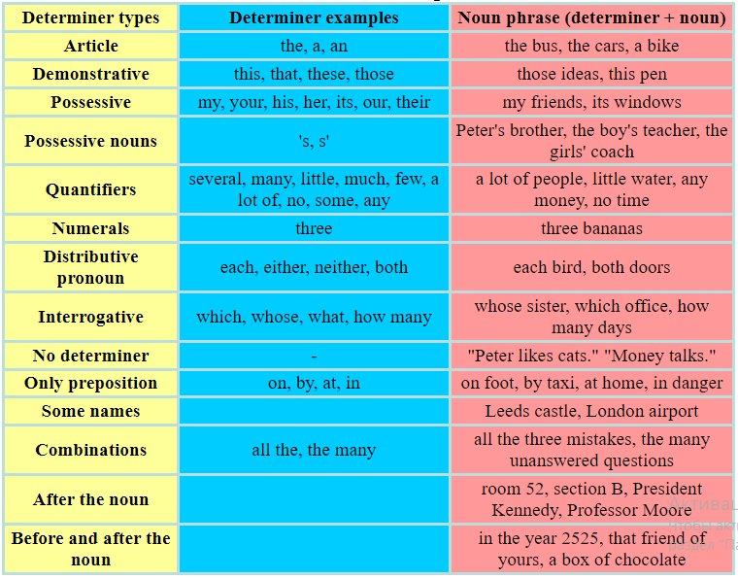

A determiner is a member of a class of words used to modify nouns or noun equivalents. Determiners help clarify what a noun is referring to and are typically placed before descriptive adjectives.
For example, in the sentence Would you like to buy this new book?, the word this is a determiner. It tells us more about the book we are talking about: this book. It’s also placed before the descriptive adjective new.

References
Primary sources
1. Kibble Tom W.B., Berkshire Frank H. Classical Mechanics. - 5th Edition. – London: Imperial College Press, 2004. – 478 p.
2. Englert Berthold-Georg. Lectures on Classical Mechanics. – Singapore, 2015. – 376 p.
3. Müller-Kirsten Harald J.W. Classical Mechanics and Relativity. – London: World Scientific Publishing Co Pte Ltd, 2017. – 560 p.
4. Lurie A.I. Theory of Elasticity. - Springer Science & Business Media, 2010. – 1050 p.
5. Martin H. Sadd. Elasticity. Theory, Applications and Numtrics. – Amsterdam: Boston:Elsevier, 2005. – 461 p.
6. Darryl D Holm. - Geometric Mechanics. - London, 2011. – 468 p.
7. Papastavridis John G. - Elementary Mechanics. - In 2 Volumes. – USA, 2019. – 1680 p.
8. Бизюк Л.К., Зенченко В.А., Потапова Н.Л., Тригубкина С.Н. Learn higher mathematics in English. – Минск : БГУ, 2015. – 96 с.
9. Прокошева И.И. Основные математические понятия в английском языке: Методические указания. – Оренбург: ГОУ ВПО ОГУ, 2003. - 50 с.
10. Downing Douglas. Dictionary of Mathematics Terms. - Third Edition. - Barron’s Educational Series, Inc. Prior editions. 2009. – 394 p.
11. Clapham Christopher, Nicholson James. The Concise Oxford Dictionary of Mathematics. – Fourth edition. - New York: Oxford University Press Inc., 2009. – 875 p.
12. Кудинова Ю.С., Никрошкина С.В. Английский язык для инженеров-механиков: уч. пособие. - Новосибирск: Изд-во НГТУ, 2019. – 94 с.

Secondary sources
13. Kai S Lam. Fundamental Principles of Classical Mechanics. - Pomona, USA, 2014. – 592 p.
14. Harald Iro. A Modern Approach to Classical Mechanics, - 2nd Edition. – Austria, 2015. – 528 p.
15. Atanackovic Teodor M., Ardeshir Guran. Theory of Elasticity for Scientists and Engineers. - Springer Science & Business Media, 2000. – 374 p.
16. Nekovar Jan. Mathematical English (a brief summary). – Universite Paris, 2011. – 30 p.
17. Schwartzman Steven. The Words of Mathematics: An Etymological Dictionary of Mathematical Terms Used in English. - MAA, 1994. – 261 p.
18. Янушкевич Л.М. English for mechanical engineers: пособие. - Минск: БНТУ, 2019. – 198 с.

Online sources
19. Shapiro Joel A. Classical Mechanics. – 2010. – 272 p. [Electronic resource] https://www.physics.rutgers.edu/~shapiro/507/book.pdf
20. Theory of elasticity. [Electronic resource]
http://limba.wil.pk.edu.pl/kpmoc/images/stories/kpmoc/pracownicy/PSz/TSiP/ToE.pdf
21. Elasticity Theory, Energy, and Forces. [Electronic resource]
https://www.tf.uni-kiel.de/matwis/amat/def_en/kap_5/backbone/r5_2_1.html
22. “Math Vocabulary” – The Language of Mathematics. – 2023. [Electronic resource]
https://www.eslbuzz.com/math-vocabulary-the-language-of-mathematics/
23. Math.Glossary. [Electronic resource] https://mandober.gitbook.io/math-debrief/900-index/990-appendix/math.glossary#theorem
24. Reading Math in English. [Presentation]
https://www.powershow.com/view4/81c9dd-NWNmO/Reading_Maths_in_English_powerpoint_ppt_presentation#google_vignette
25. English grammar tables and examples. [Electronic resource]
https://www.englishconversationcoursetutorhk.com/english_grammar_tables_e.php

Lecture 5

Lecture topic: The Main Structures of Mechanics. Rules for Reading Mathematical Formulas of Mechanics

Lecture plan

1. The Main Structures of Mechanics and Their Meanings

2. The Major Terms and Phrases of Mathematical Analysis Used in Mechanics

3. Grammar Patterns: Noun Phrase, Prepositional Phrase

1. The Main Structures of Mechanics and Their Meanings
1.1. Pure Bending
1.1.1. Kinematics of Pure Bending
When a bar is subjected to a pure bending moment as shown in the figure 5.1 it is observed that axial lines bend to form circumferential lines and transverse lines remain straight and become radial lines.

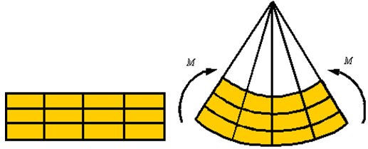

Figure 5.1. The bar is subjected to a pure bending moment

In the process of bending there are axial line that do not extend or contract. The surface described by the set of lines that do not extend or contract is called the neutral surface. Lines on one side of the neutral surface extend and on the other contract since the arc length is smaller on one side and larger on the other side of the neutral surface.
The figure 5.2 shows the neutral surface in both the initial and the bent configuration.

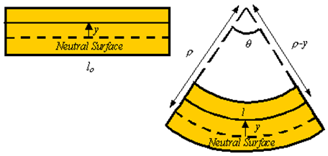

Figure 5.2. Neutral surface

1.1.2. Stress Distribution in Pure Bending
By Hooke’s law, the axial stress is given in terms of the axial strain by the relation
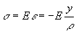
Therefore, the axial stress is zero on the neutral surface and increases linearly as one move away from the neutral axis (fig. 5.3).

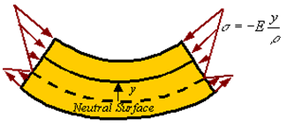

Figure 5.3. Stress distribution in pure bending

1.1.3. Axial Load and the Location of the Neutral Axis
There is zero axial load in a member under pure bending. Therefore, the axial load generated by the stress should be zero.
The axial load ΔN generated by the stress σ applied on the area ΔA of the cross section is given by the approximate relation (fig. 5.4)

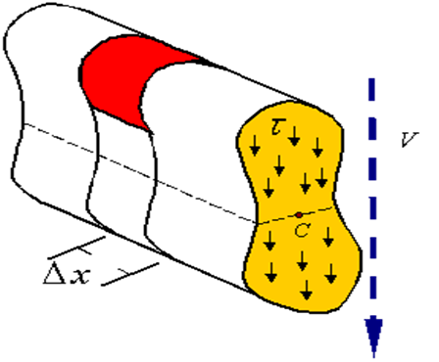
Figure 5.4. Axial load in pure bending

The total load on the cross section can be calculated by integrating this relation over the cross section. This yields
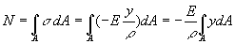
Since the axial load is zero during pure bending, one concludes that for pure bending
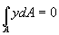
The reader recalls that the location of the centroid of an area is calculated from the relation
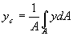
Therefore, for the axial load to be zero, the neutral axis must pass through the centroid of the cross section (i.e., y_{c}=0). In the event that the axial load is not zero, the location of the neutral axis relative to the centroid of the cross section can be calculated from the relation
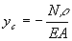
Therefore, for the axial load to be zero, the neutral axis must pass through the centroid of the cross section (i.e., y_{c}=0). In the event that the axial load is not zero, the location of the neutral axis (fig. 5.5) relative to the centroid of the cross section can be calculated from the relation

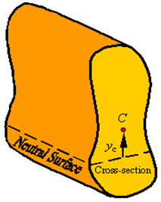
Figure 5.5. The neutral axis relative to the centroid of the cross section

1.1.4. Bending Moment and its Relation to Radius of Curvature
The bending moment ΔM about the neutral surface that is created by the normal load ΔN resulting from the normal stress σ acting on the area ΔA of the cross section (fig. 5.6) can be calculated by
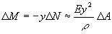
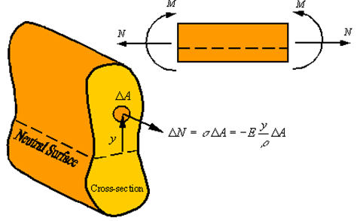
Figure 5.6. The bending moment about the neutral surface

The bending moment about the neutral surface that is created by the normal load resulting from the normal stress acting on the area of the cross section can be calculated by
Integrating over the cross section to get the total moment transmitted through the cross section gives
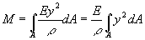
Recalling that the integral in this relation is the area moment of inertial I about the neutral axis (the line resulting from the intersection of the cross section and the neutral surface), the relation between the bending moment M and radius of curvature $ρ$ of the neutral axis of the beam becomes
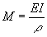
From this relation one can calculate the expression for stress as a function of the bending moment by substituting in the expression for axial stress this relation for the radius of curvature (fig. 5.7). This gives
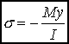

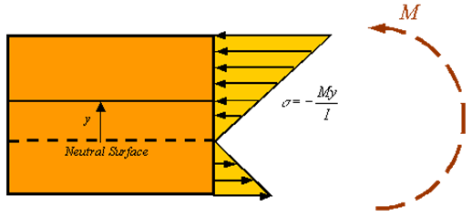
Figure 5.7. Stress as a function of the bending moment

As can be seen in the figure, the maximum and minimum normal stresses occur in the material that is furthest away from the neutral surface (either at the top or bottom of the bar depending on the actual direction of the moment).

1.2. Point Loads and Point Moments
When there is a point load F_{o} and a point moment M_{o} applied at a point in the beam, the point load results in a jump in the value of the shear load V and the point moment results in a jump in the value of the bending moment M (fig. 5.8).

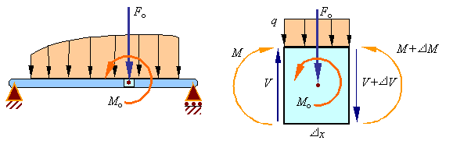
Figure 5.8. Point loads and point moments

Equilibrium of forces on the element requires that
Taking a limit as x goes to zero results in the relation for the jump in the shear load due to an applied downward point load of F_{o} to be given by
Equilibrium of moments on the element requires that
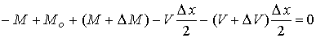
Taking a limit as x goes to zero results in the relation for the jump in the bending moment due to an applied counter-clockwise point moment of M_{o} to be given by
Therefore, there will be a discontinuity at each applied point load in the shear diagram and a discontinuity at each applied couple in the moment diagram.

1.3. Equivalent Force Systems
Let's look at the equivalent power systems in Figures 5.9 – 5.11 and comment on these figures in English.
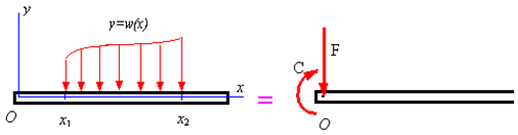
Figure 5.9. Distributed loads

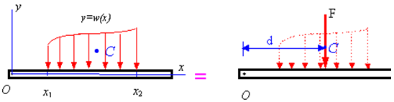

Figure 5.10. Replacing distributed loads by a resultant load and resultant couple applied at a given point O

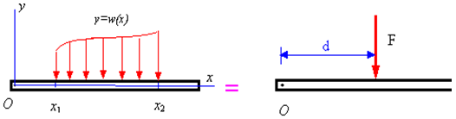
Figure 5.11. Replacing a distributed load by single resultant load

2. The Major Terms and Phrases of Mathematical Analysis Used in Mechanics
2.1. Function Definition
A function, denoted by f, is a mapping from a set X to a set Y which satisfied the following: for each element x in X, there is a single (or most one) element y in Y.
The set X (D_{f}) in the above definition is called the domain [dəˈmeɪn] of the function f and Y (E_{f}) is its codomain.
Vertical line test
If we have a graph of a function in a usual Decart’s coordinate system, then we can decide easily whether a mapping is a function or not: it is a function if there are no vertical lines that intersect the graph at more than one point.
There are a function of a single variable and a function of several variables or a multi variable function in mathematical analysis.

2.2. Limits
In mathematics, a limit is the value that a function or sequence "approaches" as the index approaches some value. So we have limit of a function or limit of a sequence. A value of the limit is called a limit point.
Denotation: Limit of a function: $\underset{x→a}{\text{lim}}f(x)=b$.
Read: The limit of f of x as x tends to a is equal to b.
Denotation: Limit of a sequence: $\underset{n→∞}{\text{lim}}c_{n}=d$.
Read: The limit of c sub n ($c_{n}$) as n tends to infinity is equal to d. (better)
Or: The limit of c sub n is equal to d as n tends to infinity.
One-sided limit, either of the two limits of a function as a specified point is approached from below or from above (left or right).
There are an upper limit and a lower limit, a left-handed limit and a right-handed limit, and a partial limit of a sequence (Table 5.1).

Table 5.1
Limits
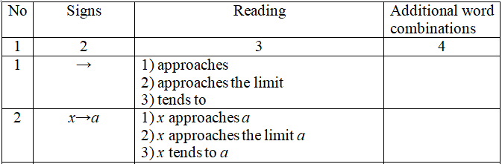
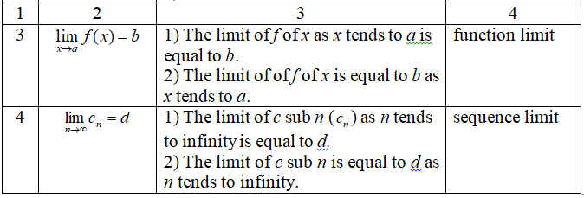

2.3. The Derivative of a Function
2.3.1. The Derivative of a Function of a Single Variable
The derivative of a function y = f(x) of a variable x is a measure of the rate at which the value y of the function changes with respect to the change of the variable x. It is called the derivative of f with respect to x.
If x and y are real numbers, and if the graph of f is plotted against x, the derivative is the slope of this graph at each point.
Differentiation is the action of computing a derivative.
$\frac{\text{dy}}{\text{dx}}=y^{'}=f^{'}(x)$ - the first derivative of y (or f) with respect to x;
$\frac{d^{2}y}{{\text{dx}}^{2}}=y^{''}=f^{''}(x)$ - the second derivative of y (or f) with respect to x;
……….
$\frac{d^{n}y}{{\text{dx}}^{n}}=y^{(n)}=f^{(n)}(x)$ - the n-th derivative of y (or f) with respect to x.
The derivative of a function of a single variable is called the total derivative.

2.3.2. The Derivative of a F of Several ariables
In mathematics, a partial derivative of a function of several variables is its derivative with respect to one of those variables, with the others held constant (as opposed to the total differential, in which all variables are allowed to vary). Partial derivatives are used in vector calculus and differential geometry.
We have $y=f(x_{1}, x_{2},\text{.}\text{.}\text{.}, x_{n})$.
$\frac{∂f}{∂x_{2}}=f_{x_{2}}^{'}$ - the partial derivative of f with respect to $x_{2}$;
$\frac{∂^{3}f}{∂x_{4}}=f_{x_{2}x_{2}x_{2}}^{'''}$ - the third partial derivative of f with respect to $x_{4}$;
………………………..
$\frac{∂^{2}f}{∂x_{5}∂x_{6}}=f_{x_{2}x_{2}x_{2}}^{'''}$ - the second partial derivative of f with respect to $x_{5}$ and $x_{6}$.
The total differential of this function is calculated using the following formula (Table 5.2)
$\text{dy}=\frac{∂f}{∂x_{1}}{\text{dx}}_{1}+\frac{∂f}{∂x_{2}}{\text{dx}}_{2}+\text{.}\text{.}\text{.}+\frac{∂f}{∂x_{n}}{\text{dx}}_{n}$.
Table 5.2
Derivatives of a function
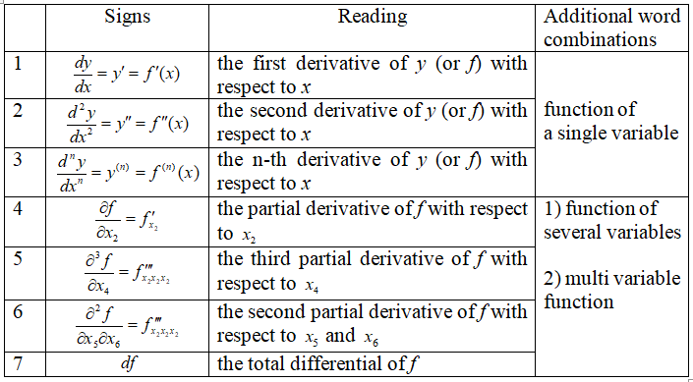

2.4. Integrals [ˈɪntɪgrəl]
$\int{f(x)\text{dx}}$ - the (indefinite) integral of f of x dx;
$\int_{a}^{b}{f(x)\text{dx}}$ - the (definite) integral from a to b (with bounds a and b) of f of x dx;
$\int_{a}^{∞}{f(x)\text{dx}}$ - the (improper) integral from a to infinity of f of x dx;
There are a multiple integral [ˈmʌltɪpl], a double integral [dʌbl], a triple integral [trɪpl], a repeated (iterated) integral [rɪˈpiːtɪd] [ˈɪtəreɪtid], a curvilinear integral [kɜːvɪˈlɪnɪə], and a surface integral [ˈsɜːfɪs] in mathematical analysis.

Example
$\int_{−2}^{5}{\left(2x^{3}+\sqrt{x−4}\right)}\text{dx}$.
Read: The integral from minus two to five (with bounds minus two and five) of the expression, round brackets opened, two multiplied by x cubed plus the square root of the difference of x and four, round brackets closed, dx (Table 5.3).

Table 5.3
Integrals
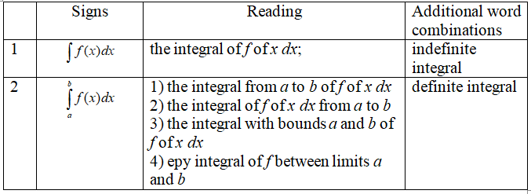

3. Grammar Patterns: Noun Phrase, Prepositional Phrase
3.1. Noun Phrase
A noun phrase is a phrase which has a noun, an indefinite pronoun or an adjective as its head word and zero or more other words. The whole noun phrase can be replaced by a pronoun (Table 5.4).

Table 5.4
Noun phrase
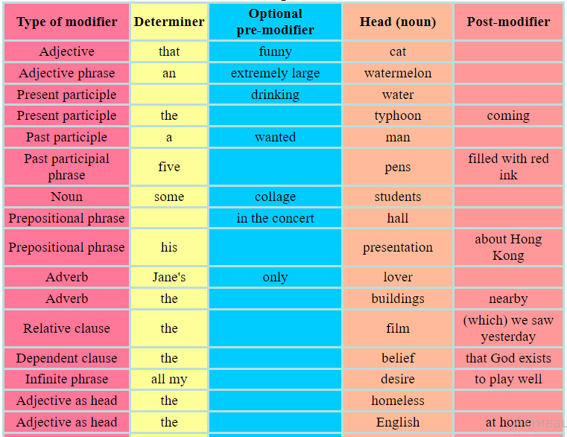
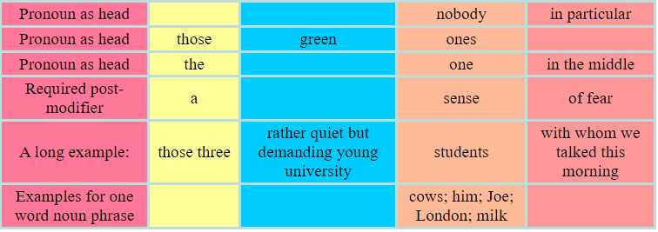

Modifiers are usually optional. They give extra information about the noun. But sometimes a post-modifier is required to complete the meaning of a noun and in this case it is called a complement. e.g. 'the claim' needs a complement 'the claim that he stole her money'
Noun phrases can be embedded inside each other or attached to one another to form a chain.

3.2. Prepositional Phrase
Prepositional phrases are groups of words containing prepositions (Table 5.5).

Table 5.5
Prepositional phrase
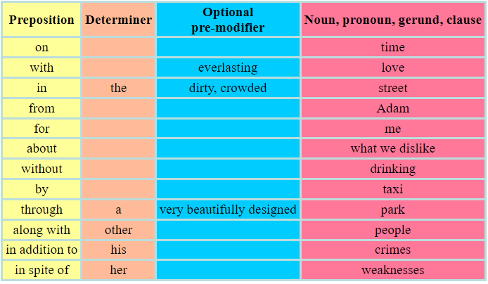

A prepositional phrase usually starts with a preposition. However, some prepositions, called postpositions, stand behind the object. For example, 'a week ago', 'her weaknesses notwithstanding.
There is a third category called circumposition where two prepositions are used together before and after a word. For example, the 'from ... on' pair in 'from now on'.
The general term for preposition, postposition and circumposition is adposition but in everyday usage preposition is used for all the three.
A prepositional phrases can function as an adverb or an adjective.
The referred word is the word to which the prepositional phrase is an adjunct. (Table 5.6).

Table 5.6
Prepositional phrase as an adjunct
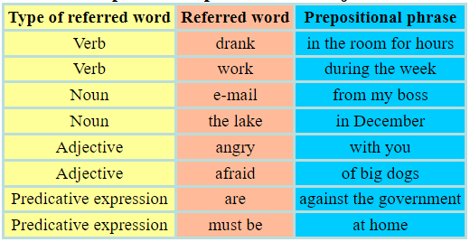

References
Primary sources
1. Kibble Tom W.B., Berkshire Frank H. Classical Mechanics. - 5th Edition. – London: Imperial College Press, 2004. – 478 p.
2. Englert Berthold-Georg. Lectures on Classical Mechanics. – Singapore, 2015. – 376 p.
3. Müller-Kirsten Harald J.W. Classical Mechanics and Relativity. – London: World Scientific Publishing Co Pte Ltd, 2017. – 560 p.
4. Lurie A.I. Theory of Elasticity. - Springer Science & Business Media, 2010. – 1050 p.
5. Martin H. Sadd. Elasticity. Theory, Applications and Numtrics. – Amsterdam: Boston:Elsevier, 2005. – 461 p.
6. Darryl D Holm. - Geometric Mechanics. - London, 2011. – 468 p.
7. Papastavridis John G. - Elementary Mechanics. - In 2 Volumes. – USA, 2019. – 1680 p.
8. Бизюк Л.К., Зенченко В.А., Потапова Н.Л., Тригубкина С.Н. Learn higher mathematics in English. – Минск : БГУ, 2015. – 96 с.
9. Прокошева И.И. Основные математические понятия в английском языке: Методические указания. – Оренбург: ГОУ ВПО ОГУ, 2003. - 50 с.
10. Downing Douglas. Dictionary of Mathematics Terms. - Third Edition. - Barron’s Educational Series, Inc. Prior editions. 2009. – 394 p.
11. Clapham Christopher, Nicholson James. The Concise Oxford Dictionary of Mathematics. – Fourth edition. - New York: Oxford University Press Inc., 2009. – 875 p.
12. Кудинова Ю.С., Никрошкина С.В. Английский язык для инженеров-механиков: уч. пособие. - Новосибирск: Изд-во НГТУ, 2019. – 94 с.

Secondary sources
13. Kai S Lam. Fundamental Principles of Classical Mechanics. - Pomona, USA, 2014. – 592 p.
14. Harald Iro. A Modern Approach to Classical Mechanics, - 2nd Edition. – Austria, 2015. – 528 p.
15. Atanackovic Teodor M., Ardeshir Guran. Theory of Elasticity for Scientists and Engineers. - Springer Science & Business Media, 2000. – 374 p.
16. Nekovar Jan. Mathematical English (a brief summary). – Universite Paris, 2011. – 30 p.
17. Schwartzman Steven. The Words of Mathematics: An Etymological Dictionary of Mathematical Terms Used in English. - MAA, 1994. – 261 p.
18. Янушкевич Л.М. English for mechanical engineers: пособие. - Минск: БНТУ, 2019. – 198 с.

Online sources
19. Shapiro Joel A. Classical Mechanics. – 2010. – 272 p. [Electronic resource] https://www.physics.rutgers.edu/~shapiro/507/book.pdf
20. Theory of elasticity. [Electronic resource]
http://limba.wil.pk.edu.pl/kpmoc/images/stories/kpmoc/pracownicy/PSz/TSiP/ToE.pdf
21. Elasticity Theory, Energy, and Forces. [Electronic resource]
https://www.tf.uni-kiel.de/matwis/amat/def_en/kap_5/backbone/r5_2_1.html
22. “Math Vocabulary” – The Language of Mathematics. – 2023. [Electronic resource]
https://www.eslbuzz.com/math-vocabulary-the-language-of-mathematics/
23. Math.Glossary. [Electronic resource] https://mandober.gitbook.io/math-debrief/900-index/990-appendix/math.glossary#theorem
24. Reading Math in English. [Presentation]
https://www.powershow.com/view4/81c9dd-NWNmO/Reading_Maths_in_English_powerpoint_ppt_presentation#google_vignette
25. English grammar tables and examples. [Electronic resource]
https://www.englishconversationcoursetutorhk.com/english_grammar_tables_e.php

Lecture 6

Lecture topic: Translating Scientific and Technical Texts. Basic Principles of Translation
Lecture plan
1. Translating Scientific and Technical Texts
2. How to Translate Scientific and Technical Texts
3. Grammar Patterns: Comment tags

1. Translating Scientific and Technical Texts
1.1. Intoduction
The theoretical part is dedicated to translating scientific and technical texts. As the headline may hint, it will be dedicated to translating and everything related to that. First of all, contemporary translation theories will be defined and discussed, their purpose and outcome as well. After short and brief discussion of the theories of translation, particularly its categories, there is point that deals with basic principles of translating. In my opinion, the principles are quite general, but, considering a wide range of styles, it is good to have some common rules that must be followed by every translator.
According to Hatim and Mason (1990, 2), “translation is a useful test case for examining the whole issue of the role of language in social life. In creating a new act of communication out of a previously existing one, translators are inevitably acting under the pressure of their own social conditioning while at the same time trying to assist in the negotiation of meaning between the producer of the source-language text (ST) and the reader of the target-language text (TT), both of whom exist within their own, different social frameworks.” (Hatim, Mason 1990, 1)
Christian Nord (2005, 32) defines translation as the production of a functional target text maintaining a relationship with a given source text that is specified according to the intended or demanded function of the target text (translation skopos). Translation allows a communicative act to take place which because of existing linguistic and cultural barriers would not have been possible without it.
Functionality is considered to be the most important criterion for a translation, but certainly not the only one. There has to be a certain relationship between the source and the target text. Therefore and undoubtedly, the translator is committed bilaterally to the source text as well as to the target-text situation, and is responsible to both the ST sender and the TT recipient. Christiane Nord calls this “loyalty”. (Nord, 2005, 32)
I agree with Christiane Nord, that functionality is important for either the source text or target text. Therefore, translator must feel committed to both the text and the result of this relationship is something more than just a mechanic translating. Loyalty is just a name for the relationship between translation and translator.

1.2. Contemporary Translation Theories
To deal with translation and, more specifically, with translation of scientific and technical texts, it is highly necessary to introduce the contemporary translation theories. This chapter operates with the basic terminology inevitable for every translator, i.e. the process of translation, the source text (ST), the target text (TT). In the final part, Jakobson's categories interlingual, intralingual a intersemiotic translation are introduced.
Translation studies are now understood as an academic discipline concerned with the study of translation covering the whole spectrum of research and pedagogical activities, training translators and developing criteria for translation assessment. (Baker 2001, 277)
Jeremy Munday (2001, 5) Susan Basnett (2002, 22) and others definitely agree on definition of translation and its types according to Jakobson (1959/2000, 114). The term translation itself has several meanings: it can refer to the general subject field, the product (the text that has been translated) or the process (the use of producing the translation, otherwise known as translating). The process of translation between two different written languages involves the translator changing an original written text (the source text or ST) in the original verbal language (the source language or SL) into a written text (the target text or TT) in a different verbal language (the target language or TL) . This type corresponds to interlingual translation and is one of the three categories of translation described by the Czech structure list Roman Jakobson in his seminar paper
On linguistic aspects of translation (Jakobson 1959/2000, 114). Jacobson’s categories are as follows:
1. intralingual translation, or rewording: an interpretation of verbal signs by means of other signs of the same language;
2. interlingual translation, or translation proper: an interpretation of verbal signs by means of some other language;
3. intersemiotic translation, or transmutation: an interpretation of verbal signs by means of signs of non-verbal sign systems.
It is the interlingual translation which is the traditional, although by no means exclusive focus of translation studies.
“The purpose of translation theory, then, is to reach an understanding of the processes undertaken in the act of translation and, not, as is commonly misunderstood, to provide a set of norms for effecting the perfect translation.” (Basnett 2002, 43)
Translation theory, in my opinion, is a very important discipline. It searches, compares, derives and creates norms and new procedures for achieving good translation.

1.3. Basic Principles of Translation
Translating as a procedure, an art, or an activity in general means that he/she should do it right and to be productive. I have chosen two opinions about what the basic principles of translations are. 1st one is according to Tytler and the second according to Nida (issued almost 60 years later) to compare just the slight difference in spite of the time gap. Hatim and Mason (1990, 16) summarize the basic “laws on translation” introduced by Tytler (1907):
• that the Translation should give a complete transcript of the ideas of the original work,
• that the style and manner of writing should be of the same character with that of the original,
• that the Translation should have all the ease of original composition A more recent formulation of the basic “requirements” of a translation are to be found in Nida (1964, 164):
• making sense,
• conveying the spirit and manner of the original,
• having a natural and easy form of expression,
• producing a similar response.
According to Basnett (2002, 29) a translator in determining what to use in English, he/she must:
• accept the untranslatability of the SL phrase in the TL on the linguistic level,
• accept the lack of a similar cultural convention in the TL,
• consider the range of TL phrases available, having regard to the presentation of class, The status, age, sex of the speaker, his relationship to the listeners and the context of their meeting in the SL,
• consider the significance of the phrase in its particular context – i.e. as a moment of high tension in the dramatic text.

1.4. Types of Translation
Translation as a procedure or a method has its own rules and ways how to progress. There is seven main translation procedures that translator should follow, or can choose yours from you, Knittlová (2005, 14) claims that even though there exist a variety of procedures, ways and methods used for translation, all of them should lead to the same target – to achieve the most appropriate form of a translation. Fjodor, Levý and Catford, the former translation theorists, did not always use the distinctive terms and named them generally as procedures. Contemporary Russian, German, or Czech linguists dealing with translation studies refer to the comparison between French and English stylistics from Canadian authors Vinay and Darbelnet. They operate with seven main translation procedures that solve the lack of equivalence (Knittlová 2005, 14):
1. Transcription – more or less adapted transcription to the utterance of TL.
2. Kalk – literal translation
3. Substitution – substituting one linguistic means with another equivalent one (e.g. substitution of nouns by personal pronouns and vice versa).
4. Transposition – i.e. necessary grammatical changes resulting from the differences in SL and TL systems.
5. Modulation – the change of aspect (e.g. angle-joint of the pipe: koleno potrubí)
6. Equivalence – Knittlová does not consider this one as a suitable term for using of stylistic and structural means different from the source text.
7. Adaptation – substitution of a situation described in ST with different adequate situation, e.g. when there is no equivalent of saying in TL.
Translation is a very complex task to manage. A translator must not only need to know their source language well; they must also have a thorough understanding of the field of knowledge covered by the source text (Krijtová 1996, 35). Translators should ensure a result that even sounds as natural as possible – though some translators have argued that, for certain types of text (e.g. scientific material), where translation accuracy is more crucial than naturalness, it makes more sense for translator to be more fluent in the source text. (Crystal 2005, 346)

1.5. Equivalence in Translation and its Typologies
Typologies. This chapter is supposed to reveal to a reader the concept of equivalence and its typologies. I have divided equivalence according to more than just one classification, because it is impossible to grasp the whole essence of equivalence following just one type of classification. I have added thee typology introduced by Baker, Nida, Koller, etc. They all offer different view at equivalence, whether equivalence at the word-level or from larger aspect, and others. Equivalence is a central concept in translation theory, but it is also a controversial one (Baker 2001, 77). According to Crystal the aim of translation is “to provide semantic equivalence between the source and target language” (Crystal 2005, 346). Apparently simple statement hides many problems, all of them connected to the standards of equivalence that should be expected and accepted. Exact equivalence is of course impossible. Basically, the equivalency can be considered from the viewpoint of lexicology, syntax or grammar (grammatical units used in SL and TL). (Baker 1992)
Equivalence is commonly established on the source language (SL) and the target language (TL) and thus on their referential or denotative equivalence and connotative equivalence (Baker 2001, 77). According to the effect the SL and TL have on their respective readers, the equivalence is distinguished as dynamic (Nida 1964) or pragmatic equivalence (Koller 1989, 102).
Routledge Encyclopedia of Language (Baker 2006) adds other types of equivalence: ƒ
- Text-normative equivalence: the SL and TL words are used in the same or similar contexts in their respective languages. (Koller 1989, 102) ƒ
- Formal equivalence: the SL and TL words have similar orthographic or phonological features. (Nida 1964) ƒ
- Textual equivalence: combination of ST and TT information flow and roles of cohesive devices. (Baker 1992) ƒ
- Functional equivalence: not all the variables in translation are relevant in every situation, and thus translators must decide which of the variables should be given priority (Newman 1994, 4695)
Baker (1992) offers fundamental and comprehensive look at the classification of equivalence. She divides equivalence into the following groups: ƒ
- Equivalence at word level: aspect of word as a unit in different languages (for further reading see also Hatim and Mason 1990, 180). ƒ
- Equivalence above word level: collocations, idioms and fixed expressions.(for further reading see also Basnett 2002, 31) ƒ
- Grammatical equivalence: grammatical vs. lexical categories. ƒ
- Textual equivalence: thematic and information structures: Hallidayan approach vs. the Prague school position on information flow. ƒ
- Textual equivalence (cohesion): reference, substitution and ellipsis, conjunction, lexical cohesion. ƒ
- Pragmatic equivalence (coherence): coherence and processes of interpretation (implicature)
A translator can reach nearly absolute equivalence when translating the terms of Greek and Latin origin, even if a problem may appear here as well. The most difficult terms to translate are those which occur only in the particular language and have no equivalence in TL. The possible solution here is to use substation in compliance with the stylistic norm and the system of TL. (Knittlová 2005, 153)
Translating of internationalisms may seem convenient. On the other hand, the mechanic translation of them can be treacherous. Knittlová demonstrates the issue on the following examples: (Knittlová 2005, 153)
Ex.: some techniques – nejsou některé techniky, ale spíše metody, patent application – není aplikace patentu ani patentová aplikace, ale patentová přihláška, etc.
According to the recent study on the creation of new terms in the magazine American Speech, contemporary scientists tend to digress from using classic languages as the source and start to seek in the vocabularies of their own languages. More than a third of new terms is created only on the basis of semantic shift/change. Another third of them is created by linking already existing lexical units in English language. A fifth of them is borrowed from other contemporary languages. The rest is created by less frequent word-formative processes. (Knittlová 2005, 153)

2. How to Translate Scientific and Technical Texts
Translating scientific and technical texts may not be attractive for some translators. It is the matter of choice, though. I agree on this point with Byrne saying, that this type of translation has been largely neglected. However, the aim of this chapter is not to discuss the issue of the value of technical and scientific translation. The purpose is to introduce main aspects to a reader, which are advised to be aware of at least and to follow them.
Technical translation has been long considered as not particularly exciting or attractive one compared to other types of translation serving as nothing more than an exercise in specialized terminology and subject knowledge. According to Byrne, this vocational and industrial type of translation has been largely neglected in the literature on translation theory. However, there is also a different opinion, that technical translation is a much more promising area for theoretical investigation. (Byrne 2006, 1)
It is important to realize that scientific and technical translation are not the same and such, cannot be compared equally. (Byrne 2006, 1) However, the following chapter intends to show the most fundamental common features and the peculiarities which will be later discussed in the analytical part in the analysis of the excerpts from technical and scientific texts.

2.1. Aspects of Scientific and Technical Translation
This chapter will discuss particular aspects of scientific and technical translation. Aspects such as causative structures, linking elements for maintaining logical sentence order, rhematic position both in Czech and English) and condensation will be described with example for an illustration.
There are fixed patterns and structures that are different in SL and TL. A translator must be aware of them in order to achieve uniformity and proper comprehensibility of translation. A very frequent structure is causative structure.
According to Knittlová (2005, 143-144) Causative structures are very frequent element in scientific English. They interrelate with the voice. It is mainly the following one:
MAKE + N + ADJ
E.g.: This makes the problem easy. – This makes/renders the metal hard.
When translating into Czech, it will be necessary to change the construction (Tím se kov tvrdí) or to use the equivalent paraphrase (Two sheared versions of the wave front under test interfere within the interferometer, making the instruments especially suited for the investigation of gradients - proto jsou tyto přístroje zvláště vhodné pro zkoumání grandientů).
Other causative structures are formed by the usage of:
ENABLE, ALLOW, PERMIT, CAUSE, MAKE + INF
Basically, it is the type of causative structures with infinitive that are usually transformed into Czech by means of the subordinate clause. E.g.: Safety valves allow the metal to cool slowly. – Bezpečnostní ventily umožňují, aby kov pomalu chladl. (Knittlová 2005, 145)
To achieve logical sentence order, there are linking elements – a translator should not definitely leave them out. There are words with high frequency such as thus, however, therefore, moreover, then, furthermore, so, in addition, on the other hand, nevertheless, again, also, yet, still, meanwhile, besides, first, finally, consequently, now, and others. However, logical sentence order is achieved not only by using appropriate linking elements but also by appropriate theme – rheme distribution within sentences.
When translating scientific and technical texts, it is very important to find the rheme in SL text and to place it to appropriate position in the ending part of a sentence in the Czech translation. This rhematic position is very typical for Czech language even if the rheme is possible to be pointed out, or by means of specific syntactic constructions. (Knittlová 2005, 145)
When speaking about rhematic position in English, it is necessary to mention that English has fixed word order within a sentence, and thus to achieve rhematic position, it has to use syntactical, lexical or morphological means, in contrast to Czech, where it can be easily achieved by simple change in word order.
There are many ways in English how to indicate rheme. A common possibility is to place a rheme behind predicate expressed by verbs to be, to seem, to appear, to stand, to live, to lie, and to hang. In addition, this enables a combination with there.
E.g.: There is a close connection between the value of the intrinsic spin of an elementary particle and the symmetry character of the wave function. – Mezi hodnotou intrinsikního spinu elementární částice a symetrickou povahou vlnových funkcí existuje těsná spojitost.
E.g..: It is this interaction that causes the absorption. – Právě tato interakce spůsobuje absorpci. (Knittlová 2000, 145)
According to Knittlová (Knittlová 2005, 145) rheme can be indicated in the Czech language by using various linguistic means:
• It can be indicated lexically by means of only, merely, just. On the other hand, the theme is pointed out by means of using definite article, pronouns (personal, relative, possessive, and demonstrative), or expressions such as such, similar, one – the other etc.
• An indefinite article may indicate rheme as well.
• Using preposition by with passive predicate (agent, source of action, circumstantial adverbial of manner).
E.g..: These properties of photoelectric effect were first explained by Einstein. – Tyto vlastnosti fotoelektrického jev vysvětlil jako první Einstein. (Knittlová 2005, 145)
As mentioned before in chapter 1.3.1, the logical word order in the sentence is one of the key features of scientific and technical style. If the principle of logical word order in the sentence would not be respected by a translator, and the English word order would be preserved in the Czech translation, we might be introducing such a translation to a Czech recipient that would not comply with the object of communication intended in the source text. (Knittlová 2005, 146)
E.g.: These phenomena will not be considered in the present book. - V této knize se o těchto jevech mluvit nebude. (Knittlová 2005, 146)
The principle of logical word ordering is equally applicable for ordering of clauses within a complex sentence. Formal structures and complex sentences without ellipses1 are predominant in scientific and technical style. That and which are not omitted in English subordinate nominal clauses. One of the most frequent expressive means that indicate relations between clauses are conditional relative conjunctions (if, unless), other linking elements are providing, provided, on condition. Another frequent prepositions are those of temporal nature (before, as, while, as soon as, when, until, once, after), of consequence (so that, with the result that, as a result of, in consequence of, consequently, therefore, whence) and those of cause (because, since, as, because of, on account of, owing to, due to). Translators often wrongly preserve the original placement of the circumstance adverbial as in English source text. Therefore, a translator translating into Czech needs to be aware of this and to change the order of clauses within a sentence. (Knittlová 2005, 146)
Every translator must be aware of the fact that the primary objective in scientific style is its functionality (pragmatic aspect). Even though the stereotype is functional here and the syntactic structures may have (mainly in mathematics and logic) the nature of terms, it does not mean that a translator is supposed to translate them literally. Precise and comprehensible transfer of relevant information is fundamental. Therefore, translators can break the sentence units and rebuild them, if it is on behalf of clarity. The form is secondary when dealing with scientific and technical texts. What is primary is the content, which happen to be very complex and a translator mustn’t make the understanding of the text more difficult to the reader of the TT by using cumbersome, complex and intricate clause constructions. (Knittlová 2005, 148)
Condensation has already been mentioned as a characteristic feature of scientific and technical style. When translating into Czech, it is necessary to enlarge and specify these condensed structures. It is possible to do it by adding clauses containing finite verb forms. However, Czech language in scientific and administrative style is also more condensed compared to other styles. (Knittlová 2005, 148) When we compare Czech language in scientific and administrative style with the Czech language in e.g. in literature, we can find out that the Czech language in scientific and technical style is more nominal than Czech language used in the theatre.
E.g.: To obtain tolerance levels by applying Eq.(12) to certain specific aberration types, we must… - Abychom zjistili toelranční hranice tím, že budeme aplikovat rov. (12) na jisté typické druhy aberací, musíme určit … .
The consistency of expressing is reflected also in using of noun groups – semantic condensers. It is often a hard case to translate for a translator. In English, the semantic relation between particular juxtaposed substantial pre-modifiers is not explicitly indicated, and yet this relation can be immensely various. A. J. Herbert demonstrates the issue on the following examples:
Steam consumption = the consumption of steam
Metal tubes = the tubes made of metal
Friction losses = losses caused by friction
In the translation of the examples into Czech, it is obvious how the Czech language is able to use variety of linguistic means:
Steam consumption = Spotřeba páry (the use of genitive)
Metal tubes = kovové roury (adjective implies the material used for the pipes)
Friction losses = ztráta při tření (the use of preposition)
On the opposite, Czech language requires the explicit expression instead. (Knittlová 2005, 149)
E.g.: Steam corrosion inhibition – zamezení koroze způsobené párou.
Consistency in this sense is applied also in translations of the headlines in scientific and technical style.
E.g.: The search-and-rescue laser – Využití laseru k vyhledávání a záchraně letců (na moři). (Knittlová 2005, 150)
The structure of headlines in English scientific style differs from the structure of the headlines in Czech. English headlines are typical for repeated occurrence of the same lexical unit (mainly the scientific and administrative styles tend to repeat pronouns). With respect to the Czech language, traditional forms with empty words such as upotřebení, použití are still preferred.
(E.g.: Holography and medicine – Upotřebení holografie v lékařství). (Knittlová 2005, 151)
We can experience two main difficulties when searching for optimal equivalences of such English terms in scientific and technical style. One of them is the different semantic condensation between SL and TL. (Knittlová 2005, 153)
Semantic condensation is considerably more frequent in English, as it has already been mentioned as one of the main features of scientific and technical style (see chapter 1.3.1). It enables to create such nominal structures in English which cannot be formed in Czech because it is synthetic flexional language. (Knittlová 2005, 153)
Knittlová recommends that the key to decode the noun groups is the fact, that in such nominal phrases, the description is hierarchical. However, there can be hidden various relationships in the underlying structure of compound terms. Vagueness and ambiguity can be exclusively reduced by matter-of-fact knowledge of the given extra lingual reality. When translating into Czech, a translator must, in most cases, convert the pre-modifying nouns into explicative and descriptive equivalents. (Knittlová 2005, 153)
The second problem that a Czech translator might be confronted with is the problem of equivalency in translating distinctive metaphors. The occurrence of these metaphors in English scientific style shows a rising tendency. Czech language is not that accessible and open to metaphors of sudden inspiration in this style. On the other hand, Czech scientific terminology is willing to adopt foreign expressions and adopt them (e.g. wi-fi, hi-fi, leasingová společnost, forfaiting/factoring (bank.), hedžovanie/hedžing (bank.)). (Knittlová 2005, 154)
Standardized terminology system in exact sciences (chemistry, medicine, and some technical disciplines), it is a possible way to achieve equivalence. On the other hand, the humanity studies differ in this aspect. They reflect immense diversity of cultural traditions and social structures. Therefore, equivalence cannot be achieved easily.
It is crucial to analyze the scientific text’s content first and then search for equivalents complying with the standard of TL. In many cases, translator has to choose an alternative solution when standard method of translation cannot be applied, for example periphrastic form. It is necessary to be aware of the fact that the description is very explicit when translating into a language that is more implicit; the asymmetry cannot be neglected, it would lead to redundancy otherwise. Other types of shift can be observed also in terms of concrete/abstract or specific/general expressions. (Knittlová 2005, 156)
Aspects of scientific technical translation were the major concern of this chapter. Causative structures and verbs, they often occur with, in the text, logical word order, and how to achieve it, standardized terminology, and semantic condensation were all defined and demonstrated on

2.2. Machine Translation of Scientific and Technical Texts
I have decided to include one chapter in my thesis that would deal with machine translation as far as my thesis discusses the translation of scientific and technical text and modern life we life brings a lot of possibilities. The chapter deals with the history of machine translation, the several attempts that have been undergone, individual technical projects and their perspective to life.
The idea of using machines to provide translations between natural languages has been recognized since 1930s, but appropriate climate for development arose after the World War II. The founder of the field, Warren Weaver, inspired several groups to begin research programmers into MT during the 1950s, and great claims were made for the future of the subject. (Crystal 2005, 352)
The term Computer-Aided Translation (CAT) refers to a translation modus operandi in which human translation (HT) is aided by computer applications. A competing term, Machine-Aided Translation (MAT), is also in use, particularly within the software community involved in developing CAT applications (Quah 2006, 6). MAT represents the use of computationally organized data banks and all kinds of peripheral equipment to help translators in their work (Crystal 2005, 353). “A key characteristic is that a human translator takes control of the translation process and technology is used to facilitate, rather than replace HT”. (Baker 2001, 49)
Technology-based solutions to translation needs are a natural consequence of the shortened timeframe available for translation and increasing budgetary constraints resulting from globalization, as well as the progressive digitalization of source content. CAT has become the predominant mode of translation in scientific and technical translations and localization, where technology is employed to increase productivity and cost-effectiveness as well as to improve quality. The CAT tools range from general purpose applications such as word processors, optical character recognition (OCR) software, Internet search engines, etc., to more translation-oriented tools such as multilingual electronic dictionaries, corpus analysis tools, terminology extractions and terminology management systems. Having emerged as one of the earliest translation technologies in the 1970s, translation memory (TM) was commercialized in the mid-1990s (Somers 2003a, 31), becoming the main CAT tool since the late 1990s. (Baker 2001, 48)
Language is a complex system that theoretically could function due to set rules from the viewpoint of mathematics. However, the spoken language contains errors, shifts, ellipsis, and gaps and therefore due to its structural nature the concept of machine translation has its own cracks and it might fail. (Gentzler 2001, 51)
To conclude the actual status of using machine translation, it is unlikely that machines will replace human translators in the foreseeable future; but they can be very helpful with routine translation work and enable much more material to be processed would be the case otherwise. To mention some of the firms providing with the systems that can process quantities of scientific texts in certain areas, it is Automated Language Processing System (ALPS), Weidner Communications or Logos Corporation in Germany. (Crystal 2005, 353)
According to Kingscot (2002) there has been an estimate that technical translation accounts for some 90% of the world's total translation output each year. It is not a surprising fact considering the importance given to availability of technical information in variety of languages as a result of increasing international interest of many companies and partly of legislation (mainly EU) or international standards. Furthermore, international cooperation in scientific, technological and industrial activity completes the whole demand for technical translation and proves its significant role in translation studies and its praxis. (Byrne 2006, 3)
In my opinion, it is improbable, that at least for the next decade that the MAT and CAT will be able to replace human work. The idea mentioned above is useful only for routine translations in high amounts of issue. Language is a complex system. On one hand it functions according to a wide range of set rules, on the other hand it can behave unexpectedly.

3. Grammar Patterns: Comment tags
Comment tags are short additions to sentences.
After affirmative statements use ordinary interrogative (+,+). After negative statements use negative interrogative (-,-).
Don't confuse comment tags with question tags, which are (+,-) or (-,+). Question tags are used for asking for a response. Comment tags are used for giving a response.
The meaning of a comment tag depends on the tone of voice used by the speaker. They look like questions syntactically but they are not semantically. They are comments, not questions and they do not require an answer.
Comment tags can be used in two ways:
1, Comment tags can express that the speaker understands the situation or the story or the related facts. It is more of a logical, intellectual response rather than emotional. The response does not need to match grammatically with the previous sentence (Table 6.1).

Table 6.1
Comment tags for expressing understanding or noting facts
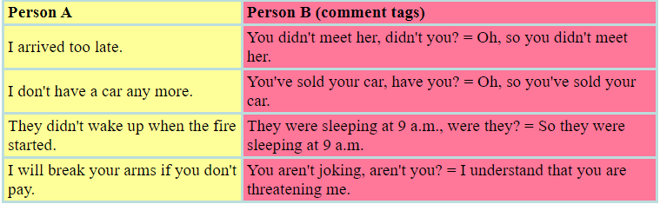

2, Comment tags are mainly used to express the speaker's reaction to a statement. The comment tag must grammatically correspond to the syntax of the sentence it refers to. Sometimes this type of comment tag means the same as 'Really!', 'Indeed!'
Comment tags often express the speaker's emotions like anger, amusement, admiration, surprise, interest, disinterest, suspicion, disbelief etc. and the listener creates the meaning based of the tone of voice. The 'auxiliary - pronoun' section can be 'doubled' to express stronger emotions (Table 6.2).
Table 6.2
Comment tags for emotional reactions
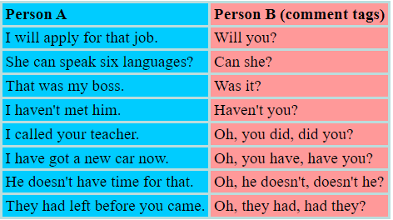

References
Primary sources
1. Schyhlo L.V., Zakharchuk T.O. Scientific-technical text: translation problem. - Sumy State University, Sumy, Ukraine , 2016.
2. Krapivkina O.A. Linguistic and pragmatic aspects of scientific and technical translation. - Irkutsk State Technical University, 2014.
3. Yves Gambier, Luc van Doorslaer. Handbook of Translation Studies. - Volume 1. - Amsterdam / Philadelphia: John Benjamins Publishing Company, 2010.
4. Bassnett Susan. Translation Studies - 3rd Edition. - New York: Routledge, 2002.
5. Munday Jeremy. Introducing Translation Studies: Theories and Applications. - New York: Routledge, 2005.
6. Olohan Maeve. Scientific and Technical Translation. - Routledge, 2016.
7. Eva Mastná. The nature of scientific/technical texts from viewpoint of translation studies. - Tomas Bata University in Zlin. Bachelor Thesis, 2010.
8. Gretzler Edwin. Contemporary Translation Theories. - Revised 2nd Edition - Clevedon: Multilingual Matters LTD, 2001.
9. Superanskaya A.V., Podolskaya N.V., Vasilieva N V. General terminology. Theory issues. - М., 2003.
10. Radjabova D.A. Difficulties of the translation of scientific and technical texts / Педагогика «Молодой учёный». - Март 2017. - № 13 (147) - C. 595-598.
11. Sofer Morry. The Translator’s Handbook. - 6th Revised Edition. - Rockville: Schreiber Publishing, 2006.
12. Baker Mona. In Other Words. A coursebook on translation. New York: Routledge, 2006.

Secondary sources
13. Nord Christiane. Text Analysis in Translation. Theory, Methodology, and Didactic Application of a Model for Translation-Oriented Text Analysis. - New York: Editions Rodopi B.V., Amsterdam – New York, 2005.
14. Venuti Lawrence. The Translation Studies Reader. - 2nd Edition. - New York: Routledge, 2002.
15. Baker Mona. Routledge Encyclopedia of Translation Studies. - London: Routledge, 2001.
16. Komissarov V. N. Modern translation. - М.: Vysshaya shkola, 2002.
17. Šarčević Susan. New Approach to Legal Translation. - Dordrecht: Kluwer Law International, 2000.
18. Byrne Jody. Technical Translation. Usability Strategies for Translating Technical Documentation. - Dordrecht: Springer, 2006.
19. Kazakova Т.А. Practical translation. - Spb: Soyuz, 2001.

Online sources
20. Orozco-Jutorán Mariana. Scientific translation. – 2022. [Electronic resource] https://zenodo.org/records/6370674
21. Actual Problems of Scientific-Technical Translation, 2024. [Electronic resource] https://bues.ru/en/articles/actual_problems.php
22. The notion of Scientific and Technical Translation. [Presentation]
https://ppt-online.org/193480
23. Technical & Scientific Translation. [Presentation]
https://faculty.ksu.edu.sa/sites/default/files/scientific_technical_translation_slides.pptx
24. Basic Scientific and Technical Translation. [Presentation]
https://www.slideserve.com/ali-newton/basic-scientific-and-technical-translation-ii
25. English grammar tables and examples. [Electronic resource]
https://www.englishconversationcoursetutorhk.com/english_grammar_tables_e.php

Lecture 7

Lecture topic: Theoretical Issues of Translation, Nature and Concept of Scientific Texts

Lecture plan
1. Theoretical Issues of Translation
2. Nature and Concept of Scientific Texts
3. Grammar Patterns: Question Tags, Special Cases of Question Tags

1. Theoretical Issues of Translation
1.1. Introduction
At present time there is a great necessity to emphasize scientific-technical translation not only as a special kind of translation activity and special theory that investigates this kind of activity but as to assign scientific-technical translation a status of independent applied science. From the linguistic viewpoint peculiarities of scientific-technical are spread on its stylistics, grammar and lexis. The main task of scientific-technical translation is a possibly clear and precise bringing of the information to the reader. This can be achieved by logical interpretation of actual material without explicit emotionality. The style of scientific-technical materials can be identified as formally logical.
Scientific-technical texts reveal a great number of grammar peculiarities. The most typical lexical feature of scientific-technical materials is terms and terminology saturation as well as presence of lexical structures and acronyms. Special places in such materials are the texts oriented not only for these group language speakers but for representatives of a certain professional group with certain extra linguistic knowledge.
The aim of this term paper is devoted to peculiarities of scientific-technical translation.
The following tasks were set up to identify translation peculiarities of technical materials:
1. Reveal and describe common linguistic basis of translation, identify what peculiarities of language systems and functions are the foundations of translation process.
2. Classify main kinds of translation activity.
3. Research peculiarities of scientific-technical materials.
4. Study specific English terminology required for professional translation.
5. Analyze grammatical and lexical peculiarities of scientific-technical texts.
The object of this research is some scientific-technical texts representing manuals for electric devices. The subject of this research is the translation of scientific-technical materials.
The paper consists of introduction, two chapters and conclusion. It is also provided with bibliography list.
The introduction explains the urgency of the research theme, its theoretical and practical value; it identifies the object, subject, aim and tasks of the work.
The first chapter of this research is devoted to the review of theoretical issues of translation, classification of translation and description of certain kinds of translation as well as types of texts being translated.
The second chapter investigates scientific-technical terminology, morphological structure of terms (simple, compound, term phrases), it analyses the main approaches of their translation into English (use of equivalents, analogues, calking and transliteration), structure of scientific-technical terms, translation of full items, acronyms, company items and difficulties related to structure differences of compared languages.
Methodology of the research. The aim achievement of the research and implementation of the set up tasks outlines the need in a number of theoretical and empirical methods of research (theoretical research, concretization, modelling, studying of specific literature, manuals, dictionaries).
Theoretical value of the research results. The investigation, detalization of the issues studied, theoretical value of the received results leads to the conclusion that this research finds out the necessity to emphasize scientific-technical translation as an independent applied science.
The results of the research are submitted in the conclusion of the work.
Scientific and technical literature is of great interest not only in content but also in form. In addition to a huge number of books on science and technology, worldwide annually published in journals over four million articles.
The need for the exchange of information has led to the emergence of a new discipline - translation of scientific and technical literature.
At the heart of the modern style of English scientific and technical literature are rules of English written language with certain specific characteristics, namely:
1. Vocabulary. Used a large number of special terms and words are not of Anglo-Saxon origin. Words are chosen with great care for the most accurate transmission of thought. Large proportion has official (functional) words (prepositions and conjunctions) and words that provide the logical connections between the individual elements of statements (adverb).
2. Grammar. Used only firmly established in writing grammar rules. Widespread passive, impersonal and indefinite-personal design. Mostly used word collocation and complex sentences, which are dominated by nouns, adjectives and impersonal forms of the verb. Logical isolation is often achieved by departing from the rigid word order (inversion).
The method of presentation. The main objective of the scientific and technical literature is very clearly and precisely to bring certain information to the readers. This is achieved by logically valid statement of the factual material, without the use of emotive words, expressions and grammatical structures. This method of presentation can be called formal logic.
The scientific and technical literature, in turn, has a number of gradations. Scientific and technical texts differ from each other not only in the field of science and technology to which they belong, but also their degree of specialization. The above characteristics completely relate scientific monographs and articles, essays and books. However, the text of technical manuals, catalogs, descriptions of supplies, technical reports, specifications and instructions may occasionally contain sentences in which the predicate is missing (when listing the technical data, and so on. N.) Or subject (if it is determined by the context). In technical handbooks found whole segments, which consist of transfers. Descriptions of supply, specifications, technical reports and directories are usually at a fixed pattern and loaded special terminology. Lexical and grammatical pattern inherents in the patent literature and language.

1.2. Theoretical Issues of Translation
Translation is the interpretation of the meaning of a text in one language and the production, in another language, of an equivalent text that communicates the same message. Translation must take into account a number of constraints, including context, the rules of grammar of the two languages, their writing conventions, their idioms and the like. Consequently, as has been recognized at least since the time of the translator Martin Luther, one translates best into the language that one knows best. Traditionally translation has been a human activity, though attempts have been made to computerize or otherwise automate the translation of natural-language texts (machine translation) or to use computers as an aid to translation (computer-assisted translation). Perhaps the most common misconception about translation is that there exists a simple “word-for-word” relation between any two languages, and that translation is therefore a straightforward and mechanical process. On the contrary, historical differences between languages often dictate differences of expression. Hence, source and target texts may differ significantly in length. In addition, translation is always fraught with uncertainties as well as the potential for inadvertent “spilling over” of idioms and usages from one language into the other, producing linguistic hybrids, for example, "Franglais" (French-English), "Spanglish" (Spanish-English) and "Polish" (Polish-English).
The translation of technical texts (manuals, instructions, etc). More specifically, texts that contain a high amount of terminology, that is, words or expressions that are used (almost) only within a specific field, or that describe that field in a great deal of detail. The translation of scientific research papers, abstracts, conference proceedings, and other publications from one language into another. The specialized technical vocabulary used by researchers in each discipline demand that the translator of scientific texts have technical as well as linguistic expertise.

1.3. Development of Translation Notion in Linguistics
Among multiple problems that modern linguistics studies an important role is played by studying of linguistic aspects of cross-language speaking activity that is called translation or translating activity. Translation is an ancient human’s activity. Due to groups of people appeared in the history of mankind had different languages the bilinguals became urgent as they helped communication between groups with different languages. Then writing appeared and along with oral interpreters written translators became urgent as well. They translated different texts of official, religious and business issues. From its very beginning translation played a significant social function allowing people of different languages communicate. Spreading of written translations gave people access to cultural achievements of other people and it made interacting and intersaturation of literatures and cultures feasible. Knowledge of foreign languages allows reading books originally written in those languages.
The first theoretical of translation were the translators themselves who tried to generalize their own experience. Translators of ancient world discussed the issue of proximity degree to the source text. In early Bible translations or translations of other materials that were considered to be sacral and exemplary we can find word for word approach of the source text interpretation that sometimes lead to partly or even full misunderstanding of translations. That is why later translators tried theoretically approve the right of translator for reasonable variety in subject to the source text that meant the interpretation of meaning and the impression of the source text instead of word for word coping.
The foundations of scientific theory of translation started to be developed in the middle of XXth century when the problematics of translating appeared to be urgent amongst linguists. Before that period it was thought that translation is not the issue of linguistic range. Translators themselves considered linguistic aspects to be non-significant but totally technical role. The translator was supposed to be fluent both in source and target languages but knowledge of the language was just a preliminary condition and did not cover its meaning.
By the middle of XXth century the attitude to translation activity had changed and its systematic studying commenced. During this period the translation of political, commercial, scientific-technical and other texts was of great priority. In those types of translation the features of individual writer’s style were not important. Due to this fact more and more attention was paid to the main difficulties of translation related to different structures and functioning of languages in this process.
The meaning of language units was emphasized by more precise requirements for the translation. During the translation of such materials it was not enough to get “general” translation as the translation was supposed to provide information transmission in all details up to the meaning of single words. It was required to identify linguistic meaning of this process and what factors identified it and what range they have for information transmitting.

2. Nature and Concept of Scientific Texts
2.1. Concept of Science
The theme of language in relation to science can be developed in different ways. An interesting and potentially useful thematization is through the idea of translation.
The notion of translation occurs sporadically in philosophy of science, but much of this literature merely glosses over the issue of translation. Even where translation is explicitly invoked, it is mostly understood in terms of what is usually called the naïve view of translation. Such an approach does not do justice to the philosophical complexity inherent in the idea of translation. It is by paying heed to the complexities inherent in the ‘idea' of translation, which one realizes the intrinsic link between science and translation. Similar to the suspicion which science has towards language, language itself harbors a suspicion towards translation. This has contributed to the view that translation is essentially a secondary activity, derivative and dependent on the idea of an original text. As much as the scientific discourse likes to believe that it can distill ideas outside the purview of language, so does the naïve view of translation believe that translations only change the language of the text but continue to keep its ‘essence' intact. These beliefs reinforce the naïve view of translation, which, according to Andrew Benjamin (1989: 60), has ‘two dimensions':
First it involves the idea of recovery; of the recovery of a meaning, or truth, and the subsequent re-expression of what has been recovered. Second this understanding of translation also involves the idea of free exchange; of an unmediated and unrestrained economy in which signifiers are the object of exchange.
The basic ground of a scientific study is the continuous relationship between a cause and its effect. In other words, wherever there is a cause there is an effect. In the modern context the term 'Science' is moved away from its original definition and is presently used for areas of study which do not show the relationship between cause and effect in traditional sense. Sciences such as political science, psychology etc. fall under this category.
In the modern world the areas of knowledge are divided mainly in three categories: 1. Natural sciences, 2. Social sciences and 3. Humanities. The Natural sciences study natural phenomenon which are not man-made. Social sciences concentrate on the study of human behavior. The areas under Humanities try to explore aesthetic and creative aspects of human mind. In fact these three categories are not mutually unrelated but one finds a narrowness of approach in these areas of study. For instance, Psychology on one hand is related to the Neuro-science and on the other to Social sciences since the human being is created as the result of a natural process and the society controls his social behavior. This to certain extent affects his psychological behavior. Similarly, in the case of sculpture and architecture the tools of measurement are derived from physical sciences. While Humanities deal with its aesthetic aspects. So far as the process of translation is concerned, it can also be treated as a scientific activity. 'As a scientist weighs his chemicals in an accurate balance and uses instruments such as microscope, telescope and the like for deciphering knowledge a translator also uses instruments in his job such as dictionaries, grammar books, encyclopedias etc. A good translator makes a judicious use of his instruments as a scientist does of those available to him. A scientist exhibits scientific temper of mind. He has an open mind on issues and problems and seeks evidence from all sources. A translator, to be successful in his work, must exhibit open-mindedness and consult all resources available to him. He can't afford to be circumscribed, whimsical or emotional.' (Wanchoo, 1965).

2.2. Nature and Concept of Scientific Texts
A scientific text, whether in original or in translation, is different from other texts because scientific text is factual and information-oriented. The language of a scientific text is clear, simple and unambiguous. Since science is objective in its approach, the language of a scientific text is also more objective and subjectivity of the author is kept out of it. It is said for the style of writing that 'Style is the man', implying that the personality of the author is reflected in his style of writing. This may be true in case of literary genres such as poetry, short story, novel, essay etc. But it is not applicable for scientific writing, especially in the case of natural sciences. That is why it is said that the language of scientific texts is not subjective but is objective.
Within sciences itself the language may vary according to the area under study. For example, the language of mathematics may vary from the language of physics. However, both are objective in their presentation of the subject. In other words, the language of scientific texts is more specific making the texts more clear and unambiguous as opposed to the literary text where language is often subjective. A Plant-scientist in his effort to understand the structure of a flower disintegrates it into smaller units. In his descriptions of the structure of the flower he has to be specific and objective without any scope of deviation from facts. A litterateur, on the other hand, in his appreciation of beauty personifies a flower and is always subjective in his descriptions. Therefore, the language of a scientific text, as opposed to the language of literary texts, if factual in its content. Every word is concrete and real. The style is not figurative and the language is semantically single layered and less ambiguous.
As mentioned earlier, the idea of translation can be found in the discourses on science, as in history and philosophy of science, although it has not inspired the detailed discussion that it should have. In the context of interpretation, there has been a more sustained engagement with this issue that has led to a substantial body of work on hermeneutic approaches to science.1 Here the idea of translation is implicit. Science is seen as reading the book of nature. This reading immediately implies the notion of translation and interpretation, which are usually used interchangeably in this context. Translation has also been explicitly invoked in the context of the incommensurability thesis.2 This thesis responds to the belief that theories in science are ‘built' upon each other, thereby implying that the concepts and entities referred to in one theory remain the ‘same' when used in another theory, although in a different context. Incommensurability about theories maintains that it will not be possible, in general, to translate a term from an old scientific theory to a new one, if by translation is meant the complete carryover of meaning in these terms.
1. Scientific language is diachronic and it is not affected by temporal considerations.
2. Since technical terms are coined by use of roots and suffixes of classical languages the language of scientific texts, therefore, tends to be hybrid.
3. Every branch of science defines its terms in its own way and therefore, they are context-free and express single meaning.
4. Surface level meaning is more important in scientific' language than deep level.
5. Its use is always restricted.
6. Subjective elements are avoided to the extent possible and therefore passive constructions are mostly used. (Sharma 1985).

2.3. The Importance of the Translation of Scientific Texts
The translation of scientific texts is an essential need in the modern Indian context since most of the scientific texts are written in English, a colonial heritage, which is not the language of the masses. Consequently, most Indians are not in a position to take advantage of the scientific developments within the nation and abroad. They do not get even the preliminary knowledge of scientific achievements. Due to its dependence on a foreign language for scientific learning, Indian society has not made technical advances on par with the technically developed countries. To overcome this situation it is necessary that our scientists should be encouraged to develop scientific writings in Indian languages. Till such time, the only course left to us is to depend upon the translation of scientific texts which would not only contribute to our knowledge but also help us in the development and modernization of our languages. The language development not only means the development of vocabulary but also uses of language in the domains of science and technology. Within the Indian context, whenever the scientific text is translated, the gaps in the terminology are filled either by coining terms through borrowing Sanskrit roots, or adaptation of English words into our own language systems, or by borrowing terms from other Indian languages. In this way our languages develop scientific registers and become capable of expressing new ideas in new norms.
As stated earlier, the translation of scientific texts also contributes in the modernization of our languages. For instance, the translation of an ordinary book of 18th centuries from English into an Indian language may only help in the development of the TL literature, but the translation of a modern scientific text not only enriches the TL but also helps in its modernization.
Before tackling the problems of translating scientific texts, it is necessary to consider the ability levels of the target group which is a decisive factor in the selection of appropriate equivalents such as words, terms, styles, descriptions etc. in the translation process. It is obvious that the largest consumer of the translated scientific text is by and large the student community. Besides this group, there might be some smaller groups of people interested in understanding the happenings of scientific world for the sake of knowledge. From this point of view the scientific literature may be placed in three categories:
a. Text addressed to common masses (Journalistic writings)
b. Student Community (Text books, Reference material)
c. Expert group (Research papers, dissertations etc.)
The first category, i.e., scientific literature addressed to masses may include reports, features, short notes, reviews, columns for general reading on scientific subjects etc. As mentioned earlier, in the Indian context the main source of scientific knowledge is English language. Therefore, to a certain extent the scientific information remains restricted to educated elite. To spread this knowledge to the masses the scientific text written in English have to be translated into Indian languages with non- technical terms and in expository style. In this type of translation the focus is on the message rather than on the structure and style of the original text.
The second category i.e., the Student community studying through the media of Indian languages also requires instructional material including textbooks, reference books, work books etc. in Indian languages. The language to be used in such material has to be technical but should not be like the one used in the research papers written by scientists. All these textbooks and reading material have to be developed by translating or adapting or adopting from English sources.
The third category, i.e., Expert group may not require translation as this group is already proficient in English language. As such whatever their research findings are, they contribute through English only. But if Indian scientists someday decide to present their research findings in their own tongue they will have to develop the necessary jargon and styles of presentation in it.
Keeping in view the constitutional obligations and the growing importance of Indian languages in our national life efforts are being made by governmental and non-governmental institutions to develop scientific and technical terminologies by preparing bi-lingual and tri-lingual glossaries, text books etc. in Indian languages. It is obvious that for all these tasks we have to depend upon translation only.
There are many practical problems of the translation of scientific concepts and ideas from English into Indian languages. It is almost impossible to develop scientific material in our languages without overcoming these problems. In other words, for proper exposition, description, discussion and presentation of the scientific concepts and ideas in Indian languages, there are many practical problems which need to the combated properly. The following points should be considered before translating a scientific text:
(i) The author,
(ii) The subject matter,
(iii) The translation method and
(iv) The reader.
Galison (1997) offers a more sustained critique of the idea of translation in science, both at the level of discourse and praxis. Instead of a model of translation, he suggests that it is the formation of languages at the boundary of different disciplines that is relevant. He concludes that it is the notion of trading that illustrates the way scientific communities interact and languages so formed at the boundaries are more in common with languages like Creole and pidgin. But his reading of translation is also limited as attested to by his comments that the idea of temporality is not captured in the model of translation. He also believes that translation is insensitive to the sociological issues pertaining to the dynamics of language.
These are contentions that a serious view of translation will not allow. The link between translation and science that I develop below will make this explicit. It is clear that there has been minimum engagement between the discourses of translation and those of science. Also, this engagement, when it occurs, has been overshadowed by a dominant emphasis on the naïve view of translation.
Notion about the importance of the translation of scientific texts. Scientific and technical literature translation is a subject aimed at developing of undergraduate students’ skills in translating English and American texts with a number of terms from different scientific and technical spheres. The aim is to develop the skills to analyze the given texts from different branches of science and translate them. On the completion of the subject a undergraduate studentt should know:
- types of dictionaries and reference books;
- general rules of scientific and technical literature translation;
- genre subdivisions of scientific and technical literature;
- grammatical reasons to use different means in the target language;
- terminology used for the translation analysis;
- ways to translate non-finite forms of the verb;
- ways of terms translation;
- ways of internationalisms and Latinisms translation;
- term and terminological system definition;
- terms structure;
- ways of translation of terms neologisms;
- emphatic constructions translation;
- types of abbreviations and ways of their translation;
- standards of the comparative analysis of the SL and TL texts;
- stylistic usage of terms;
- main types of translation,
be able:
- to work with different dictionaries;
- to use the Internet and electronic databases for translation;
- to translate terms and term word combinations in the texts of different scientific and technical directions;
- to find adequate ways of translation for articles, English passive voice constructions, infinitive and participle constructions;
- to understand the abbreviations and change the measurements;
- to translate patents.
Word formation peculiarities and other possibilities of the English language are studied thoroughly as they are connected with the special translation tasks while dealing with terminological nomination and normalization, standards of professional speech
It is important to emphasize here that the scientific discourse is not totally distinct from literary discourse. As a discourse, it has its own stylistics, aesthetics, rhetoric, metaphors and so on. But it also has something more - it is this extra space which needs to be delineated clearly. The nature of the scientific discourse, as a multiple semiotic system and in its use of multiple literary strategies, is already implicated within the notion of translation. Setting out some salient points related to translation, derived from the concerns of literature, will help broaden the understanding of the scientific discourse, as manifested in its written form. This task is indeed urgent considering the widespread belief that scientific and technical texts do not exhibit the problems present in literary translation.
If the text is perceived as an object that should only produce a single invariant reading, any ‘deviation' on the part of the reader/translator will be judged as transgression. Such a judgement might be made regarding scientific documents, for example, where facts are set out and presented in unqualifiedly objective terms for the reader of SL and TL text alike, but with literary texts the position is different.
This privileging of the scientific text is unnecessary and also untenable. Ironically, the sentence following the above quote is, "one of the greatest advances in twentieth century literary study has been the re-evaluation of the reader". This shift to the reader reinforces the complexity that is inherent in scientific texts, which attain this status by being read as such. Barthes' view of the reader as a producer of the text, and not merely a consumer, along with Kristeva's positioning the "reader as realizing the expansion of the work's process of semiosis" are comments equally applicable to the scientific discourse. In fact, this constant schizophrenia of reader/translator is a defining mark not only of translation but also of the scientific activity. If translators are readers of the source text that they translate, scientists are readers of the ‘book of nature' which they then translate.
There is no getting away from the textual character of science. Being a collection of texts, written in natural and symbolic languages, there are various factors which regulate its form and, not so obviously, it's content. It would be easy to say that scientific texts form one uniform genre. But like poetry and fiction, the boundaries defining the genre are constantly under pressure to change. Thus although texts can be ‘identified' as belonging to the scientific (and/or technical) genre, this does not negate the possibility of overlaps with those characteristics which mark literary genres. This intermarriage of different genres creates further problems, as far as translation is concerned. Each genre deals with the concerns of translation in different ways.
Translators, drawing upon the practice of translating texts, have attempted to set some basic rules of translation for different genres. Lefevere's seven strategies for translating poetry and Hilaire Belloc's six general rules for translating prose are attempts in this direction. These strategies respond to the textuality specific to these different genres. Although, at this point, I do not believe that one can attempt a similar exercise for scientific discourse, more detailed analysis of that discourse might lead to such attempts in the future. Here I will only assert that the writing of the scientific discourse already, and implicitly, involves discursive strategies dealing with translation. Most, if not all, scientific texts are ‘structurally similar' to prose texts. The text is bifurcated into chapters, sections, paragraphs and sentences. There is an apparent linearity to the text—the development of the text beginning with simple ideas and equations and proceeding to more complex physical (and mathematical, if required) problems and solutions. The first chapters are literally the foundation upon which the edifice of the text rests. In the text, we can find claims, arguments, proofs, suppositions, references and so on. All these elements go to constitute the style of the genre itself. Thus the process of translation has to negotiate with, build upon and integrate all these elements. It is also the case that the possibility of research itself is based on the ambiguities inherent in the activity of translation.
In spite of translation being one of the oldest professions in the world (or maybe because of it!), Venuti (1998) observes that the "study of the history and theory of translation remains a backwater in the academy." This observation points to a fundamental tension present in according due importance to the study and practice of translation, and highlights the need for a sociological perspective, which is already inherent in this activity. It also suggests an expansion of the academic stakes in translation.
In particular, one can read Venuti's Scandal of Translation as a sign of growing pains. As a sign of the times, too, Venuti uses translation as a prism through which larger sociological issues are articulated. My focus on Venuti's book here is an act of appropriation of certain conceptual categories that well suit my own reading and re-writing of the scientific discourse.

3. Grammar Patterns: Question Tags, Special Cases of Question Tags
3.1. Question Tags
Question tags are short additions to sentences for asking for agreement or confirmation. After affirmative statements use negative interrogative (+,-). After negative statements use ordinary interrogative (-,+) (Table 7.1).
Don't confuse question tags with comment tags, which are (+,+) or (-,-). Question tags are used for asking for a response. Comment tags are used for giving a response.

Table 7.1
Question tags with affirmative and negative sentences
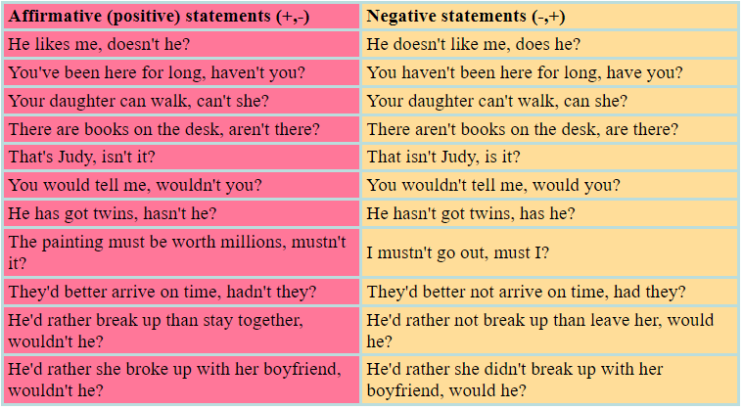

3.2. Special Cases of Question Tags
Statements containing: no (as adjective), no one, nobody, nothing, none, neither, scarcely, hardly, hardly ever, barely, seldom are regarded as negative sentences so ordinary interrogative tag is used after them.
When the subject is anybody, anyone, no one, none, neither, everyone, everybody, somebody, someone the pronoun 'they' is used (Table 7.2).

Table 7.2
Special question tags with affirmative and negative sentences
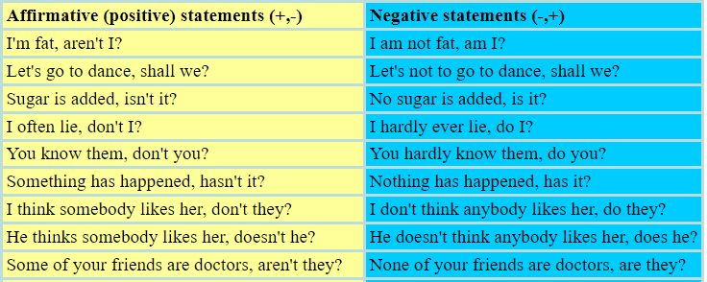
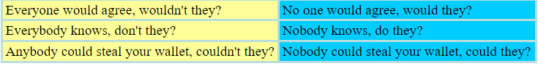

References
Primary sources
1. Schyhlo L.V., Zakharchuk T.O. Scientific-technical text: translation problem. - Sumy State University, Sumy, Ukraine , 2016.
2. Krapivkina O.A. Linguistic and pragmatic aspects of scientific and technical translation. - Irkutsk State Technical University, 2014.
3. Yves Gambier, Luc van Doorslaer. Handbook of Translation Studies. - Volume 1. - Amsterdam / Philadelphia: John Benjamins Publishing Company, 2010.
4. Bassnett Susan. Translation Studies - 3rd Edition. - New York: Routledge, 2002.
5. Munday Jeremy. Introducing Translation Studies: Theories and Applications. - New York: Routledge, 2005.
6. Olohan Maeve. Scientific and Technical Translation. - Routledge, 2016.
7. Eva Mastná. The nature of scientific/technical texts from viewpoint of translation studies. - Tomas Bata University in Zlin. Bachelor Thesis, 2010.
8. Gretzler Edwin. Contemporary Translation Theories. - Revised 2nd Edition - Clevedon: Multilingual Matters LTD, 2001.
9. Superanskaya A.V., Podolskaya N.V., Vasilieva N V. General terminology. Theory issues. - М., 2003.
10. Radjabova D.A. Difficulties of the translation of scientific and technical texts / Педагогика «Молодой учёный». - Март 2017. - № 13 (147) - C. 595-598.
11. Sofer Morry. The Translator’s Handbook. - 6th Revised Edition. - Rockville: Schreiber Publishing, 2006.
12. Baker Mona. In Other Words. A coursebook on translation. New York: Routledge, 2006.

Secondary sources
13. Nord Christiane. Text Analysis in Translation. Theory, Methodology, and Didactic Application of a Model for Translation-Oriented Text Analysis. - New York: Editions Rodopi B.V., Amsterdam – New York, 2005.
14. Venuti Lawrence. The Translation Studies Reader. - 2nd Edition. - New York: Routledge, 2002.
15. Baker Mona. Routledge Encyclopedia of Translation Studies. - London: Routledge, 2001.
16. Komissarov V. N. Modern translation. - М.: Vysshaya shkola, 2002.
17. Šarčević Susan. New Approach to Legal Translation. - Dordrecht: Kluwer Law International, 2000.
18. Byrne Jody. Technical Translation. Usability Strategies for Translating Technical Documentation. - Dordrecht: Springer, 2006.
19. Kazakova Т.А. Practical translation. - Spb: Soyuz, 2001.

Online sources
20. Orozco-Jutorán Mariana. Scientific translation. – 2022. [Electronic resource] https://zenodo.org/records/6370674
21. Actual Problems of Scientific-Technical Translation, 2024. [Electronic resource] https://bues.ru/en/articles/actual_problems.php
22. The notion of Scientific and Technical Translation. [Presentation]
https://ppt-online.org/193480
23. Technical & Scientific Translation. [Presentation]
https://faculty.ksu.edu.sa/sites/default/files/scientific_technical_translation_slides.pptx
24. Basic Scientific and Technical Translation. [Presentation]
https://www.slideserve.com/ali-newton/basic-scientific-and-technical-translation-ii
25. English grammar tables and examples. [Electronic resource]
https://www.englishconversationcoursetutorhk.com/english_grammar_tables_e.php

Lecture 8

Lecture topic: Translation of Terms in Scientific and Technical Texts.

Lexical Problems of Translation
Lecture plan

1. Translation of Terms in Scientific and Technical Texts

2. Lexical Problems of Translation

3. Types of Translation
4. Grammar Patterns: Affirmative Additions to Remarks

1. Translation of Terms in Scientific and Technical Texts

1.1. Basic Requirements to Be Met by a Good Translation
When translating scientific and technical literature should be noted that, although the language of scientific texts is part of the national language, it uses the vocabulary and grammatical structure, however, it is characteristic of a certain style that meets the goals and objectives of the content of the scientific literature, and Now, there are a number of features in the field of terminology, and in grammar.
Language for scientific and technical literature is characterized by a large number of terms, the prevalence of different types of cuts, some syntactic preference turns to others, especially the transfer of a number of grammatical constructions, elliptical expression of thought, and so on. N.
The main stylistic feature of scientific and technical literature is the brevity of presentation and clarity of language. One of the main differences between the language of technical literature on the language of literature is considerable richness of the text of special terms that are often lacking not only in regular, but also in terminological dictionaries. As we expand the boundaries of human knowledge is increasing the need for new definitions of concepts, both in developed and in emerging areas of science and technology, and, consequently, expanding vocabulary, and the expansion is mainly due to the new terms.
When translating scientific and technical texts requires quite distinct knowledge of new terminology and the ability to accurately convey it to the Russian language. This is one of the main difficulties.
Basic requirements to be met by a good translation are as follows:
1. Accurate original text.
2. Strict clarity of thought at maximum compression and concise form, the inherent style of scientific and technical literature Upon transfer should not be moved to the original text of the specific features of the English language. Ego is particularly important because it is necessary to formulate the thought in their native language that is consistent with current practice.
3. Transfer shall meet generally accepted standards of original literary language. This should be considered when no translation in their native language and English for specific syntax. Furthermore, it should always be remembered that the semantic saturation in the English language to the end of sentence is reduced, whereas in the native language, on the contrary, is meaningful increase from the beginning to the end of proposals. Thus that on which concentrates attention in the English sentence is in the first place, and in original language - at last.

1.2. The Notion of the Term
Terms - words or phrases that have a special, well-defined value in a particular field of science and technology. They just express the concepts, processes, and the names of things inherent in any manufacturing industry.
In order to correctly identify the expressed terms of the concepts you need to know the area of science and technology, to which this terminology. Any term should not be seen as separate semantic units, without any connection with the surrounding words and context as a whole, and the word that has your specific technical meaning, but that can change its content depending on the industry in which it is used in this case.
For a proper understanding and translation of the term must also be aware of the morphological structure of terms, semantic features that distinguish them from common words, the main types of terms, phrases, their structural characteristics and specificity of use. This will ensure a thorough understanding of the content of the concepts expressed by the term, and facilitate the work with the relevant terminology dictionaries.
The term should if possible be concise and precise. The accuracy of the term refers to its ability to properly orient, in other words, the literal meaning of its components must comply with semantic content.

1.3.Morphological Structure Terms
All terms in its structure divided into:
1. simple - circuit цепь, feeder - фидер;
2. complex - flywheel маховик, clock-work часовой механизм '
3. The terms, phrases - отключающая катушка, earth fault замыкание на землю, circuit breaker выключатель, автомат
Terms-word combinations
In scientific and technical terminology found a large number of terms, consisting of several components.
Multicomponent terms may be:
a) the phrase in which the semantic relationship between the components expressed by contiguity. For example: load governor power regulator, brake landing with brake;
b) phrases, the components of which are decorated grammatically (by the preposition or the presence of endings). For example: rate of exchange rate, braking with rocket braking with the rocket engine.
In terms semantically-phrases are integral lexical units.
Terms, phrases are divided into 3 types.
The first type includes the terms, phrases, both components of which are the words of a special dictionary. They are independent and can be used outside of this combination, while maintaining inherent to each of them individually value, for example: brake, gear drive, and others.
The second type are also the terms in which the first component (adjective) has a special, specific to a particular field of science or a number of interconnected Sciences value.
The third type are the terms, phrases, both components of which are the words of general vocabulary, and only a combination of those words is -terms. Such a method of forming a scientific and technical terms is not productive.
Terms as a member of terminological systems
The terms are combined in certain terminological system, expressing the concept of a particular branch of knowledge.
Each nomenclature system defined terms to form a group, which is a general they belong to the class or object or to a class of processes, properties and m. N. Each of these groups is divided, in turn, to a narrow band terminology. In terms of complex terminology group often performs one common element. Thus, for example, a group of alloys terminology as a general term includes element alloy, and the other element is a word characterizing the alloy in this series, for example: superalloy (magnetic nickel-based alloy магнитный сплав на основе никеля)) permalloy (nikelezhelezny alloy никележелезный сплав)
Linguistic units tele, scope serve as components of a compound word - telegraph, television, horoscope, telescope, and so on. N.
Consecutive interpreting the Terms - phrases
Translation of terms, phrases beginning with the translation of the noun, which is the main component, and then successively transferred to each semantic group, mostly from right to left. For example, multi-term temperature compensating condenser arrangements translates as follows: arrangements device, condenser, temperature compensating temperature compensation, temperature compensating condenser temperature compensation capacitor, the entire term translates device for temperature compensation capacitor. The term translates bent tube boilers: boilers, bent-tube with curved pipes, bent- tube boilers with curved pipes.

2. Lexical Problems of Translation
2.1. Lexical Features of Scientific and Technical Texts
The study of the language is arguably the most hotly contested property in the academic realm. It becomes a tangle begetting multiple language discrepancies. That is why linguistics compares languages and explores their histories, in order to find and to account for its development and origins to give the answers to this or that language point.
Due to the semantic features of language the meanings of words, their ability to combine with other words, their usage, the “place” they hold in the lexical system of a language do not concur for the most part. All the same “ideas” expressed by words coincide in most cases, though the means of expression differ.
The principal types of lexical correspondences between two languages are as follows:
1) Complete correspondences;
2) Partial correspondences;
3) The absence of correspondences.
Let’s deal with them more exactly.
1) Complete lexical correspondences.
Complete correspondence of lexical units of two languages can rarely be found. As a rule they belong to the following lexical groups:
- proper names and geographical denominations:
- the months and days of the week, numerals.
- scientific and technical terms (with the exception of terminological polysemy).
2) Partial lexical correspondences.
While translating the lexical units partial correspondences mostly occur. That happens when a word in the language of the original conforms to several equivalents in the language it is translated into. The reasons of these facts are the following.
1. Most words in a language are polysemantic. That’s why the selection of a word in the process of translating is determined by the context.
2. The specification of synonymous order. However, it is necessary to allow for the nature of the semantic signs which an order of synonyms is based on. Therefore, it is advisable to account for the concurring meanings of members of synonymic orders, the difference in lexical and stylistic meanings, and the ability of individual components of orders of synonyms to combine.
3. Each word affects the meaning of an object it designates. Not infrequently languages “select” different properties and signs to describe the same denotations. The way, each language creates its own “picture of the world”, is known as” various principles of dividing reality into parts”. Despite the difference of signs, both languages reflect one and the same phenomenon adequately and to the same extent, which must be taken into account when translating words of this kind, as equivalence is not identical to having the same meaning.
4. The differences of semantic content of the equivalent words in two languages. These words can be divided into their sub-group:
a) Words with a differentiated (undifferentiated) meaning: e.g. In English: to swim (of a human being), to sail (of a ship), to float (of an inanimate object);
b) Words with a “broad” sense: verbs of state (to be), perception and brainwork (to see, to understand), verbs of action and speech (to go, to say).
c)”Adverbial verbs” with a composite structure which have a semantic content, expressing action and nature at the same time: e.g. the train whistled out of the station.
5. Most difficulties are encountered when translating the so called pseudo-international words. The regular correspondence of such words in spelling and sometimes in articulation coupled with the structure of word-building in both languages may lead to a false identification.
6. Each language has its own typical rules of combinability. A language has generally established traditional combinations which do not concur with corresponding ones in another language.
Adjectives offer considerable difficulties in the process of translation. It does not always coincide with their combinability in the Ukrainian or Russian languages on account of differences in their semantic structure.
Frequently one and the same adjective in English combines with a number of nouns, while in Ukrainian and Russian different adjectives are used in combinations of this kind. For this reason it is not easy to translate English adjectives which are more capable of combining than their Ukrainian and Russian equivalents.
A specific feature of the combinability of English nouns is that some of them can function as the subject of a sentence though they do not belong to a lexico-semantic category.
The habitual use of a word, which is bound up with the history of the formation and development of its lexical system. This gave shape to clichés peculiar to each language, which are used for describing particular situations.

2.2. Lexical Transformations
Lexical transformations change the semantic core of a translated word. They can be classified into the following groups:
Lexical substitution, or putting one word in place of another. It often results from the different semantic structures of the source language and target language words. Thus the word молодой is not always translated as young; rather, it depends on its word combinability: молодой картофель is equal to new potatoes. This translation equivalent is predetermined by the word combination it is used in. This type of translation can hardly be called substitution, since it is a regular equivalent for this phrase.
Deliberate substitution as a translation technique can be of several subtypes:
- Specification, or substituting words with a wider meaning with words of a narrower meaning: Will you do the room? – Ты уберешься в комнате? I’ll get the papers on the way home. – Я куплю газеты по дороге домой. The underlined English words have larger scopes of meaning than their Russian counterparts and their particular semantics is recognized from the context.
- Generalization, or substituting words of a narrower meaning with those of a wider meaning: People don’t like to be stared at. – Людям не нравится, когда на них смотрят. If we compare the semantic structure of the English and Russian verbs, we can see that the English stare specifies the action of seeing expressed by the Russian verb. The Russian смотреть can imply staring, facing, eyeing, etc. The specific meaning in the Russian sentence can be expressed by the adverb is. Another reason for generalization in translating can be that the particular meaning expressed by the source language word might be irrelevant for the translation receptor: She bought the Oolong tea on her way home. – По дороге домой она купила китайского чаю. Oolong is a sort of Chinese tea but for the receptor this information is not important; therefore, the translator can generalize.
- Differentiation is a rather rare technique of substitution. It takes place when we substitute a word by another one with parallel meaning, denoting a similar species: bamboo curtain – железный занавес. Both bamboo and железо (iron) are materials known for their hard nature. They are used figuratively to denote the barriers between the Western and Communist countries (bamboo curtain in reference to China, железный занавес in reference to other Comecon (Council for Mutual Economic Aid) states. There are no hyponymic relations between the notions of bamboo and iron (though the referential area of железный занавес is of course much wider than that of bamboo curtain.)
- Modulation is a logical development of the notion expressed by the word: But outside it was raining. -– Но на улице шел дождь. The primary equivalent of the word outside is снаружи. But it is impossible to say in Russian *Но снаружи шел дождь. By means of unsophisticated logical operation the translator finds another equivalent: на улице. Thus he takes into consideration a tradition of the word combination and acceptability of collocation. He is aided in this by the metonymical closeness of word meanings based on contiguity of the two notions.
2. Compensation is a deliberate introduction of some additional element in the target text to make up for the loss of a similar element in the source text. The main reason for this transformation is a vocabulary lacuna in the target language. For example, one of the Galsworthy’s characters was called a leopardess. But there is no one-word equivalent of the same stylistic coloring in Russian. Therefore, the translator compensated the word by using the word тигрица to characterize the lady.
3. Metaphoric transformations are based on transferring the meaning due to the similarity of notions. The target language can re-metaphorize a word or a phrase by using the same image (Don’t dirty your hands with that money! – Не марай рук этими деньгами!) or a different one (Он вернет нам деньги, когда рак свистнет. – He will pay us our money back when hell freezes over). The source language metaphor can be destroyed if there is no similar idiom in the target language: Весна уже на пороге. – Spring is coming very soon. Or, on the contrary, the target text is metaphorized either to compensate a stylistically marked word or phrase whose coloring was lost for some reason, or merely to express a source language lacuna: Он решил начать жить по-новому. – He decided to turn over a new life.

2.3. Complex Transformations
This type of transformations concerns both the lexical (semantic) and grammatical level, i.e. it touches upon structure and meaning. The following techniques can be associated with lexical and grammatical transformations:
1. Explicatory translation, that is, rewording the meaning into another structure so that the receptor will have a better understanding of the phrase. Sometimes this transformation is named as explication, defined as the technique of making explicit in the target text information that is implicit in the source text.⁵¹
This transformation is often accompanied by the extension of the structure, the addition of new elements: I have a nine-to-five job. –Я работаю с 9 утра до 5 вечера. Leslie Mill’s play, which was also included in the FORUM, was taken up with children from grades 1-5. – Пьеса Лесли Милла, которая также была опубликована в журнале «Форум», была поставлена детьми 1-5 классов.
The reason for which this transformation is made is that the target text receptor has different background knowledge. Sometimes this transformation is required because of the dissimilarity between the language structures, with the source language structure being incomplete for the target language, like gun licence is удостоверение на право ношения оружия.⁵²
2. Reduction (omission, implication) is giving up redundant and communicatively irrelevant words: Elvis Presley denied being lewd and obscene. – Элвис Пресли отрицал свою непристойность. The reduction is a must if a source language expresses the notion by a phrase and the target language compresses the idea in one word: сторонники охраны окружающей среды – conservationists. There is a general tendency of the English language to laconic and compressed expressions as compared with Russian: внебюджетные источники финансирования – nonbudget sources; контроль за ходом проекта – the Project control.
3. Integral transformation is the replacement of a set phrase with another clichéd structure that has the same speech function: How do you do! – Здравствуйте!; Wet paint. – Осторожно, окрашено. Help yourself. – Угощайтесь.
4. Antonymic translation is describing the situation by the target language from the contrary angle.
It can be done through antonyms: the inferiority of friendly troops – превосходство сил противника. The reason for this transformation is the lack of a one-word translation equivalent to the word inferiority.
This transformation can also take place when we change the negation modality of the sentence: She is not unworthy of your attention. – Она вполне достойна вашего внимания. In the English sentence we deal with double negation, called understatement, which, according to logic rules, means the positive expressed in the Russian sentence. Through understatement, English-speaking people avoid expressing their ideas in too a categorical tone.
Shifting the negation is another manifestation of the antonymous translation: I don’t think I can do it. – Думаю, я не смогу сделать это., which is a result of linguistic tradition peculiar to this or that language.
5. Metonymical translation is the transference of meaning and structure based on the contiguity of forms and meanings of the source and target languages: The last twenty years has seen many advances in our linguistic knowledge. – В последние 20 лет наблюдается значительный прогресс в лингвистике. In the English sentence, time is expressed by the subject of the sentence, whereas in Russian it is more typical to express it by the adverbial modifier. This causes grammar restructuring of the sentence.
6. Complex compensation is a deliberate change of the word or structure by another one because the exact equivalent of the target language word or phrase is unable to produce the same impact upon the receptor as does the source language word or phrase. For example, we often have to compensate on the lexical level the meaning of the Past Perfect in the Russian text translation, since there is no similar tense category in Russian: Their food, clothing and wages were less bad than they had been. – Теперь их еда, одежда и зарплата были не такими уж плохими, как когда-то. Puns, riddles, tongue-twisters are often compensated; for example, Don’t trouble until trouble troubles you. – Во дворе трава на траве дрова. Compensation exercises the translator’s ingenuity; however, the effort it requires should not be wasted on textually unimportant features.

3. Types of Translation
Jakobson (1966) identifies three types of translation.
The first is ‘translation' within the same language, referred to as intralingual translation. We are immersed in this kind of translation whenever we use different words and phrases to communicate similar meanings. Translation within the same language also shares this problem of ‘equivalence' prevalent in translation from one language to another. Jakobson points out those even synonyms do not capture ‘equivalence' of words.
Thus when we replace one word by its synonym we are already giving into the mode of translation. In the case of scientific discourse, the problems associated with theory incommensurability arise out of intralinguas translation. Although theories may use words and terms in the same language, and in fact carry over the same words into different theories, the incommensurability may arise because of changing historical and differing social contexts in which the words first gained currency.
The second type of translation is interlingual translation. This is what we commonly understand as translation, where translation involves rewriting a text in one language into another. Thus interlingual translation converts a text written in the source language (SL) to one written in the target language (TL). The problems associated with this form of translation are numerous.
It is well illustrated in the simple example of translating yes and hello to equivalent words in French, German and Italian. This task, although seemingly simple, is filled with difficulties, even though "all are Indo-European languages, closely related lexically and syntactically, and terms of greeting and assent are common to all three" (Bassnett, 1991). Both ‘yes' and ‘hello' are used in very specific contexts. In languages other than English, they convey very different meanings. For example, in the case of ‘hello,' it is pointed out that English does not distinguish between face to face greeting or that on the phone, whereas the other three languages explicitly make this distinction.
The third type of translation is intersemiotic translation, "an interpretation of verbal signs by means of signs of nonverbal sign systems." Although this seems to be of little interest to the practitioners of translation, this is closer to the translation mode present in the reading of scientific texts that are essentially multisemiotic in character.
What unites these three different activities into a common category of translation? Jakobson identifies the problem of ‘complete equivalence' as a common category, which is never possible in any of these three types. This idea of complete equivalence, as also the notion of faithful translation, has been the bane but also the stimulus towards generating more complex theories of translation.
All these three types are concerned with the notions of identity and change, whether it is the search for synonyms (re-wording), or finding other appropriate expressions in another language (re-writing). This suggests that the primary impulse to an activity we would name as ‘translation' should first respond to an already-given, to an original.
The concerns with equivalence and faithfulness arise after the initial acknowledgement of the original. It is this primary impulse which also allows us to gather the activity of science under the name ‘translation,' where the ‘original' is the world as presented to us. All these three types of translation can be clearly discerned in the scientific discourse. Although there is a predominance of translation in the discourse, there is almost no acknowledgement of this process. This is indeed startling and suggests that science must have strategies to erase this domineering presence of translation in its activities.
This would then imply that there is always a meta-discourse on translation, which the scientific discourse holds, upon which the erasure of translation is itself, based. The success of science in erasing the presence of translation has lessons for both science and translation. First, consider intralingua translation.
The case of interlingual translation in the context of scientific discourse is also interesting. Although, globally, the scientific discourse is increasingly written in the language of English, that was not always the case. Pioneering work in modern physics, including Einstein's papers on relativity, was largely written in German. Russian mathematicians, as also their physicists, wrote almost exclusively in Russian. There has also been a large body of work in French, both in mathematics and physics. It is translation and science indeed remarkable that these diverse texts in different languages have all been rewritten and expressed in one language, English, with scarcely any mention of the problems present in translating from one language into another!
The facile acceptance of quantum and relativity theories, for example, without any mention of the problems of translation is remarkable for it points to the insistence by which science ignores the claims of translation. Why should the problems of translation not be present in translating scientific texts from German to English? Are the problems of equivalence, faithfulness, communication of meaning and so on not present in these texts? Or is it that they are seen to be unimportant in the context of science? If so, who makes this judgment? And why?
The neglect of translation in the re-writing of scientific texts is due to many reasons. Let me focus on one reason that recurs repeatedly in our understanding of the scientific discourse and which is related to a view of natural language that science holds. In theoretical texts, as in quantum and relativity theories, it is presumed that the ‘essential' content of the text is contained in the mathematical sub-text.
The natural language component of the text, whether in German or English, is seen not to have ‘substantial' content as far as the meaning of those texts is concerned. This is also emphasized in the text in the form of the mathematical equations that remain the same whether the theory is written in English or German. And since these equations carry the ‘essential' content, what does it matter what natural languages one uses?
This is, roughly, the argument that explains science's total disdain for the concerns of translation. I shall not develop a response to this now; here, I merely want to mention that scientific texts are beholden to both mathematical and natural language sub-texts. And the concerns of translation are also not indifferent to mathematics.
This argument is also related to the third kind of translation, namely, intersemiotic translation. I think it is clear that in the case of mathematics, there is always the ‘presence' of translation in the way we continuously interpolate from symbols to natural language. The semiotic system of mathematics does not derive any meaning without prior reference to natural language. In reading and writing the scientific text, there is always a movement from one semiotic system to another.
There is no other mechanism, other than translation, that can effectively explain how it is possible for us to generate ‘coherent' meaning of such texts. This will then imply that a scientific text, which glosses over the issue of translation in order to present a ‘unified' text as if the problems of translation across different semiotic systems are absent, is only one translation among many other possible translations. The use of diagrams, figures, tables, charts and so on in the scientific discourse also relates the scientific activity to the concerns of intersemiotic translation. Since translation is translation of an original, the ideas of equivalence between the translated and original text arise naturally.
There have been many attempts to find criteria for equivalence. As is well known, even word for word equivalence is problematic. The referential aspect of a word creates one possible criterion for equivalence, which is usually called denotative equivalence.
Equivalence can also be on the order of connotation, formal, pragmatic and so on. It may also be desirable to go beyond the orbit of the text and search for the notion of equivalence in the agency of the reader and the different cultures involved in translation. Nida's (1964) idea of dynamic equivalence, for instance, argues for a notion of equivalence based on the ‘equivalent' effect of the text on the reader.
In his influential work, Popovic (1976) distinguishes between four types of equivalence arising in translation—Linguistic, Paradigmatic, Stylistic and Syntagmatic.
Related to this is his emphasis on the ‘invariant core' in each text, suggesting that translation function to transmit and transfer this core. The idea of invariance is very suggestive of its uses in other disciplines, particularly science. Invariance is essentially a concept associated with dynamics and change. It is only under the agency of some action that we can recognize the invariance of an object or system. Invariance is, therefore, specifically linked to an act as also to that element, in part or in full, which remains invariant. In the case of translation, the specific dynamic act is that of translation.
Under this action, it may be believed that ‘something' remains invariant, perhaps the meaning of the text. The text by itself cannot be invariant, nor can the number of words or pages. This idea of invariance has striking philosophical similarities to the notion of invariance as it occurs in science.
As is well known, the idea of symmetry in science is deeply implicated in the idea of invariance. Although I do not mean to suggest a facile analogy between the two, I mention this merely to draw attention to the close conceptual links between the concerns of translation and of science. In all these three types of translation, the problems of equivalence, identity and sameness are present.

4. Grammar Patterns: Affirmative Additions to Remarks
Additions to remarks
Addition can be spoken by the same person who said the remark or by another person.

4.1. Affirmative Additions to Affirmative Remarks
There are two types:
1. Subject + auxiliary + too
2. So + auxiliary + subject (Table 8.1)

Table 8.1
Affirmative additions to affirmative remarks
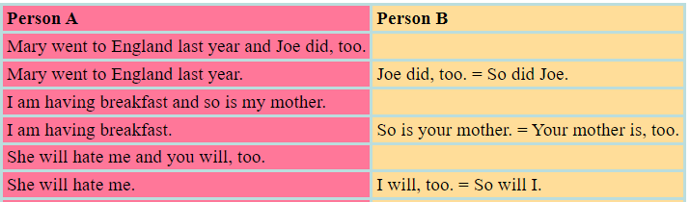

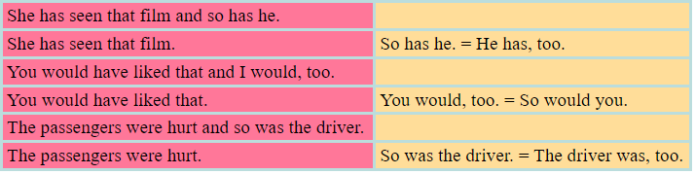

4.2. Affirmative Additions to Negative Remarks
But + subject + auxiliary (Table 8.2)

Table 8.1
Affirmative additions to negative remarks
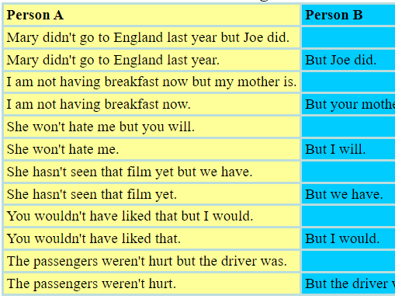
References
Primary sources
1. Schyhlo L.V., Zakharchuk T.O. Scientific-technical text: translation problem. - Sumy State University, Sumy, Ukraine , 2016.
2. Krapivkina O.A. Linguistic and pragmatic aspects of scientific and technical translation. - Irkutsk State Technical University, 2014.
3. Yves Gambier, Luc van Doorslaer. Handbook of Translation Studies. - Volume 1. - Amsterdam / Philadelphia: John Benjamins Publishing Company, 2010.
4. Bassnett Susan. Translation Studies - 3rd Edition. - New York: Routledge, 2002.
5. Munday Jeremy. Introducing Translation Studies: Theories and Applications. - New York: Routledge, 2005.
6. Olohan Maeve. Scientific and Technical Translation. - Routledge, 2016.
7. Eva Mastná. The nature of scientific/technical texts from viewpoint of translation studies. - Tomas Bata University in Zlin. Bachelor Thesis, 2010.
8. Gretzler Edwin. Contemporary Translation Theories. - Revised 2nd Edition - Clevedon: Multilingual Matters LTD, 2001.
9. Superanskaya A.V., Podolskaya N.V., Vasilieva N V. General terminology. Theory issues. - М., 2003.
10. Radjabova D.A. Difficulties of the translation of scientific and technical texts / Педагогика «Молодой учёный». - Март 2017. - № 13 (147) - C. 595-598.
11. Sofer Morry. The Translator’s Handbook. - 6th Revised Edition. - Rockville: Schreiber Publishing, 2006.
12. Baker Mona. In Other Words. A coursebook on translation. New York: Routledge, 2006.
Secondary sources
13. Nord Christiane. Text Analysis in Translation. Theory, Methodology, and Didactic Application of a Model for Translation-Oriented Text Analysis. - New York: Editions Rodopi B.V., Amsterdam – New York, 2005.
14. Venuti Lawrence. The Translation Studies Reader. - 2nd Edition. - New York: Routledge, 2002.
15. Baker Mona. Routledge Encyclopedia of Translation Studies. - London: Routledge, 2001.
16. Komissarov V. N. Modern translation. - М.: Vysshaya shkola, 2002.
17. Šarčević Susan. New Approach to Legal Translation. - Dordrecht: Kluwer Law International, 2000.
18. Byrne Jody. Technical Translation. Usability Strategies for Translating Technical Documentation. - Dordrecht: Springer, 2006.
19. Kazakova Т.А. Practical translation. - Spb: Soyuz, 2001.
Online sources
20. Orozco-Jutorán Mariana. Scientific translation. – 2022. [Electronic resource] https://zenodo.org/records/6370674
21. Actual Problems of Scientific-Technical Translation, 2024. [Electronic resource] https://bues.ru/en/articles/actual_problems.php
22. The notion of Scientific and Technical Translation. [Presentation]
https://ppt-online.org/193480
23. Technical & Scientific Translation. [Presentation]
https://faculty.ksu.edu.sa/sites/default/files/scientific_technical_translation_slides.pptx
24. Basic Scientific and Technical Translation. [Presentation]
https://www.slideserve.com/ali-newton/basic-scientific-and-technical-translation-ii
25. English grammar tables and examples. [Electronic resource]
https://www.englishconversationcoursetutorhk.com/english_grammar_tables_e.php

Lecture 9

Lecture topic: Translating Scientific and Technical Style. Scientific Translation and Scientific Language
Lecture plan

1. Translating Scientific and Technical Style

2. Scientific Translation and Scientific Language
3. Grammar Patterns: Negative additions to Remarks

1. Translating Scientific and Technical Style
1.1. Scientific and Technical Style and Its Translation
The main function of the scientific and technical style is informative. To convey logical information, prove its novelty and significance is the main goal of a scholarly, scientific or technical author. This style is used in professional spheres of science, humanities, technology.
The scientific and technical style involves the following substyles: scientific, technical, instructional (educational), popular science substyle. The substyles are classified into the following genres: monograph, manual, textbook, article, report, technical description, discussion, etc.
The distinctive features of scientific and technical style are preciseness, clear logic, compressive character, impersonality, formality.
Preciseness is a basic property of a scientific and technical text, and it should be strictly maintained in translation. A translator must be fully aware of what s/he is translating to render precisely the content of the text. Special attention must be paid to terms*. To translate precisely, it is not enough to know an equivalent of the term. It is crucial to know the exact place of the concept, denoted by the term, in relation to other concepts. Therefore, translators in science and technologies have to specialize in a foreign language and a particular subject field. In fact, there are two types of translators: linguist translators and engineering translators. The former usually require penetration into the subject matter, the latter need good language skills.
In specialized translation, search for interlingual equivalents is a time-consuming activity even for an experienced translator. Therefore, the mid-1960s and early 1970s gave rise to term banks, or terminological data banks, that is systems for storing specialized vocabulary in electronic form. Term banks are commercially available.
Preciseness and reliability of a scientific text is also established with references and citations. The Russian style researcher N. Razinkina compared references with currency, by which scientists pay their intellectual debt to their predecessors. The bibliography is considered to be a kind of social control over scientific value and reliability of the results of research.
In the target text, references in the source language and foreign languages are retained in the original form, so that the receptor would not search for a non-translated book, thinking that it has been translated. For the same reason a translator keeps untranslated quotations in a third language. (Though, for the receptor’s convenience, the translator may do a quote translation in parentheses, footnotes or after-text commentaries.)
The translation of units of measurement depends on the system they are expressed in. If in metric system, weights, measures and quantities are usually retained. If expressed in imperial system (miles, pints, pounds, etc.), they are normally converted to the metric system.
Clear logic is achieved through a system of logical connections and interrelations. A stock of linking phrases will help a translator make a connection between a point in the past and future, to refer a receptor forward or back.
For example, As we will see… – Как будет видно… As I said earlier… - Как было сказано раньше… Linking phrases help to develop a point (Moreover… – Кроме того… Despite this… - Несмотря на это…According to our estimates,… - Согласно нашим подсчетам…)*
A specialized text tends to emphasize thematic components by various means because the theme serves as a linking element between what has been said in the text and what will follow (new, rhematic element). English texts, though, often manifest their implicit character and do not verbalize the thematic component of the sentence. Therefore, in the more explicit Russian text, a translator has to extend the sentence by adding an implied thematic element: The fundamental principles of alternating current are presented in this chapter. Included are the basic principles of some alternating current machines.
Logical enumeration of classification in a scientific text is a matter of graphical hierarchy: first come Roman numerals (I, II, etc), then Arabic numerals (1. 2.), then, if necessary, Arabic numerals with a parenthesis: 1), 2), followed by capitalized letters (A, B), lowercase: a, b, or lowercased letters with parenthesis: a), b). It is advisable not to change the hierarchy of enumerating elements, since a different order will seem illogical. In marking the enumeration, the translator (like the author)should be consistent: the numeral I implies the numeral II. If the text receptor sees only the numeral 1), not to be followed by the numeral 2), s/he might be confused. After saying (or writing) a, it is necessary to say (write) b.
Economy and compressive character of the text. A scientific text must provide a reader with maximal information within a minimal time period and with minimal effort. This stylistic feature is achieved with lexical and grammatical means, such as: using compressive structures, like attributive clusters (a liquid rocket – ракета на жидком топливе), Complex Subject (these devices were proved to be sufficiently reliable), Complex Object (assume this to make…), reduced adverbials (if found), article ellipsis (General view is that…); abbreviation (PC = personal computer; CD-ROM = Compact Disk-Read-Only Memory; NC = Norton Commander).
It is necessary that a translator decipher all the abbreviations in the original (by using every available dictionary and reference book) and render them according to the standards. If the form has no standard abbreviated form in the target language, it is given in full form. The abbreviations that cannot be deciphered are retained in the source language.
Impersonality is a measure of the extent to which the producer of a text avoids reference to him/herself or to the receptor. Such avoidance is far commoner in written than in spoken texts, and in Russian than in English. Using impersonal and indefinite structures, passive constructions, infinitive clauses, etc. provides the impression of the impersonal and objective style. Several experiments were run. – Было проведено несколько экспериментов.
As has been mentioned, in English texts a smaller degree of impersonality is acceptable, as compared with Russian. This results in a more frequent usage of personal pronouns (I, we, you) in English. Such sentences are often translated from English into Russian by infinitive clauses or impersonal constructions: If we introduce an extra member… - Если ввести лишний элемент…
English instructions and directions normally list instructions in the imperative mood. To observe impersonality as a characteristic feature of a Russian technical style, it is recommended translating the imperative verbs by Russian infinitives:
To run test 3,… you need to attach the loopback plug to your Ether Link board.
To Attach the Loopback Plug
1. Locate the personal computer that contains the board you are going to test.
2. Identify the Ether Link board connector on the rear or side panel of the computer…
3. Push the loopback plug onto the round BNC connector and twist the sleeve clockwise one-quarter turn until it stops.
Some authors prefer to use the so-called ‘royal plural’: we – мы. Today this usage is considered somewhat outdated. It is better to keep an impersonal style.
Formality. This feature results from the author’s tendency to avoid connotative words in the scientific text. However, research by N. Razinkina and other linguists has shown that English scientific text is not void of expressive elements, which greatly differs from the Russian style. Metaphors and bright similes are not infrequent in the English scientific text: Many of us are amused by grammatical acrobatics. (R.Quirk). Since this feature is so different in English and Russian, translators generally leave out metaphors in the Russian translation according to the rule of functional equivalence.

1.2. Quality Control of the Translation
Quality control of the translation must be done by the translator, first and foremost, and can be done by an editor, either a hired editor or the translator’s colleague.
Giving advice to translators, an experienced British professional translator Geoffrey Samuelsson-Brown suggests the following steps for quality control:
- Resolve any queries that you may have with a subject expert or the client. It is not infrequent that the quality of the translation is governed by the quality of the source text.
- Check to ensure that the entire text has been translated - you could easily have been interrupted for a number of reasons and missed some part of the text.
- Check all figures and dates in the text and in tables.
- Carry out a spell check using your word processor program and grammar check if available.
- In every case proofread your translation. If possible, set your translation aside for as long as possible when you have completed the first draft. Read your text as an original text and not as a translation.
- Pass the translation to a colleague for checking in order to get a more objective view of the translation.
- Discuss any corrections with the proof-reader, where required. Incorporate the corrections and changes where these are relevant. Repeat the spell check to ensure that the corrections and changes do not contain typing errors.
In evaluating a translation, proof-readers usually mark four types of mistake:
- distortions,
- inaccuracies,
- stylistic drawbacks, and
- solecisms.
Distortion is a blunder marring the sense of the original by describing another situation and, thus, misinforming a receptor. Distortions generally occur because of the translator’s misunderstanding of the text, poor language knowledge, and insufficient background awareness. The often repeated example of machine translation of the biblical text can illustrate the point: The spirit is willing but the flesh is weak translated as Спирт хорош, а мясо протухло.
Inaccuracy occurs when a translator mistranslates some detail of the text. Inaccuracies result from misunderstanding a word or a structure. For example, the time of the situation is incorrectly conveyed in the translation of the sentence: Говорят, эта церковь была построена в 14 веке. – *This church is said to be built in the 14th century. The wrong form of the infinitive is the cause of the inaccuracy. Or another example, cited by Nora Gal: the source text tell of an old woman who wants to buy a dog and explains her desire this way: I want something human. – Хочу, чтоб рядом было что-то человеческое. This translation sounds somewhat unnatural in Russian; it would be much better Хочу, чтобы рядом была живая душа.280
Stylistic drawback is a deviation from target language stylistic and semantic norms. Often, this fallacy is due to underestimating translation transformations: e.g., It’s high noon. The sun beats down on the dusty, deserted main street of Dodge City. - * Полдень. Солнце бьет по пыльной пустой улице Додж-Сити. *Солнце палит на безлюдную улицу города Додж-Сити. The translation would be more natural if the student translators used partitioning of the sentence and found another equivalent to the verb: Город Додж-Сити. Главная улица пустынна. Стоящее в зените солнце жжет нещадно.
Solecism is a syntactical error resulting from breaking structural norms of the target language because of the translator’s illiteracy or because of source language interference. Another citation from Nora Gal’s experience: И никто не увидит нас вернувшимися обратно. Evidently, the translator meant Никто нас больше не увидит. (Мы не вернемся обратно.)
If a translated text is meant to be published, the translator is sure to deal with an editor, the central figure in the publishing industry. Some experienced translators become eventually editors of publishing companies (Nora Gal, Ivan Kashkin and others).
Generally, the editor’s tasks are as follows:
- arranging creative and publishing work;
- checking the translation;
- consulting the translator;
- in some countries, the editor’s tasks include recommending titles (authors and books), appealing to them, for publishing.
The editor is a conductor of the publishing house strategies. S/he oversees that the translated text meet all the proper norms and requirements. One of the exemplary editors of the time was Alexandre Blok who required that translators show the author’s individual style in the natural flow of the target discourse.
To perform his/her role successfully, the editor must be very competent, even more experienced than a translator. It is desirable that the editor know two languages (unfortunately, sometimes publishing companies have only monolingual editors, editing translations haphazardly). Normally, editors check translations into their native tongue, in which stylistic, semantic and syntactic resources they are completely proficient.
An intelligent, patient and benevolent editor is a real help and mentor to a translator. The editor has the right to insist on emending the text, but it is the translator who is responsible for the target text, not the editor. The translator, after all, comes to a consensus with the editor, or rejects his comment. It is as illegal for a translator to emendate by him/herself the text, already checked by the editor, as for an editor to alter the target text without the translator’s consent.
It is essential that a translator understand proofreading (editing) marks, which follow national standards and are marked both in text and in margin. The most important of them are as follows:
- leave unchanged (both in English and Russian): _ under characters to remain unchanged;
- refer to translator if anything is of doubtful accuracy: encircled question mark or word;
- insertion: Ù in English, and Ú in Russian; etc.*

2. Scientific Translation and Scientific Language
Scientific translation is considered to be translation of texts whose content fall within the scope of science.
To discover the separation between scientific and technical translation, it is thus worth examining other parameters, such as the objective sought by the texts subject to translation. The usual function of scientific texts is to spread knowledge, transmit research findings, results or proposals related to specific phenomena and, therefore, some of the most common text genres are scientific articles, essays, treatises, text books, reports, etc.
When talking about scientific translation, only interlingual translation tends to be considered, whereas there is also intralinguas translation, usually for reasons of dissemination, such as a less specialized target audience than the audience of the source text.
The language of science is a specialized form of communication used by scientists and other professionals to accurately express complex ideas and concepts. It is based on a set of rules and conventions that are designed to be precise and concise. There are several types of scientific language, including mathematical and mechanical notation, formulas, and scientific terminology.
Venuti (1998) begins with the theme of minor literature, which reflects his personal preference to "translate foreign texts that possess minority status in their cultures." As a translator, he does not hold the position that language is "simply an instrument of communication." Rather, he begins with a view of language as a "collective force" with "diverse cultural constituencies and social institutions." There is a hierarchy in this diversity with the "standard dialect in dominance."
But the standard dialect has to negotiate constantly and interact with the "regional or group dialects, jargons, clichés and slogans, stylistic innovations" and so on. These are minor variables that dynamically constitute the language and, furthermore, "subvert major form," thereby "revealing it to be socially and historically situated" .Literary works can give into this majoritizing influence of the dominating aspect of the language and culture or they can increase the "radical heterogeneity by submitting the major language to constant variation." In doing this, the literary work may succeed in releasing the ‘remainder,' through which a minor literature "indicates where the major language is foreign to itself".
Although the above remarks may seem to apply to very particular instances of literary texts that embody a minor literature, the issues they generate are relevant to a more critical understanding of reading, writing and translating. The emphasis on the minor, as forms of language and culture, responds to an integral aspect of all languages, namely, the tendency present in writing to gather around the domineering presence of the ‘majority' and a concomitant subjugation of the minor voices. It needs a conscious act to release the minor from the overpowering presence of the major. This attempt to consciously release the remainder and to let the ‘minor' exhibit itself introduces an ‘ethics' of translation. Thus he notes Good translation is minoritizing: it releases the remainder by cultivating a heterogeneous discourse, opening up the standard dialect and literary canons to what is foreign to themselves, to the substandard and the marginal.
Explicitly invoking the foreign is a strategy that I find useful in a discussion of the scientific discourse. ‘Foreign' is not just the site of a different language. Being foreign is not merely being different. It also suggests a perpetual possibility of conflict and a ‘distance' that can never get assimilated entirely. The relevance of this to scientific discourse is immediate. The view of natural language (NL) in the scientific discourse is strongly suggestive of its role as a minor language in the dominant culture of scientific ‘language.' Attesting to this is the belief that literary strategies, such as the use of metaphors and rhetoric are not ‘part' of science but rather belong to the baggage of NL which is taken as a reluctant partner in the scientific discourse. The discourse always attempts to attain and sustain discursive homogeneity. Heterogeneity, in the context of opening up the foreign, is a problematic task in this discourse.
The relevance of NL sub-text, as minor literature, and the inhering presence of the foreign within the scientific discourse can only be released through attempts at translation.
What else constitutes the foreign for the scientific discourse? I think it can be persuasively argued that the discourses of history, philosophy and sociology of science constitute the foreign, in the context of being a minor literature in a dominant major (scientific) culture. The repeated suspicion of scientists towards the relevance of these fields, in the context of scientific practice, is a pointer to this.
As mentioned earlier, the presence of literary elements within the discourse, conceptual ideas like subjectivity and cultural mediation are seen to be outside the orbit of this discourse.
The literary elements are seen to constitute the space of jargons, clinches, dialects and so on of the scientific discourse. All these together form the ‘foreign' as far science is concerned. The priority given to mathematics and mechanics and the repeated attempts to claim that the language of nature is mathematics only succeeds in bracketing natural language as a tongue of the foreign within this discourse.
I am even prepared to go to one end of the spectrum to say this: it is only through acknowledging ideas of translation in the scientific discourse that the presence of the foreign can be made visible and legitimate. The suspicion of science towards language can now be expressed as a suspicion towards the heterogeneity of language. Venuti's shift towards minor literature and the exhibition of the remainder are precisely what counter this suspicion and allow the heterogeneity of language and culture to be made explicit in the scientific discourse. In this context, it is worth recollecting Walter Benjamin's citation of Rudolf Pannwitz (Benjamin, 1992).
The basic error of the translator is that he preserves the state in which his own language happens to be instead of allowing his language to be powerfully affected by the foreign tongue… He must expand and deepen his language by means of the foreign language.
Authorship: Venuti explores the idea of authorship in the context of translation. I isolate this category mainly because the scientific discourse has a unique engagement with the idea of authorship and its association with the notion of original. This engagement once again reinforces the intrinsic link between science and translation.
The issue of authorship is significant in the formation of the scientific discourse. The world is the original, the touchstone around which scientific discourse emanates and by which it is sustained. The idea of authorship that derives from being associated with this given original is quite different from that of literary texts. It is in this sense that scientific discourse is always derivative and always a translation. Authorship in science, both in its writing and practice, mimics the secondary role it holds for translators.
The scientists are never the original authors. They can only write, rewrite and translate the world as original. The first authorship, the one who holds the copyright over the translation, is the world. Scientific discourse only opens up the text of the world, one that is already ‘written.'
I will discuss this issue through the literary form known as ‘pseudo translation,' because it allows me to exhibit the unique relationship between science and authorship.
In order to expose the lack of critical engagement with the foreign, Venuti (19980) introduces the discussion of pseudo translation, which is "an original composition that its author has chosen to present as a translated text." In the field of translation, such a move is useful, "since it involves a concealment of authorship," which, "inevitably provokes a reconsideration of how an author is defined in any period, leading either to a reactionary imposition of the dominant conception or to an unsettling revision that sparks new literary trends".
Something similar happens constantly in the scientific discourse. The claims of science, as far as authorship is concerned, are articulated in the following manner.
The world is the original author. Science merely speaks that which is already written in the text of this world. Thus science and scientists abdicate the responsibility that is due to the original author. This also implies that science speaks for the world and does not, by itself, add anything to what the world says. Therefore, the scientific narrative of the world is not a construction of the practitioners who are embedded in a history and culture, but is merely a ‘revelation' of the text of the world. In contrast, the sociological critique of science tries to place the responsibility of the discourse on the scientists themselves by suggesting that scientific discourse is co-constituted by their narrative of the world, which is ‘contaminated' by the historical and cultural positions they embody.
As far as the question of authorship is concerned, the scientific discourse presents itself on the order of pseudo translation. The traditional displacement of the author in scientific texts, and the cultivated image of the discoverer as one who merely speaks about the wonder of nature, are best captured by this image of pseudo translation. Pseudo translation implies an abdication of responsibility. It also bestows an ability to say something on somebody else's behalf. The discourse on technology, by scientists and technocrats, follows a similar argumentative pattern.
The explicit realization that scientific narrative should be seen as pseudo translation implies that this narrative of the scientists should itself be acknowledged as ‘original' rather than displace this ‘originality' to the voice of the world. If this position of the scientific discourse as pseudo translation is tenable, then it would be more in tune with the claim that scientific narrative is one narrative of the world; one translation of the world.
The final category that I want to introduce here, in the context of the link between science and literary concerns of translation, is the notion of dubbing. The process of dubbing is predicated on a particular conception of language and its relation to pictures.
Dubbing is usually a process associated with filmmaking. After the film has been shot, the sound track is overlaid so that there is synchrony of sound and vision. Dubbing of films is also associated with replacing the language of the ‘original' film with the dubbed language. This process of dubbing has inherent presuppositions about the nature of the original and the role of language in visual media, and is closely related to translation.
First, the language of the original film is removed and then the soundtrack of another language superposed on the film, largely following lip synchronization. In this translation, there is the assumption that the ‘essence' of the film is retained, thereby suggesting that in visual media, language plays a secondary role in comparison to the visuals. There are two themes associated with dubbing that I shall mention here, which, I believe, are related to the scientific discourse.
First, is the close link between dubbing and culture, both dominant (associated with the original) and derivative (that of the translated). Inherent in this is the issue of language and its relation to the film. This link between language and film in the case of dubbing can be contrasted with the case of subtitling foreign language films. Second, the example of dubbing also illustrates something intrinsic to the nature of texts and translation, and is related to the possibility that texts are multi-layered. This is obvious in the case of visual texts, but the possibility that there are ‘multiple layers' even in written texts cannot be easily discounted. If there are multiple layers in a text, then what does the translation of a text mean? Does it imply that all the layers have to be translated simultaneously? Or is it that only those parts of the text implicitly associated with language should be translated?
These questions are important in articulating the link between science and translation. The scientific text is itself multi-layered in that it is primarily multisemiotic. In moving from one semiotic system to the other, the activity of dubbing is present. Dubbing does not occur across the expanse of the text, but only in certain parts of the text. Labeling of diagrams, figures and tables, for example, is similar to the process of sub-titling. Just as language is changed but the visuals are retained in dubbing, mathematical equations are many times retained but the ‘language' related to the specific problems is changed. I believe that this is a fertile way of understanding how similar mathematical structures are taken over to model, describe and explain different physical situations.
The world is manifested through various means. One is by ‘reading' nature; others correspond to various forms of visual presentation of the world. The world is converted to the text of science through continuous translation—at the level of language, no doubt, but also at the level of visual, auditory, tactile and other sensory media. Different scientific theories translate the world at different levels, while always ‘retaining' something of the original. This is as much a reflection of the scientific discourse as it is of the world. The consequences of such multi-layered translations are crucial to an understanding of the meaning and practice of science. The different semantic domains created with the use of pictures, diagrams, geometry and mathematics, as part of the scientific texts, imply the essential multiple layering of these texts. The notions of translation and dubbing therefore play a crucial part in transmitting and communicating with such texts.
Sequence of translating scientific and technical literature
When translating scientific and technical literature we recommend the following work on the text:
1. Read the entire text or a paragraph and try to understand its overall content.
2. Each complex sentence divided into separate proposals: Compound on the main and subordinate.
3. In the analysis of the complex in its structure proposals that do not immediately possible to determine their constituent elements, it is recommended primarily to find the predicate of the main and subordinate clauses.
4. Each sentence to define the predicate group (on the personal form of the verb), then find the subject group and group supplement.
5. Transfer of sentence begins with the subject group, and then translate the predicate group, additions and circumstances.
6. To find unfamiliar words in the dictionary, understand beforehand what part of speech they are in this proposal. It does not take the first meaning of the word, and read all the values that give for a given part of speech, and choose the most suitable content of the source text.
In the English declarative sentence (except emphatic), there is a strong word order: a) the subject (with explanatory words) b) the predicate (with explanatory words), c) addition, g) the circumstances that for stylistic reasons, in some cases, can stand in beginning of a sentence, before the group to be. Thus, one of the main means of determining the syntactic function of speech is its place in the sentence.

3. Grammar Patterns: Negative additions to Remarks
3.1. Negative Additions to Affirmative Remarks
But + subject + negative auxiliary (Table 9.1)

Table 9.1
Negative additions to affirmative remarks
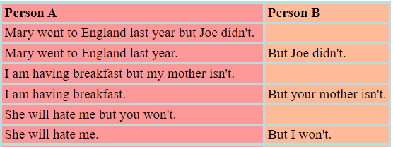
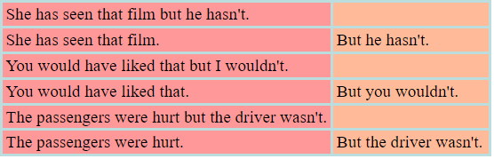

3.2. Negative Additions to Negative Remarks
There are four types:
1, Neither + auxiliary + subject
2, Nor + auxiliary + subject
3, Subject + negative auxiliary + either
4, Subject + whole verb in negative + object (if there is one) + either
The neither and the nor types are exactly the same. So nor = neither (Table 9.2).

Table 9.2
Negative additions to negative remarks
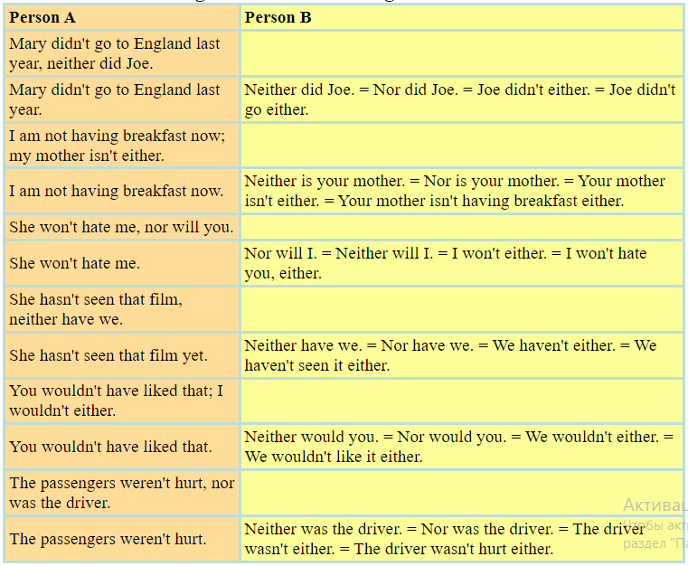
References
Primary sources
1. Schyhlo L.V., Zakharchuk T.O. Scientific-technical text: translation problem. - Sumy State University, Sumy, Ukraine , 2016.
2. Krapivkina O.A. Linguistic and pragmatic aspects of scientific and technical translation. - Irkutsk State Technical University, 2014.
3. Yves Gambier, Luc van Doorslaer. Handbook of Translation Studies. - Volume 1. - Amsterdam / Philadelphia: John Benjamins Publishing Company, 2010.
4. Bassnett Susan. Translation Studies - 3rd Edition. - New York: Routledge, 2002.
5. Munday Jeremy. Introducing Translation Studies: Theories and Applications. - New York: Routledge, 2005.
6. Olohan Maeve. Scientific and Technical Translation. - Routledge, 2016.
7. Eva Mastná. The nature of scientific/technical texts from viewpoint of translation studies. - Tomas Bata University in Zlin. Bachelor Thesis, 2010.
8. Gretzler Edwin. Contemporary Translation Theories. - Revised 2nd Edition - Clevedon: Multilingual Matters LTD, 2001.
9. Superanskaya A.V., Podolskaya N.V., Vasilieva N V. General terminology. Theory issues. - М., 2003.
10. Radjabova D.A. Difficulties of the translation of scientific and technical texts / Педагогика «Молодой учёный». - Март 2017. - № 13 (147) - C. 595-598.
11. Sofer Morry. The Translator’s Handbook. - 6th Revised Edition. - Rockville: Schreiber Publishing, 2006.
12. Baker Mona. In Other Words. A coursebook on translation. New York: Routledge, 2006.

Secondary sources
13. Nord Christiane. Text Analysis in Translation. Theory, Methodology, and Didactic Application of a Model for Translation-Oriented Text Analysis. - New York: Editions Rodopi B.V., Amsterdam – New York, 2005.
14. Venuti Lawrence. The Translation Studies Reader. - 2nd Edition. - New York: Routledge, 2002.
15. Baker Mona. Routledge Encyclopedia of Translation Studies. - London: Routledge, 2001.
16. Komissarov V. N. Modern translation. - М.: Vysshaya shkola, 2002.
17. Šarčević Susan. New Approach to Legal Translation. - Dordrecht: Kluwer Law International, 2000.
18. Byrne Jody. Technical Translation. Usability Strategies for Translating Technical Documentation. - Dordrecht: Springer, 2006.
19. Kazakova Т.А. Practical translation. - Spb: Soyuz, 2001.

Online sources
20. Orozco-Jutorán Mariana. Scientific translation. – 2022. [Electronic resource] https://zenodo.org/records/6370674
21. Actual Problems of Scientific-Technical Translation, 2024. [Electronic resource] https://bues.ru/en/articles/actual_problems.php
22. The notion of Scientific and Technical Translation. [Presentation]
https://ppt-online.org/193480
23. Technical & Scientific Translation. [Presentation]
https://faculty.ksu.edu.sa/sites/default/files/scientific_technical_translation_slides.pptx
24. Basic Scientific and Technical Translation. [Presentation]
https://www.slideserve.com/ali-newton/basic-scientific-and-technical-translation-ii
25. English grammar tables and examples. [Electronic resource]
https://www.englishconversationcoursetutorhk.com/english_grammar_tables_e.php

Lecture 10

Lecture topic: How to Write an Article on Mechanics in English

Lecture plan
1. Tips and Tricks for Writing an Article. Typical Writing Mistakes
2. How to Write a Mechanical Article in English. Scientific paper layout
3. Grammar Patterns: Active Verb, Passive Verb, Adjective Form, and Verbals

1. Tips and Tricks for Writing an Article. Typical Writing Mistakes
1.1. Writing a Paper. Checklist for Writing a Scientific Paper
Writing is a process, and no two people write in the same way. We recommend following these steps when writing your paper, and remember that it is okay to jump between steps if you need to do more thinking or researching as you write.
The following is a checklist for writing an academic style paper.

1) Understand the Assignment's Purpose
Every assignment has a purpose—a reason why you are doing this assignment. Look at your assignment instructions, and ask yourself: What is the point of this assignment?
For this assignment, are you trying to...
- Persuade? Make a point? Convince someone of something?
- Explain an idea or concept?
- Present research, facts, or findings?
- Analyze a story, article, case study, or business practice?
- Apply theories to an idea?
- Reflect on what you have learned?
- Tell a personal story?
Once you have figured out your purpose, use it to guide your writing. For example, after writing each paragraph, ask yourself: Does this paragraph support my assignment’s purpose?
2) Understand Your Assignment
Prepare
- Identify the purpose or goal of your assignment: Why are you writing this paper?
- Think about how the assignment relates to what you are learning in yor scientific research.
- Understand what you need to accomplish in your paper.
- Read all of your required course materials about your topic.
3) Brainstorm
Think and Decide
  - Pinpoint your paper’s topic from the assignment instructions. If you have a choice, pick a topic to write about.
  - Think about what you already know about this topic and brainstorm a few more ideas.
  - Ask yourself who, what, where, when, why, and how questions about your topic.
  - For more, see our page on overcoming writer's block.
4) Research, if needed
Find Information
  - Use your university library and other scientific and technical libraries to find academic and credible articles and information that you’ll use as sources in your paper.
  - Ask a librarian for help if you get stuck in the research process.
  - Do a basic Google (Yandex and others) search to learn about your topic. Explore web pages and images. Watch related YouTube videos.
  - Review Wikipedia articles. Although you don’t want to rely on Wikipedia for scholarly sources, Wikipedia is a good starting point for an overview of the topic and a list of references.
  - Find the answers to your who, what, where, when, why, and how questions.
5) Outline
Review Information and Organize
  - Review the information that you found.
  - Develop a list of “talking points” (main points) you hope to get across.
  - Find evidence (facts, quotes, details, or expert opinions) to support your main points.
  - Organize your points into a structure that makes sense.
  - For more, see our page on outlining.
6) Draft
Write
  - Start writing. Don’t worry about making it perfect. Just get your thoughts on paper.
  - Draft an introduction that grabs your reader’s attention, states your topic, and explains the point of your paper.
  - Write body paragraphs that logically support your thesis statement.
  - Put the information you researched into your own words.
  - Draft a conclusion that reflects on and summarizes the main points of your paper.
  - Write until you have said everything you want to say about your topic.
7) Revise
Make it Better
  - Read what you have written and revise your paper.
  - Rearrange words, sentences, or paragraphs so that everything makes sense.
  - Remove any unnecessary or off-topic sections.
  - Do more research if you think your points need more evidence or support.
  - Make sure you use an academic voice in your paper.
8) Edit & Proofread
Make it Correct
  - Run spell check.
  - Read your writing aloud to be sure it flows smoothly.
  - Correct spelling, capitalization, and punctuation.
  - Be sure all sentences are complete.
  - Replace unclear or overused words.
  - Make sure your paper is correctly formatted in APA style and all your research is cited within your paragraphs and in your references page.
APA style is the style and format for writing academic papers such as articles and books in scientific journals.

1.2. Typical Writing Mistakes
Here is a list of the most frequent errors in the translation of mathematical and mechanical texts.
The list is given in the form of case studies. The reader can easily restore the original Kazakh language each phrase (word by word translation of the reverse). Immediately after the example we explain what the error is.
1) Let G is an Abelian group. You need to write be instead of is. (shameful, but often common mistake!).
2) Let B has the singularity in the point v € V. You need to write have instead of has, a instead of the, at instead of in.
3) Suppose that the sequence tend to A when… You need to write tends instead of tend, at instead of when.
4) Now we can to prove the Theorem 3.5. You don't need either to (a gross error!) or the (a more subtle question).
5) That establish Lemma 2.1, we must to prove B.5. You need to write tends to instead of that.
6) We now prove the Lagrange's theorem. You need to write either the Lagrange theorem, or Lagrange's theorem (without the article).
7) There is a strong algebraic geometry school in the Moscow. Remove this the before the proper name!
8) Now we use the singular homology theory of the space
which will be constructed in section 3. Which - what's this? What will be constructed - a theory or the space ? If there is such a theory, then you should write this theory instead of which.
9) Take any element , such that . Comma is unnecessary (blunder ).
10) Suppose G is the group, that was considered in § 2. Again there is extra comma!
11) Therefore we must suppose that there is the necessity of generalization of the method of bifurcation diagrams of VI Arnold. Can not be so much of and so much meaningless nouns! Need simpler example: Hence VI Arnold's bifurcation diagram method must be generalized.
12) For f take the constructed previously function . It is illogical (not English) order of words. You need: For f, take the function constructed previously. Or: Take the function , constructed previously, for f.
13) The set {a ₁,. . . , a_{n}) generates in the complex case the demanded subalgebra. It is non-English order of words. You need to write required instead of demanded. You can write: In the complex case, the set {a_{i}, ..., a_{n}] generates the required subalgebra.
14) There exists the unique x € K such that f (x) = y. Here you need a instead of the.
15) Suppose x is a point in the Euclidean space. Again the is not needed.
16) We remind that X is compact. This remind here is terrible! You must write recal.
17) Glue the handle H to the boundary of W. You are much better to take the word attack instead of glue.
18) W₁ is the space of generalized functions. Speaking in English mathematicians usually do not recognize generalized functions, occurring mainly in the articles translated from Russian. We need to use distribution.
19) Let be a proper vector of the operator A. Proper vectors are not found in English. We need to use eigenvectors or eigenvalues.
20) A Mersenne number is a simple number of the form ... Need not simple, need prime. But it is translated as simple group. Need to know the terminology!
21) Let K be a compact in R^{n}. The word compact was always present adjective! Here you need to write compact set or compact subset.
22) The elder coefficient is nonzero. You need to write leading instead of elder (literal translation of the word is elder).
23) Let V be a variety of the finite dimension. Here the is unacceptable. It is no need at this point the article !
24) Consider the extension of f on X. You need to write to instead of on.
25) The space X is linearly connected. This term is not right: instead of linearly need arc wise.
26) In this paragraph we prove some auxiliary lemmas. This is not a paragraph, this is a section or a subsection.
27) Let us introduce the following notations. Here it is necessary notation (in the singular), even if you enter a lot of different symbols.
28) This theorem is well-known. Here you need well known (without the hyphen), in contrast to the phrase This well-known theorem is proved in [3], where the well-known is an adjective.
29) The definition of multiplication is correct. Correct word is correct and not correct. Need: The product is well defined.
30) We have to prove that F is compact. You are much better to use we must prove.
31) Then n equals to 5. You can write n equals 5 or n is equal to 5, but you can not write equals to.
32) So A is linear; it means that. . . You need to write this instead of it. Word it refers to objects, word this refers to statements.

2. How to Write a Mechanical Article in English. Scientific paper layout
For most areas of science, from mathematics to mechanics, writing a research paper is one of the most important skills.
The first thing you must do is make sure that you have designed and performed a good research work.
Once it is finished and you have lots of results, you can present them to the world.
Scientific paper layout
Most science papers should have the same layout:
- Title
- Introduction
- Method
- Results
- Discussion
- Conclusion
- References
Most use this or a similar outline when writing a research paper.

1. Title
The title must not be too long but must describe exactly what your experiment is about.

For example, "Deformation of the Beam" tells us nothing whereas "The Effect of Temperature on Deformation of the Beam" everybody know what the experiment is about.

2. Introduction
Introductions and conclusions are important components of any essay. They work to book-end the argument made in the body paragraphs by first explaining what points will be made (in the introduction) and then summarizing what points were made (in the conclusion).
An introduction is typically the first paragraph of your paper. The goal of your introduction is to let your reader know what he or she can expect from your paper. While there is no one formula for writing a good introduction, in general, an introduction should do the following:
a) Attract the Reader’s Attention
Begin your introduction with a "hook" that grabs your reader's attention and introduces the general topic. Here are some suggestions on how to create a “hook”:
- State an interesting fact or statistic about your topic
- Ask a rhetorical question
- Reveal a common misconception about your topic
- Set the scene of your story: who, when, where, what, why, how?
b) State Your Focused Topic
After your “hook”, write a sentence or two about the specific focus of your paper. What is your paper about? Why is this topic important? This part of the introduction can include background information on your topic that helps to establish its context.
c) State your Thesis
Finally, include your thesis statement. The kind of thesis you include depends on the type of paper you are writing, but, in general, your thesis should include:
- your specific topic
- your main point about that topic
- the points of discussion you will include in your paper
Your thesis should be clear, and easy to find. Most often, it is the last sentence of the introduction.
In this section it is important to give the reasons why you picked this experiment and show the background research you did for it.
You have to assume that somebody reading your experiment may know nothing about the subject so you must give them a quick summary.
There is one problem; how do you keep your introduction short whilst trying to teach somebody about your subject?
This is where you use references, sometimes called citations. For every piece of information included, you should let the reader know where it came from.
Whether from articles, books, magazines, the internet or your teacher, if you include your references, somebody interested in your subject can easily read them and find out more.
Finally, you should include your hypothesis statement. This is what you are trying to prove or disprove. For example 'Mold grows quicker at higher temperatures' or 'Expensive brands of paper towel absorb more water than cheaper ones' are testable hypotheses.
To write an article on mechanics in English, use the grammatical stamps presented in [2]. Here we present the stamps used to compose the Introduction of the article.
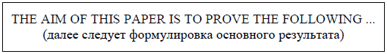
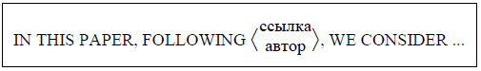
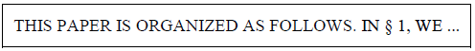

3. Method
Here you must describe exactly the equipment and methods you used.
What you must remember is that somebody might want to test your results so you must make sure that they are able to perform exactly the same experiment with exactly the same equipment.
It is a good idea to include a list of all the equipment you used and step by step instructions on what you did.
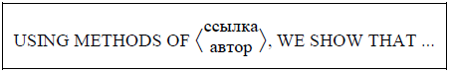
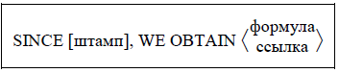

4. Results
Here you describe what you found. In this section, you should not discuss what your results mean; only what you found. You must try to be exact and give numbers instead of just observations.
Use graphs and tables as they are easier for people to understand easily. Be careful not to put in lots of graphs just for the sake of it. Every graph and table should be clear and referred to in the text.
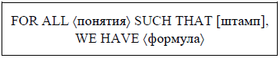
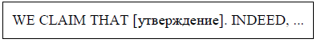
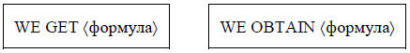

5. Discussion
The discussion is where you interpret your results and try to explain what they mean. This is called significance. You should point out whether your hypothesis is proved, disproved or inconclusive, if you are not sure one way or the other.
If your hypothesis is proved, great, but the world of science does not stay still. Here you should speculate where science goes next or what experiments you could do next.
For example, in the case of the mold bread experiment, after testing the effect of temperature, you could check whether the amount of light has an effect on the rate of growth.
If your hypothesis was wrong or unproven, this is not a problem. There is no right and wrong in science, only answers. Even if your hypothesis was wrong, the world of science has still learned something.
In the discussion you must describe why the experiment did not give the results you expected. Maybe your initial hypothesis was wrong, but maybe there were some flaws in your experimental design or method.
You should describe why it might be wrong or what changes you would make if you were to repeat the experiment again. Be honest. Nobody is going to punish you for having these problems, only for not understanding why.
Even great scientists like Charles Darwin and Stephen Hawking have had flaws in their theories so you are in good company if your experiment did not work out exactly how you planned!
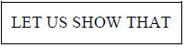
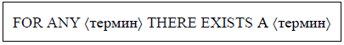
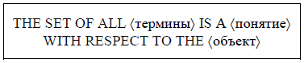
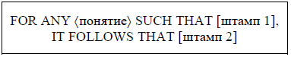
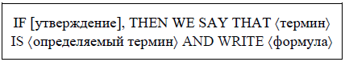

6. Conclusion
It is always a good idea to write a short summary of the conclusion at the end of the report to make everything a little clearer to the reader.
A conclusion works to remind your reader of the main points of your paper and summarizes what you want your reader to “take away” from your discussion. Consider these tips when writing your conclusion:
• Begin with your rephrased thesis statement to remind your reader of the point of your paper.
• Summarize the points you made in your paper and show how they support your argument; tie all the pieces of your paper together.
• Tell your reader what the significance of your argument might be. Why is the discussion important? Do you want your reader to think differently, question something, or perform some action? Make a recommendation of what your reader should "do" with the information you just gave them, or share the importance of the topic.
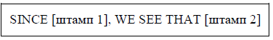
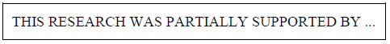

7. References
It is good practice to list the books, magazines and websites from where you found out your background research when writing a research paper. This makes sure that somebody who is interested in your subject can find out a little more.
For a book, you should include the name of the author, the title, the date it was written and the page numbers of where you found the information.
For magazines you should include the name of the author, the title of the magazine, the issue number and/or date, and the name of the article.
For a website you should put the exact website address and the date you looked at it.
Not every science report or article insists that you have a bibliography (references) but if you want to follow a career as a scientist it is a good idea to get used to it now.
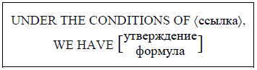
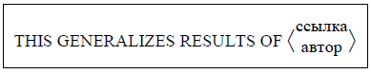
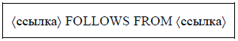
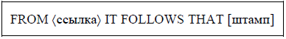

Working from your own ideas will help you avoid plagiarism. Plagiarism is the uncredited use of someone else’s words or ideas, whether you meant to use them without credit or not. This sounds scary, but it doesn’t have to be. If you follow the steps outlined in this lecture, you can be confident that you’ve created your own essay that builds on the ideas, writing, and work of others, without stealing, copying, or plagiarising.

3. Grammar Patterns: Active Verb, Passive Verb and Adjective Form. Verbals
3.1. Active Verb, Passive Verb and Adjective Form
Passive voice, a grammatical construction often misunderstood and misused, can add depth and variety to your writing when used correctly.
In terms of the proper way to use passive voice in a sentence, it is necessary know how Passive voice is formed.

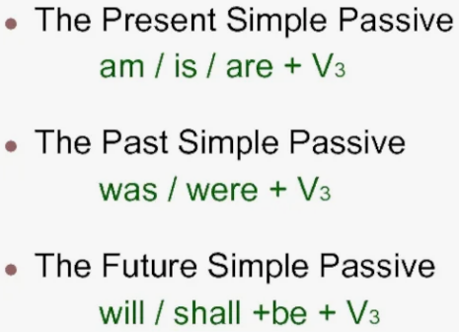

Here we will explore how to use passive voice in a sentence, providing you with the knowledge and confidence to write your scientific papers (Table 10.1).

Table 10.1
Active verb, passive verb and adjective form
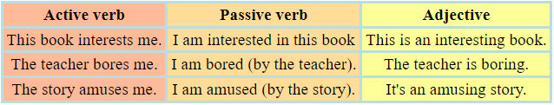

Passive voice is a grammatical construction that places emphasis on the recipient of an action rather than the doer. It is a useful tool in writing as it allows for variation in sentence structure and can create a more formal tone.
However, it is important to use passive voice judiciously and in accordance with grammatical rules to ensure clarity and precision in communication (Table 10.2).

Table 10.2
The passive voice
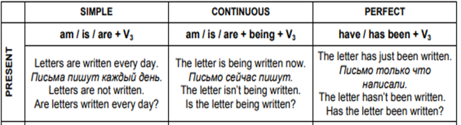

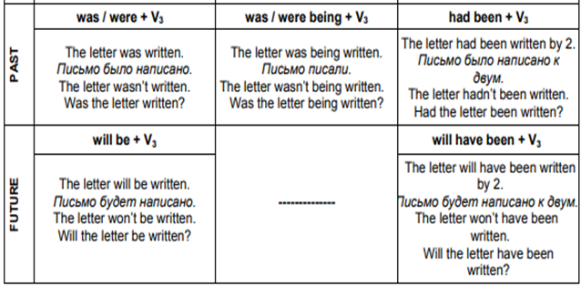

3.2. Verbals
A verbal is a verb form that does not function as a verb. Verbals function as nouns, adjectives, or adverbs. There are three types of verbal:
(1) Gerunds
(2) Participles
(3) Infinitives (Tables 10.3 – 10.6).
Table 10.3
Forms of the Gerund
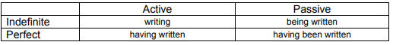

Table 10.4
Forms of the Participle I
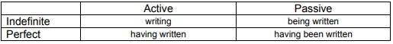

Table 10.5
Forms of the Infinitive
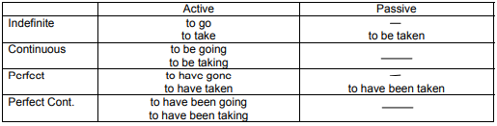

Table 10.6
The use of the bare Infinitive
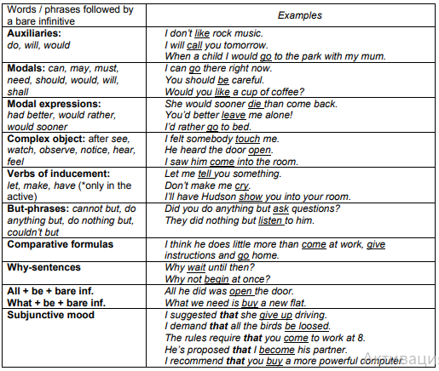

References
Primary sources
1. Bryan Tony, Volchenkova Ksenia. Writing a Research Paper in English. - South Ural State University, 2015.
2. Сосинский А.Б. Как написать математическую статью по-английски. – М.: Факториал, 1998.
3. Schyhlo L.V., Zakharchuk T.O. Scientific-technical text: translation problem. - Sumy State University, Sumy, Ukraine , 2016.
4. Krapivkina O.A. Linguistic and pragmatic aspects of scientific and technical translation. - Irkutsk State Technical University, 2014.
5. Yves Gambier, Luc van Doorslaer. Handbook of Translation Studies. - Volume 1. - Amsterdam / Philadelphia: John Benjamins Publishing Company, 2010.
6. Bassnett Susan. Translation Studies - 3rd Edition. - New York: Routledge, 2002.
7. Munday Jeremy. Introducing Translation Studies: Theories and Applications. - New York: Routledge, 2005.
7. Olohan Maeve. Scientific and Technical Translation. - Routledge, 2016.
9. Eva Mastná. The nature of scientific/technical texts from viewpoint of translation studies. - Tomas Bata University in Zlin. Bachelor Thesis, 2010.
10. Gretzler Edwin. Contemporary Translation Theories. - Revised 2nd Edition - Clevedon: Multilingual Matters LTD, 2001.
11. Superanskaya A.V., Podolskaya N.V., Vasilieva N V. General terminology. Theory issues. - М., 2003.
12. Radjabova D.A. Difficulties of the translation of scientific and technical texts / Педагогика «Молодой учёный». - Март 2017. - № 13 (147) - C. 595-598.

Secondary sources
13. Nord Christiane. Text Analysis in Translation. Theory, Methodology, and Didactic Application of a Model for Translation-Oriented Text Analysis. - New York: Editions Rodopi B.V., Amsterdam – New York, 2005.
14. Venuti Lawrence. The Translation Studies Reader. - 2nd Edition. - New York: Routledge, 2002.
15. Baker Mona. Routledge Encyclopedia of Translation Studies. - London: Routledge, 2001.
16. Komissarov V. N. Modern translation. - М.: Vysshaya shkola, 2002.
17. Šarčević Susan. New Approach to Legal Translation. - Dordrecht: Kluwer Law International, 2000.
18. Byrne Jody. Technical Translation. Usability Strategies for Translating Technical Documentation. - Dordrecht: Springer, 2006.
19. Kazakova Т.А. Practical translation. - Spb: Soyuz, 2001.

Online sources
20. Orozco-Jutorán Mariana. Scientific translation. – 2022. [Electronic resource] https://zenodo.org/records/6370674
21. Actual Problems of Scientific-Technical Translation, 2024. [Electronic resource] https://bues.ru/en/articles/actual_problems.php
22. The notion of Scientific and Technical Translation. [Presentation]
https://ppt-online.org/193480
23. Technical & Scientific Translation. [Presentation]
https://faculty.ksu.edu.sa/sites/default/files/scientific_technical_translation_slides.pptx
24. Basic Scientific and Technical Translation. [Presentation]
https://www.slideserve.com/ali-newton/basic-scientific-and-technical-translation-ii
25. English grammar tables and examples. [Electronic resource]
https://www.englishconversationcoursetutorhk.com/english_grammar_tables_e.php

5
5

